**New Directions Community Youth Ministry**

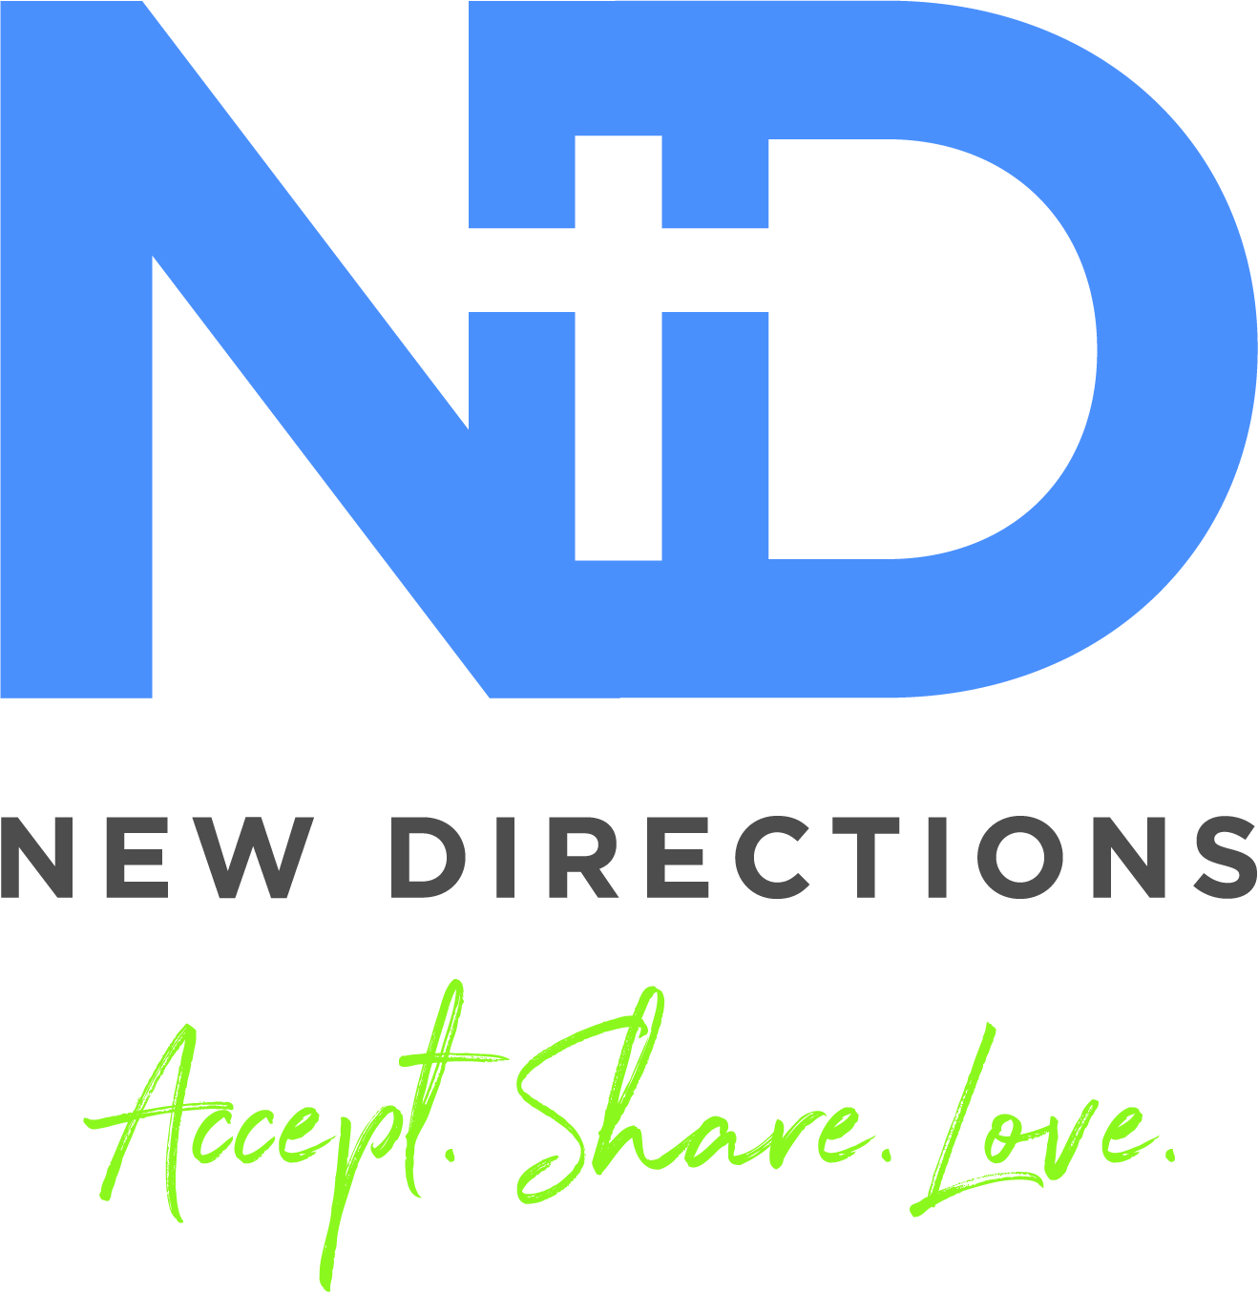

910 North 5th Street, Greenfield, Ohio 45123

Tonia McLanahan, Director

[tmcnewdirections@gmail.com](mailto:tmcnewdirections@gmail.com), (937)661-0197

**~~~~~~~~~~~~~~~~~~~~~~~~~~~~~~~~~~~~~~~~~~~~~~~~~~~~~~~~~~~~~~~~~~~~~~~~~~~~~~~~~~~~~~**

Participant’s Name(s)___________________________________________________________________ Age(s)______________Grade(s) ______________Birthday(s)__________________________________

Student Phone(s)__________________________________________________ Text? Yes___ No___

Student can be contacted by New Directions, directly, regarding upcoming activity: Yes___ No___

Student’s Address_____________________________________________________________________

Responsible Adult(s)_______________________________ Relationship__________________________

Adult Phone/Address (if different from above) _______________________________________________

____________________________________________________________________________________

Adult Phone__________________________ Text? Y___ N___ email____________________________

for upcoming events/additional information? Y___ N___

Others approved to pick up_______________________ Phone___________________ Text? Y___ N___

Other Emergency Contact______________________ Phone____________________ Text? Y___ N___

Permission to: Walk to New Directions unaccompanied______ Home unaccompanied after activity_____

Allergies/medical concerns_______________________________________________________________

____________________________________________________________________________________

Special interests or talents_______________________________________________________________

____________________________________________________________________________________

Other Considerations___________________________________________________________________

Photos can be taken of student(s) and can be used on social media/website: Y___ N___

Student(s) can be driven by driver(s) approved by New Directions to attend offsite activities: Y___ N___

My student(s) has/have permission to participate in the New Directions programming. The staff and approved volunteers of New Directions Community Youth Ministry have permission to attend to minor first aid issues and to seek any reasonable, necessary emergency medical attention if parents or responsible parties cannot be reached.

Parent/Guardian Signature___________________________________________Date________________

**PARENTAL/GUARDIAN CONSENT FOR:**

* Acknowledgement of Personal Liability
* My student to Ride with Private Drivers who have been approved by the New Directions Youth Ministry Board (NDYMB) and/or the Director of New Directions

**CONDUCT DURING ACTIVITY**

I understand that my student’s participation in New Directions activities both at the youth center and other host sites is a privilege, and not a right. I acknowledge that I have spoken with my student about my student’s need to comply with the specific rules and requirements established for this activity; the New Directions rules; and, state and federal regulations and laws. I understand that all New Directions rules and policies apply to my student and the other students during New Directions activities.

**PERMISSIONS AND WAIVER**

I understand that private drivers, which may include the New Directions director, NDYMB approved adult leaders or the parent of another student participating in the activity, may be used to transport students to and from the activities. The owner of the vehicle must carry insurance.

New Directions insurance does not cover damages arising from, or related to, the operation of any private vehicle, failure to follow the directed driving route, or any personal negligence related to this activity. Any damages/harm resulting from a parent/guardian/or other designated driver arising from the operation of a motor vehicle in relation to the above listed activity(ies), is hereby waived.

Please initial on the spaces to the left of the statement below to acknowledge your acceptance of the following permissions.

_____ I give permission

I also understand that I have the ability to refuse to sign this form. In addition, that if I refuse to sign, my student will not be permitted to participate in the activity.

**ACKNOWLEDGEMENT OF PERSONAL LIABILITY AND WAIVER**

I also understand that participation in New Directions activities and programs may expose my student to some risks and I assume any such risk that may arise there from. I accept full responsibility for all medical expenses for any injuries that might occur to my student by reason of his/her participation. By signing this form, however, I hereby release New Directions, the NDYMB, its Board members, youth director, summer intern(s), and volunteers (“released parties”) from and against any and all claims, demands, actions, complaints, suits or other forms of liability that any of them may sustain (a) arising out of my child’s failure to comply with local, state, and federal laws and New Directions policies, procedures, and rules; (b) arising out of any damage or injury caused by my child; or, (c) arising out of a parent/guardian/or other designated driver’s operation of a motor vehicle in relation to this activity. I also agree to indemnify and hold harmless the released parties from the released claims, including any and all related costs, attorney fees, liabilities, settlements, and/or judgments unless injury is a result of gross negligence.

**SIGNATURE**

I confirm that I have carefully read this CONSENT AND RELEASE and agree to its terms knowingly and voluntarily. I also confirm that I am the parent or legal guardian of the student or I am a student 18 years or older.

I have signed this CONSENT AND RELEASE this ___ day of ________, 20__.

This consent and release have been read and are understood by me. ___________________________________________ _________________ Student's signature (If 18 years or older) Date __________________________________________

_________________________________________________Signature of Student's Parent or Legal Guardian Date ________________________________(If Student is less than 18 years)