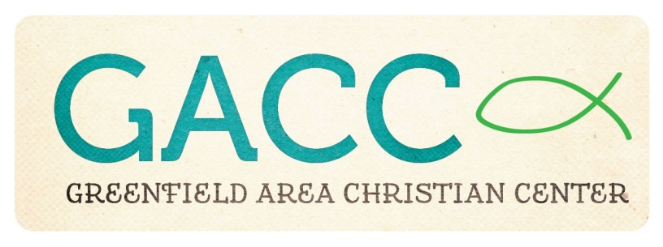
Building Usage Request Form/Agreement
Name Of Individual/Group Requesting Use: _____________________________________________________
Contact Phone Number: ____________________________________________________________________
Address (for the returned deposit): ____________________________________________________________
Type Of Event: ___________________________________________________________________________
Event Date _______________ and Time (including set-up and clean-up):___________________________
Guidelines For Use Of Greenfield Area Christian Center/New Directions Facility
- GACC is an alcohol/tobacco/drug-free facility.
- The availability of the GACC facility is based on a first-come, first-served basis. GACC/New Directions activities always have first priority on the calendar.
- Individuals/groups are responsible for providing their own kitchen supplies, paper products, etc., for their event.
- The use of tape or thumb tacks on the walls or ceiling is not permitted.
- Any damage to GACC/New Directions equipment and/or facility will be repaired or replaced at the cost of the renter.
- Individuals/groups must maintain occupancy within safety codes. If you have questions about safety codes, please contact (937) 661-0197.
- The GACC facility must be left in the proper condition at the end of the event. Counters, stove top, tables, and chairs should be wiped down and returned to their proper place, floors should be swept and mopped (if needed), and all trash should be in garbage bags. Please turn off all lights and electrical equipment before exiting the building. All doors must be locked before the responsible adult leaves the building.
- Full payment is due at the beginning of your event. Cost for the use of the GACC/New Directions facility is as follows: (Circle the space(s) you will be using.)
Community Room/Kitchen: $25 per hour (up to 4 hours) $100 per day
Community Room/Kitchen & Gym: $50 per hour (up to 4 hours)
$200 per day

A $50 deposit is required upon reservation to hold your date. The deposit will be returned to the renter within one week if the building is in proper order. If additional cleaning is required or there is damage, the $50 will be forfeited.

To schedule the GACC Facility, please contact Tonia McLanahan at 937-661-0197.

