
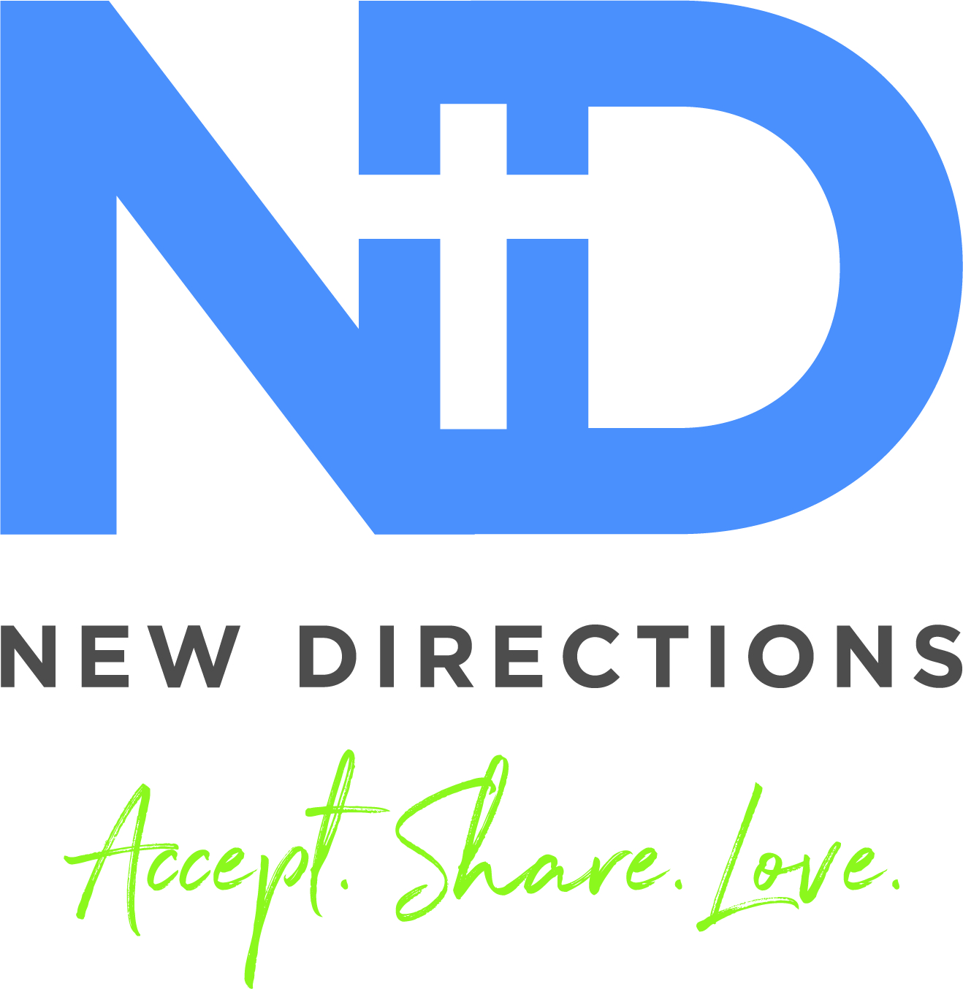

9-2 every Tuesday is for students going into grades 4, 5, and 6. This year’s theme is “Fruits of the Spirit”-Galatians 5:22-23. Each week, we’ll explore scriptures, meet new friends, play games, create and make great memories. Lunch will be provided through the Greenfield Schools’ Tiger Bites program. Or students can pack.

You are LOVED!!
John 3:16-17

DIGG Summer 2026
DIGGs for grades 6-12 are on Mondays and Wednesdays. Check the calendar for what’s happening and when.
High School Hangout (grades 9-12) on Thursday evenings (The day of the week and time may change with the plan) will have a different focus each week. Preparing and enjoying food, game tournaments, movie night, service projects, and more are in the plans.
Be sure to check “New Directions” on Facebook. ndym.org “sign-up” and weekly emails for the latest updates and details. It’s going to be a MARVELOUS Memory Making Summer!!

Hey! Are you ready to DIGG into something great this summer? New Directions has some FABULOUS ways for you to do just that…We are SO EXCITED to offer Summer #6 of DIGGs (Discover, Inspire, Grow, Groups) June 1st-July 23rd.
DIGGs will be led by adults who want to share their interests and skills with YOU!
We are so excited Jaedyn Watson will be serving as the New Directions summer intern.
Jaedyn and I look forward to discovering, being inspired, and growing as we “DIGG” with you this summer.
I hope to see YOU soon!
Tonia McLanahan
Tweens on Tuesdays

Students must have Parental Release Forms on file to participate in Summer DIGGs. Parental Release Forms are available at New Directions, 910 N. Fifth Street, or ndym.org under the “Consent form” tab.
There are a variety of DIGG options each week. Please sign-up in advance for the ones you will attend. DIGG Sign-up forms are online @ ndym.org under the “Summer 2026” tab or you can text/call 937-661-0197, or email tmcnewdirections@gmail.com. Some DIGGs have limited space, so be sure to sign-up early!
NOTE-after you’ve signed up for a DIGG or given us your email, you will get a weekly email with details about that week’s schedule. Weekly details for the coming week will also be posted on our Facebook page on Fridays.

Parental Release Forms & Sign-Ups
From the Youth Director…

