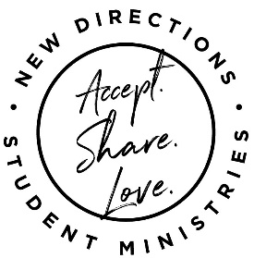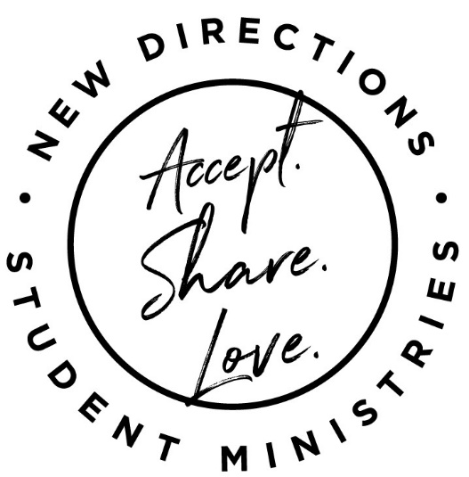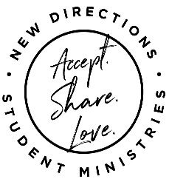

You are LOVED!!

John 3:16-17

DIGG Summer 2025

**DIGGs** for grades 6-12 are on **Mondays** and **Wednesdays**. Check the calendar for what’s happening and when.

**High School Hangout** (grades 9-12) on **Thursday** evenings will have a different focus each week. Preparing and enjoying food, game tournaments, movie night, weekly devotions and more are in the plans.

Be sure to check “New Directions” on **Facebook**. **ndym.org** “sign-up” and weekly **emails** for the latest updates and details. It’s going to be a **MARVELOUS Memory Making** Summer!!

Hey! Are you ready to DIGG into something great this summer? New Directions has some FABULOUS ways for you to do just that…We are SO EXCITED to offer Summer #5 of **DIGGs** (Discover, Inspire, Grow, Groups) June 2nd-July 30th.

**DIGGs** will be led by adults who want to share their interests and skills with YOU!

We are super blessed, Braden Wright will be serving another summer as the New Directions intern.

Braden and I look forward to discovering, being inspired, and growing as we “**DIGG**” with you this summer.

I hope to see YOU soon!

Tonia McLanahan

Tweens on Tuesdays

Students must have **Parental Release Forms** on file to participate in Summer DIGGs. Parental Release Forms are available at New Directions, 910 N. Fifth Street, or **ndym.org** under the “Consent form” tab.

There are a variety of **DIGG** options each week. Please sign-up in advance for the ones you will attend. DIGG Sign-up forms are **online** @ ndym.org under the “Summer 2025” tab or you can **text/call** 937-661-0197, or **email** [tmcnewdirections@gmail.com](mailto:tmcnewdirections@gmail.com). Some DIGGs have limited space, so be sure to sign-up early!

**NOTE**-after you’ve signed up for a DIGG or given us your email, you will get a weekly email with details about that week’s schedule. Weekly details for the coming week will also be posted on our **Facebook** page on **Fridays**.

**Parental Release Forms & Sign-Ups**

**From the Youth Director…**

9-2 every Tuesday is for students going into grades 4, 5 and 6. This year’s theme is “Walking with Jesus: Learning to live God’ way!” Each week, you’ll explore scriptures to see what God wants to teach you through them, meet new friends, play games, create and make great memories. Lunch will be provided through the Greenfield Schools’ Tiger Bites program.