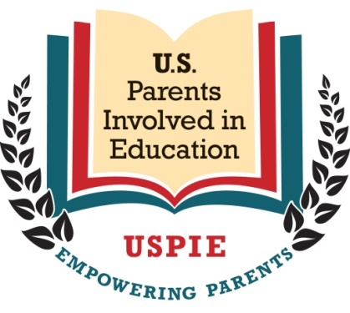
State Chapter President Candidate Questionnaire

Candidate’s Name: ______________________________________
Candidate’s State: _______________________________________

- What is the purpose of education?

- Do you support or oppose the US Department of Education? Why or why not?

- Which education issue (or issues) are you most concerned about and why? What additional issues does your community or district face?

- What experience do you have in actively addressing education issues such as being involved with the PTA/PTO, attending school board meetings, etc.?

- How comfortable are you with social media platforms like Facebook?

- How did you hear about USPIE?

