EPOC 2026
Title: Blueprints vs. Footprints: Designing the Future of Construction Strategy Through Digital Footprints - a conversation starter.
Author: Dr. Sittimont Kanjanabootra Dr. Bernard Tuffour Atuahene
Abstract:
The AEC industry has moved way beyond blueprints and paper with the adoption of digital innovations such as BIM, Digital Modelling, 3D printing, use of drones, AI, data analytics and digital business management. The sum total of this digitisation process has been the creation of Digital Footprints (DF) which are permanent markers of all of activity data created, leaving publicly available footprints that can be traced. These DFs can be created deliberately or accidentally and can represent all aspects of a project’s operations. The effects can be minimal or significant; can threaten business intelligence and project security; but can also be analysed using data analytics to improve business performance. This paper highlights the importance of the Digital Footprint concept for conversations in the AEC industry and develops a framework for AEC organisations to strategically unlock the value, and address the potential problems, of Digital Footprints.
Keywords: Digital Footprint, strategy, AEC, business transformation
Introduction:
With the adoption of digital management processes, data storage, and internet-based communications across business organisations, a digital footprint has been created. In the business domain broadly, the concept and management of organisational digital footprints have been researched for a decade or more (e.g. Hinds and Joinson 2018; Sai and Vranken 2024; Arya et al 2024). Digital footprint creation and management is transformative for business, often being used to link business process and strategy to brand awareness or to digital market contexts via social media. However, in the construction business domain, the importance and management of organisational digital footprints have been paid little attention. This paper is intended to bring the importance of the Digital Footprint concept into conversations in the construction industry.
Digital footprints exist already in the ‘cloud’, and their existence is permanent until better managed. Being able to have the capacity in a construction organisation to address this is essential as the DFs can be both a threat and an advantage to organisations. It is important for construction organisations to understand that to meet this challenge they need to continue to transform beyond business as usual, to better enable the construction industry to meet the demands of the Greenhouse Gas (GHG) Protocol (Hickmann 2017), better manage their data and information resilience in a secure context, improve their capacity for managing business confidentiality and their IP, and better connect their business image with social media. This paper conceptualises and justifies a framework for digital footprint strategy applicable to the construction industry and is made up of five sections. Section 1 introduces the study by stating the purpose of the paper; Section 2 elaborates on the importance of DF through conceptualising the DF ecosystem; Section 3 discusses the relevance of the DF ecosystem and identifies research gaps. The fourth section examines critical issues related to DF with a DF framework, while the final section concludes the study.
Digital Footprints
Tabaghdehi, (2024, p377) defined Digital Footprint Data as “the traces or records left behind by individuals’ online activities, interactions and behaviours across digital platforms and devices.” The National Protective Security Authority (NPSA: 2015) indicated that DF is the generated trail of data after using any digital services, either online or offline. Bushuyev et al., (2021a) further define a digital footprint (DF) as an integral characteristic of an organisational project, reflecting both the “official” information on the project, and any mention of the project, including social networks and other Internet resources. They argue that there are two forms of DF, active and passive. They define an active digital footprint as that which has been formed intentionally and includes both project documentation and project information generated within the framework of project marketing (advertising and PR events) to create a certain image of the project and its future results. On the other hand, a passive digital footprint occurs as “leaked” information on a project, that is, information that was not originally intended for its active dissemination in the environment. An internal passive digital footprint is formed as an accidental or deliberate distribution of a piece of information on a project or organisation to those participants or managers who should not be aware of it.
DF then are the trail of data and the release of that data from digital operations in organisations. In a related study, Hicks et al., (2020) indicated that digital files, created in engineering projects, have made DF an inseparable element for project management for the AEC sector. DF are created in the AEC sector from both online and offline activities undertaken by agents within the sector. At different levels (project, organisation and industry) in the sector, digitalisation of processes has become the new norm contributing to the enormous trails of data. The release of data, by jurisdictional data regulations, are predicated by agreed practices and protocols in the establishment of these levels, though it might be the opposite. The trail and release of data are always to be linked to the form/creation since these represent the rationale for the action taken, either active or passive. Today nothing can disappear in the digital space (Tabaghdehi, 2024). Traces of project participants and the project itself live as long as the digital world lives. From both forms then, there are consequences for organisations Bushuyev et al (2021b) argue that a digital footprint for a project can be assessed as either useful or harmful or can have little consequence, depending on whether the project’s success is affected, either immediately or in the longer term.
Digital footprints created within a project can create a crisis with real pressure being on process. For example, a client can send an email and as the client, demands an immediate response. However, the email might not be received by those responsible as they could be ‘on site”, out of the office, ill etc. If the client creates a storm or crisis because of a lack of responses, what might have been a simple fix becomes a serious issue, diverts people from their normal tasks and potentially can have the effect of project staff needing to prioritise time, with other ‘just as important’ tasks being deferred or delayed. Dealing with time prioritisation is a standalone set of skills which has nothing to do with the digital footprint, but the DF and the information/exchange created by the interaction can create (perceived) unnecessary pressure and force people to prioritise the wrong things/issues. Sometimes, it is able to be suggested from many case studies, ignorance evident in the DF exchange can also create an immediacy effect. Jeffares (2014:85) notes that “ignorance or what is occurring or is being said (online) can be detrimental to reputation”, creating a crisis as exemplified by resignation of the BBC Director General in 2012.
Kanjanabootra et al (2019:19) reported a study of the Sydney Light Rail Project highlighting that the ‘boundary spanning’ or ‘control by the partners in the project’ were never implemented as closed systems. There was ‘leakage’ and subsequently there were often crises created as the communications and planning was findable online in the DF’s that it left. Kanjanabootra concluded that: “almost all of the issues created by the project via the actual construction process and which generated substantial social media commentary that expressed essentially negative sentiment towards the construction, were effectively ones where decisions were made by Transport for NSW at the direction of government ministers. Trust between those directly affected by the construction of the light rail project began with promises of goodwill and support but ended quickly as businesses were affected by hoardings, which affected foot traffic to their business, noise that drove customers away and the continued lack of response to complaints ultimately leading to another disintegration of trust and, ultimately, to legal action. Similarly, the trust with residents was broken by the continuous noise, construction through the night and dust issues. Again, promises were made and not kept, which led to legal action.” There was a failure of the project execution in that their communications/planning strategy neglected to address the digital footprint created continuously throughout the project and enabled those directly affected to find the data or create trails of data themselves and then create a public awareness (release of data) of the negativities that the lack of strategy enabled. This paper is not concerned with differential strategies, rather it is concerned with strategy as a general concept. In AEC all strategy for any project is integrated within the organisational strategy of the stakeholders involved in the project.
A Typology of Digital Footprint content
A summary of the types and effects of these simplified Digital Footprints are summarised in Fig 1. In AEC industries, the boundary lines for creating DF could be drawn at project, organisational and industry levels.
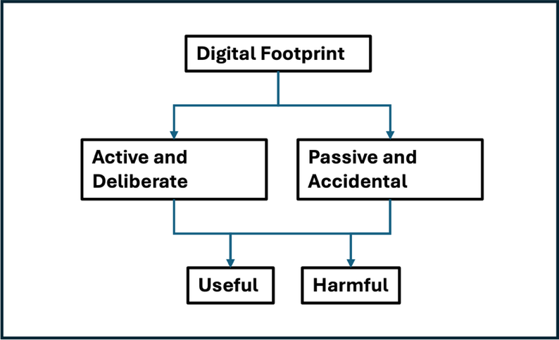
Fig 1 Creation and effects of Digital Footprints (modified after Bushuyev et al., 2021b)
Within active and passive digital footprint, there are elements that are essential to determine usefulness and harmfulness and the effectiveness of data management. These are data ownership, control, ethics and cyber threats. Data ownership is generic and applies to all because trails of data are generated by (in)direct agents within the boundary lines, to achieve the efficiency and productivity (Sharma & Aggarwal, 2024). Control creates distinction amongst the boundary lines, for instance, the organisation boundary line most likely aligns with the active and deliberate creation of DF because there is higher level of control of the DF, unlike the project and industry lines which, by practice, involves multiple organisations contributing to operational processes and accidentally ‘leaking’ information (Sharma & Aggarwal, 2024). The consideration of ethics is dependent on the boundary lines ecosystem, especially the data governance/regime practice at each level, it also applies to cyber threats. The shrouded traits across these idiosyncrasies are strategy and element of behaviour, arising from the interface between humans and DF (Ketipov et al., 2024). Strategy implicitly does not only influence only the form/creation, but the effects of the DF as well. For instance, in order to achieve positive interest of public (effects of DF) at the project, organisation and industry levels, the strategy will include creating positive trails of data by design and release them either deliberately or accidentally.
However, other more explicit research demonstrates that there is a more complex set of digital footprints being created in organisations, including the AEC. Esser et al. (2022) classified business and design modelling software, detection logs, model validation reports, specification documents and drawings as Models and Documentation DFs.
Yilmaz et al. (2025) categorise and analysed RFIs and responses; issue tracking; logistics and delivery notes; equipment telematics; worker attendance and competency records; safety inspections as Operational Processes DFs. Jassim et al. (2025) and Fazil et al. (2021) identified the relevance of Financial and Contractual Dfs evident in documents and communications about cost estimates and actuals; variations and claims; payment certificates; procurement transactions; performance bonds and guarantees; and compliance audits. Pirson and Bol (2021) and Maistriaux et al (2022) have both identified sets of data as Environmental and Assets DFs, comprising elements such as IoT sensor data (e.g., vibration, humidity, temperature); energy use; embodied carbon tagging; emissions and waste logs; and lifecycle condition assessments. The organisational actions regarding permissions and access; access logs and the behaviours associated with them, are also digital footprints created in projects as part of organisational identity. Each of these DF types can emerge from either active and deliberate, or passive and accidental actions and each can result in the set of effects already identified in Fig 2. A more realistic framework of DF typology and effects are illustrated in Fig 2. The discussion has argued that digital footprints are created either deliberately or accidentally and either as an active or passion process. This defines the second level of understanding the DF typology. These actional processes can be related to one of more of a set of operational, financial, environmental, behavioural or documental processes (Level 3 of the typology), all of which can produce specific outcomes dependent on their usefulness, harmfulness, immediacy or have little effect at all (Level 4 of the typology).
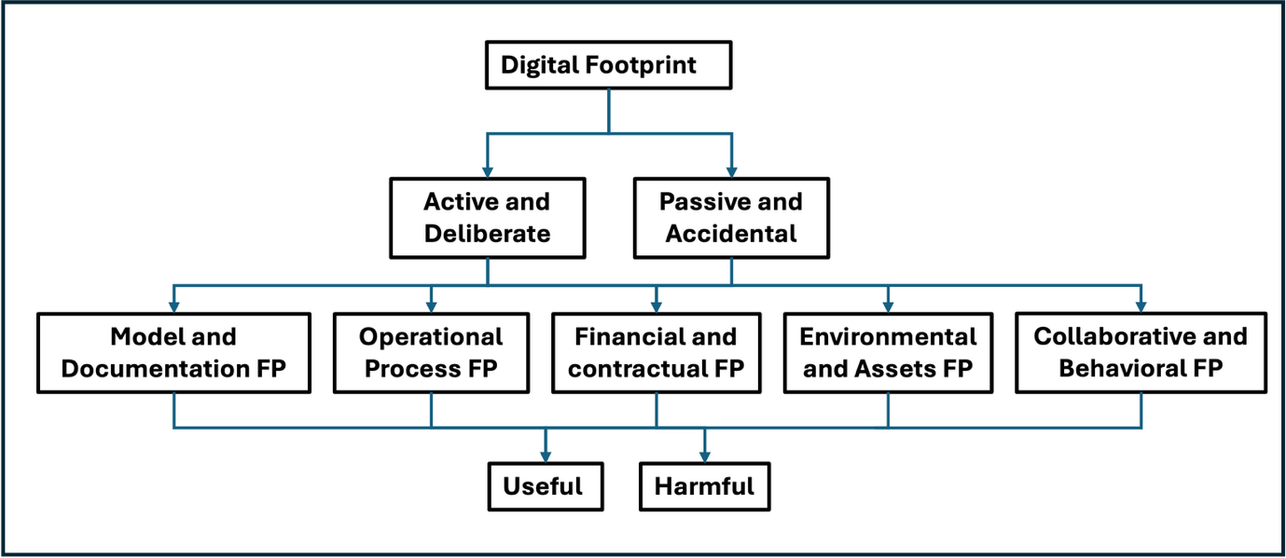
Fig 2. Creation, typology and effects of Digital Footprints
Discussion: Why is all of this important?
1) Benefits: Hicks et al. (2020) demonstrate that using and managing DFs can be beneficial to overcoming problems in engineering projects such as unforeseen dependencies, a lack of understanding, late changes, poor communication, limited resource availability (inc. personnel), incomplete data and aspects of culture and planning. They suggest that adoption of business intelligence tools, big data analytics and computer modelling of the DFs can enable more effective and coherent management of complex projects. In a specific application of the use of these tools in DF analysis in construction, Yan et al. (2022) showed that their adoption can be effective in assessing carbon emissions footprints and assist in the development of carbon emissions reduction strategies. Another positive outcome of undertaking DF analysis in an organisation in a different context highlights advantages that could be possible in construction and engineering projects where so much business process is dependent on effective logistics. Shmatko et al. (2021) have shown that an analysis of the DFs of the cargo flows in a logistics hub for Huawei produced improved efficiency resulting in 10-40% reduction in costs, increased the speed of delivery of goods and improved the profitability of the logistics company.
North and Oliver (2014) analysed the impact of DF adoption and expansions in organisations. They concluded that whilst there can be considerable advantage from deliberate and strategic development of a digital footprint in an organisation, there is also the capacity to incur financial and reputational loss when the process is not thought through sufficiently or carefully. Fan et al. (2025) address the issue of construction companies and management of their carbon footprints offering quantitative models using the extant DFs of a number of Chinese companies. They conclude that their models applied in the Chinese context can help construction companies to achieve the adaptive optimisation of their carbon footprint knowledge systems and promote low-carbon transformation and sustainability development, both at the organisational and industry levels. They also argue that management capability in management of DFs is essential in boosting business resilience and a lack of it is a substantial problem. Szigeti et al. (2023) have researched a similar problem in the context of SMES and their capacity to undertake DF analysis in a simpler way. They note that most construction companies do not have the capacity to undertake detailed DF analysis. They have developed a model and tested it on construction projects in Hungary, that show important practical results, including that the process can be standardised quickly and cheaply, sufficient to assess critical elements in the construction process. Wu et al. (2021) have shown previously that these capabilities are the drivers behind the creation, evolution, and combination of resources to gain competitive advantage. In the new dynamic of the digital footprint, it is therefore essential again for organisations to have the capability to gain the advantages offer by DF analysis and achieve enhanced competitive advantage. This is part of the digital transformation.

2) Transformative Effects: Atuahene et al. (2023) argued that digital transformation is needed to position construction companies to adapt to change, through developing new forms of competitive advantage by integrating, building and reconfiguring internal and external capabilities. In a larger study of problems with adoption of Big Data Applications, one of the elements of the digital footprint left after each project, they showed that a set of twenty-eight big data application enabling capabilities was needed to transform processes in construction companies. These cross 5 dimensions (people, knowledge, technology, data, and environment) appear to be equally important in the attainment of effective transformation. As Big Data is one element of the DF, it can be suggested that these same set of competencies are equally important for organisations to have to gain the advantages from the DF and ensure that the DF left will not negatively affect business competitive advantage.

However, there is little research in AEC industries to ascertain which effects of the DF are most common, or what effects are more or less important. There is also little research on what strategies are/would be effective for AEC organisations to gain the benefits from and counter the issues created by DFs. If we are to consider the DF as part of the digital transformation process for these industries, then there is a need to better understand the answers to these questions.

Critical issues for Digital Footprints as transformative

Digital Footprints are part of the digital transformation process in business, including AEC businesses. Like all elements of the digital transformation the key is the extent to which the process, here digital footprints, are even obvious. Digital footprints differ from drones, BIM, Blockchain, in that they are not immediately physical or obvious. In fact, their presence can remain oblivious as awareness of their creation is not immediately observable. They have to be searched for. So how can DFs become an essential tool in AEC business?
The driver of decision making in all construction business organisations is strategy (e.g. Moshood et al., 2025; Seaden et al., 2003). Strategy relies on recognition of an issue and an understanding that something has outcomes that can improve competitive advantage, improve business process or enable better quality improvement. The other consequence of digital transformation is the exposure of data and information in the organisation to industrial espionage or security breaches. Creating appropriate strategies are an essential part of digital age business. This requires leadership and then the capacity of the organisations ability to absorb and utilise the business element as part of their transformation.
Absorptive capacity is defined as ‘the ability of a firm to recognise the value of new, external information, assimilate it, and apply it to commercial ends’ (Cohen and Levinthal, 1990). Zahra and George (2002) reconceptualised this theory as ‘organisational routines by which a firm acquires, Information Management Systems Categories Interoperability’ through data science and including websites, drone data, digital footprints, social media, and email etc. In an analysis of the “hashtag” economy, Jeffares (2014) demonstrates that digital footprint analyses have been used in business and politics to ‘monitor and visualise’ and/or to ‘capture and sift’. Each process is designed to enable the analyst to understand data with the intention of knowing more. This is transformative and translatable into the business context of AEC organisations if they have the absorptive capacity to realise the value created by the analyses. In an AEC context, the ultimate goal of any construction project is profit. That profit is derived from efficient business and technological processes utilising the specific sets of knowledge that combine in the complexity of a construction project. In that process data is created and in modern businesses, captured digitally, creating a digital footprint. How effective that process is depends on the extent to which the AEC company can absorb, analyse and then use that data. In essence there has to be realisation that every action in a construction process that creates data, creates a DF.
The importance in any kind of business problem is the organisation needs to derive realisation of the issue’s existence. An organisation needs to recognise their current work processes, their communications, and their documentation create Digital Footprints. This will enable the organisation’s leadership to understand what specific processes in their operation creates DFs. An organisation needs to be able to identify what type of DFs that they are generating from their work processes and what kind of impacts that DFs pose for the organisation. This is a strategic problem not a business operations problem. This can then help an organisation to develop relevant strategies to utilise their business’s DFs. Potential actions that can be implemented include 1) monitoring and visualising their DFs and/or 2) by capturing and sifting their DFs. Kaku (2024) argues that by monitoring and visualising an organisation’s DF, they can better protect their privacy, enhance security, and optimise their digital engagement. In essence the monitoring can enable better privacy management, improved data security and better ensure reputation management. Mayda (2022) demonstrates the importance of understanding that so much data and documentation is visualized before it is uploaded that understanding how to utilise these visualisations is essential to monitoring.
Visualising makes complex data more understandable, can be used as justification in strategy development and can be used to identify risks and patterns quickly. The capturing process of Digital Footprints collects raw data traces left by users, devices and systems during digital activities. This can include IoT sensor data, website analytics, transaction logs and social media interactions. The sifting of Digital Footprints refers to the filtering, cleaning and organising of captured data to extract relevant insights and remove, irregularities and outliers (Meckin and Elliot 2024; Burgess et al. 2025; Martins et al. 2025). These methods of monitoring, visualising, capturing and sifting of DFs forms the basis of analyses that evaluate patterns, content, risk and possibilities which can be utilised as a basis for making decisions about actions to meet the intent of strategy. However, the effectiveness of this process, as argued above, is dependent on the organisation having the analytical capabilities to undertake the work and the absorptive capacity to undertake and utilise the work effectively. As an example, it was previously argued that DF management is essential to meet the demand of the GHG Protocol. GHG are becoming increasingly required as part of AEC company annual reporting by many governments. Having the capacity to utilise GHG component DFs will enable AEC firms to report the extent to which they are meeting their GHG obligations.
Requirements for use of DFs and strategy
For AEC organisations it is therefore essential that they recognise the DFs they are creating and how they are creating them. Are they active and deliberate, or passive and accidental, or a combination of both (Fig 2)? This requires analyses of what DF has been created on the internet and what it relates to. Is it financial, or operational, concerned with project documents, or the environment, or with project assets? Once this is determined or at least, begun to be understood, there is the opportunity to better understand the behavioural processes that have enabled the nature and extent of the DF created. It is essential for this realisation of ‘what they know’ to become evident. This knowledge then can be used to evaluate the effects of the various components of the DF, and enable a determination to be made of both the risks associated and of the benefits that may accrue (Fig 2). Once this is known then strategy to deal with these risks and benefits can be established and implemented. This proposed process is illustrated in Fig 3.
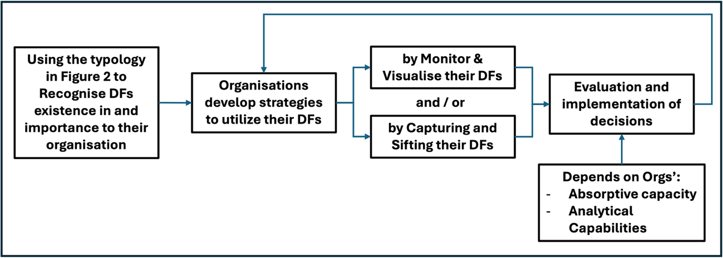Fig 3. Digital Footprints Strategy Process Framework.
Conclusion
This paper has explored the need for strategy in dealing with the very large digital footprints being created as AEC organisations adopt digital business processes and transform their operations using digital innovations. This is a little explored area in AEC research (Hicks et al 2020). The problems associated with, and benefits of DFs, have already been identified in the retail, banking, insurance etc industries. There appears to be little cognitive knowledge, i.e. mental understanding and awareness of facts, concepts and principles (Dehaene, 2020), in the professional or academic literatures relevant to the AEC. We have utilised previous and related research in relevant aspects of DF issues such as Big Data Applications (e.g. Atuahene et al. 2023) or engineering projects (Hicks et al 2020), to progress an understanding of the issues relevant to identification and application of DFs. This paper uses that understanding to develop a potential framework for AEC organisations to utilise to develop strategy, dealing with the risks associated with DFs, and understanding the benefits they offer improve organisational efficiency and work practices using data analytics. This approach has limitations. Whilst the literature on DFs is quite expansive, the literature on DFs in AEC is inadequate for generalisation. It is an important part of the research process to initiate discussion on the application of demonstrated useful concepts, like DFs, even when there is to know data relevant to the research context, AEC. Through discussion the bones of potential research process can emerge. EPOC represents a good initial starting point for this discussion. The next step in this research will be undertaking case studies with AEC organisations utilising the framework, and assessing the effectiveness of it.

References:
Arya, A., Bachheti, A., Bachheti, R. K., Singh, M., & Chandel, A. K. (2024). Role of artificial intelligence in minimizing carbon footprint: A systematic review of recent insights. Biorefinery and Industry 4.0: Empowering Sustainability, 365-386.
Atuahene, B. T., Kanjanabootra, S., & Gajendran, T. (2023). Transformative role of big data through enabling capability recognition in construction. Construction Management and Economics, 41(3), 208-231. https://doi.org/10.1080/01446193.2022.2132523
Burgess, R., Boyd, A., Davis, O. S., Millard, L. A., Mumme, M., Robertson, S., Skinner, A., Xiao, Z., & Skatova, A. (2025). Linking digital footprint data into longitudinal population studies. International Journal of Population Data Science, 10(1), 2946.
Bushuyev, S., Bushuieva, V., Bushuyeva, N., & Bushuiev, D. (2021a). Conceptual model of project digital footprint. 2021 IEEE 16th International Conference on Computer Sciences and Information Technologies (CSIT),
Bushuyev, S., Onyshchenko, S., Bushuiev, D., Bushuieva, V., & Bushuyeva, N. (2021b). Dynamics and impact of digital footprint on project success. Scientific Journal of Astana IT University, 15-22.
Cohen, W. M., & Levinthal, D. A. (1990). Absorptive capacity: A new perspective on learning and innovation. Administrative Science Quarterly, 35(1), 128-152.
Dehaene, S. (2020). How we learn: The new science of education and the brain. Penguin UK.
Esser, S., Abualdenien, J., Vilgertshofer, S., & Borrmann, A. (2022). Requirements for event-driven architectures in open BIM collaboration. Proceedings of the 29th EG-ICE international workshop on intelligent computing in engineering,
Fan, M., Lai, W., & Wu, C. (2025). A Study on the Driving Factors of Resilience in the Carbon Footprint Knowledge System of Construction Companies. Buildings, 15(16), 2856.
Fazil, M., Sah, A. K., & Abulaish, M. (2021). Deepsbd: a deep neural network model with attention mechanism for socialbot detection. IEEE Transactions on Information Forensics and Security, 16, 4211-4223.
Hickmann, T. (2017). Voluntary global business initiatives and the international climate negotiations: A case study of the Greenhouse Gas Protocol. Journal of Cleaner Production, 169, 94-104.
Hicks, B., Culley, S., Gopsill, J., & Snider, C. (2020). Managing complex engineering projects: What can we learn from the evolving digital footprint? International Journal of Information Management, 51, 102016.
Hinds, J., & Joinson, A. N. (2018). What demographic attributes do our digital footprints reveal? A systematic review. Plos One, 13(11), e0207112.
Jassim, H. S., Hasan, M. F., Altaee, M. J., & Gamil, Y. (2025). A model for preliminary cost estimation in buildings construction projects. Frontiers in Built Environment, 11, 1359777.
Jeffares, S. (2014). Capturing the Digital Footprint of Policy Discussion. In Interpreting Hashtag Politics: Policy Ideas in an Era of Social Media (pp. 85-111). Springer.
Kaku, S. (2024). Navigating the Digital Landscape: Understanding and Managing Your Digital Footprint. Global Media Journal, 22(68), 1-3.
Kanjanabootra, S., Peszynski, K., & Atuahene, B. (2019). On-going social commentary and the new project manager: sentiment in large infrastructure projects. 17th annual engineering project organization conference,
Ketipov, R., Schnalle, R., Doukovska, L., & Dehez, D. (2024). Managing cybersecurity: digital footprint threats. Cybernetics and Information Technologies, 24(3), 151-162.
Maistriaux, P., Pirson, T., Schramme, M., Louveaux, J., & Bol, D. (2022). Modeling the carbon footprint of battery-powered IoT sensor nodes for environmental-monitoring applications. Proceedings of the 12th International Conference on the Internet of Things,
Martins, P., Cardoso, F., Váz, P., Silva, J., & Abbasi, M. (2025). Performance and Scalability of Data Cleaning and Preprocessing Tools: A Benchmark on Large Real-World Datasets. Data, 10(5), 68.
Mayda, M. (2022). Digital Footprint Management In Dıigital Visual Culture. Erciyes İletişim Dergisi, 9(2), 1031-1044.
Meckin, R., & Elliot, M. (2024). Digital Footprint Management. NCRM Futures Briefing #003. https://eprints.ncrm.ac.uk/id/eprint/4953/1/Method%20Futures%20Briefing_Digital%20Footprint%20Management.pdf
Moshood, T. D., Rotimi, J. O., & Shahzad, W. (2025). Enhancing construction organizations’ performance through strategic decision-making: unveiling the mediating role of quality of information. International Journal of Organizational Analysis, 33(9), 2956-2991.
North, S., & Jason Oliver, J. (2014). A strategic look at how to extend your digital footprint. Strategic direction, 30(7), 1-3.
NPSA. (2015). My Digital Footprint: A brief guide. United Kingdom: Crown Copyright
Pirson, T., & Bol, D. (2021). Assessing the embodied carbon footprint of IoT edge devices with a bottom-up life-cycle approach. Journal of Cleaner Production, 322, 128966.
Sai, A. R., & Vranken, H. (2024). Promoting rigor in blockchain energy and environmental footprint research: A systematic literature review. Blockchain: Research and Applications, 5(1), 100169.
Seaden, G., Guolla, M., Doutriaux, J., & Nash, J. (2003). Strategic decisions and innovation in construction firms. Construction Management and Economics, 21(6), 603-612.
Sharma, I., & Aggarwal, A. (2024). Digital footprints and the battle for data sovereignty: Digital privacy, security, and ownership. In Driving decentralization and disruption with digital technologies (pp. 74-83). IGI Global Scientific Publishing.
Shmatko, A., Barykin, S., Sergeev, S., & Thirakulwanich, A. (2021). Modeling a logistics hub using the digital footprint method—the implication for open innovation engineering. Journal of Open Innovation: Technology, Market, and Complexity, 7(1), 59.
Szigeti, C., Major, Z., Szabó, D. R., & Szennay, Á. (2023). The ecological footprint of construction materials—a standardized approach from hungary. Resources, 12(1), 15.
Tabaghdehi, S. A. H. (2024). Chapter 17: Ethical governance of digital footprint data: a journey towards a responsible society. In Business Strategies and Ethical Challenges in the Digital Ecosystem. Edited by Tabaghdehi, S. A. H. and Foroudi, P. Emerald Publishing. https://doi.org/10.1108/9781804550694
Wu, M., Kozanoglu, D. C., Min, C., & Zhang, Y. (2021). Unraveling the capabilities that enable digital transformation: A data-driven methodology and the case of artificial intelligence. Advanced Engineering Informatics, 50, 101368.
Yan, J., Lu, Q., Tang, J., Chen, L., Hong, J., & Broyd, T. (2022). Digital tools for revealing and reducing carbon footprint in infrastructure, building, and city scopes. Buildings, 12(8), 1097.
Yilmaz, N., Ergen, E., & Citipitioglu, A. M. (2025). Enhancing RFI management in construction through machine learning-driven predictive models. Smart and Sustainable Built Environment, 1-21.
Zahra, S., & George, G. (2004). Absorptive capacity and entrepreneurship.(2004). In (Vol. 44, pp. 118-131): Blackwell encyclopedia of management: Entrepreneurship.

Associate Professor in Construction Management, School of Architecture and Built Environment, The University of Newcastle, Australia: Sittimont.kanjanabootra@newcastle.edu.au
Assistant Professor in Construction Management and Engineering, School of Computing and Engineering, University of Bradford, UK: b.t.atuahene@bradford.ac.uk

