Solar Technology Diffusion in Non-Proprietary Contexts:
Ecosystem Archetypes and Driving Forces Shaping Future Pathways
Asif Mehdi¹, Paulo Savaget¹, Malcolm McCulloch¹
¹Department of Engineering Science, University of Oxford

1. Research Problem Statement or Purpose
Over the past two decades, solar energy has become a central component of global energy transition efforts, driven by declining technology costs, climate commitments, and concerns over energy security (Breyer et al., 2018; IPCC, 2018). Early research on solar technology diffusion primarily focused on technological performance, cost competitiveness, and policy instruments designed to stimulate adoption, such as feed-in tariffs, subsidies, and renewable portfolio standards (Yu et al., 2016). As deployment expanded across diverse economic and institutional contexts, it became evident that diffusion outcomes varied widely across countries, even where similar technologies and policy incentives were present (Erdogdu, 2014).
Subsequent literature shifted attention towards the institutional, regulatory, market, and financing conditions shaping renewable energy diffusion, while a substantial body of work has explored barriers to technology adoption in emerging and developing economies (Bhattarai et al., 2022; Grubb and Newbery, 2018; Kennedy and Basu, 2013; Urpelainen and Yang, 2017; Zanello et al., 2016). Together, these studies explain why diffusion progresses unevenly across contexts. Yet, the existing literature offers limited insight into how the solar technology ecosystem is structured, how different actors interact across various solar diffusion trajectories, and why diffusion pathways stall even when supportive policies are formally in place. This limitation is especially crucial for non-proprietary contexts, defined as settings in which domestic firms and institutions do not develop core solar photovoltaic (PV) technologies and the ecosystem relies predominantly on imported PV components (Ukoba et al., 2024).
In non-proprietary contexts, solar diffusion depends less on local technology ownership and more on how effectively actors coordinate across regulatory, financial, and implementation interfaces (Ukoba et al., 2024). To make the diffusion pathways analytically visible, this paper uses the term ‘ecosystem archetypes’ to refer to stylised, recurring configurations through which solar projects are organised and delivered. While ecosystem perspectives have been applied in innovation and sustainability research, they remain less integrated into mainstream solar diffusion studies in ways that make actor relationships, process structures, and sequencing dynamics explicit (Adner, 2017; Baldwin et al., 2024). Moreover, although scenario analysis is used in energy research, it is less commonly employed to examine how uncertainty and structural driving forces shape the long-term evolution of solar diffusion in specific non-proprietary technology contexts.
Accordingly, the paper addresses the research question: What does the existing solar technology ecosystem look like, what are its challenges and possible futures? This question is important for the relevant stakeholders because it remains unclear how actors participate in, coordinate within, or disengage from solar ecosystems in such contexts, and which driving forces matter most for future diffusion pathways.

2. Brief Research Methodology and Approach
This study adopted a qualitative case-study design based on semi-structured interviews, documentary analysis, and scenario analysis, coupled with ecosystem theory as the main analytical lens (Adner, 2017; Eisenhardt, 1989; Van der Heijden, 2005; Yin, 2014). Bangladesh provides a suitable empirical context because solar diffusion is actively promoted in the country, yet renewable energy expansion continues to face persistent implementation challenges (SREDA, 2025).
We conducted 54 interviews with key actors across government agencies, financial institutions, project developers, EPC contractors, researchers, and customers within Bangladesh’s solar ecosystem. Interviewee selection followed role-based purposive sampling, using publicly available information to identify actors directly involved in solar project development, financing, implementation, regulation, or use. Regulators and policymakers are mostly Dhaka-based, while developers and EPC firms operate across multiple regions; therefore, the sample captures the national ecosystem through Dhaka-centred decision nodes and countrywide implementation activity.
The solar technology diffusion related literature stream seldom intersects with ecosystem theory, even though this lens can be highly useful for countries where proprietary technologies are absent (Baldwin et al., 2024). Ecosystem theory emphasises that value creation or diffusion depends not on isolated actors but on interdependent networks of actors whose roles, incentives, and timing must be aligned (Adner, 2017). The ecosystem theory lens was adopted in this study for the following four advantages. Firstly, it makes the roles, interests, and influences of the actors comprehensible, fosters effective collaborations and steers collective efforts (Dedehayir et al., 2018). Secondly, it enables a detailed understanding of the interdependencies in the ecosystem across technological, regulatory, financial, and socio-cultural dimensions (Jacobides et al., 2018). Thirdly, it helps identify how actors should align their activities to improve overall ecosystem performance in relation to timeliness of approvals, clarity of role allocation, predictability of procurement and contracting, bankability of financing arrangements, transparency, and feedback (Ritala et al., 2013). Fourth, it supports the identification of partnership and governance arrangements tailored to local needs (Savaget et al., 2024).
Furthermore, in the study, scenario analysis enabled the examination of how the system may evolve under different contextual conditions (Van der Heijden, 2005). Thus, the approach of adopting the ecosystem theory lens and scenario analysis methodology allowed the study to investigate both current ecosystem archetypes and plausible future pathways.
Data collection and analysis proceeded in three iterative stages. In the first stage, 25 interviews with ecosystem actors were conducted, and this stage led to the identification of two main diffusion pathways of solar technologies. Interview data and secondary materials, including national energy policies, regulatory guidelines, planning documents, and institutional reports, were used to map ecosystem actors, roles, and interdependencies, leading to the development of ecosystem archetypes. In the second stage, we created process flow diagrams to represent the sequence of steps and the transfer of responsibilities across project planning, approval, finance, and implementation. These diagrams, together with interview data analysis, were used to identify the prevailing key challenges in the ecosystem. In the third stage, additional actors, who hold considerable influence over the empirical context and can introduce new perspectives, were purposively selected and interviewed to examine the underlying causes (contextual driving forces) of the challenges. Although the analysis is presented in three stages, the process was iterative, and the full dataset was used to examine the contextual driving forces shaping future diffusion trajectories.
To examine possible future pathways, we conducted scenario analysis in accordance with the five stages of scenario development (Van der Heijden, 2005): (i) identifying contextual space driving forces, (ii) ranking drivers against uncertainty and impact, (iii) examining best and worst outcomes for selected drivers, (iv) creating a 2×2 scenario matrix, and (v) developing narrative scenarios. A broad set of contextual driving forces was identified from interview data and secondary sources and subsequently ranked by uncertainty and impact. The two most uncertain and high-impact driving forces were then used to construct a 2×2 matrix that structured the scenario space. This process enabled the identification of the most influential driving forces shaping plausible future diffusion trajectories.

3. Key Findings
The study produced a structural mapping of the solar ecosystem in a non-proprietary context and identified two distinct diffusion pathways: one for publicly funded projects and one for privately financed projects. Each pathway involves different actor arrangements, approval sequences, dependencies, and bottlenecks. Using the developed process-flow diagrams, the study revealed several challenges embedded in the current ecosystem and showed where and how breakdowns occur along the project pathway.
The study first identified a set of observable ecosystem challenges, including disconnected and time-consuming approval processes, regulatory ambiguity and weak inter-actor coordination, weak statutory enforcement and escalation mechanisms, slow loan processing, weak subsidy and incentive frameworks, inadequate support for niche actors, weak quality assurance and reduced investor confidence, and absence of adaptive feedback mechanisms. Interview evidence illustrates these challenges. For instance, one interviewee stated that “There is no coordination among government entities such as SREDA and BPDB” (DEV01), while another argued that “This coordination crisis… is actually a basic flaw in Bangladesh’’ (REG08). Some respondents described the ecosystem in which “There is no accountability. There is no SLA. There is no digital platform for tracking” (EPC03), and where “Bank takes 60 to 90 days to release funds” (DEV07). Financing constraints were reinforced by the observation that “The biggest problem is funding” (DEV06). Interviewee quotations are anonymised using actor-group codes; for example, REG refers to regulator, DEV to project developer, and EPC to engineering, procurement, and construction contractor.
To clarify these identified challenges in relation to evidence from other contexts, the paper summarises five coordination standards drawn from the empirical contexts that illustrate efficient solar technology diffusion. For instance, digitised approval portals and time-bound service delivery in India’s rooftop solar programme (Purohit et al., 2024), programme-based procurement with standardised power purchase agreements (PPAs), bid windows, and government-backed guarantees in South Africa’s Renewable Energy Independent Power Producer Procurement Programme (REIPPPP) (Chetty et al., 2023), and centralised, time-bound approvals with digital tracking under the UK’s Nationally Significant Infrastructure Projects (NSIP) framework (Planning Inspectorate, 2026). These examples were used to clarify the meaning of the five standards. They are: (i) timeliness of decisions and adherence to time-bound steps; (ii) role clarity, including a clearly accountable lead actor for each step; (iii) traceability and transparency, such as trackable application and decision status; (iv) bankability, including predictable contracting structures and risk allocation; and (v) feedback and learning, whereby implementation problems feed back into regulatory adjustment. These standards also helped distinguish different growth patterns: rapid but haphazard growth refers to expansion where projects move forward unevenly and scaling occurs without strategic alignment, whereas well-orchestrated growth implies expansion where approvals, financing, and delivery capability are more predictably aligned.
The analysis then moved from observable barriers to the contextual driving forces shaping future diffusion trajectories. Among the wider set of contextual factors, two driving forces emerged as most consequential: (1) non-coordinated regulation and (2) private investment in solar. These forces formed the basis of a 2×2 scenario matrix that helped to develop four plausible futures, ranging from fragmented, low-investment stagnation to coordinated, high-investment expansion (Fig. 01).
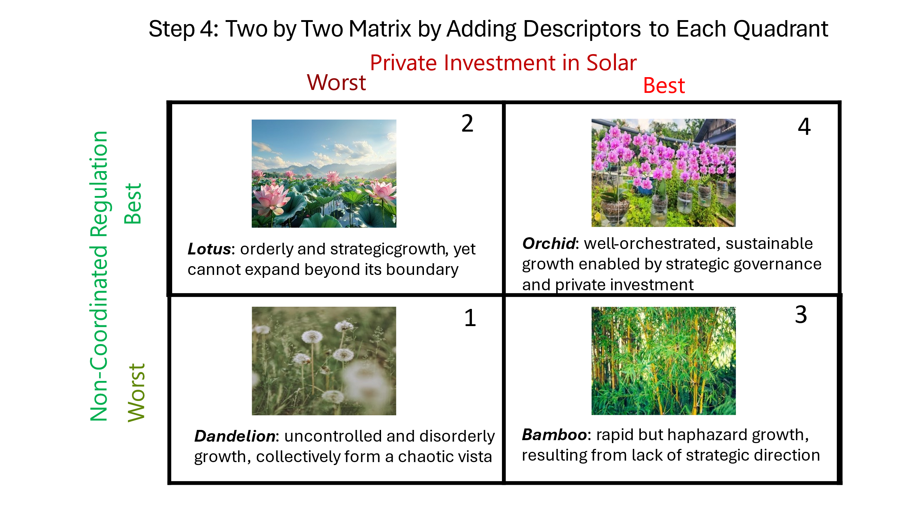
Fig. 01: Four plausible future scenarios for solar technology diffusion
in a non-proprietary context.

The four scenarios portray distinct solar technology diffusion trajectories. Dandelion represents a future characterised by non-coordinated regulation and low private investment, whereas Lotus exhibits coordinated regulation combined with limited private investment. Bamboo scenario captures high private investment under weak regulatory coordination, which leads to rapid but haphazard expansion without strategic direction. Orchid illustrates the thriving future, where coordinated regulation and robust private investment enable well-orchestrated, scalable, and sustainable solar diffusion.

4. Implications
By focusing on actor interdependencies, coordination dynamics, and process structures, the research provides a more integrated understanding of why diffusion outcomes remain uneven despite supportive policy intentions in a country that does not have proprietary solar technologies. Moreover, this study illustrates the value of combining scenario analysis with ecosystem theory, where ecosystem theory maps current structures, roles, and interactions, while scenario analysis identifies the most influential driving forces shaping future diffusion trajectories under uncertainty. Finally, the findings offer actionable insights for policymakers, regulators, and project developers by identifying where the breakdowns occur across the solar technology ecosystem and clarifying the key driving forces that must be addressed to enable a thriving diffusion pathway.

Acknowledgement
This research is funded by the Science and Technology Fellowship Trust, Ministry of Science and Technology, Government of the People’s Republic of Bangladesh.

References
Adner, R. (2017). Ecosystem as Structure: An Actionable Construct for Strategy. Journal of Management, 43: 39–58.
Baldwin, C.Y., Bogers, M.L., Kapoor, R. and West, J. (2024). Focusing the Ecosystem Lens on Innovation Studies. Research Policy, 53: 104949.
Bhattarai, U., Maraseni, T. and Apan, A. (2022). Assay of Renewable Energy Transition: A Systematic Literature Review. Science of The Total Environment, 833: 155159.
Breyer, C., Bogdanov, D., Aghahosseini, A., Gulagi, A., Child, M., Oyewo, A.S., Farfan, J., Sadovskaia, K. and Vainikka, P. (2018). Solar Photovoltaics Demand for the Global Energy Transition in the Power Sector. Progress in Photovoltaics: Research and Applications, 26: 505–523.
Chetty, K., Davids, Y.D., Kanyane, M., Madzivhandila, T., Moosa, T. and Ndaba, L. (2023). Fostering A Just Energy Transition: Lessons from South Africa's Renewable Energy Independent Power Producer Procurement Programme. South African Journal of International Affairs, 30: 225–244.
Dedehayir, O., Mäkinen, S.J. and Ortt, J.R. (2018). Roles during Innovation Ecosystem Genesis: A Literature Review. Technological Forecasting and Social Change, 136: 18–29.
Eisenhardt, K.M. (1989). Building Theories from Case Study Research. Academy of Management Review, 14: 532–550.
Erdogdu, E. (2014). Investment, Security of Supply and Sustainability in the Aftermath of Three Decades of Power Sector Reform. Renewable and Sustainable Energy Reviews, 31: 1–8.
Grubb, M. and Newbery, D. (2018). UK Electricity Market Reform and the Energy Transition: Emerging Lessons. The Energy Journal, 39: 1–26.
IPCC (2018). Global Warming of 1.5◦C. Intergovernmental Panel on Climate Change.
Jacobides, M.G., Cennamo, C. and Gawer, A. (2018). Towards a Theory of Ecosystems. Strategic Management Journal, 39: 2255–2276.
Kennedy, M. and Basu, B. (2013). Overcoming Barriers to Low Carbon Technology Transfer and Deployment: An Exploration of the Impact of Projects in Emerging Economies. Renewable and Sustainable Energy Reviews, 26: 685–693.
Planning Inspectorate (2026). Nationally Significant Infrastructure Projects. Available at: https://www.gov.uk/government/organisations/planning-inspectorate (Accessed: April 24, 2026).
Purohit, I., Sharma, A.K. and Purohit, P. (2024). Leveraging Information Technology for Accelerating Residential Rooftop Solar: A Case Study from Odisha, India. Mitigation and Adaptation Strategies for Global Change, 29: 47
Ritala, P., Agouridas, V., Assimakopoulos, D. and Gies, O. (2013). Value Creation & Capture Mechanisms in Innovation Ecosystems: A Comparative Case Study. International Journal of Technology Management, 63: 244–267.
Savaget, P., Ozcan, P. and Pitsis, T. (2024). Social Entrepreneurs as Ecosystem Catalysts: The Dynamics of Forming and Withdrawing from a Self-Sustaining Ecosystem. Journal of Management Studies.
SREDA (2025). Sustainable and Renewable Energy Development Authority. Available at: https://sreda.gov.bd/
(Accessed: December 19, 2025).
Ukoba, K., Yoro, K.O., Eterigho-Ikelegbe, O., Ibegbulam, C. and Jen, T.C. (2024). Adaptation of Solar Power in the Global South: Prospects, Challenges and Opportunities. Heliyon.
Urpelainen, J. and Yang, J. (2017). Policy Reform and the Problem of Private Investment: Evidence from the Power Sector. Journal of Policy Analysis and Management, 36: 38–64.
Van der Heijden, K. (2005). Scenarios: The Art of Strategic Conversation. John Wiley & Sons.
Yin, R.K. (2014). Case Study Research: Design and Methods (Vol. 5), Sage.
Yu, H.J.J., Popiolek, N. and Geoffron, P. (2016). Solar Photovoltaic Energy Policy and Globalization: A Multiperspective Approach with Case Studies of Germany, Japan, and China. Progress in Photovoltaics: Research and Applications,
24: 458–476.
Zanello, G., Fu, X., Mohnen, P. and Ventresca, M. (2016). The Creation and Diffusion of Innovation in Developing Countries: A Systematic Literature Review. Journal of Economic Surveys, 30: 884–912.

