Rethinking the Economic Value of Urban Flood Protection:
Network-Wide Benefits of Deep Tunnel Storm Sewer Systems
Bomin Sohn^{𝑎}, Nahyung Kang^{𝑎}, Sieun Park^{𝑎}, Seongsoo Yang^{𝑎}, Soh Young In^{𝑎∗}
^{𝑎}Korea Advanced Institute of Science and Technology, Daejeon, Republic of Korea
∗Corresponding author: Soh Young In; si2131@kaist.ac.kr
Note: After the first author, the remaining authors are listed in alphabetical order.
This study evaluates the economic viability of Deep Tunnel Storm Sewer Systems (DTSS) by widening the appraisal accounting boundary to jointly quantify transport-inclusive direct asset losses and indirect network-wide socio-economic losses from urban pluvial flooding. We develop an integrated Flood–Transport Economic Assessment Framework coupling climate-adjusted design rainfall, CADDIES-2D pluvial flood modeling, the Korea Flood Risk Management (K-FRM) damage model, and User Equilibrium (UE) traffic assignment under a unified paired-counterfactual structure. The framework is applied to the planned Gangnam DTSS in Seoul across 42 scenarios, spanning return periods RP10–RP500 and 1–3 h storm durations. Preliminary results show that transport-related direct assets, namely vehicles and public infrastructure, account for roughly 80% of K-FRM Full direct flood damage, while residential and non-residential buildings, the conventional cost-benefit-analysis target, account for only about 16%. DTSS reduces direct losses by about 71% on average. The UE-derived indirect network channel accounts for approximately 20–30% of combined economic loss under the cap240–cap480 delay-cap sensitivity band, a channel entirely omitted by building-only appraisal. These preliminary findings indicate that conventional building-only flood appraisal substantially undervalues large-scale flood protection in dense metropolitan settings such as Gangnam, and that DTSS-class infrastructure should be appraised as a cross-sectoral urban-resilience investment rather than a single-sector drainage asset.

1. Research Problem Statement and Objectives
Climate change and rapid urbanization are intensifying urban pluvial flooding, which emerges with limited lead time and disproportionately disrupts highly interconnected metropolitan systems beyond directly inundated areas (Arnbjerg-Nielsen et al., 2013; Skougaard Kaspersen et al., 2017). Deep Tunnel Storm Sewer Systems (DTSS) are a common large scale grey-infrastructure response (Park et al., 2024a) but require substantial capital investment, raising the importance of the economic justification of their use.
Despite their hydraulic effectiveness, DTSS projects are frequently undervalued because conventional cost-benefit analysis defines benefits narrowly as avoided direct building damage (Doeffinger & Rubinyi, 2023; Molinari et al., 2021). This narrow accounting boundary omits two important benefit channels. The first is transport-related direct asset damage, including vehicles and public infrastructure. The second is indirect, network-wide loss from flood-induced transport disruption, including congestion propagation and time-based delay losses across metropolitan road networks (Singh et al., 2018; Zhou et al., 2022). Consistent with the triple-dividend-of-resilience framework (Tanner et al., 2015), these omitted channels can be substantial and policy-relevant (Brandon et al., 2025), motivating an appraisal approach that makes the accounting boundary explicit.
This study therefore asks: how does the appraised value of DTSS change when evaluation expands from building-only damage to transport-inclusive direct damage and indirect network-wide disruption? The objective is not only to compute flood damages, but to show how project appraisal boundaries shape the perceived economic feasibility and governance implications of climate-adaptation infrastructure.

2. Brief Research Methodology and Approach

2.1 Integrated Flood–Transport Economic Assessment Framework
We develop an integrated Flood–Transport Economic Assessment Framework linking physical inundation to system-wide economic consequences through a unified paired-counterfactual structure. Avoided socio-economic losses are quantified by comparing, under identical rainfall, a baseline scenario without DTSS against an adaptation scenario in which DTSS mitigates surface inundation and preserves transportation-network functionality.
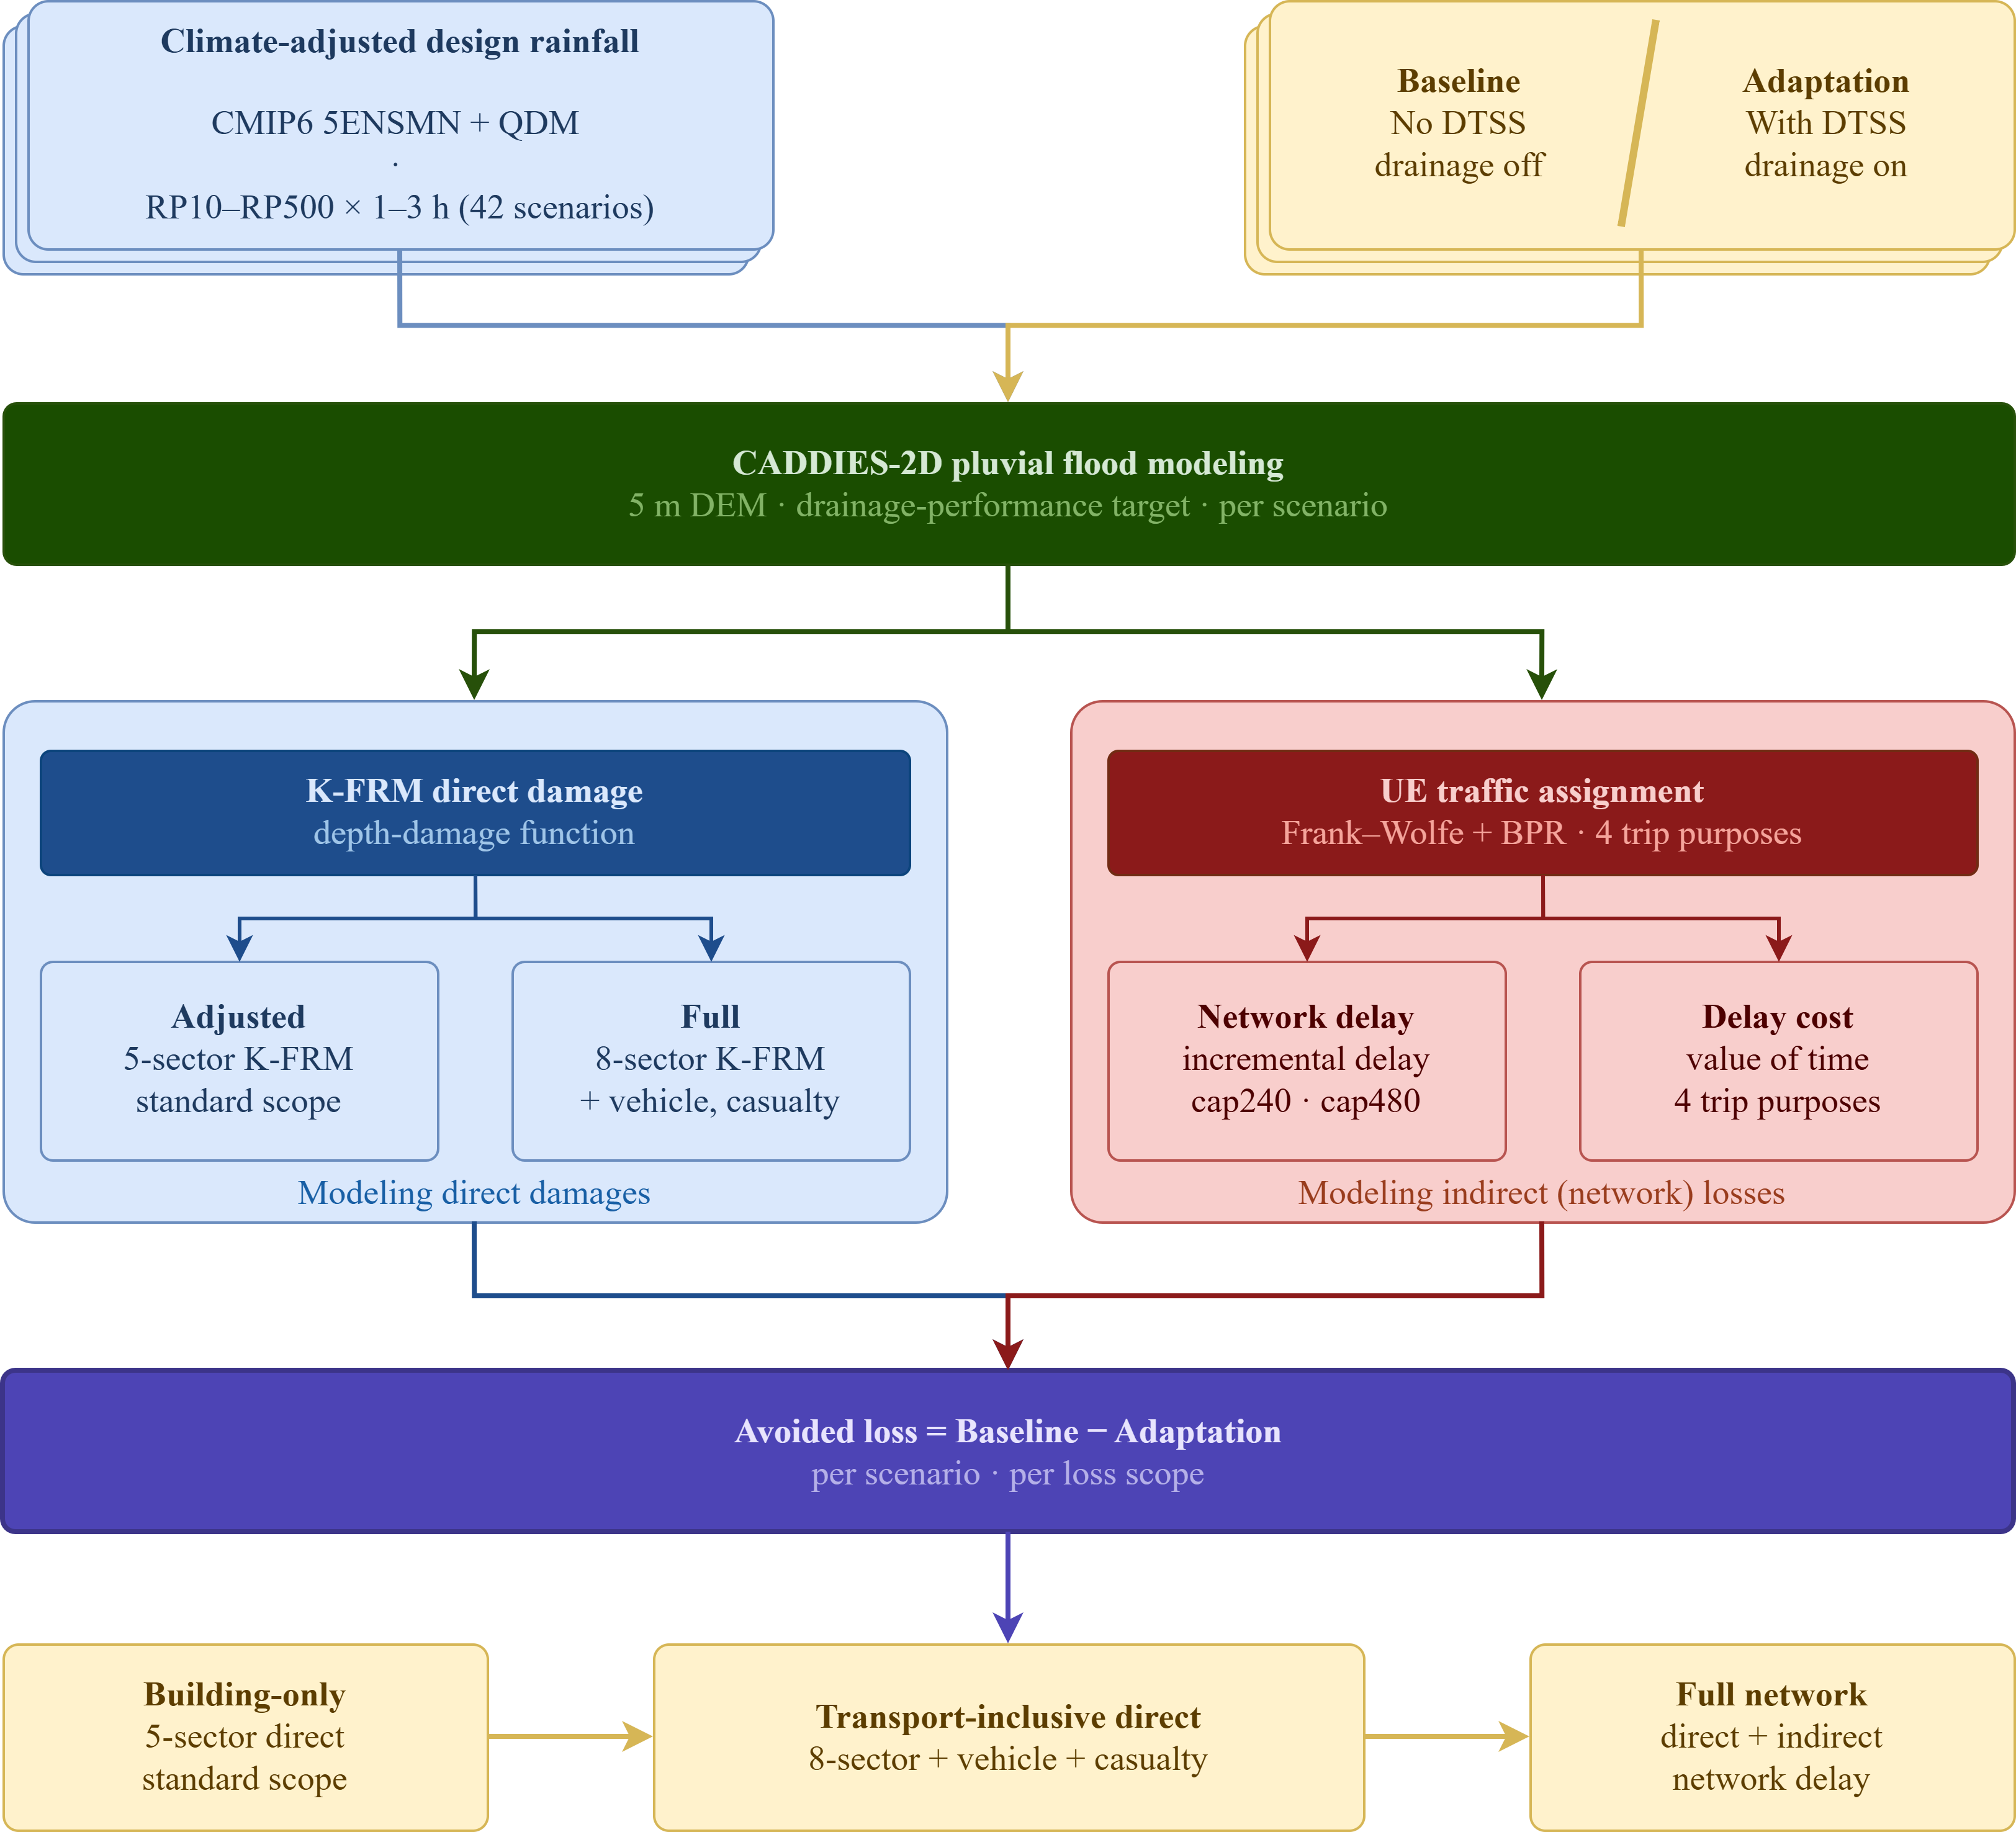
Figure 1. Accounting-boundary framework for integrated flood–transport economic assessment: a paired baseline/adaptation counterfactual under identical rainfall, CADDIES-2D flood modeling, K-FRM direct losses under Adjusted and Full accounting scopes, UE-based indirect network losses, and a scope-explicit appraisal (building-only, transport-inclusive direct, direct plus indirect).
Climate-adjusted design rainfall is constructed using Korea Meteorological Administration Automatic Weather Station observations and CMIP6 five-model ensemble projections bias-corrected via Quantile Delta Mapping (Cannon et al., 2015). The resulting intensity-duration-frequency curves generate design hyetographs for 42 paired scenarios spanning RP10–RP500 and 1–3 h storm durations. Surface inundation is simulated with the CADDIES-2D pluvial flood model (Guidolin et al., 2016) over a 5 m digital elevation model using scenario-specific drainage performance targets for baseline and DTSS adaptation conditions. The flood model is validated against 2022 inundation-trace polygons using extent-based goodness-of-fit, with depth errors reported as a secondary diagnostic.
Direct economic losses are estimated using the nationally standardized Korea Flood Risk Management (K-FRM) methodology (Kim & Kim, 2024), which applies asset-specific depth-duration-damage functions to the K-FRM Inventory DB. Direct losses are reported under two K-FRM scopes. The Full scope is the Korean national standard and aggregates all eight damage-categories (residential and non-residential buildings, vehicles, life and victim modules, crops, farmland, and public infrastructure). The Adjusted scope excludes the vehicle and casualty modules, aligning with the building–agriculture–infrastructure decomposition of internationally harmonized flood-damage frameworks (Dottori et al., 2018; Alfieri et al., 2017; Bernhofen et al., 2022); in Gangnam's urban catchment the agriculture components are almost zero, so Adjusted is effectively buildings plus public infrastructure and equals ~62% of Full. Importantly, the Adjusted scope is not equivalent to building-only appraisal because it retains public-infrastructure damage. Dual reporting serves as a robustness check, since K-FRM assigns roughly a third of Full direct damage to vehicles.
Indirect transport-network impacts are quantified by overlaying peak inundation-depth rasters on the Seoul road network: link speeds are degraded with a depth-disruption relationship (Pregnolato et al., 2017) and severely inundated links are removed. User Equilibrium traffic assignment (Frank-Wolfe with BPR cost functions, all four trip purposes) is solved for a no-flood state and for each flooded scenario, and the flood-induced incremental travel-time delay per origin-destination pair is monetized with a value-of-time approach.
Indirect economic loss is computed with the standard value-of-time relationship:
L = (Δt / 60) × VOT × V
where Δt is the flood-induced incremental travel-time delay (minutes) per origin-destination pair, VOT is the value of time, and V is the trip volume. To prevent non-physical delay divergence on a near-severed network under static assignment, a per-pair delay cap is applied, and indirect losses are reported as a sensitivity band rather than a single point estimate.

2.2 Application Case and Data
The framework is applied to Gangnam catchment, Seoul, where the August 2022 rainfall event exceeded 116 mm h⁻¹ and motivated a planned DTSS targeting the city’s highest drainage-performance zone (Seoul Metropolitan Government, 2024). Flood modeling and direct damage assessment are conducted for the Gangnam catchment, while transportation-network impacts are evaluated at the Seoul metropolitan scale to capture citywide congestion propagation.
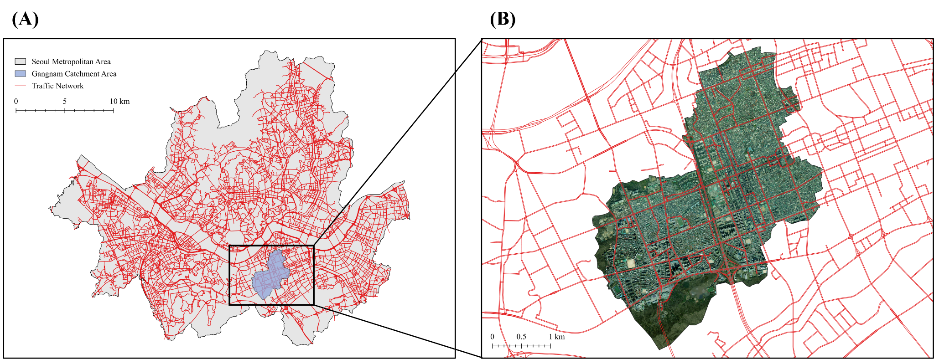
Figure 2. Study area and traffic network: flood modeling and direct damage assessment are conducted for the Gangnam catchment, while UE traffic assignment is evaluated over the Seoul metropolitan road network.
Table 1. Input data and sources.
Input data | Description | Source
Rainfall scenario data
Climate model data | Daily precipitation, 1 km × 1 km, SSP1–2.6, SSP2-4.5, SSP3-7.0, and SSP5–8.5 (2015–2100); 5ENSMN ensemble (HadGEM3-RA, WRF, CCLM, GRIMs, RegCM4) | Korea Meteorological Administration (KMA)
AWS observation data | Daily precipitation, 127.02601°E / 37.48462°N (1997–2014) | Korea Meteorological Administration (KMA)
Flood modeling data
Design drainage performance target | Input to CADDIES-2D pluvial flood model | Seoul Metropolitan Government (2024)
Sewershed data | Input to CADDIES-2D pluvial flood model | Park et al. (2024b)
Elevation data | 5 m-resolution Digital Elevation Map | Seoul Metropolitan Government
Flood-record polygons | Model validation (inundation extent) | Ministry of Climate, Energy and Environment
Direct damage assessment data
Building data | Building locations, types, structural information | K-FRM Inventory DB via K-CDMS (2022)
Population data | Population distribution and demographics | K-FRM Inventory DB via K-CDMS (2022)
Vehicle data | Vehicle registration, distribution, detail type | K-FRM Inventory DB via K-CDMS (2022)
Agriculture data | Agricultural land use and crops | K-FRM Inventory DB via K-CDMS (2022)
Traffic flow modeling data
Traffic network data | National standard node/link road network | National Standard Node-Link, NTIC (ITS, MOLIT)
Traffic demand data | Seoul Capital Area, purpose-based (home/work/school/other), multi-mode O/D, 2023 | Korea Transport Database (KTDB), Korea Transport Institute
Socio-economic data
Wage data | Seoul major-KSIC monthly wages and working hours, 2023 | Survey on Labor Conditions by Employment Type, Ministry of Employment and Labor (via KOSIS)
Employment data | Seoul district (gu)-level establishments by major KSIC, 2023 | Census on Establishments, Statistics Korea (via KOSIS)

3. Key Findings (Preliminary Results)
The results reported here are preliminary, from ongoing work. Across the 42-scenario matrix, CADDIES-2D simulations show that DTSS implementation substantially reduces both flood extent and depth relative to the no-DTSS baseline under identical design rainfall. The reduction is most pronounced at low-to-moderate return periods, where the design drainage target is not yet exceeded, and remains material, though incomplete, at RP200–RP500.
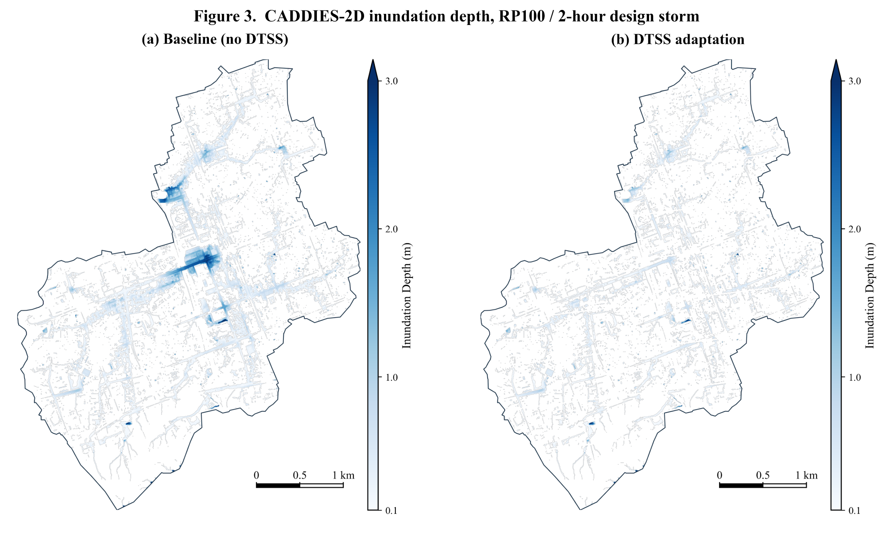
Figure 3. CADDIES-2D simulated inundation depth under baseline and DTSS adaptation for the RP100, 2-hour design storm: DTSS reduces flood extent and depth across the Gangnam catchment.
Transportation-network analysis shows that catchment-scale inundation translates into metropolitan-scale disruption. Under the baseline, flooded and closed links degrade road capacity and reroute traffic beyond the inundated Gangnam catchment. Under the adaptation scenario, DTSS reduces flood-induced network disruption beyond the directly inundated area, sustaining mobility across a wider urban system.
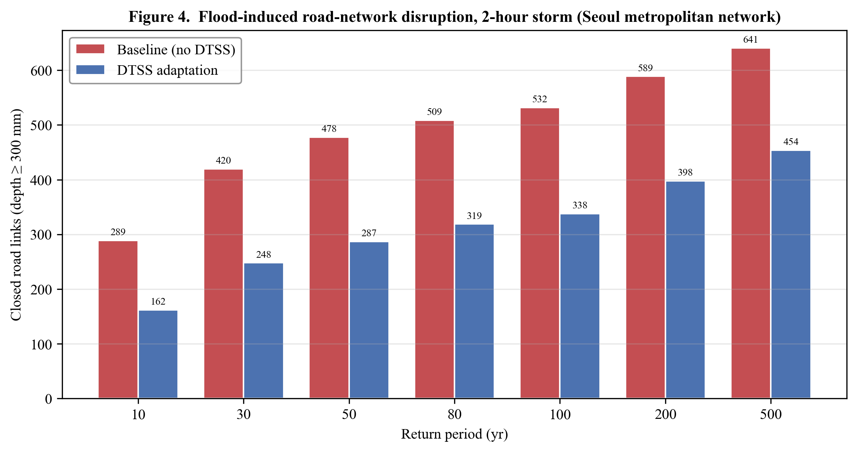
Figure 4. Flood-induced road-network disruption (closed links, depth ≥ 300 mm) under baseline and DTSS adaptation across return periods for 2-hour storms. DTSS reduces network disruption across the Seoul metropolitan network at every return period.
Three economic findings emerge. First, transport-related direct assets dominate K-FRM Full direct flood damage in Gangnam: vehicles account for about 33% and public infrastructure for about 46%, jointly representing roughly 80% of Full direct damage. Residential and non-residential buildings, the conventional CBA target, account for only about 16% of Full direct. This indicates that even before indirect network effects are added, building-only appraisal captures only a narrow portion of flood-related economic exposure.
Second, DTSS reduces direct losses by about 71% on average across the 42 paired scenarios, with the largest absolute reductions at high return periods. The UE-based indirect network channel is itself substantial, averaging one-fifth to one-third of combined economic loss under the cap240–cap480 sensitivity band and contributing a material share of avoided benefits within the reported sensitivity band; yet this channel is omitted entirely by building-only appraisal.
Third, conventional asset-based appraisal misses a substantial share of avoidable flood damage in this high-density metropolitan setting. To avoid ambiguity, the building share is about 16% when measured against K-FRM Full direct damage, and about 11% when measured against the combined direct-plus-indirect total for the RP100, 2-hour scenario, because the denominators differ.
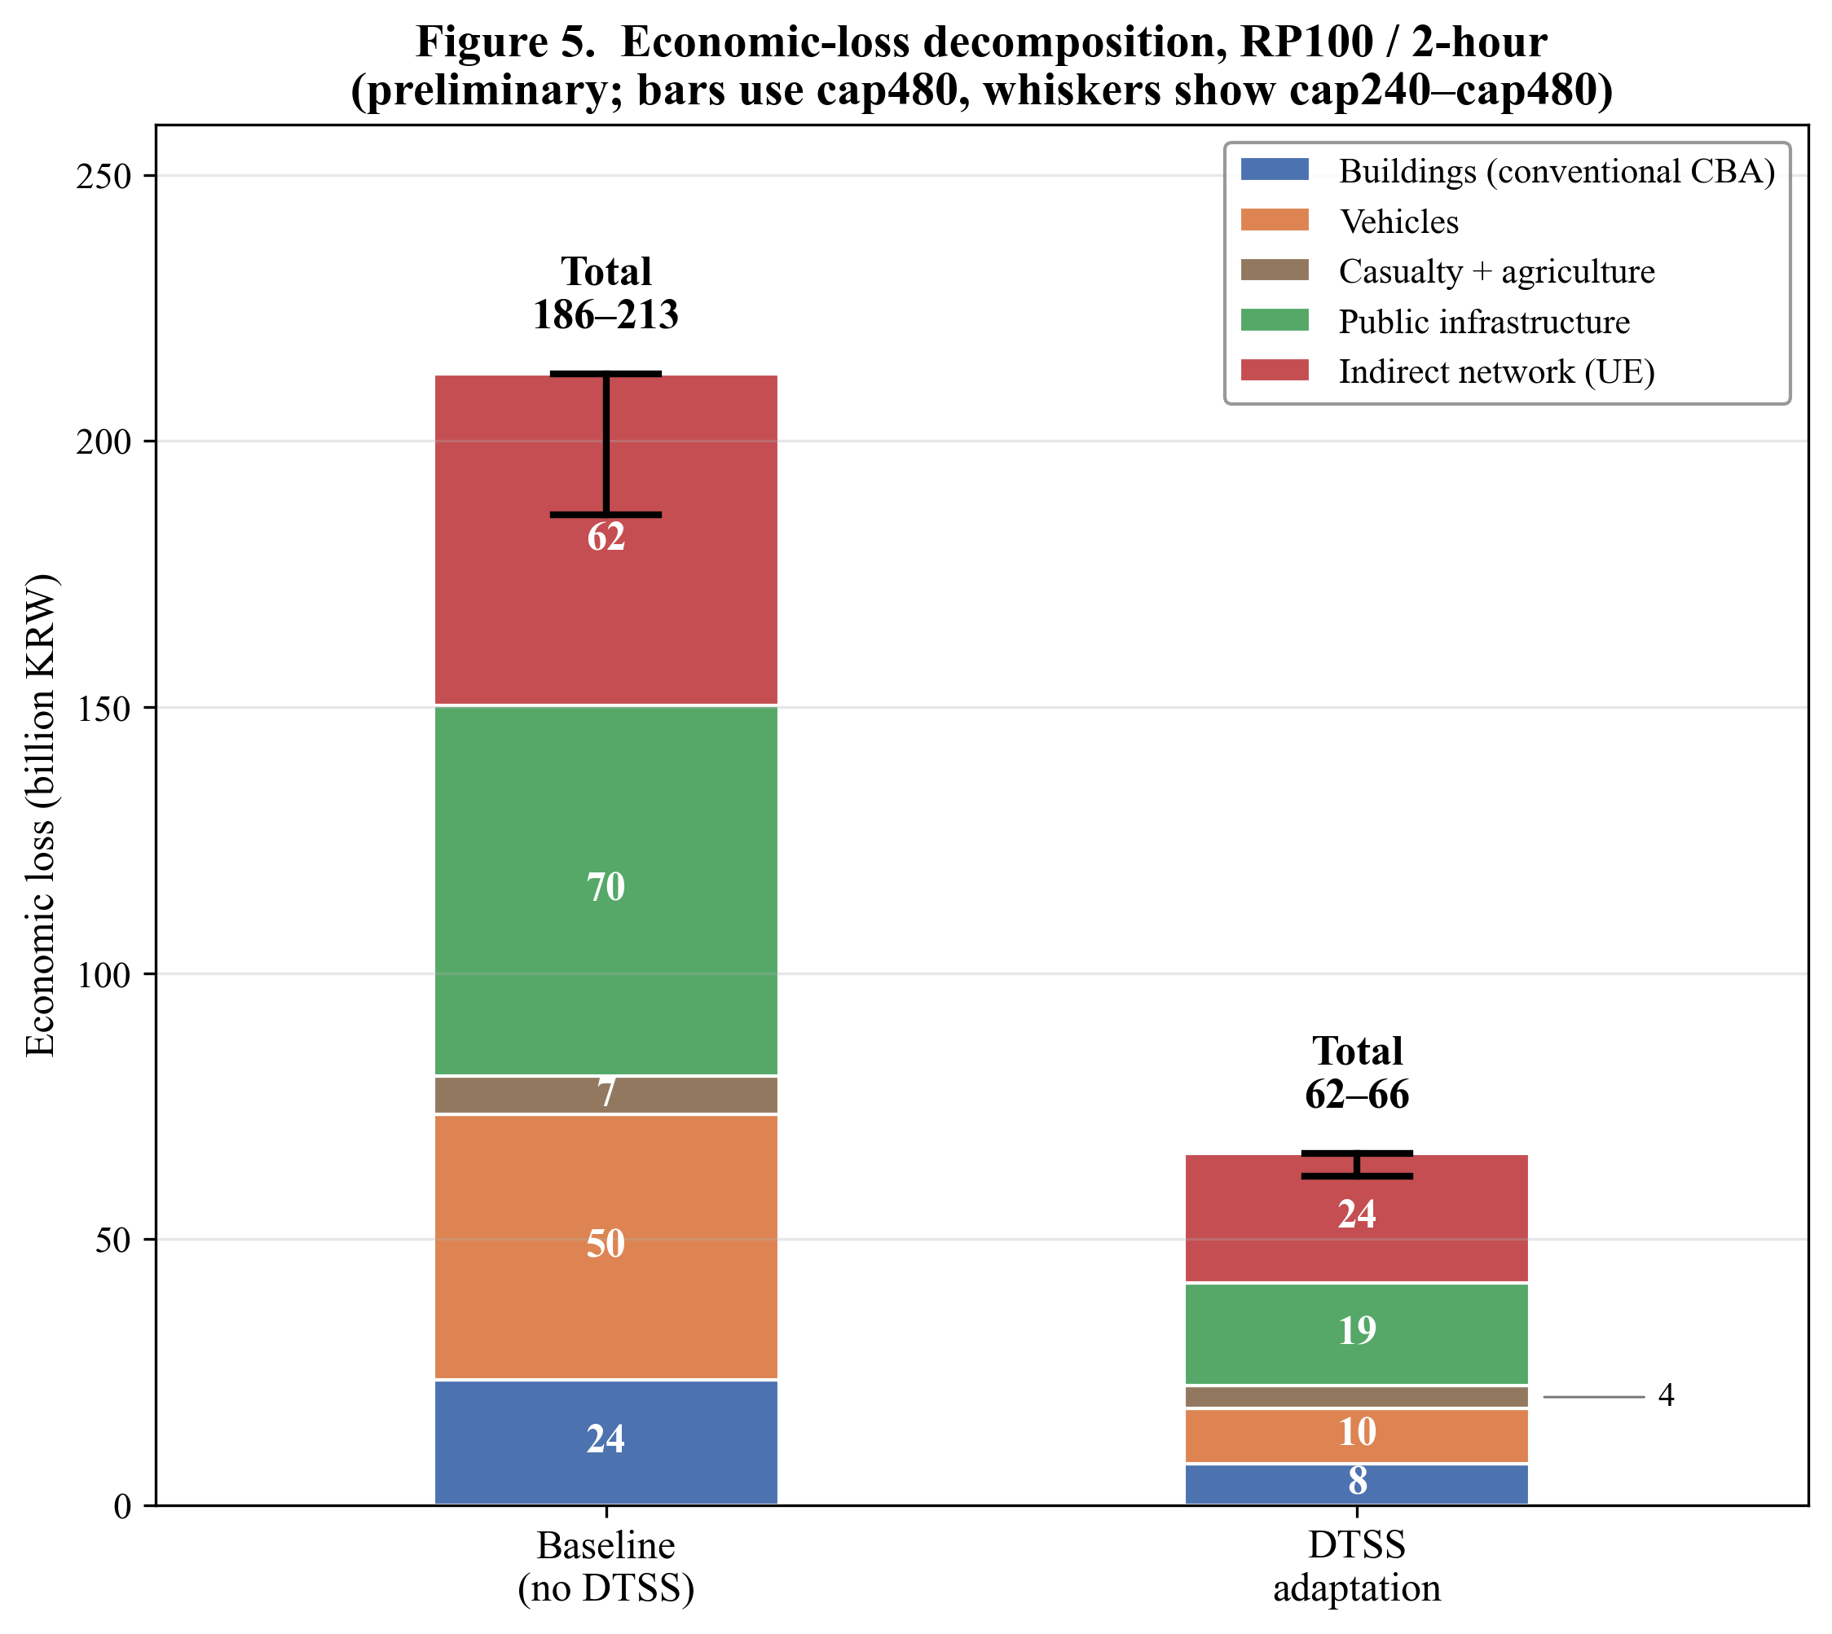
Figure 5. Economic-loss decomposition under K-FRM Full plus UE indirect accounting for the RP100, 2-hour scenario, baseline versus DTSS. Bars are reported under the 480-minute delay cap; whiskers show the cap240–cap480 sensitivity range for the indirect channel. The uncapped variant is excluded because near-severed networks generate non-physical BPR delay divergence.
For the RP100, 2-hour event class, total economic loss is on the order of 190 to 210 billion KRW, of which K-FRM Full direct damage is about 150 billion KRW and the UE indirect channel a few tens of billions; buildings alone are only about 24 billion KRW. Under DTSS the total falls to roughly one-third. Across the 42 scenarios DTSS reduces direct losses by about 71% and substantially reduces the indirect channel as well.

4. Implications
This study shows that asset-based and building-centric appraisal frameworks substantially undervalue large-scale flood adaptation infrastructure by truncating the accounting boundary. For capital-intensive projects such as DTSS, major avoided losses lie in transport-related assets and the network functionality they enable, channels that fall outside the remit of a single water-sector authority. DTSS-class infrastructure should therefore be appraised not merely as drainage infrastructure, but as cross-sectoral urban-resilience infrastructure that preserves mobility, economic continuity, and metropolitan system functionality.
This reframing has direct implications for project appraisal and governance. First, benefit-cost results should be reported under explicit accounting scopes, including building-only, transport-inclusive direct, and direct plus indirect network-loss accounting, since perceived economic feasibility can change substantially across them. Second, flood-protection appraisal should involve not only drainage authorities, but also transport planners, emergency managers, urban planners, and metropolitan finance agencies, because the costs and benefits of DTSS are distributed across sectors. This creates a governance misalignment: drainage authorities may bear the capital cost of DTSS, while a large share of the benefits accrues to transport users, public-infrastructure managers, emergency services, and the wider metropolitan economy. Third, indirect network losses should not be treated as peripheral sensitivity results when transport disruption is a core pathway through which urban flood risk materializes.
Two caveats define the scope of these preliminary conclusions. First, the indirect channel is sensitive to the delay cap and to depth-capacity degradation, link-capacity calibration, peak-hour conversion, and value-of-time assumptions; applying the destination wage to all trip purposes and peak-period delays to daily volumes biases indirect losses upward, whereas the delay cap, a behavioral proxy for trip cancellation or rescheduling on a near-severed network, bounds them. We therefore report indirect losses as a cap240–cap480 sensitivity band rather than a point estimate, exclude the divergent uncapped variant, and treat the magnitudes as order-of-magnitude and bounded rather than precise. Second, while the transferable contribution is that transport-asset and indirect network losses should enter routine flood appraisal, the specific magnitudes are conditioned on Gangnam’s high travel-demand density, limited network redundancy, and high value of time. They should not be assumed to transfer unchanged to other cities.
The contribution of this study is therefore not simply a new flood-damage calculation, but an appraisal-boundary argument: DTSS-class infrastructure produces benefits across water, transport, and metropolitan economic systems. Designing for transformation requires evaluation and governance arrangements that recognize urban flood protection as a cross-sectoral resilience project, with uncertainty and accounting scope made explicit.

References
[1] Alfieri, L., Bisselink, B., Dottori, F., Naumann, G., de Roo, A., Salamon, P., ... & Feyen, L. (2017). Global projections of river flood risk in a warmer world. Earth's Future, 5(2), 171-182.
[2] Arnbjerg-Nielsen, K., Willems, P., Olsson, J., Beecham, S., Pathirana, A., Bülow Gregersen, I., ... & Nguyen, V. T. V. (2013). Impacts of climate change on rainfall extremes and urban drainage systems: a review. Water science and technology, 68(1), 16-28.
[3] Bernhofen, M. V., Cooper, S., Trigg, M., Mdee, A., Carr, A., Bhave, A., ... & Shukla, P. (2022). The role of global data sets for riverine flood risk management at national scales. Water Resources Research, 58(4), e2021WR031555.
[4] Brandon, C., Kratzer, B., Aggarwal, A., & Heubaum, H. (2025). Strengthening the investment case for climate adaptation: A triple dividend approach. Working Paper. Washington DC: World Resources Institute. Available at: https://www.wri. org/research/climate-adaptation-investment-case.
[5] Cannon, A. J., Sobie, S. R., & Murdock, T. Q. (2015). Bias correction of GCM precipitation by quantile mapping: How well do methods preserve changes in quantiles and extremes? Journal of Climate, 28(17), 6938-6959.
[6] Doeffinger, T., & Rubinyi, S. (2023). Secondary benefits of urban flood protection. Journal of Environmental Management, 326, 116617.
[7] Dottori, F., Szewczyk, W., Ciscar, J. C., Zhao, F., Alfieri, L., Hirabayashi, Y., ... & Feyen, L. (2018). Increased human and economic losses from river flooding with anthropogenic warming. Nature Climate Change, 8(9), 781-786.
[8] Guidolin, M., Chen, A. S., Ghimire, B., Keedwell, E. C., Djordjevic, S., & Savic, D. A. (2016). A weighted cellular automata 2D inundation model for rapid flood analysis. Environmental Modelling & Software, 84, 378-394.
[9] Kim, G., & Kim, K. (2024). Development of QGIS-based Plug-in and Services for Quantitative flood Risk Assessment. Korean Society of Civil Engineers, 524-525. [In Korean]
[10] Molinari, D., Dazzi, S., Gattai, E., Minucci, G., Pesaro, G., Radice, A., & Vacondio, R. (2021). Cost–benefit analysis of flood mitigation measures: a case study employing high-performance hydraulic and damage modelling. Natural hazards, 108(3), 3061-3084.
[11] Park, S., Kim, J., & Kang, J. (2024a). Exploring optimal deep tunnel sewer systems to enhance urban pluvial flood resilience in the gangnam region, South Korea. Journal of Environmental Management, 357, 120762.
[12] Park, S., Kim, J., & Kang, J. (2024b). Heuristic approach to urban sewershed delineation for pluvial flood modeling. Journal of Water Process Engineering, 67, 106129.
[13] Pregnolato, M., Ford, A., Robson, C., Glenis, V., Barr, S., & Dawson, R. (2016). Assessing urban strategies for reducing the impacts of extreme weather on infrastructure networks. Royal Society open science, 3(5), 160023.
[14] Pregnolato, M., Ford, A., Wilkinson, S. M., & Dawson, R. J. (2017). The impact of flooding on road transport: A depth-disruption function. Transportation Research Part D: Transport and Environment, 55, 67-81.
[15] Seoul Metropolitan Government. (2024). 2040 sewerage improvement master plan. Seoul Metropolitan Government.
[16] Singh, P., Sinha, V. S. P., Vijhani, A., & Pahuja, N. (2018). Vulnerability assessment of urban road network from urban flood. International journal of disaster risk reduction, 28, 237-250.
[17] Skougaard Kaspersen, P., Høegh Ravn, N., Arnbjerg-Nielsen, K., Madsen, H., & Drews, M. (2017). Comparison of the impacts of urban development and climate change on exposing European cities to pluvial flooding. Hydrology and Earth System Sciences, 21(8), 4131-4147.
[18] Tanner, T., Surminski, S., Wilkinson, E., Reid, R., Rentschler, J., & Rajput, S. (2015). The triple dividend of resilience: realising development goals through the multiple benefits of disaster risk management.
[19] Zhou, R., Zheng, H., Liu, Y., Xie, G., & Wan, W. (2022). Flood impacts on urban road connectivity in southern China. Scientific reports, 12(1), 16866.

