Governing Climate-Related Risk in Real Property: A Polycentric Analysis of Physical and Financial Risk in Climate Change

Extended Abstract
Authors:
First author: Beata Henriksson^{a, b}, beata.henriksson@utwente.nl
Second author: Kent Erikssonª, kent.eriksson@abe.kth.se
Third author: Jenny Paulssonª, jenny.paulsson@abe.kth.se
ª Department of Real Estate and Construction Management, KTH Royal Institute of Science and Technology, Teknikringen 10B, 114 28 Stockholm, Sweden.
^{b} Department of Construction Engineering & Management, University of Twente, Drienerlolaan 5, 7500 AE, Enschede, the Netherlands.
Corresponding author: Beata Henriksson, E-mail: beata.henriksson@utwente.nl, beatahen@kth.se
Permanent address: beata.henriksson@utwente.nl

1. Research Problem, Purpose and Gap

Climate change is intensifying the frequency and severity of extreme weather events, generating physical and financial risks for the built environment (Diffenbaugh et al., 2017; IPCC, 2021). Flooding and other hazards damage buildings and infrastructure (de Wilde & Coley, 2012; Spekkers et al., 2015; Glaas et al., 2024), while associated losses propagate through insurance systems, mortgage markets and public budgets, exposing financial actors to climate-related risk (Bell & Van Vuuren, 2022; Campiglio et al., 2023; Wu et al., 2023).

Although research has examined physical climate impacts on buildings and financial-sector exposure separately, limited attention has been paid to how physical damage to real property translates into financial and governance consequences across institutional actors. This gap is particularly in polycentric governance systems, where in climate adaptation is distributed across multiple decision-making centres.

The purpose of this paper is to develop and apply a polycentric framework for analysing climate-related risk in real property by integrating its physical and financial dimensions. Using the 2021 Gävle flood in Sweden as a case, the study examines how risks are distributed among actors, how responsibilities overlap and how coordination mechanisms function in practice.

The analysis is guided by two research questions:
- How are physical and financial climate-related risks distributed among actors involved in real property?
- What are the implications of this distribution for local adaptation within a polycentric governance system?
This study advances research on climate-related risk governance in real property in three ways.

This paper contributes to the field by reconceptualising real property as a material governance node where physical climate risks are first realised and translated into financial and institutional consequences, thereby linking literatures on climate impacts and financial risk. Empirically, it operationalises polycentric governance by showing how a single extreme weather event activates multiple independent decision-making centres, revealing how fragmented coordination shapes the redistribution of risk. Together, the study advances polycentric theory by demonstrating how climate-related risks in real property are materially and institutionally produced within polycentric systems.

2. Methodology

This study adopts an interdisciplinary qualitative case study design (Yin, 2018) to examine how physical climate impacts on real property are translated into financial and governance consequences. The 2021 extreme rainfall event in Gävle, Sweden, serves as a critical case through which the interaction between material damage and institutional response can be traced.

The empirical material consists of (1) official post-event investigations by the County Administrative Board (Länsstyrelsen, 2022), (2) supervisory and insurance-sector reports (Finansinspektionen, 2023), (3) government inquiries on liability and adaptation responsibilities (SOU 2017:42; SOU 2025:51), (4) technical risk assessments (RISE, 2023) and (5) national and local media coverage documenting disputes and recovery processes. These sources were selected to capture perspectives across public authorities, financial actors, infrastructure providers and property owners.

The analysis proceeded in three steps. First, event data were examined to identify the sequence through which physical impacts on buildings (e.g., basement flooding, sewer backflows, structural damage) generated financial claims, liability disputes and institutional responses. Second, actors involved in these processes were identified and categorised according to their formal mandates and decision-making authority. Third, interactions between actors were analysed using the three polycentric governance mechanisms of overlap, independence and coordination. This enabled mapping how responsibilities intersected, where authority was fragmented and how risk was redistributed across institutional boundaries.

The primary analytical output is a governance-risk transmission model that traces how a localised climate event propagated through real property into insurance systems, municipal infrastructures and financial markets. By systematically linking material damage to institutional response, the method makes visible the transformation of physical risk into financial and governance risk within a polycentric system.

3. Theoretical Framework
Polycentric governance refers to systems in which multiple formally independent decision-making centres interact around shared problems (Ostrom, 1990; 2010; McGinnis, 2016). Rather than being centrally coordinated, such systems are characterised by overlapping jurisdictions, autonomous rule-making and varying degrees of cooperation. Polycentric arrangements are frequently highlighted as particularly relevant for climate change governance, where risks span administrative scales, sectors and knowledge domains (Ostrom, 2009; Jordan et al., 2018; Dorsch & Flachsland, 2017).
To analyse how such systems operate in practice, this study focuses on three relational mechanisms: overlap, independence and coordination. Overlap occurs when multiple actors influence or are affected by the same risk outcome. Independence refers to the autonomy actors retain over their mandates and resources. Coordination captures the formal and informal processes through which actors align actions, exchange information and manage interdependencies.
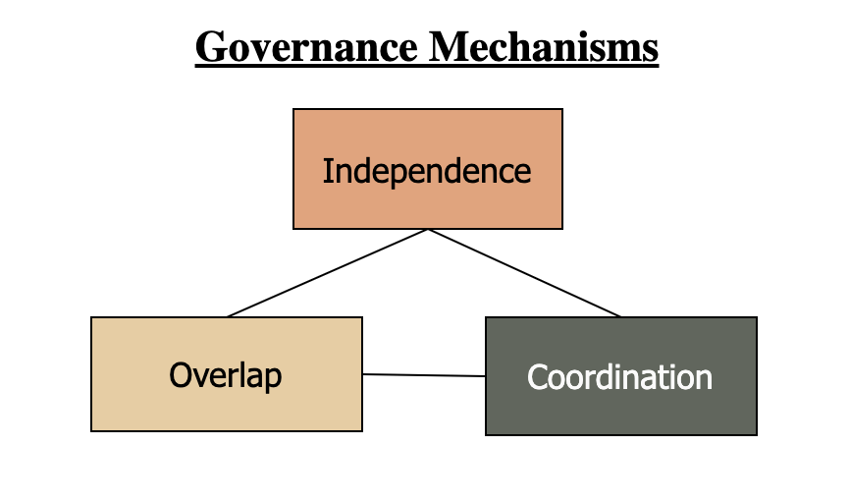
Fig 1. Governance mechanisms in a polycentric system.
While polycentric systems are often associated with adaptability and experimentation, they also generate governance tensions. Overlapping responsibilities may obscure accountability, independence can fragment responses and weak coordination can produce reactive rather than anticipatory adaptation (Ba & Galik, 2019; Tobin et al., 2024). These tensions are particularly visible in climate adaptation, where long-term investments and uncertain risk projections intersect with diffuse responsibility for existing building stocks and privately owned assets (Berrang-Ford et al., 2021; Boehnke et al., 2023).
This paper extends polycentric governance theory by foregrounding the material role of real property. Real property is conceptualised as the site where climate risks first become tangible and from which they propagate across infrastructural, financial and regulatory systems. This perspective shifts attention from abstract institutional arrangements to the concrete transmission of risk across governance boundaries.
4. Physical and Financial Climate-Related Risk in Real Property

Physical climate-related risk refers to the direct impacts of climate hazards on buildings, land and infrastructure (de Wilde & Coley, 2012; Spekkers et al., 2015; Glaas et al., 2024). Financial risk emerges as these impacts generate repair costs, insurance claims, asset devaluation and fiscal pressure across private and public actors (Clayton et al., 2021; Bell & Van Vuuren, 2022; Campiglio et al., 2023).

While physical damage is spatially concentrated, financial exposure is pooled and redistributed through insurance and lending systems. This spatial and institutional separation weakens incentives for proactive adaptation and complicates accountability. Property owners experience immediate losses, insurers redistribute costs nationally, banks are indirectly exposed through collateral values and public authorities confront infrastructure strain and liability questions.

Real property functions as the transmission site where physical impacts are converted into financial and governance consequences. When a building floods, the event simultaneously activates material damage, contractual insurance mechanisms and regulatory responsibilities. Understanding this transformation is essential for analysing how climate-related risks propagate within polycentric governance systems.

5. Key Findings

Fig 2 presents the analytical framework guiding the analysis. It conceptualises real property as the central decision node where climate-related risks first materialise. An extreme rainfall event functions as a trigger that generates physical impacts on properties, which in turn activate responses from multiple governance actors. These actors engage with the property through distinct mandates, ownership, regulation, finance and operation, forming a polycentric decision-making network characterised by overlapping responsibilities, partial independence and varying degrees of coordination.

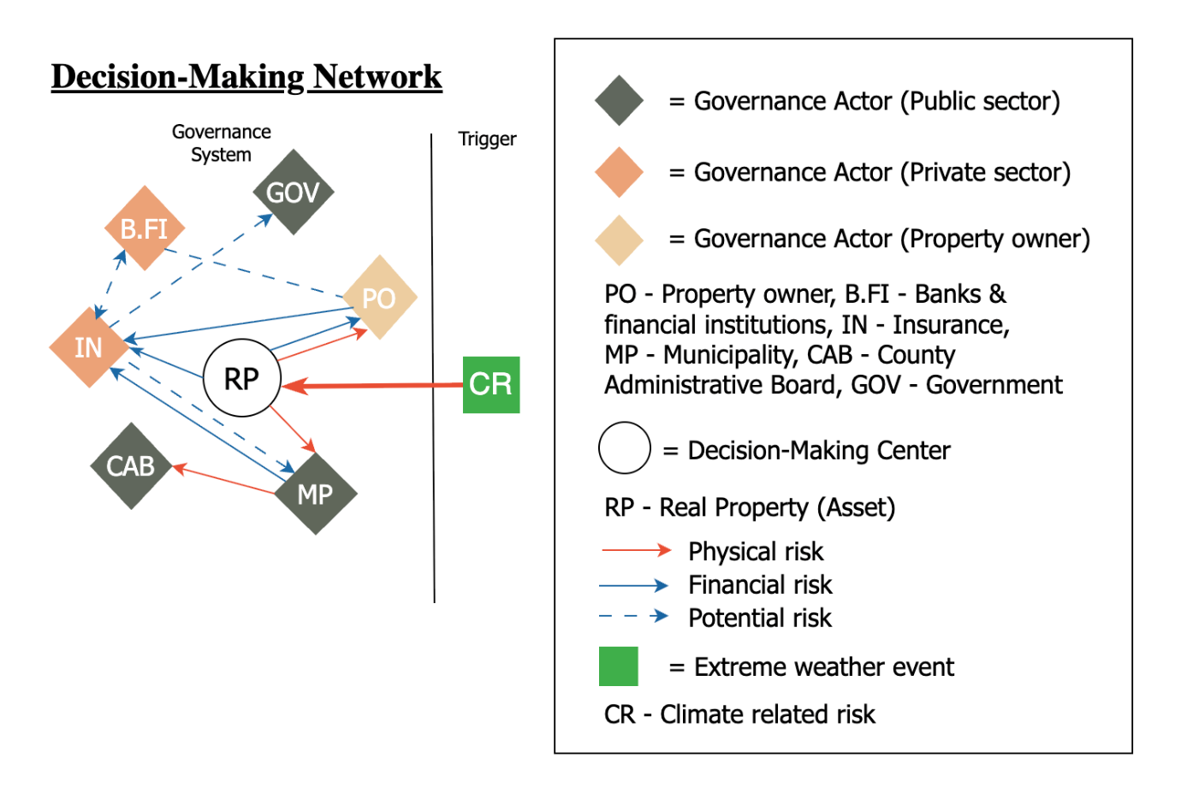
Fig 2. Decision making network for Real property in Climate-related risk.

Applied to the Gävle flood, this framework clarifies how physical damage to property activated multiple, interconnected responses. The event caused widespread basement flooding, sewer backflows and structural damage, resulting in approximately 6,830 insurance claims totalling around EUR 160 million (Finansinspektionen, 2023). Real property emerged as the primary site where both physical and financial risks materialised. Floodwater entered buildings through surface openings, sewer backflows and structural vulnerabilities (Spekkers et al., 2015; Glaas et al., 2024), translating localised impacts into large-scale financial losses through insurance systems.

These responses were linked through the shared asset (i.e. real property) but governed by separate actors. Property owners experienced immediate physical losses which for insurers translated into claims and compensation processes. The municipally owned stormwater utility confronted infrastructural strain and questions of liability and public authorities assessed responsibility and future adaptation needs. The spatial distribution of damage deviated significantly from pre-existing risk maps, revealing gaps in vulnerability assessments (RISE, 2023), while disputes between insurers and the municipal utility highlighted governance ambiguities.

Interpreted through the three polycentric mechanisms of overlap, independence and coordination, the Gävle case illustrates how climate-related risks are produced and governed in practice. Multiple actors shaped the same risk outcomes: municipal planning decisions, infrastructure standards, insurance rules and mortgage systems all influenced vulnerability and recovery trajectories. Yet no single actor held authority over the entire risk chain. This overlap generated ambiguity rather than collective responsibility.

Actors also operated with high degrees of independence. Property owners faced highly localised exposure; insurers pooled risk nationally; banks managed exposure indirectly through collateral values; and municipalities followed planning laws and engineering standards that lagged evolving climate extremes. This fragmentation limited anticipatory adaptation. Coordination mechanisms were weak: risk maps underestimated property-level vulnerability, data were not systematically shared and post-event learning occurred through conflict rather than collaboration.

6. Conclusion
The findings demonstrate that climate-related risks in real property are neither purely physical nor purely financial. They are hybrid risks that move through governance networks, reshaping responsibilities, incentives and conflicts. This has important implications for project-based organising, infrastructure governance and adaptation design.
Rather than calling for centralisation, the analysis suggests the need for better alignment within polycentric systems.
First, overlap was extensive. Municipal planning decisions, infrastructure standards, insurance contracts and mortgage systems all shaped exposure and recovery trajectories. Yet this overlap did not translate into shared responsibility. Instead, the event revealed ambiguity regarding liability for sewer backflows and infrastructural capacity, generating conflict rather than collective problem-solving.
Second, actors operated with substantial independence. Property owners bore immediate physical losses, insurers pooled risk nationally, banks were indirectly exposed through collateral values and municipalities followed regulatory and engineering standards that did not fully account for emerging climate extremes. This institutional separation contributed to a structural disconnect between localised damage and redistributed financial consequences, weakening incentives for anticipatory adaptation.
Third, coordination mechanisms were limited. Pre-existing risk maps underestimated property-level vulnerability and systematic data-sharing between insurers and municipal authorities was absent. Post-event learning occurred reactively and through dispute rather than through established channels for collaborative risk governance.
Together, these measures would improve anticipatory capacity, reduce governance fragmentation and support a shift from reactive compensation toward proactive adaptation. The finding furthermore supports smaller decision-making centres to encourage testing from the financial sector and more innovative adaptation to a climate change and extreme weather because then the ability to absorb and distribute losses on a wider portfolio will result in less of an impact.
References
Ba, Y., & Galik, C. (2019). Polycentric Systems and Multiscale Climate Change Mitigation and Adaptation in the Built Environment. Review of Policy Research, 36(4), 473–496. https://doi.org/10.1111/ropr.12342
Bell, F., & Van Vuuren, G. (2022). The impact of climate risk on corporate credit risk. Cogent Economics & Finance, 10(1), 2148362. https://doi.org/10.1080/23322039.2022.2148362
Berrang-Ford, L., Lesnikowski, A., Fischer, A. P., Siders, A. R., Mach, K. J., Thomas, A., Callaghan, M., Haddaway, N., Kerr, R. B., Biesbroek, R., Bowen, K., Deryng, D., Elliott, S., Ford, J. D., Garschagen, M., Gilmore, E., Harper, S., Hassnoot, M., Lissner, T., … Aalst, M. V. (2021). The Global Adaptation Mapping Initiative (GAMI): Part 1 – Introduction and overview of methods. Protocol Exchange. https://doi.org/10.21203/rs.3.pex-1240/v1
Boehnke, D., Jehling, M., & Vogt, J. (2023). What hinders climate adaptation? Approaching barriers in municipal land use planning through participant observation. Land Use Policy, 132, 106786. https://doi.org/10.1016/j.landusepol.2023.106786
Bracking, S., & Leffel, B. (2021). Climate finance governance: Fit for purpose? WIREs Climate Change, 12(4), e709. https://doi.org/10.1002/wcc.709
Campiglio, E., Daumas, L., Monnin, P., & Von Jagow, A. (2023). Climate‐related risks in financial assets. Journal of Economic Surveys, 37(3), 950–992. https://doi.org/10.1111/joes.12525
Clayton, J.; Devaney, S.; Sayce, S. and van de Wetering, J. (2021) Climate Risk and Commercial Property Values: a review and analysis of the literature. UNEP FI. Available: https://www.unepfi.org/industries/investment/climate-risk-and-commercial-property-values/ [2025-10-20]
De Wilde, P., & Coley, D. (2012). The implications of a changing climate for buildings. Building and Environment, 55, 1–7. https://doi.org/10.1016/j.buildenv.2012.03.014
Diffenbaugh, N. S., Singh, D., Mankin, J. S., Horton, D. E., Swain, D. L., Touma, D., Charland, A., Liu, Y., Haugen, M., Tsiang, M., & Rajaratnam, B. (2017). Quantifying the influence of global warming on unprecedented extreme climate events. Proceedings of the National Academy of Sciences, 114(19), 4881–4886. https://doi.org/10.1073/pnas.1618082114
Dino, I. G., & Meral Akgül, C. (2019). Impact of climate change on the existing residential building stock in Turkey: An analysis on energy use, greenhouse gas emissions and occupant comfort. Renewable Energy, 141, 828–846. https://doi.org/10.1016/j.renene.2019.03.150
Dorsch, M. J., & Flachsland, C. (2017). A Polycentric Approach to Global Climate Governance. Global Environmental Politics, 17(2), 45–64. https://doi.org/10.1162/GLEP_a_00400
Finansinspektionen. (2023). Försäkringsföretagen och översvämningarna i Gävleborg. Available: https://www.fi.se/contentassets/3a4ad469a4824808913462bbafbc1221/fi-tillsyn-26-forsakringsforetagen-och-oversvamningarna-gavleborg.pdf [2025-10-30]
Glaas, E., Hjerpe, M., & Storbjörk, S. (2024). The 2021 extreme rainfall in Gävle, Sweden: Impacts on municipal welfare services and actions towards more resilient premises and operations. Hydrology Research, 55(4), 431–443. https://doi.org/10.2166/nh.2024.107
Intergovernmental Panel On Climate Change (Ipcc). (2021). Climate Change 2021 – The Physical Science Basis: Working Group I Contribution to the Sixth Assessment Report of the Intergovernmental Panel on Climate Change (1st ed.). Cambridge University Press. https://doi.org/10.1017/9781009157896
Jordan, A., Huitema, D., Schoenefeld, J., Van Asselt, H., & Forster, J. (2018). Governing Climate Change Polycentrically: Setting the Scene. In A. Jordan, D. Huitema, H. Van Asselt, & J. Forster (Eds.), Governing Climate Change (1st ed., pp. 3–26). Cambridge University Press. https://doi.org/10.1017/9781108284646.002
Liu, X., Liu, J., & Hao, Y. (2024). Climate Change Shocks and Credit Risk of Financial Institutions: Evidence from China’s Commercial Banks. Emerging Markets Finance and Trade, 60(7), 1392–1406. https://doi.org/10.1080/1540496X.2023.2278659
Lofthouse, J. K., & Herzberg, R. Q. (2023). The Continuing Case for a Polycentric Approach for Coping with Climate Change. Sustainability, 15(4), 3770. https://doi.org/10.3390/su15043770
Länsstyrelsen. (2022). Utredning av skyfall och översvämningar i Gävleborgs län, augusti 2021. Available: https://www.lansstyrelsen.se/download/18.74b418a31817ff11b11152a4/1656404563637/Utredning%20av%20skyfall%20och%20översvämningar%20i%20Gävleborgs%20län,%20augusti%202021.pdf [2025-10-09]
McGinnis, M. D. (2016). Polycentric Governance in Theory and Practice: Dimensions of Aspiration and Practical Limitations. SSRN Electronic Journal. https://doi.org/10.2139/ssrn.3812455
Morrison, T. H., Adger, W. N., Brown, K., Lemos, M. C., Huitema, D., Phelps, J., Evans, L., Cohen, P., Song, A. M., Turner, R., Quinn, T., & Hughes, T. P. (2019). The black box of power in polycentric environmental governance. Global Environmental Change, 57, 101934. https://doi.org/10.1016/j.gloenvcha.2019.101934
Ostrom, E. (1990) Governing the Commons. The Evolution of Institutions for Collective Action. Cambridge University Press.
Ostrom, E. (2009). A Polycentric Approach for Coping with Climate Change. SSRN Electronic Journal. https://doi.org/10.2139/ssrn.1934353
Ostrom, E. (2010). Beyond Markets and States: Polycentric Governance of Complex Economic Systems. American Economic Review, 100(3), 641–672. https://doi.org/10.1257/aer.100.3.641
Petzold, J., Hawxwell, T., Jantke, K., Gonçalves Gresse, E., Mirbach, C., Ajibade, I., Bhadwal, S., Bowen, K., Fischer, A. P., Joe, E. T., Kirchhoff, C. J., Mach, K. J., Reckien, D., Segnon, A. C., Singh, C., Ulibarri, N., Campbell, D., Cremin, E., Färber, L., … Garschagen, M. (2023). A global assessment of actors and their roles in climate change adaptation. Nature Climate Change, 13(11), 1250–1257. https://doi.org/10.1038/s41558-023-01824-z
Repko, A. F., & Szostak, R. (2021). Interdisciplinary research: Process and theory (Fourth edition). SAGE.
RISE, Klimatresiliensdeklarationer – en standardiserad bedömning av klimatrisker i fast egendom, Report 2023:5.
Spekkers, M. H., Clemens, F. H. L. R., & Ten Veldhuis, J. A. E. (2015). On the occurrence of rainstorm damage based on home insurance and weather data. Natural Hazards and Earth System Sciences, 15(2), 261–272. https://doi.org/10.5194/nhess-15-261-2015
Tobin, P., Huitema, D., & Kellner, E. (2024). The Empirical Realities of Polycentric Climate Governance: Introduction to the Special Issue. Global Environmental Politics, 24(3), 1–23. https://doi.org/10.1162/glep_a_00758
Tress, B., Tress, G., & Fry, G. (2005). Integrative studies on rural landscapes: Policy expectations and research practice. Landscape and Urban Planning, 70(1–2), 177–191. https://doi.org/10.1016/j.landurbplan.2003.10.013
Wu, X., Bai, X., Qi, H., Lu, L., Yang, M., & Taghizadeh-Hesary, F. (2023). The impact of climate change on banking systemic risk. Economic Analysis and Policy, 78, 419–437. https://doi.org/10.1016/j.eap.2023.03.012
Yin, R. K. (2018). Case study research and applications: Design and methods (Sixth edition). SAGE.

