***The Effect of COVID-19 on Society’s Perception on Hospital Procedure***

Arya Sasikumar1*, Shreya Sripada2*, Arjun Reddy2*,

Nandana Abburi2*, Arunan Elamaran3*, Iniyan Sasikumar1*,Alex Colin4

1The Quarry Lane School, Dublin, California

2Dougherty Valley High School, San Ramon, California

3Foothill High School, Pleasanton, California

4Dublin Robotics, Dublin, California

*Authors contributed equally.

***Summary***

During the Covid-19 Pandemic, the healthcare sector has experienced a great deal of innovation. Covid-19 has acted as a catalyst leading to a greater reliance on technology in the treatment of patients. While existing research explores the development of such novel biotech solutions, there is minimal research on society’s perception of healthcare treatment shifting to a digital medium. A comprehensive survey was developed and disseminated through a network of contacts on a series of questions regarding biotech, user comfortability, and receptiveness to medical treatment changes over a two week. Society’s perception of hospital procedure was hypothesized to have faced a change in areas like safety and methods due to the impactful nature of the pandemic. The data gathered was used to compare different populations of respondents. Statistically significant differences were not observed between identified populations using Chi-Square Analysis. All respondents identified that they would be open to changes in the triage procedure that catered greater attention to safety even through new mediums to an extent. These findings can guide future innovators in the users' perception of potential biotech solutions and raise awareness to healthcare systems on how best to handle patient treatment.

***Introduction***

Over the past year, COVID-19 has severely impacted all aspects of daily life. COVID-19 is a respiratory virus that originated in Wuhan, China, in December 2019 [1]. The high transmission rate was evident in how quickly the virus spread all over the world. COVID 19 has an R0>1 ranging between 1.4 to 2.5 as declared by the World Health Organization (WHO) in a statement dated 1/23/2020. The United States of America reported the first case of COVID-19 on February 26, 2020 [2]. Due to the rise of cases worldwide, the WHO declared COVID-19 a global pandemic [3].

As a result, California imposed a Stay at Home Order on March 19th, 2020, making it the first state to do so, with other US states following soon after [2]. Precautions such as social distancing and mask-wearing were also implemented to limit the transmission of the virus [4]. Across all demographics, society made a mass migration to online mediums of interaction. This included education, work, and social gatherings shifting to an online format in hopes of mitigating the spread of COVID-19 [1].

Despite these efforts, a sudden spike in COVID-19 cases overwhelmed physicians, medical assistants, and the healthcare system as a whole [5]. There were severe shortages of medical equipment such as ventilators to treat patients and COVID-19 testing kits [6]. Medical staff not only needed to deal with the lack of equipment for the rising number of patients but also risked contracting COVID-19 every time they stepped foot into a hospital [7]. Many hospitals saw the need for innovation amid the crisis, which resulted in the rapid development of medical technologies [8].

This research primarily aims to evaluate how future advancements like these will be received by the general public and whether it can integrate them into the medical system. Prior research evaluating the public’s acceptance of new technologies in medicine concludes that change and acceptance of these alternatives will take time. However, there has not been any considerable research since the COVID-19 pandemic, which is critical when examining this topic [9]. Given that COVID-19 has significantly changed the public’s view on the healthcare system and forced them to adapt to the new reality of social distancing and safety precautions, we hypothesize that if technological advancements in medicine are implemented, then society will adapt and accept it as the new normal because the pandemic has forced a successful integration of medical technologies in the healthcare system and will continue to do so.

***Results***

To better understand society’s perception of medical procedures, we released a survey to the public that collected their opinions on various topics related to hospital procedures. One hundred eleven males and 139 females responded to the survey (Table 1). Respondents are organized into age groups: 0-14, 15-24, 25-64, and 65+. There were 12 respondents ages 0-14 (4.8%), 105 respondents ages 15-24 (42%), 127 respondents ages 25-65 (50.8%), and six respondents ages 65 and older (2.4%). Thirty four of the respondents identified as Caucasian (13.6%), one as African American (0.4%), three as Hispanic (1.2%), 0 as Native American (0%), 208 as Asian (Including subcontinents) (83.2%), and four as other races (1.6%). Nine participants were in Elementary School and Middle School (3.6%), 93 participants were in High School (37.2%), 51 participants were in an Undergraduate Program (20.4%), 83 participants were completing or have completed a Master’s Degree (33.2%), 14 participants were completing or have completed PhDs (5.6%).

|  |  |  |  |  |
| --- | --- | --- | --- | --- |
| Table 1 - | | | | |
|  | **n** | **Age (years)** | **Race** | **Education Level** |
|  |  |  |  |  |
| **Male** | 111 | 15-24 | Asian | High School |
| **Female** | 139 | 15-24 | Asian | High School |

The modal value of age is 15-24 making up 42% of the population respondents. The race that was the majority of respondents was Asian, making up 83.2% of the population responding. High School was the modal value of the Education Level category and made up 37.2% of all respondents.

Of the 303 respondents, 171 were female (56%) and 132 respondents were male (44%). While there were 6% more female responses than male responses, Chi-Square Analysis of the data from both groups has shown that there is no statistical correlation between male and female responses for all questions asked in the survey. No results from any question were significant at p < 0.05. Thus, we can state that the null hypothesis is valid in that there is no statistical significance between male and female responses.

Of the 303 respondents, 15 had tested positive for COVID-19 (5%) and 288 had never tested positive for COVID-19 (95%). The differences in populations are immense, but performing Chi-Square Analysis of the data from both groups has shown there is no statistical correlation between COVID-19 positive and COVID-19 negative responses. This implies that while there was a large difference in the number of respondents per category, both groups responded similarly. Since no results from any question were significant at p < 0.05, we can state that the null hypothesis is valid in that there is no statistical significance between COVID-19 positive and negative responses.

Of the 303 respondents, 172 of them had been vaccinated (57%) and 131 respondents had not been vaccinated (43%). While there is a 14% population difference between the two groups, performing Chi-Square analysis on the data set from both group’s responses to the survey showed no statistical correlation between vaccinated and not vaccinated responses. No results from any question were significant at p < 0.05 between both populations which means that we can state that the null hypothesis is valid in that there is no statistical significance between Vaccinated and Not Vaccinated populations response to the survey.

. Hundred and fifteen people would prefer interacting with a robotic replacement (38%) during the COVID-19 pandemic and 188 would still prefer interacting with a healthcare worker during the COVID-19 pandemic. We can see that of those that answered “Healthcare worker”, vaccinated females were the most frequent responders but not an overwhelming majority. On the other hand, there was an overall equal spread of types of responders who answered “Robotics replacement”. (Figure 1). The results for the “how safe do you feel in a hospital during COVID-19” question were quite distributed but with a majority of respondents, 110, said they felt somewhat safe 36%. Somewhat Comfortable, Pretty Comfortable, and As Comfortable as Before COVID-19 made up the majority of respondents in the “On a scale of 1-5, how comfortable do you feel about interacting with health care workers during COVID-19 (medical assistants, nurses, physician assistants, physician, etc)?” (82, 86, 63).

The majority of people, 288, did not feel comfortable touching surfaces in the hospital (75%) and 75 respondents still felt comfortable (25%). One hundred and eighty seven people did not feel comfortable going to hospitals during the COVID-19 pandemic (62%) and 116 respondents were still comfortable going to the hospital (38%). For the “How safe would you feel if you were protected by some kind of barrier or shielding between you and anyone you interact with in a hospital?” question, the most common response was pretty safe with 123 respondents (41%) but the general trend was people feeling much more comfortable with the existence of some form of protection between whomever they were interacting with at the hospital. The question, “Are you afraid to go to hospitals during the pandemic?”, the participants overwhelmingly responded “Yes” (60.5%). Those who answered “No” made up only 39.5%. In both categories, there were more vaccinated females than any other group. There were more vaccinated participants who answered “No”, however there was no difference between the two groups for the respondents who answered “Yes” (Figure 2). When survey respondents were asked whether they would “be receptive to changes in the way that hospitals go about the check-in/ triage process?”, a clear majority of 278 respondents said they would be open to the idea which makes up 92% of the total population. Those who answered “No” are evenly split between the 4 groups. Vaccinated people yet again, made up the majority of respondents who responded “Yes”, especially vaccinated females (Figure 3).

***Discussion***

Through the use of a google form disseminated through our network of contacts, data was collected to examine to what extent COVID-19 affects society’s perception of Hospital Safety. After analyzing the results, findings and trends were synthesized based on the questions: some expected and some unexpected.

The main finding that was explored was the general rationale of the population examined during the pandemic. We found that there was a general trend where most individuals felt unsafe in hospitals which has significant implications. When asked to rate how safe they feel in a hospital during COVID-19, there was an overall normal distribution of answers; however, there was a slight skew to the left: more people felt unsafe than safe in hospitals. This demonstrates the overall view of the public that due to COVID-19, hospitals are no longer viewed as safe. This conclusion is further bolstered when examining how “comfortable [people are] touching surfaces in hospitals”, as the majority of people responded that they weren’t. In fact, the majority of respondents go as far as to say that they are “afraid of going to hospitals during the pandemic”. While studies have shown that hospital safety has still been maintained during the pandemic and hospitals are not an unsafe environment, it is clear that the general population does not feel this way because they are anxious about contracting COVID-19 [10]. Although we originally hypothesized that most people would choose to use a robotic replacement instead of a human healthcare worker due to it significantly reducing the risk of transmission of disease, the majority of respondents still prefer engaging with a healthcare worker. Although they are not ready to completely switch to a robotic replacement, they still responded positively to the idea of changes to the check-in process and a possible barrier for protection from the virus. Our inference from these responses is that the general population is not comfortable with a complete shift to automated healthcare with something like a robotic replacement to a healthcare worker, but they feel a need for changes in the procedure in which the triage process operates with greater emphasis on safety during the pandemic. This supports the general trend we are observing in the healthcare space with the migration to telemedicine and other solutions where the medical sector interfaces with technology to provide high-quality services that cater to the rationale of the general population during a pandemic [3].

Through our findings, we were able to conclude that most people would be receptive to changes in the hospital process. The pandemic has revealed that medical resources, including professionals, will be stretched thin during a contingency, preventing normal hospital processes and proper patient management. If hiring more staff during a pandemic is unfeasible, using automated systems will ease the burden on handling hospital management. A self-checkup process, for example, will allow the hospital staff to focus on the pandemic. Such a program can then decide whether the health conditions of the patient warrants a check-up by a doctor.

Although there was already a shift to integrating technology with medicine, COVID-19 has been accelerating the process. The results show that people are open to the idea of changes in the triage process, and likely these changes would be switching to a more technological process. Now that COVID-19 has happened and there have already been many changes, people have been adapting without them realizing it. The respondents stated they would prefer a healthcare worker over a robotic replacement which limits the switch to technology, but that great shift likely won’t happen soon. Instead, there would be a gradual shift in slowly mechanizing certain processes such as in-person hospital interfaces set up to connect patients with available staff. Based on the conditions of the patient, the nurse or doctor can determine if the patient needs in-person attention.

Based on our finding that people feel more unsafe than safe in hospitals during the COVID pandemic, it could prove fruitful to further research the societal receptiveness to innovations in the healthcare space. Societies are composed of a gradient of diverse opinions and people. Thus, the generalizability of a claim applying to humanity’s opinions on a topic is always one that is hard to determine due to the individualistic nature of all people’s experiences. Therefore, conducting further research that explores the effect these innovations have on the healthcare industry and how individuals react on a larger scale would further explore the areas discussed in this study. In our survey, sampling bias has limited us because we sent it to a population that mostly responded to the survey. This means it wasn’t a complete random sampling, so we cannot blindly generalize our findings to all populations. Another possible limitation is that 25.83% of respondents were high schoolers, which was the most common age group. This may have skewed our data as the bulk of our responses come from the perspective of adolescents, who may have different opinions than adults about the pandemic. Further research could provide a greater understanding of how certain groups, based on criteria such as location, race, etc, view these changes in medical practices. This research would effectively build on the research conducted in this study.

People might progressively become more open to the idea of technology in the medical sector. We cannot assume that their point of view is suggestive of the actual progress of this shift because of the barriers legislators need to overcome to pass such legislation. We hypothesize that the COVID-19 pandemic has pushed politicians into seeing the need for such a shift and accelerated the ongoing process.

***Materials and Methods***

The receptiveness of novel robotic medical technologies in healthcare during the COVID-19 pandemic was determined by disseminating a questionnaire prepared on Google Forms through social networks of contacts. The survey is designed to obtain the participants' preferences on topics ranging from sanitation to hospital procedures. The first step in the research process was to determine what factors play the most crucial role in how patients seek healthcare. Due to the pandemic, contacting surfaces and human interaction at hospitals were of the utmost concern to patients. Each question evaluated a different topic:

Questions

We conducted a survey of 10 questions, in addition to demographic data. Respondents were asked the following questions: have you tested positive for COVID-19, on a scale of 1-5, how safe do you feel in a hospital during COVID-19, on a scale of 1-5, how comfortable do you feel about interacting with health care workers during COVID-19 (medical assistants, nurses, physician assistants, physicians, etc.), how safe would you feel if you were protected by an insulated barrier in a hospital, what additions to the hospital would make you feel safer, would you prefer interacting with a robotic replacement or a healthcare worker during the COVID-19 pandemic, do you feel comfortable touching surfaces in hospitals, are you afraid of going to hospitals during the pandemic, have you received the COVID-19 Vaccine, and would you be receptive to changes in the way that hospitals go about the check-in/ triage process.

1. Have you tested positive for COVID-19?
   * This question was asked to the participants to determine whether contracting COVID-19 would affect in any degree the responses to new medical technologies.
2. On a scale of 1-5, how safe do you feel in a hospital during COVID-19?
   * In order to gauge how COVID-19 has affected how comfortable people feel going to hospitals in COVID-19, the question was put on the survey.
3. On a scale of 1-5, how comfortable do you feel about interacting with health care workers during COVID-19 (medical assistants, nurses, physician assistants, physicians, etc)?
   * This was asked to determine how COVID-19 has affected interactions with healthcare workers
4. How safe would you feel if you were protected by an insulated barrier in a hospital?
   * Question #4 was meant to figure out if protective measures such as insulated barriers would help make people feel safer and more comfortable in hospitals, especially after the pandemic.
5. What addition to the hospital would make you feel safer?
   * This was a free response question that was asked to get feedback that is not necessarily restricted to the multiple-choice responses of the survey.
6. Would you prefer interacting with a robotic replacement or a healthcare worker during the COVID-19 Pandemic?
   * This question was asked to see if people would be more comfortable with a robotic replacement, to see if the limited social interaction will create a safer environment for people.
7. Do you feel comfortable touching surfaces in hospitals?
   * This was to help determine whether resources should be made online/ virtual or if people are still comfortable using physical resources.
8. Are you afraid of going to hospitals during the pandemic?
   * To determine whether people would rather perform check-ups at home or in the hospital, this question was added.
9. Have you received the COVID-19 Vaccine?
   * This question was asked to determine whether being immunized against COVID-19 would produce results that would differ from someone that was not immunized.
10. Would you be receptive to changes in the way that hospitals go about the check-in/ triage process?
    * To investigate people's opinions on how efficient hospitals are at admitting patients, this question was asked.

The survey was sent out to people across the country and to others living across the world, such as in India and Australia, both of whom had different pandemic responses than the U.S., thus giving us a more holistic view of how to approach our design. The participants ranged in age from minors at schools to elderly patients and in educational level from K-12 to PhD.

Since this survey was not in-person but rather a shareable online form, there was no necessity in having to allocate time limits or material resources in producing surveys. Instead, the link to the form was sent out via text message and social media.

***References***

**1** J. Y. Chung, M. N. Thone, Y. J. Kwon. COVID-19 vaccines: the status and perspectives in delivery points of view. *Advanced drug delivery reviews*. 170:1-25, PMID: 33359141; PMCID: PMC7759095, (2021). https://doi.org/10.1016/j.addr.2020.12.011

**2** A. Onajah, A. A. Onajah. ``Inspiration of technology; effect of COVID-19 Pandemic on education''. AIR Preprints, 120, version 1, 2020. <https://doi.org/10.21467/preprints.120>

**3** B. Boserup, M. McKenney, A. Elkbuli. (2020). The financial strain placed on America's Hospitals in the wake of the COVID-19 Pandemic. The American journal of emergency medicine, S0735-67.57(20)30601-X. Advance online publication. <https://doi.org/10.1016/j.ajem.2020.07.007>

**4** N. Babu, P. Kohli, C. Mishra, S. Sen, D. Arthur, D. Chhablani,, G. Baliga, & K. Ramasamy. (2020). To evaluate the effect of COVID-19 Pandemic and national lockdown on patient care at a tertiary-care ophthalmology institute. Indian journal of ophthalmology, 68(8), 1540–1544. <https://doi.org/10.4103/ijo.IJO_1673_20>

**5** S. Dhawan. (2020). Online Learning: A Panacea in the Time of COVID-19 Crisis. Journal of Educational Technology Systems, 0047239520934018. https://doi.org/10.1177/0047239520934018

**6** D. K. Chu, E. A. Akl, S. Duda, K. Solo, S. Yaacoub, H. J. Schünemann; COVID-19 Systematic Urgent Review Group Effort (SURGE) study authors. Physical distancing, face masks, and eye protection to prevent person-to-person transmission of SARS-CoV-2 and COVID-19: a systematic review and meta-analysis. Lancet. 2020 Jun 27;395(10242):1973-1987. doi: 10.1016/S0140-6736(20)31142-9. Epub 2020 Jun 1. PMID: 32497510; PMCID: PMC7263814.

**7** S. Helou, E. E. Helou, V. Abou-Khalil, J. Wakim, J. E. Helou, A. Daher, C. E. Hachem. (2020). The Effect of the COVID-19 Pandemic on Physicians’ Use and Perception of Telehealth: The Case of Lebanon. International Journal of Environmental Research and Public Health, 17(13), 4866. doi:10.3390/ijerph17134866

**8** J. Willan, A. J. King, K. Jeffery, N. Bienz. Challenges for NHS hospitals during covid-19 epidemic. BMJ. 2020 Mar 20;368:m1117. doi: 10.1136/bmj.m1117. PMID: 32198166.

**9** S. Safi, T. Thiessen, K. J. Schmailzl (2018, December 4). Acceptance and resistance of new digital technologies in medicine: Qualitative study. JMIR research protocols. https://dx.doi.org/10.2196%2F11072

***Figures, Tables, & Captions***

**Figure 1**

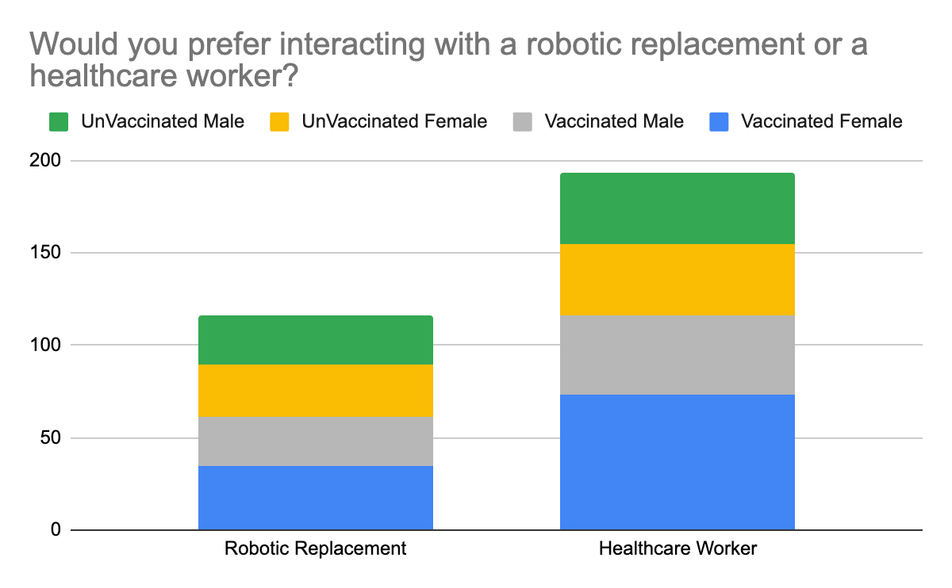

**Figure 2**

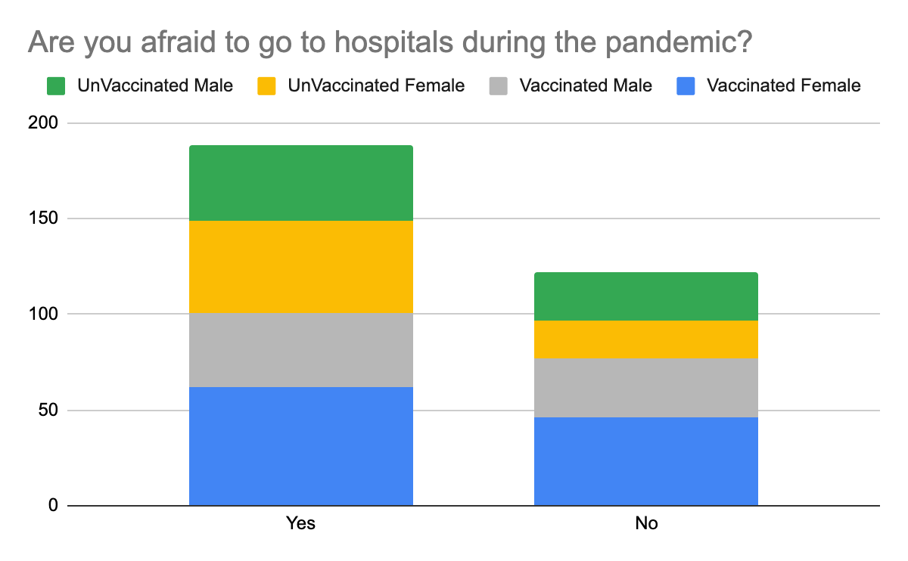

**Figure 3**

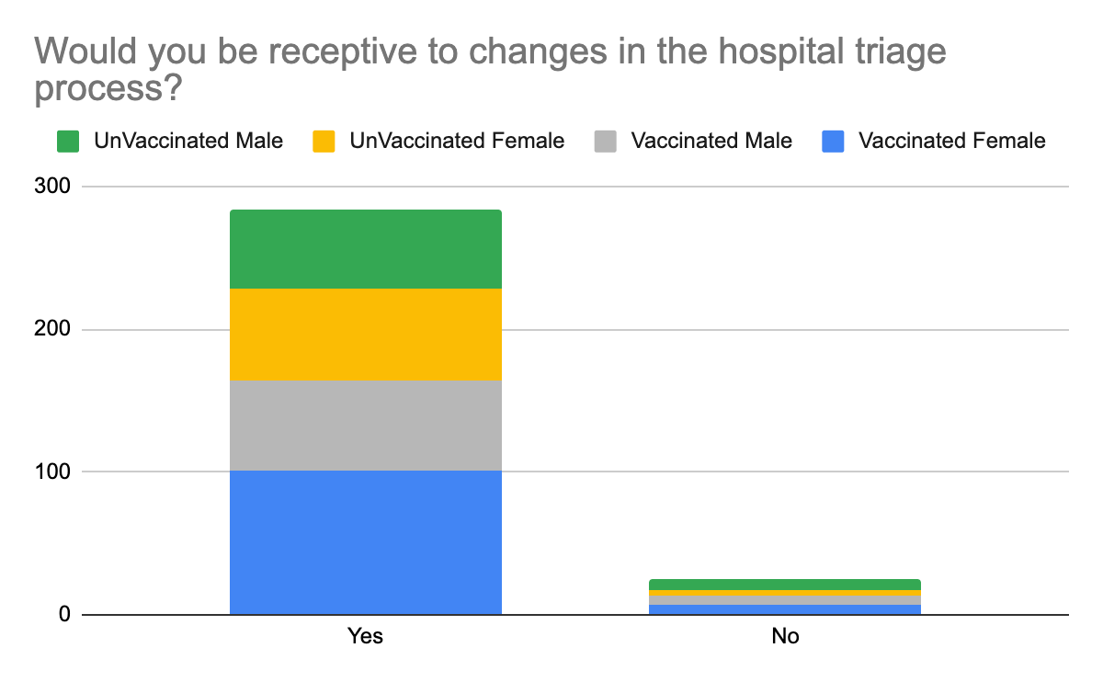

**Captions**

Figure 1 - Would you prefer interacting with a robotic replacement or a healthcare worker?. number of people said yes while “number” people said no to interacting with a robotic replacement.

Figure 2 - “Are you afraid to go to hospitals during the pandemic?“, number responded yes for the question that assesses if people are afraid to go to hospitals during the pandemic.

Figure 3 - “Would you be receptive to changes in the hospital triage process?” number responded yes to the question that assesses whether or not people would be receptive to changes in the hospital triage process.

Table 1 - “Table 1 - Descriptive Statistics”