**Modular and Autonomous Ship Attachment Technology for Ocean Plastic Retrieval**

Conceptual Design Proposal for OP-SMART

**Aditya Verma1*, Juhyeong Pang5*, Jason Rajan2* Varshan Kumar6*, Sarveshan Saravanan2*, Barrett Brooks7*, Janice Rajan2*, Brianna Brooks7*, Mithran Senthil Sadasivam2*, Iniyan Sasikumar4*, Alex Colin8**

*1American High School, Fremont, California****,*** *2Dougherty Valley High School, San Ramon, California, 3 Dublin High School, Dublin California, 4The Quarry Lane School, Dublin, California,* *5Head Royce School, Oakland, California, 6Mountain House High School, Mountain House, California, Dublin High School, 7Monte Vista High School, Danville, California, 8Dublin Robotics, Dublin, California*

*Authors contributed equally.

**Abstract**

Ocean plastic pollution is one of the most disturbing ecological realities of modern times. According to UNESCO, there are about 75 trillion pieces of plastic in the ocean and the Center for Biological Diversity estimates that about 40% of the surface of the ocean is made up of trash. Much of this litter is microplastics, which pose the problem of passing through almost all the filters that have been used to clean up the ocean. Microplastics have now been discovered in virtually every corner of the ocean and are slowly poisoning marine life and ultimately end up being ingested by humans. While a solution for cleaning up the microplastics in the ocean is devised, the best way to prevent more from accumulating is to clean up the bigger pieces of plastic floating, or macroplastics, before they disintegrate and become minuscule unretrievable fragments. This paper puts forward the concept of Ocean Plastic Scalable, Modular, and Autonomous Retrieval Technology (OP-SMART), essentially an attachment for large ships that routinely cross the ocean to collect macroplastic on their commercial routes. Results indicate that the modular and scalable design of OP-SMART coupled with its autonomous and continuous operation makes the invention a viable solution to help rid the ocean of macroplastics and thereby prevent more microplastics from forming.

**Keywords:** Autonomous, Macroplastic, Ocean Pollution, Collection/Retrieval, Nets, Ships

**1.0 Introduction**

Ocean plastic pollution affects a multitude of cultures, communities, and biodiversity across the globe, both in and out of the sea. Marine life chokes on soda can holders, animals get stuck in large plastic segments and when ingested by animals and humans alike, plastics cause a host of harmful effects. The problem is only projected to get worse, according to the United Nations, ocean plastic pollution could more than double by 2030 (United Nations, 2021). As damaging as large pieces of ocean plastic can be, it is still possible for them to be collected and properly disposed of or recycled. Once large pieces of plastic decompose into microplastic, however, it is virtually impossible to retrieve them. Hence more ocean plastic pollution breaking up into unretrievable segments should be prevented at all costs.

Microplastics are so damaging for several reasons. They affect the health and behavior of marine animals by causing physical damage to them, they can also increase inflammation and alter hormone levels (Rochman, 2018). Further, microplastics carry harmful chemicals that seep into the water and the tissue of wildlife that consumes them (Gross & Enck, 2021). What is more, it has been shown that microplastics enter the human food chain through drinking water, seafood, and other avenues causing severe risks to human health (Amobonye et al., 2021).

The problem of ocean plastic pollution is severe and multifaceted. There are several factors contributing to the issue such as the increase in disposable single-use items (Gill, 2019), and an overall lack of proper waste management and disposal systems and infrastructure coupled with inappropriate manufacturing techniques that release contaminants into the environment that eventually make their way into waterways and the ocean (Rochman, 2020). Over time, these pieces of plastic disintegrate into millions of tiny particles which tend to sink and become unretrievable.

Cleaning up the oceans of macro plastics, larger pieces easier to collect, is the first step in preventing more microplastic from forming. Clean oceanic habitats are essential to maintaining a sustainable global environment (Visbeck, 2018). Several existing initiatives are working on this problem such as Ocean Cleanup, an environmental nonprofit committed to this very mission of ridding the oceans of plastics through developing technologies. Their signature system consists of a network of barriers that use ocean currents to trap large floating marine pollution which is then extracted and recycled by supporting vessels. While their efforts have proven to be effective so far and they have set the ambitious goal of wanting to clean up 50 % of the Great Pacific Garbage Patch in five years, their solutions require entire systems to be implemented. They are dependent on vessels being commissioned for the sole purpose of collecting trash. It is an independent project instead of an integrated one aiming to leverage existing resources. The solution presented in this paper, an Ocean Plastic Scalable, Modular, and Autonomous Retrieval Technology (OP-SMART), offers an alternative approach with mobility and frequency as priorities; OP-SMART is essentially a modular solution that can be attached to any large vessel and is thought to be used routinely at scale by container ships crossing the ocean on commercial routes. Another interesting solution on a much smaller scale is the Floating Robot for Eliminating Debris (FRED), an autonomous solution developed by the nonprofit Clear Blue Sea which aims to harvest floating pollution from rivers, bays, and the ocean. Being an unmanned, largely self-sustained, independent vessel, scaling FRED for a significant collection quota would require manufacturing a sizable fleet of them which is not necessarily the most efficient approach. OP-SMART on the other hand is designed to leverage the existing inventory of marine vessels, primarily large shipping boats, by attaching a modular integrated system onto them that can collect marine debris while completing their commercial shipping routes. This way OP-SMART can be scaled at a faster rate than building a fleet of FREDs.

On a more academic front, a floating trash collector robot proposed in the International Journal of Innovation and Learning (Othman *et al*., 2022), offers a framework to build small-scale semi-autonomous floating devices that consist of a conveyor belt system and a storage bin. Unlike OP-SMART, these devices need to be self-sustainable and may not be able to cover many areas because of their smaller size and inferior navigational capabilities. Since OP-SMART is attached to large existing vessels that routinely navigate international waters this is not an issue. OP-SMART solves the problem of ocean plastic pollution becoming microplastic by making it autonomous and scalable to routinely pick up plastic floating on the ocean by attaching a robotic ocean plastic collection system to existing ships that are already in operation. Effectively, the invention presented in this paper leverages the existing inventory of vessels that are already traveling the ocean by providing a modular, attachable system that autonomously collects and compresses ocean plastic pollution. The system would work best with larger container ships that travel through traffic-heavy routes while shipping freight worldwide.

**2.0 Methodology**

The OP-Smart System utilizes equipment that includes air bubble pumps, nets, motors, swivel towers, pulleys, a compactor, and various sensors that detect the status of the nets and the weather. With both sides of the ship set up with nets, the OP-SMART System determines if they are full or not, which then either retracts or keeps the nets expanded. Once the system determines that the nets are full, the nets are reeled in and the trash is sent to the compactor. The compacted trash cubes are either sent to the contained space if there is room, or to a heat compactor.

**2.1 General Design Being Proposed**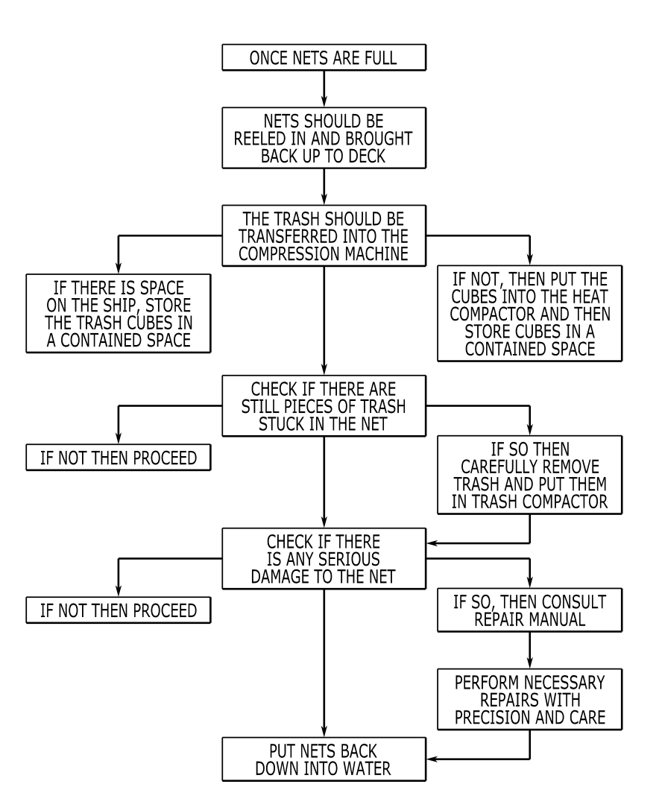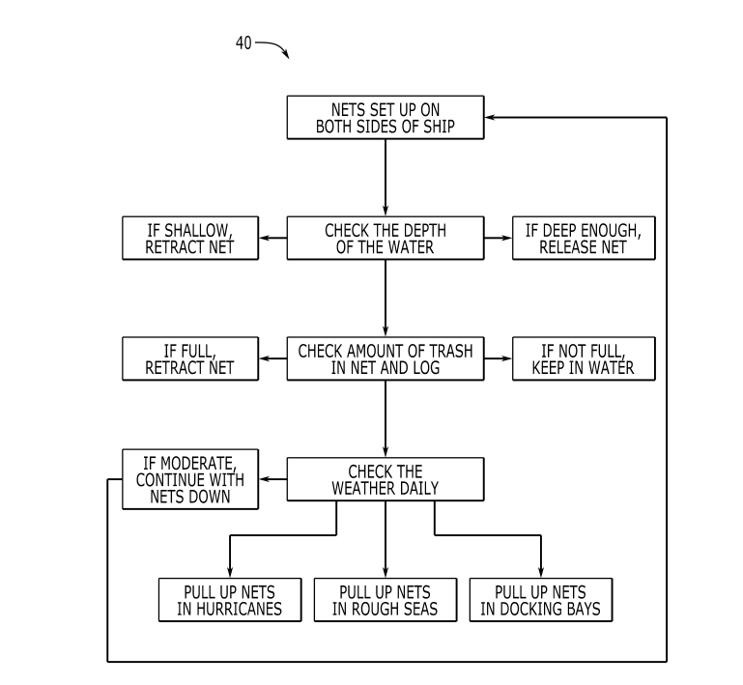

**Figure 1: OP-SMART Flowchart (self-drawn)**

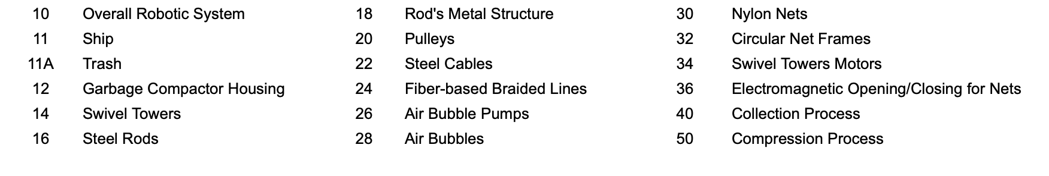

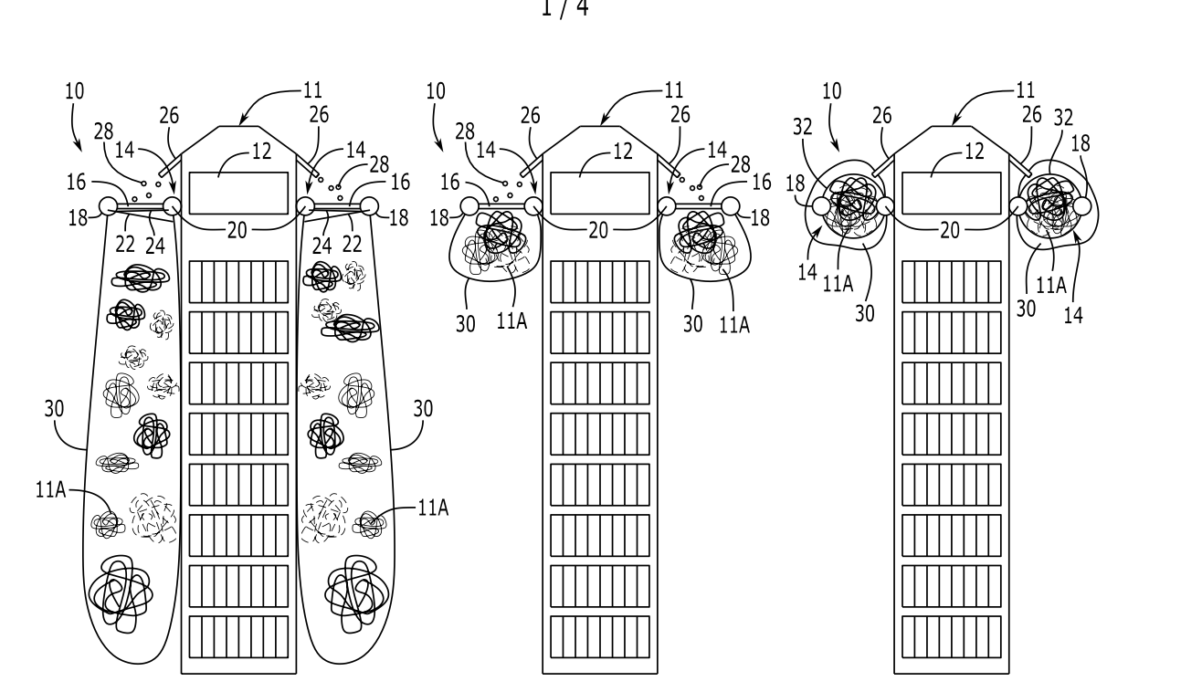

**Figure 2: OP-SMART Schematic**

**2.2 Functionality of System**

The invention operates using several independent subsystems consisting of bubble pumps, large submersible nets, sliding rails, and trash compactor. The bubble pumps are located at the bow of the ship where they can funnel plastic waste inwards so that they have a higher chance of being caught by the nets at midship. The submersible nets collect the plastic funneled in by the bubble pumps. The sliding rails help the nets when full. The nets are pulled up the rails via industrial, high-torque motors and they are opened so the plastic falls into the compactor, located on the deck of the ship. The trash compactor will pack the plastic trash into more manageable sizes. When the plastic falls in, it is heated until it melts, after which it is compacted, cut into small 3-foot cubes, and stored somewhere below deck until the ship docks. The crew can then unload the cubes and send them to the nearest recycling plant to be processed and broken down.

**2.3 Systems Applied in OP-SMART**

| **System** | **Function** |
| --- | --- |
| System A: | Once nets are lowered, trash is collected passively as the ship sails. |
| System B: | Bubble machines are located at the bow of the ship, on both the port and starboard sides. |
| System C: | Once full, the nets are raised along sliders and swivel inward, dropping their loads into a garbage compactor. Then, they return to their original position inside the water. |
| System D: | Once the plastic is inside the compactor, it is melted and compressed into many uniform cubes, which are stored in a separate container. Once the boat docks, the entire container is shipped to the nearest recycling plant where its contents can be taken care of. |

**Table 1: Systems applied in OP-SMART**

**2.4 Structural Design**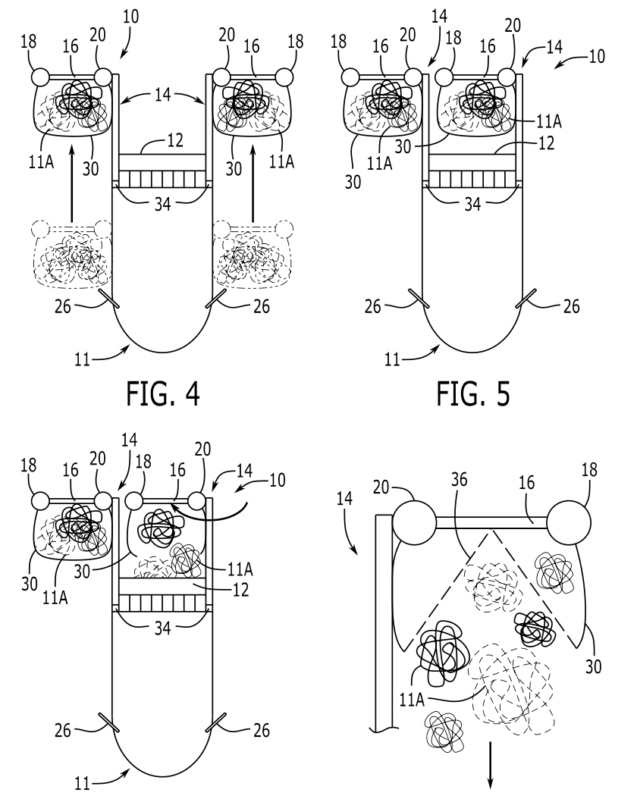



**Figure 2: OP-SMART Design Structure**

**2.5 Hardware Design Description**

This invention contains a garbage disposal unit that is placed near the front of the vessel, where all collected trash will be disposed of. The trash will be dumped by nets attached to the sides of the vessel. The nets are elongated so their trash-collecting range is extremely large. They are placed on the sides of the ship and once filled with enough trash the net contracts and flips the trash into the disposal and it is ready to be used again. Once the plastic is in the disposal it is melted down and molded into cubes for easy storage. They will be shipped to a recycling plant once the boat reaches a dock.

Two nets are attached to two steel rods reinforced by a metal structure which themselves are mounted on two swivel towers directly bolted down on each side of the front of the ship. The swivel towers are powered by two motors and allow for a rotational motion in which the rods expand outside of the ships’ perimeter permitting the nets to fall into the water while being held by fiber-based braided lines and reinforcing steel cables. A trawl winch allows for the net system to be deployed and retracted and is powered by six motors, three on each side, and a system of pulleys. A circular net frame is attached to the nets for the structure. A system of six air pumps mounted on the front of the ship produces a multidirectional current of bubbles meant to act as a funneling curtain to guide the plastic pollution into the nets. A vision sensor is mounted on the steel rods on each side of the ship. The trawling mechanism is connected to the nets and can lift them up to the main deck height. The swivel towers are designed to rotate the rods with the loaded nets back into the ship perimeter, directly on top of the garbage compactor. An electromagnetic system is embedded in the nets and permits them to open up to drop the garbage collected into the garbage compactor which is made out of a strong metal housing, a compressing steel wall inside of the housing, two compactor motors that rotate on a linear slide to push said compressing wall into the housing, a conveyor belt then feeds the compacted cubes of garbage out of the compressing unit into a designated area on the deck.

**2.6 Components of OP-SMART and their functions**

| **Components** | **Function** |
| --- | --- |
| Motors [(WESSCO, USA)](https://wessconw.com/compactors/rj-100sc-compactor/) | Trash compactor that can handle both dry and wet waste from Wessco. Used for compacting the trash that has been recovered. |
| Compactor steel wall [(WESSCO, USA)](https://wessconw.com/compactors/rj-100sc-compactor/) | Trash compactor that can handle both dry and wet waste from Wessco.Used for compacting the trash that has been recovered. |
| Steel cable [(E-RIGGING, USA)](https://www.e-rigging.com/three-eighths-X-250-foot-Galvanized-Cable?utm_source=google&utm_medium=ppc&utm_campaign=Shopping_40-50&utm_term=&gclid=Cj0KCQjw166aBhDEARIsAMEyZh6afdrFUbUpw2CxS5EyKTb5nNJl0yEiqyLrXHQU3PlaV0YXOJEbBfkaAkfJEALw_wcB) | Steel cable for structure from E rigging |
| Industrial Winch [(TSC, USA)](https://www.tractorsupply.com/tsc/catalog/atv-u) | Winch can haul loads of up to 10 tons, with 100ft of cable length. Used to lift nets from the water and into the trash compactors. |
| Industrial pulleys [(ROPEMASTER, USA)](https://rope-master.com/en/pulleys/655-double-pulley-transf-air-twin-b-3700288262820.html?msclkid=6261387c020d1081c3815b30b9776772) | Pulley is used to allow the winch to lift the nets completely into the air, above the surface of the ship’s deck. |
| Industrial nets [(DULUTH NETS, USA)](https://duluthfishnets.com/product-category/knotless-seines/) | To grab all plastic and waste quickly and effectively in the vicinity |
| Industrial Nylon Nets [(KASON, CHINA)](https://www.kasonsource.com/high-strength-trawl-net-fishing-net-multifilament-fishing-net-for-wholesale.html) | Industrial grade polyester nylon knitted nets. Holes large enough for fish to pass through, very high tensile strength with tightly woven fibers. |
| Bubble Machine [(AMAZON, USA)](https://www.amazon.com/Fleeting-Time-Gatling-Machine-Automatic/dp/B096R74CZZ) | Submersible bubble machine |
|  |  |

**Table 2:** Components in OP-SMART and their function

**2.7 Assembly of Innovation**

The invention consists of three subsystems designed to work together in synchrony: a funneling, a collecting, and a compressing system. To make the invention you would have to first attach three air bubble pumps to each of the front sides of the ship. These pumps are required to be underwater for proper functioning. As a result, mounting them will require some underwater equipment and industrial fasteners suitable for the ship’s hull. Once these commercially available air pumps are strategically mounted in the front enclosure of the vessel, the funneling mechanism is ready. Next, the collecting system must be assembled. A swiveling tower must be bolted down on each side of the deck’s front. These will be industrial steel towers properly braced and reinforced to withstand the weight of the garbage collected. A capable trawling unit like the ones used for fishing will be centrally mounted in the middle of the deck and wired with a system of pulleys onto the towers. A metal rod and an accompanying metal structure will then be mounted on each of the two swiveling towers. The reinforced nets with a built-in electromagnetic opening and the closing system will then be attached and connected to the rods and trawling mechanisms. Finally, a garbage compactor unit will be mounted in the middle of the deck, lined up with the towers and next to the trawling system. The compactor will be assembled separately and then mounted on the deck. The compactor will be made by putting together a reinforced metal housing, a compressing wall powered by a linear slide, and a conveyor belt to convey the compressed garbage out into the deck.

**2.8 Mechanism of Components**

Once a ship’s voyage starts, the swivel towers on the sides of the front part of the ship will pivot and allow the rods to flip out, ultimately ending up perpendicular to the ship. The trawling system will then be activated and extend the nets allowing them to touch the water and begin the collection phase. Once the nets have been fully extended, the system of air bubble pumps will begin creating an air curtain funnel to guide marine debris into the nets. Two vision sensors, mounted on each side of the ship, will continuously monitor the filling-up process, and trigger a retraction command once the nets have reached full capacity. The retraction phase will consist of a trawling system pulling the nets up either individually or simultaneously to reach the same level of the main deck. Once the loaded nets are leveled, the dumping phase begins. Each side of the system will dump the collected material into the compactor once at a time. A swivel tower will rotate and align the loaded net directly on top of the garbage compactor. At this point, the electromagnetic opening and closing system embedded in the net will be activated, opening the net at the bottom, and allowing the collected material to freely fall into the compressing unit. Once the compressing unit has received the material, the compression phase begins. The motors on the compactor’s linear slide will push the compressing steel wall into the unit’s reinforced frame-shaped un in the form of a cube. After multiple compression cycles, a “unit” of collected material will be formed and bundled up with some type of wire. Such a unit will then be conveyed out of the compressor by a conveyer belt and will be dropped into a designated area on the ship’s deck. While the first compression cycle takes place, the other side of the system will begin its dumping phase following the same steps described above. After both sides of the system have been unloaded, the process can start over and be repeated however many times it is needed or permitted by the ship’s route.

**2.9 Application of OP-SMART**

OP-SMART is designed to primarily work autonomously once mounted on a ship. On a larger scale, the invention can be thought of as a system of multiple ships with machines attached to them which could potentially cover a large area of the ocean’s commercially traveled area. After the machine is mounted and configured, no constant operator is needed. Instead, it will operate autonomously primarily according to the ship’s location and weather. At any time, the system can be manually controlled by the ship’s captain or authorized crew members. Once the ship is deep enough into the ocean, the machine will automatically deploy the system of nets and initialize the funneling mechanism made from the air bubble pumps. The entire process will be autonomous and independent from the ship’s normal operation. When the ship arrives at its destination, the collected waste will be properly disposed of or recycled.

**3.0 Results and Discussion**

The implementation of OP-SMART on a large scale on ships that routinely intersect maritime plastic pollution on their commercial routes would effectively result in an automated and continuous cleaning system of sorts for the ocean. OP-SMART would be in effect leveraging the existing inventory of vessels to remove macroplastic from the ocean, preventing more microplastic from forming. Further, OP-SMART:

1. *Scales:*

OP-SMART is a scalable system due to its standardized design and materials, making it easy to produce in large quantities. The system is designed to enable integration into existing container ships, allowing it to leverage the vast infrastructure of the global maritime industry. This approach minimizes the need for additional resources, such as dedicated garbage collection vessels, which would otherwise be required to combat ocean pollution. By utilizing readily available materials and integrating with existing infrastructure, the OP-SMART system can be rapidly deployed on a global scale, making it a scalable solution to the growing problem of ocean pollution. This system is a very realistic solution to ocean pollution as it does not require the use of any new, untested technology, meaning it can be produced in almost any factory and can be produced immediately.

1. *Has a Mobile and Versatile Design*

With its modular design, OP-SMART guarantees compatibility with all types of large vessels. This means that it can be adapted to fit and be functionally moved. Components can also be easily replaced and are all sourced to be commercially available.

1. *Operates Efficiently:*

The net design of OP-SMART allows for maximum efficiency in ocean litter collection. The system of air pumps funnels debris into a set of nets. By placing said nets on the side of the ship, the area of collection is maximized compared to any other location on the ship. This approach allows for the efficient use of available resources and helps to minimize the time and effort required for effective ocean pollution control. By optimizing the location and design of the garbage collection system, the OP-SMART system ensures that the maximum amount of debris can be captured.

1. *Operates Autonomously:*

OP-SMART is an autonomous system that can operate without human intervention, or with small crews, due to its advanced sensors and adaptive algorithms. These technologies enable the system to detect and respond to environmental conditions, such as ocean currents and weather patterns. By operating autonomously, the system can operate continuously and consistently, maximizing its impact in combating ocean pollution.

1. *Protects Wildlife*

OP-SMART would not only help remove macroplastics but also prevent the process of bioaccumulation from occurring in marine ecosystems. This process physically harms animals and indirectly affects humans that consume seafood products. Additionally, OP-SMART has wildlife protection measures in place to minimize harm to marine animals, such as bubble pumps to ward away fish and large holes in the net to allow any other trapped marine life to escape easily.

1. *Prevents Fuel Wastage:*

The OP-SMART system utilizes container ships that are already scheduled to navigate the ocean, thereby leveraging their fuel to power onboard ocean cleanup systems. This innovative approach enables the cleanup system to be integrated into the ship, making use of the vessel’s existing infrastructure for efficient and effective ocean pollution control.

1. *Decreases Shipping Cost:*

With the OP-SMART system, there is no need for dedicated trash collection vessels to transport the collected garbage. Instead, the system allows the trash to be discharged at the destination of the container ship equipped with OP-SMART technology, eliminating the need for additional ships solely dedicated to waste management. This approach streamlines the process and reduces overall transportation costs while effectively addressing ocean pollution.

1. *Is A Continuous Solution for an Ongoing Problem:*

Given the nature of the ocean plastic pollution problem, which is not projected to slow down, a continuous solution is needed. OP-SMART is thought of as a big autonomous cleaning system for the ocean that is always running.

**4.0 Conclusion**

OP-SMART automates and streamlines the removal of ocean plastic pollution by attaching to existing vessels that already navigate the ocean to pick up litter on their current commercial routes and compact said trash to help properly dispose of it. By leveraging the existing supply of vessels and using commercially available technology and materials in its design, OP-SMART is an economically viable solution to the problem of marine plastic pollution. The invention’s safe design and operation protects wildlife and offers an alternative to more invasive solutions that further crowd and pollute the oceans. Ultimately, the continual removal of macroplastics facilitated by OP-SMART means fewer microplastics forming and having a negative ecological impact.

**5.0 Acknowledgments**

We would like to express our gratitude to our mentors that helped us every step of the way through this project. We would like to thank Dublin Robotics for their encouragement and helping hand during this endeavor as we would not be able to complete this project without them.

**References**

1. Amobonye, A., Bhagwat, P., Raveendran, S., Singh, S., & Pillai, S. (2021). Environmental Impacts of Microplastics and Nanoplastics: A Current Overview. *Frontiers in Microbiology*, *12*. https://doi.org/10.3389/fmicb.2021.768297
2. Center for Biological Diversity. (2019, May 17). *Ocean Plastics Pollution*. Biologicaldiversity.org. https://www.biologicaldiversity.org/campaigns/ocean_plastics/
3. Evers, J. (2022, June 2). *Great Pacific Garbage Patch | National Geographic Society*. Education.nationalgeographic.org; National Geographic. https://education.nationalgeographic.org/resource/great-pacific-garbage-patch
4. Fava, M. (2022, May 9). *Ocean plastic pollution an overview: data and statistics*. Ocean Literacy Portal; UNESCO. https://oceanliteracy.unesco.org/plastic-pollution-ocean/
5. Gill, V. (2019, April 16). Early ocean plastic traced to 1960s. *BBC News*. https://www.bbc.com/news/science-environment-47914580
6. Gross, L., & Enck, J. (2021). Confronting plastic pollution to protect environmental and public health. *PLOS Biology*, *19*(3), e3001131. https://doi.org/10.1371/journal.pbio.3001131
7. Isobe, A., Uchiyama-Matsumoto, K., Uchida, K., & Tokai, T. (2017). Microplastics in the Southern Ocean. *Marine Pollution Bulletin*, *114*(1), 623–626. https://doi.org/10.1016/j.marpolbul.2016.09.037
8. Lau, W. W. Y., Shiran, Y., Bailey, R. M., Cook, E., Stuchtey, M. R., Koskella, J., Velis, C. A., Godfrey, L., Boucher, J., Murphy, M. B., Thompson, R. C., Jankowska, E., Castillo, A. C., Pilditch, T. D., Dixon, B., Koerselman, L., Kosior, E., Favoino, E., Gutberlet, J., & Baulch, S. (2020). Evaluating scenarios toward zero plastic pollution. *Science*, *369*(6510). https://doi.org/10.1126/science.aba9475
9. *Meet Fred – Clear Blue Sea*. (n.d.). Clear Blue Sea. https://www.clearbluesea.org/meet-fred/
10. Othman, H., Petra, M. I., d, L. C., Silva, e, Caesarendra, W., Seneviratne, S., & Glowacz, A. (2022). Implementation of semi-autonomous robot as solution to water pollution from floating trash. *International Journal of Innovation and Learning*, *32*(3), 239. https://doi.org/10.1504/ijil.2022.125767
11. Quiñones, L. (2021, October 21). *Plastic pollution on course to double by 2030*. UN News. https://news.un.org/en/story/2021/10/1103692
12. Rochman, C. (2020). The Story of Plastic Pollution: From the Distant Ocean Gyres to the Global Policy Stage. *Oceanography*, *33*(3), 60–70. https://doi.org/10.5670/oceanog.2020.308
13. Rochman, C. M. (2018). Microplastics research—from sink to source. *Science*, *360*(6384), 28–29. https://doi.org/10.1126/science.aar7734
14. The Ocean Cleanup. (2021). *Oceans | The Ocean Cleanup*. The Ocean Cleanup. https://theoceancleanup.com/oceans/
15. United Nations. (2021, October 21). *Plastic pollution on course to double by 2030 | UN news*. United Nations. Retrieved May 7, 2023, from https://news.un.org/en/story/2021/10/1103692
16. Visbeck, M. (2018). Ocean science research is key for a sustainable future. *Nature Communications*, *9*(1), 690. https://doi.org/10.1038/s41467-018-03158-3