*Article*

**Coral Oceanic Restoration Autonomous Lander Submersible: Conceptual Design Proposal for CORALS**

Anjali Sharma-Tiwari1*, Eashan Mahajan2*, Johann Webber*3\**, Dhruva Vutukury4*, Jibran Haris5*, Vedant Kathrani6*,Tejas Channaveerappa7\***,** Iniyan Sasikumar8\***,**Alex Colin9

**1**Basis Independent Silicon Valley, San Jose, California, 2Dublin High School, Dublin, California, **3**Stanford online High school, Redwood City, California, 4Foothill High School, Pleasanton, California, 5 Rise Academy, San Jose, California, 6Dougherty Valley High School, San Ramon, California, *7 Somerset Middle School, Modesto, California,8 The Quarry Lane School, Dublin, California,* 9 Dublin Robotics, Dublin, California

*Authors contributed equally

**Abstract:** Coral reefs are facing unprecedented threats due to rising ocean temperatures, acidification, and pollution, with chemical contaminants like oxybenzone from sunscreens exacerbating coral bleaching and ecosystem decline. The Coral Oceanic Restoration Autonomous Lander Submersible (CORALS) presented in this paper, is an innovative autonomous underwater drone designed to mitigate chemical pollution and promote coral reef restoration. CORALS operates using a dual approach: it deploys biodegradable beads to absorb oxybenzone from surrounding waters while simultaneously utilizing acoustic enrichment technology to simulate the sounds of a healthy reef, encouraging marine biodiversity. The system leverages advanced sensing technologies, including LiDAR, electrochemical sensors, and sonar, to navigate coral environments with precision, autonomously collecting data and optimizing its deployment strategy. Designed for scalability, CORALS functions as a fleet-based system capable of covering extensive reef areas with minimal human intervention. This paper presents the conceptual framework, functionality, and ecological potential of CORALS, detailing its development, operational methodology, and capacity to complement existing conservation strategies in preserving these critical marine ecosystems.

**Keywords: Coral Reef Conservation, Autonomous Underwater Systems, Chemical Remediation, Oxybenzone, Acoustic Enrichment, Environmental Monitoring, Marine Robotics, Biodegradable Technology.**

**1. Introduction**

Coral reefs are among the most biodiverse and ecologically valuable marine ecosystems, supporting approximately 25% of all ocean species while protecting coastlines and sustaining local economies through tourism and fisheries (National Oceanic and Atmospheric Administration [NOAA], 2019). Despite their critical role in marine biodiversity and global ecological balance, these ecosystems face unprecedented threats. The Global Coral Reef Monitoring Network (GCRMN) reported that over 14% of the world’s coral reefs were lost between 2009 and 2018, with projections indicating that up to 90% could disappear by 2050 if current trends continue (GCRMN, 2020). While rising ocean temperatures and acidification are well-documented stressors, chemical pollution, particularly from personal care products, poses an increasingly significant yet understudied threat to reef survival. Among these pollutants, oxybenzone, a common UV filter found in sunscreens, has emerged as a particularly harmful compound, with concentrations as low as 62 parts per trillion capable of inducing coral bleaching, DNA damage, and reproductive failure (Downs et al., 2015).

The impact of chemical pollutants on coral reefs extends beyond direct ecological degradation. More than 60% of the world’s reefs are threatened by one or several man-made disturbances, with overfishing being the most immediate pressure (Miller et al., 2021). However, chemical pollutants, particularly UV filters from sunscreens such as oxybenzone, exacerbate these threats. Studies have shown that oxybenzone contamination can significantly disrupt coral development, with some coastal regions detecting concentrations far exceeding safe environmental thresholds (Danovaro et al., 2008). Although some regions have implemented sunscreen bans to limit future contamination, these regulations fail to address the existing accumulation of chemicals in reef environments (Raffa et al., 2019). Traditional conservation efforts, such as marine protected areas (MPAs), coral transplantation, and fishing restrictions, focus primarily on preventing habitat destruction rather than actively mitigating chemical pollution. Similarly, reef restoration projects such as Biorock technology, which uses electrical currents to stimulate coral growth, have shown promise in enhancing coral resilience (Sabater & Yap, 2004), but do not directly remove contaminants from the marine environment. Attempts to eliminate pollutants from marine ecosystems have relied on passive filtration methods such as activated carbon systems, which are inefficient on a large scale and require frequent human intervention.

To address these limitations, this paper presents the Coral Oceanic Restoration Autonomous Lander Submersible (CORALS), an autonomous underwater drone designed to actively remove oxybenzone from coral reef environments while simultaneously promoting reef restoration through acoustic enrichment. CORALS integrates biodegradable bead deployment and acoustic enrichment technology into a fully autonomous and scalable system. Using electrochemical sensors, the robot detects the presence of oxybenzone in reef ecosystems and deploys biodegradable beads composed of algae and chitosan, capable of absorbing contaminants effectively while minimizing ecological disruption. Research indicates that biodegradable materials, such as those used in reef restoration, provide a viable alternative to conventional plastics without negatively impacting coral-associated bacterial communities (Strudwick et al., 2024). This filtration process significantly reduces chemical contamination, mitigating its long-term effects on reef health. Additionally, CORALS incorporates acoustic enrichment technology, in which underwater speakers emit pre-recorded reef sounds that mimic the natural auditory environment of a healthy reef. Research has shown that this method increases fish population density by up to 50% and enhances overall biodiversity in degraded reef environments (Gordon et al., 2019).

CORALS is designed for autonomous operation, leveraging LiDAR, electrochemical sensors, and sonar-based navigation to map reef structures, detect pollution levels, and optimize deployment strategies without direct human intervention. The system is intended to function as a fleet-based solution, where multiple units operate in coordination to maximize coverage and efficiency. By combining chemical mitigation with ecological restoration, CORALS presents a novel, scalable, and technology-driven approach to coral reef conservation. This paper details the conceptual framework, technical implementation, and ecological potential of CORALS, outlining its role in enhancing marine conservation efforts through autonomous, data-driven intervention.

**2. Methodology**

The Coral Oceanic Restoration Autonomous Lander Submersible consists of three integrated systems: a mobile underwater drone equipped with environmental sensors and navigation capabilities, a modular bead deployment mechanism for chemical absorption, and a docking station for maintenance and recharging. These systems work together to form a comprehensive solution for automated coral reef monitoring and chemical remediation. The mobile unit navigates autonomously through reef environments, detecting and treating areas with elevated oxybenzone levels, while simultaneously providing acoustic enrichment to promote ecosystem recovery. The docking station enables extended operation by facilitating automated recharging, bead cartridge replacement, and system diagnostics.

*2.1 CORALS Deployment*

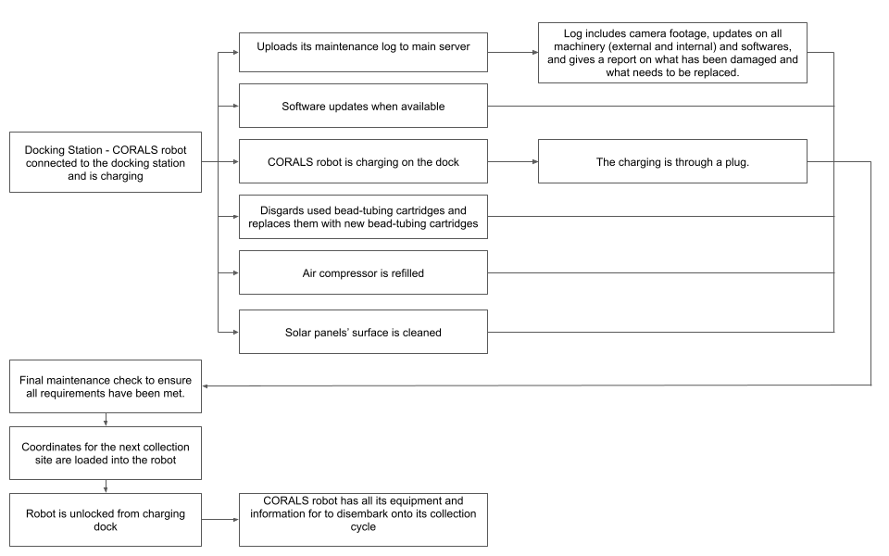

***Step 1. Pre-Collection Stage (Dock Station to Collection Site)***

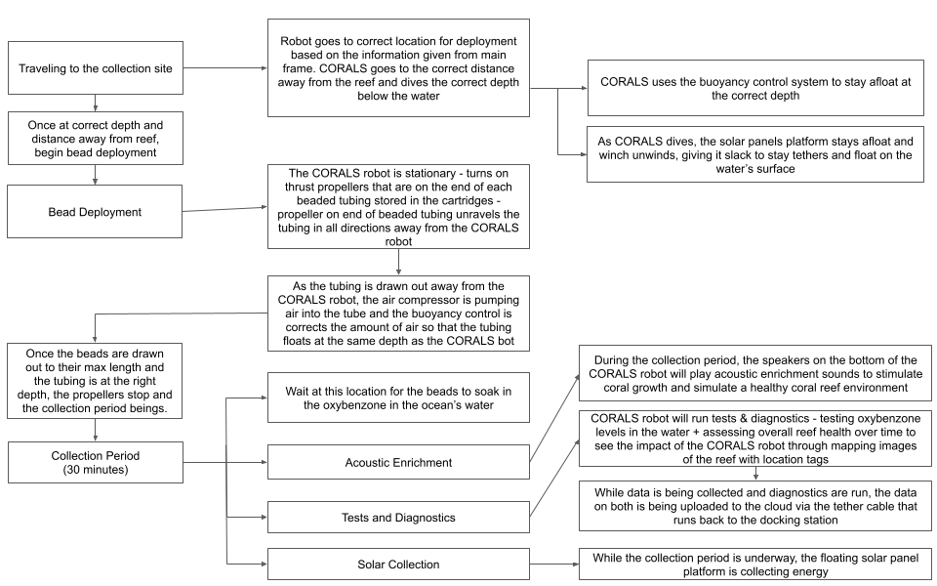

***Step 2. Collection Stage (Collection and Diagnostics)***

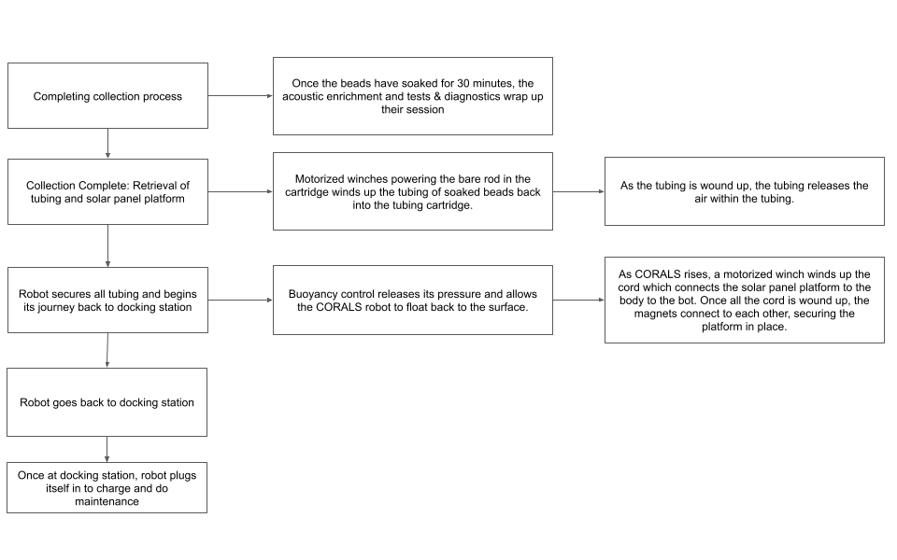

***Step 3. Post-Collection Stage (Retrieval and Return to Dock)***

*2.2 Functionality of System*

The CORALS system operates through multiple integrated subsystems: a navigation and positioning array, a chemical detection and monitoring system, a modular bead deployment mechanism, and an acoustic enrichment module. Each subsystem coordinates through a central control unit to execute the reef treatment protocol.

Upon completion of charging cycles, the system receives deployment coordinates via its central processing unit. The navigation array, comprising LiDAR, dual cameras, and circumferential proximity sensors, guides precise positioning while the buoyancy control system manages descent through a regulated air evacuation process. The drone achieves optimal treatment position through real-time triangulation of sensor data.

The bead deployment mechanism operates through a precision-engineered framework of motorized rods and pistons. Upon activation, the system extends deployment rods at precisely calibrated 45-degree angles, while synchronized thrust propellers facilitate the controlled dispersal of treatment tubes. The modular design enables simultaneous deployment in multiple vectors, maximizing treatment coverage area.

During the 30-minute treatment cycle, the system maintains position while executing three parallel processes: chemical absorption through deployed beads, acoustic enrichment via strategically positioned speakers, and continuous environmental monitoring through electrochemical sensors. The control system maintains real-time feedback loops, adjusting deployment patterns based on detected oxybenzone levels.

Post-treatment retrieval employs a reverse-sequence protocol, with coordinated action between thrust propellers and rod motors ensuring secure containment of treatment mechanisms. Upon verification of system closure, the buoyancy control initiates ascent procedures for return to the docking station, where automated systems manage recharging and bead cartridge replacement.

*2.3 Systems Applied in CORALS*

| **System** | **Function** |
| --- | --- |
| Communication/Data Logging System | Including an antenna/radio, this system enables communication between the robot and external control systems like the docking station or main server. Using the brain/motherboard and sensors, this system records and logs data on oxybenzone levels, reef health, and operational parameters for analysis and monitoring. |
| Sensing/Navigation System | Comprising LiDAR, cameras, rear proximity sensor, and an electrochemical sensor, this system deals with precision navigation, reef health monitoring, and oxybenzone detection. |
| Propulsion/Buoyancy Control System | Utilizing angled propellers, propeller motors, and a buoyancy control system, this system allows the robot to move underwater efficiently and maintain desired depths. |
| Bead Deployment + Collection System | Featuring collection mechanisms and an air compressor, this system enables the deployment, retrieval, and pressurized release of biodegradable beads for oxybenzone removal. |
| Maintenance/Charging System | Incorporated within the docking station, this system handles maintenance, software updates, and bead replacement while also recharging the robot for continuous operation. |
| Acoustic Enrichment System | Utilizing speakers, this system plays acoustic enrichment sounds to stimulate coral growth and enhance reef vitality during the collection period. |
| Logic/Feedback Control System | Implemented with subroutines and sensor feedback loops, this system autonomously coordinates the robot’s actions, optimizing performance based on environmental conditions. |
| Structural/Modular System | This system allows for the modular assembly and integration of various components within the aluminum frame structure and polycarbonate shell. |

**Table 1: Systems in CORALS and their function**

*2.4 Structural Design*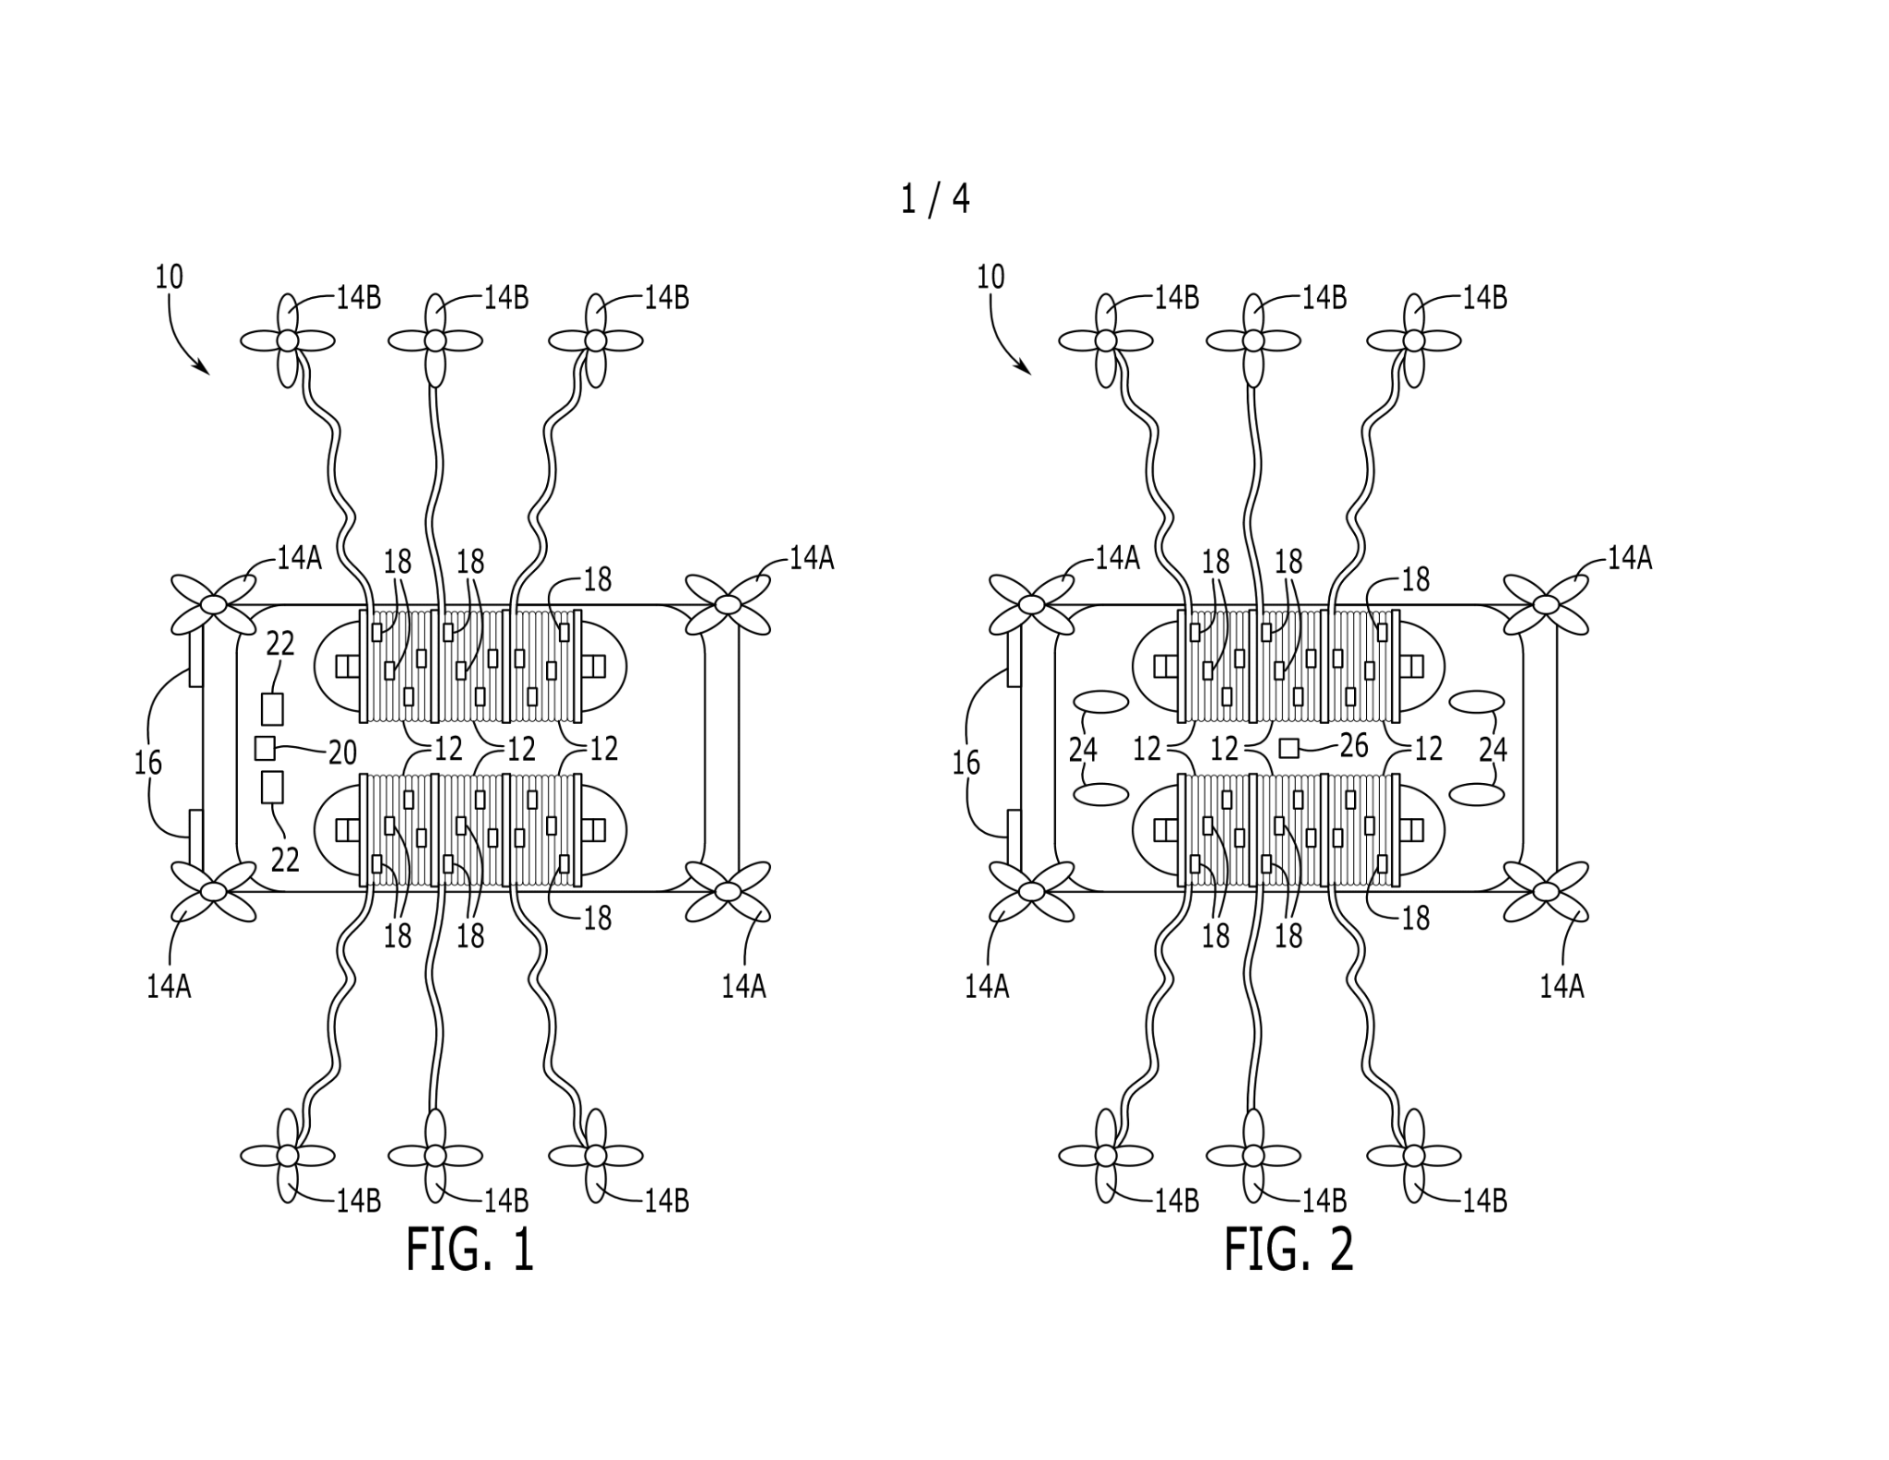

| 10 | Overall Autonomous CORALS Robot |
| --- | --- |
| 12 | Beaded Tubing Rolls |
| 14A | Angled Propellers |
| 14B | Thrust Propellers |
| 16 | Headlights |
| 18 | Beads |
| 20 | LiDAR Module |
| 22 | Cameras |

**Figure 1: Outside Top View**

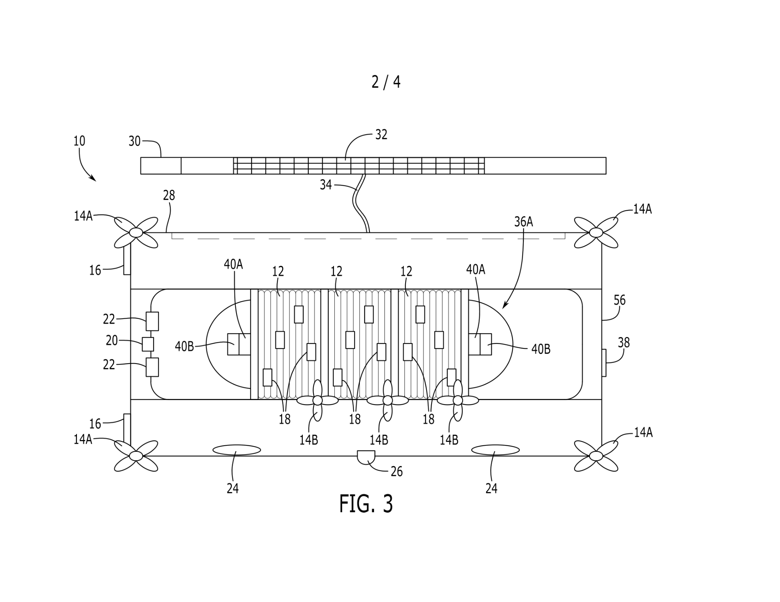

| 10 | Overall Autonomous CORALS Robot | 28 | Frame Structure |
| --- | --- | --- | --- |
| 14A | Angled Propellers | 30 | Antenna |
| 14B | Thrust Propellers | 32 | Solar Panel Module |
| 16 | Headlights | 34 | Tether Cable |
| 18 | Beads | 36A | Exterior Collection Mechanism |
| 20 | LiDAR Module | 38 | Rear Proximity Sensor |
| 22 | Cameras | 40A | Rods |
| 24 | Speakers | 40B | Rod Motors |
| 26 | Electrochemical Sensor | 56 | Polycarbonate Shell |

**Figure 3: Sectional View from Side**

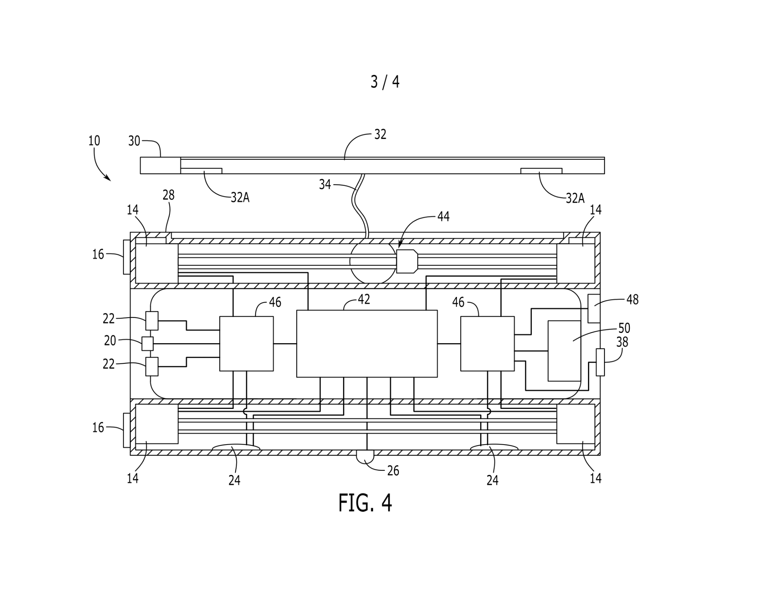

| 10 | Overall Autonomous CORALS Robot | 32 | Solar Panel Module |
| --- | --- | --- | --- |
| 14 | Propeller Motors | 32A | Solar Panel Securing Magnets |
| 16 | Headlights | 34 | Tether Cable |
| 20 | LiDAR Module | 38 | Rear Proximity Sensor |
| 22 | Cameras | 42 | Motherboard |
| 24 | Speakers | 46 | Battery Packs |
| 26 | Electrochemical Sensor | 48 | Charging Dock Connection Site |
| 28 | Frame Structure | 50 | Air Compressor |
| 30 | Antenna |  |  |

**Figure 4: Sectional View from Outside**

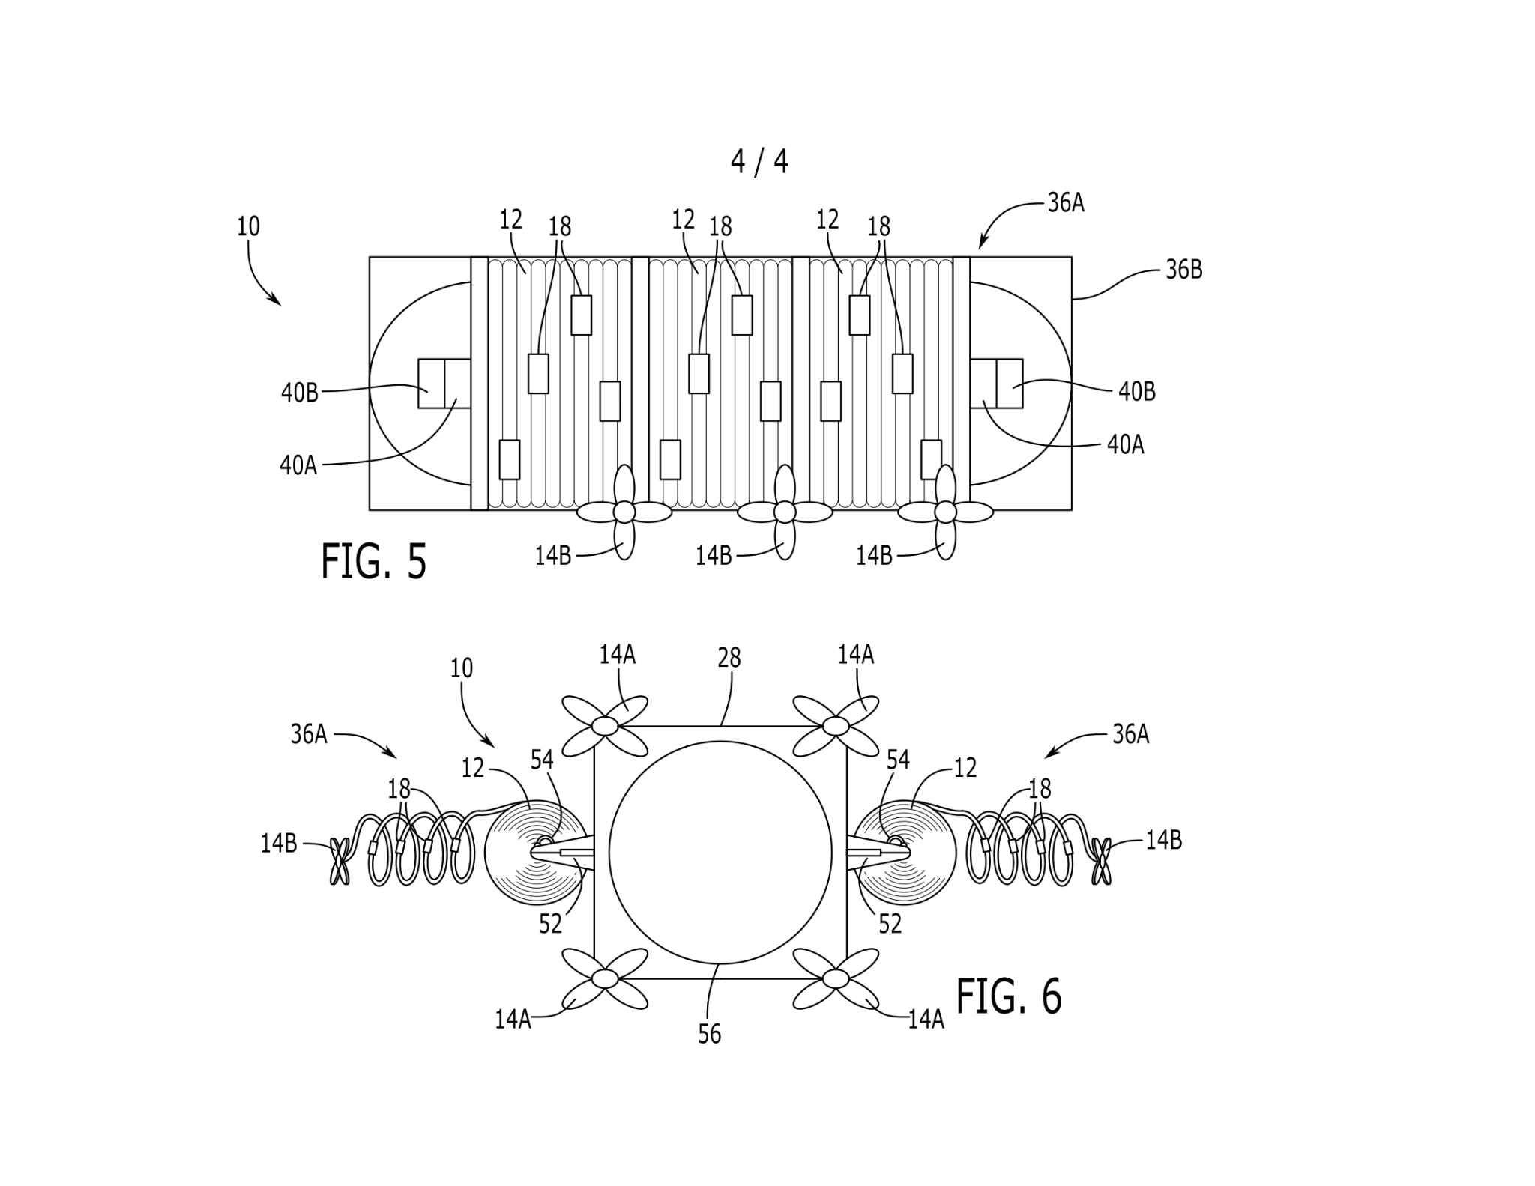

| 10 | Overall Autonomous CORALS Robot | 36B | Exterior Collection Mechanism Frame |
| --- | --- | --- | --- |
| 12 | Beaded Tubing Rolls | 40A | Rods |
| 14A | Angled Propellers | 40B | Rod Motors |
| 14B | Thrust Propellers | 52 | Pistons |
| 18 | Beads | 54 | Tubing Valve Connection |
| 36A | Exterior Collection Mechanism | 56 | Polycarbonate Shell |



**Figure 5: Collection System View from Outside and Inside**

*2.5 Hardware Design Description*

The CORALS system integrates sophisticated hardware components within a pressure-resistant framework designed specifically for underwater operation. The primary structure consists of three distinct modules: a sensor array for environmental monitoring and navigation, a central processing and power distribution system, and an external deployment mechanism for chemical treatment.

The navigation module, positioned at the forward section of the vessel, incorporates a LiDAR system, dual high-definition cameras, and marine-grade LED illumination arrays. This arrangement optimizes the drone's field of view while enabling precise navigation in complex reef environments. The LiDAR system provides real-time distance measurements from reef structures, while the camera array, enhanced by the LED illumination system, ensures comprehensive visual monitoring of the surrounding environment.

At the core of CORALS, a central compartment houses the primary control and power systems. The motherboard and high-capacity battery arrays are centrally positioned to ensure optimal weight distribution and system stability. This central module utilizes a specialized polycarbonate housing, rated for deep-water pressure resistance, to protect sensitive electronic components. The power distribution network extends throughout the vessel via marinized electrical conduits, supplying energy to critical systems including the sensor array, propulsion motors, deployment mechanisms, and acoustic enrichment speakers.

The external framework incorporates the bead deployment system and propulsion mechanisms. Multiple propeller arrays, positioned strategically around the vessel, provide precise navigational control. The deployment mechanism, comprising motorized rods and pressure-compensated pistons, enables controlled distribution of the treatment beads. A secondary polycarbonate shell encases these external components, creating a barrier between the marine environment and the internal systems while maintaining operational functionality.

Environmental protection features include pressure-resistant seals, waterproof connectors, and corrosion-resistant materials throughout the construction. The entire system is designed to operate reliably at varying depths while maintaining the integrity of both internal electronics and external mechanisms.

*2.6 Software Architecture and Control Systems*

The CORALS software architecture implements an integrated control system designed to manage autonomous operation through four distinct operational phases, each critical to the system's effectiveness in reef treatment and monitoring. The control structure employs a hierarchical approach that ensures both autonomous operation and environmental safety through multiple layers of system management and monitoring protocols.

At its foundation, the system operates through a base control layer that governs fundamental operations. This primary layer maintains continuous oversight of power distribution, processes incoming sensor data, and monitors critical system parameters in real-time. Through dedicated microcontrollers, this layer maintains constant communication with all hardware subsystems, enabling responsive operation while ensuring system stability and environmental awareness.

Building upon this foundation, the navigation and positioning systems integrate data from multiple sensor arrays to execute precise positioning near reef structures. The software processes combined inputs from LiDAR, optical cameras, and proximity sensors through sophisticated algorithms that maintain safe operating distances while optimizing treatment coverage. This integration enables the system to adapt to changing environmental conditions while following predetermined treatment protocols.

The mission control system orchestrates four essential subroutines that constitute a complete operational cycle. During pre-collection initialization, the system performs comprehensive diagnostics while connected to the docking station, uploading maintenance logs and installing necessary software updates. This phase concludes with the download of mission parameters and verification of all system components before deployment authorization.

The navigation and deployment phase engages once the system detaches from its docking station. During this phase, the software continuously calculates optimal travel paths while managing depth through precise buoyancy control. Real-time environmental monitoring ensures safe transit to designated treatment areas while avoiding sensitive reef structures. The system maintains constant awareness of its position relative to reef formations through continuous sensor data processing.

During active treatment, the control system manages multiple simultaneous operations. It monitors chemical concentrations through electrochemical sensors while controlling the bead deployment mechanism. Simultaneously, it manages acoustic enrichment protocols and oversees energy collection through the solar array system. This phase requires precise coordination between multiple subsystems to ensure effective treatment while maintaining optimal positioning.

The final recovery phase initiates after treatment completion, beginning with a comprehensive verification of treatment effectiveness. The software coordinates the sequential retrieval of deployment mechanisms while calculating the optimal return path to the docking station. Throughout this phase, the system maintains careful monitoring of all mechanical systems while preparing for the next operational cycle.

Throughout all operational phases, the control system maintains comprehensive data logging and performance monitoring. Advanced error detection algorithms enable quick response to unexpected conditions, with built-in safety protocols ensuring both system and environmental protection. This sophisticated software architecture ensures reliable autonomous operation while maintaining the integrity of both the system and the delicate reef environment it serves.

*2.7 Components of CORALS and their Functions*

| **Components** | **Function** |
| --- | --- |
| Aluminum Frame Structure [(Xometry, USA)](https://www.xometry.com/capabilities/cnc-machining-service/cnc-aluminum/?utm_term=aluminum%20cnc%20service&utm_campaign=PB:G%7CNT:SN%7CAN:Manufacturing%7CCN:CNC_Machining_Broad&utm_source=adwords&utm_medium=ppc&hsa_acc=3789459769&hsa_cam=21058411415&hsa_grp=160465773498&hsa_ad=692181093495&hsa_src=g&hsa_tgt=kwd-295646560759&hsa_kw=aluminum%20cnc%20service&hsa_mt=b&hsa_net=adwords&hsa_ver=3&gad_source=1&gbraid=0AAAAADn8J0-nKdYukdw_DYabfuPt3KTgr&gclid=CjwKCAiAzba9BhBhEiwA7glbalbbgOUHRLae0ETlVJOoeFpbIo7vxGPzG7jMUqCRjBxQ9K8uD4HroRoCnkYQAvD_BwE) | Provides a strong support structure for all components |
| Polycarbonate Shell [(A&C Plastics, USA)](https://www.acplasticsinc.com/categories/polycarbonate) | Durable and transparent cover protecting internal components from water and pressure. |
| Tether Cable [(Backscatter, USA)](https://www.backscatter.com/product-category/Remote-Cables) | Connects the robot to a surface vessel or platform, allowing for communication and retrieval |
| Antenna / Radio ([DiveandSea, USA](https://diveandsee.com/uwater-wi-fi-antennas/?srsltid=AfmBOopvmApPrJAcy0TKLK6cQz-JEykqYF5Z79jLriCHUdN3TSyCxPS3)) | Enables wireless communication with the control station |
| Tether Cable Motor and Winch [(Unique Group, UAE)](https://www.uniquegroup.com/product/ug-tether-winch/) | Allows for the extension and retraction of the tether cable, adjusting the robot’s depth or retrieving it |
| Angled Propellers (qty: 8) [(BlueRobotics, USA)](https://bluerobotics.com/store/thrusters/t100-t200-thrusters/t200-thruster-r2-rp/) | Provide multidirectional movement and stability underwater |
| Propeller Motors (qty: 8) [(BlueRobotics, USA)](https://www.google.com/url?q=https://bluerobotics.com/store/thrusters/t100-t200-thrusters/t500-thruster/&sa=D&source=docs&ust=1723251630404710&usg=AOvVaw2O0s5twreqTaUiyT3eqgyd) | Power the propellers, enabling the robot to navigate through water |
| Speakers (qty: 4) [(Lubell, USA)](https://www.lubell.com/products/university-sound-uw30portable-or-flush-mount-underwater-speaker/) | Emits sound for acoustic enrichment |
| Charging Dock [(SmartChargeAmerica, USA)](https://smartchargeamerica.com/electric-car-chargers/commercial/?srsltid=AfmBOoqljubBU4OzdE3JZOISWBEi_9hHmfQzz_3VHnor0496XNZ1us9R) | Station where the robot is recharged, supplies are restocked, and data from brain can be uploaded |
| Solar Panel Module [(Renogy, USA)](https://www.renogy.com/100-watt-12-volt-monocrystalline-solar-panel-compact-design/) | Harvests solar energy to recharge the battery when near the surface |
| Rear Proximity Sensor [(Seatec, USA)](https://www.seatec.nl/productgroup/proximity-sensors/) | Detects objects or obstacles behind the robot, aiding in navigation |
| Headlights (qty: 2) [(NauticExpo, USA)](https://www.nauticexpo.com/boat-manufacturer/underwater-rov-light-28076.html) | Provide illumination for the cameras and assist in navigation under low light conditions |
| LiDAR Module [(Leica Geosystems, USA)](https://leica-geosystems.com/en-us/products/airborne-systems/bathymetric-lidar-sensors) | Uses light to measure distances to the surrounding environment for mapping and obstacle avoidance |
| Cameras (qty: 2) [(GoPro, USA, Hero12)](https://gopro.com/en/us/shop/activity/dive-snorkel) | Capture visual data for navigation, monitoring the environment, or to aid in deploying the net of tubing |
| Electrochemical Sensor [(Ocean Science Technology, USA)](https://www.oceansciencetechnology.com/company/elwave/tetrapulse-esense-300/) | Detects specific chemicals in the water, indicating where beads should be deployed |
| Exterior Collection Mechanism Frame (qty: 2)  [(TitaniumJoe, CAN)](https://www.titaniumjoe.com) | Supports and moves the collection mechanisms for deploying and retrieving beads |
| Rods (qty: 2) [(Baselinequipment, USA)](https://www.baselineequipment.com/robotic-poles) | Structural components involved in housing the roll of tubing |
| Rod Motors (qty: 4) [(BlueRobotics, USA)](https://bluerobotics.com/store/thrusters/t100-t200-thrusters/m200-motor/) | Powers the rod movement, helping to deploy the tubing when necessary with precision |
| Tubing Rolls With Beads (qty: 6) ([Underwater Warehouse,USA](https://www.underwaterwarehouse.com/38-in-id-x-polyethylene-tubing-50-ft-roll/)) | Stores the beads that will be deployed into the ocean for oxybenzone absorption |
| Thrust Propeller (qty: 6) [(BlueRobotics, USA)](https://bluerobotics.com/store/thrusters/t100-t200-thrusters/t200-thruster-r2-rp/) | Additional propellers providing extra thrust or maneuverability, especially for positioning during bead deployment |
| Tubing valves connection (qty: 6) [(McCaster, USA)](https://www.mcmaster.com/products/plastic-tube-fittings/push-to-connect-tube-fittings-for-air-9/?s=plastic-tube-fittings) | Connects the tubing mechanism to the centralized air compressor |
| Pistons (qty: 4) [(SMC, USA)](https://www.smcpneumatics.com) | Mechanical components that add an angle to the tubing mechanisms, facilitating bead deployment |
| Brain / Motherboard [(Advantech, USA)](https://buy.advantech.com/Boards-Cards/Industrial-Motherboards/IM.products.htm) | Central processing unit that coordinates all robotic functions and processes data |
| Rechargeable Battery pack [(CsubCtech, USA)](https://subctech.com/ocean-power/vehicle-batteries/) | Stores electrical energy to power the robot’s systems, including motors, cameras, and sensors |
| Electrical Wiring [(Helukabel, USA)](https://www.helukabel.us/us-en/industries/industrial/robotics/) | Connects electrical components, distributing power and signals throughout the robot |
| Air Compressor [(DiveBlue3, USA)](https://www.diveblu3.com/product/nomad) | Generates compressed air for various mechanisms, including the bead deployment system |
| Magnets on solar panel [(Voltaic, USA)](https://voltaicsystems.com/magnet-mount-4-pack/) | Holds the panel and helps with charging |

**Table 3: Components in CORALS and their function**

*2.8 Assembly of Innovation*

The CORALS system assembly integrates three distinct modules—internal, external, and hybrid—designed to operate cohesively in marine environments while maintaining system integrity. The construction follows a systematic approach that ensures both operational efficiency and environmental protection.

The internal module forms the core of the system, built around a robust aluminum frame that serves as the primary structural skeleton. This frame is encased in a high-grade polycarbonate shell, creating a watertight environment for critical electronic components. At the center of this module, the main control unit (motherboard) and rechargeable battery pack are mounted on shock-absorbing supports, optimizing weight distribution while protecting sensitive electronics. The sensor array is strategically positioned throughout the frame: forward-facing high-definition cameras and LED illumination systems are mounted at the bow, a rear proximity sensor at the stern, and both LiDAR and electrochemical sensors along the bottom surface. The acoustic enrichment system employs a triangulated speaker configuration, with single units on the front and rear faces and dual speakers on the bottom face, enabling omnidirectional sound projection for maximum ecological impact. An industrial-grade air compressor occupies the central cavity, with reinforced tubing extending to the external systems through marinized conduits.

The external module, designed for direct interaction with the marine environment, houses the chemical treatment and propulsion systems. The collection mechanism's framework attaches directly to the main aluminum structure through pressure-rated mounting points. Six independent bead deployment units—three on each side—are mounted on motorized rods controlled by precision servos housed within the internal module. Each deployment unit incorporates a piston-driven release mechanism and dedicated thrust propeller for controlled dispersal and retrieval of the treatment tubes. A sophisticated tether system connects the vessel to its surface solar array, incorporating both power transmission and communication capabilities through a centralized winch mechanism.

The hybrid module serves as the critical interface between internal and external components, managing the complex interactions required for system operation. This module includes the pressurized air distribution network, connecting the central compressor to the buoyancy control system and deployment mechanisms. The power distribution network routes through marinized connections, linking the internal battery systems to external propulsion units and sensors. Specialized pressure-compensating valves regulate air flow throughout the system, enabling precise control during depth changes and deployment operations.

The assembly process prioritizes system reliability and maintenance accessibility. All critical components are mounted on quick-release brackets, enabling efficient servicing while maintaining structural integrity. Redundant sealing systems protect against water intrusion, with multiple pressure sensors monitoring compartment integrity during operation. This modular approach to assembly not only facilitates maintenance but also allows for future system upgrades and modifications as treatment technologies evolve.

*2.9 Mechanism of Components*

The CORALS system operates through a series of precisely coordinated operational phases, each designed to maximize treatment effectiveness while ensuring system reliability. The mechanism's operation can be divided into three primary phases: pre-deployment preparation, active treatment execution, and post-treatment recovery.

**Pre-Deployment Operations**

The operational sequence initiates at the docking station, where the system undergoes comprehensive preparation protocols. During this phase, the central processing unit performs diagnostic routines while uploading operational data to the main server through a secure connection. This data transmission includes high-definition visual records, comprehensive machinery status reports, and software performance metrics. The system executes automated maintenance procedures, including the replacement of depleted bead-cartridge units and replenishment of the pneumatic systems. Environmental sensors undergo calibration sequences while the solar collection array receives automated cleaning to ensure optimal energy generation efficiency. Upon completion of these preparatory procedures, the system downloads mission parameters including precise deployment coordinates and depth requirements.

**Active Treatment Protocol**

Upon deployment initiation, the navigation system engages multiple subsystems simultaneously. The buoyancy control mechanism maintains precise depth through regulated air displacement, while the tether management system coordinates the controlled release of the solar platform connection. The deployment sequence activates once the system achieves optimal positioning, verified through multi-sensor data integration. Thrust propellers, mounted at strategic points on the bead delivery system, initiate coordinated movement patterns to achieve maximum dispersal coverage. The pneumatic system maintains precise buoyancy control of the treatment arrays through continuous pressure monitoring and adjustment.

Throughout the 30-minute treatment cycle, the system maintains stationary positioning while executing multiple parallel processes. The acoustic enrichment system generates specifically calibrated sound patterns designed to simulate healthy reef environments, while environmental sensors continuously monitor chemical concentrations and ecosystem responses. The solar collection system optimizes energy capture through automated panel orientation adjustments, maintaining system power reserves.

**Recovery and System Reset**

The post-treatment phase initiates through a coordinated sequence of mechanical operations. The retrieval mechanism engages through synchronized operation of the winch systems and buoyancy controls, while internal pressure management systems facilitate the controlled evacuation of deployment tubes. As the system ascends, the tether management mechanism executes a precise retrieval sequence, culminating in the magnetic securing of the solar platform. The final docking sequence includes automated alignment procedures and connection protocols for power restoration and data transfer.

This mechanistic approach ensures reliable, repeatable performance while maintaining system integrity through multiple deployment cycles. The integration of redundant safety protocols and continuous monitoring systems enables autonomous operation while protecting both the equipment and the sensitive marine environment.

*2.10 Applications of CORALS*

The CORALS system addresses multiple aspects of coral reef preservation through its integrated approach to chemical remediation and ecosystem restoration. Its primary application focuses on the reduction of oxybenzone concentrations in reef environments, where this chemical compound has been demonstrated to cause significant damage to coral populations and associated marine species. Through its selective absorption capability, the system provides a methodical approach to removing these harmful compounds while ensuring safe containment and disposal.

The system's applications extend beyond direct chemical removal. The biodegradable bead technology enables broad-spectrum absorption of various harmful compounds, providing protection against multiple chemical threats to reef ecosystems. This comprehensive approach to chemical remediation helps preserve not only coral populations but also the diverse array of marine organisms that depend on reef environments for survival, including various species of fish, invertebrates, and algae that form the foundation of marine food webs.

CORALS' deployment strategy addresses the broader implications of reef degradation on coastal protection. By helping to maintain healthy reef structures, the system contributes to natural coastal defense mechanisms that protect communities from storm surges and wave action. This application has significant economic implications, as healthy reef systems can substantially reduce coastal erosion and storm damage, potentially saving billions of dollars in infrastructure protection and community displacement costs.

The acoustic enrichment component of CORALS represents an innovative application in ecosystem restoration. By simulating the soundscape of healthy reef environments, the system promotes the return of native species and encourages natural reef recovery processes. This acoustic technology, combined with chemical remediation, creates a comprehensive approach to reef restoration that addresses both immediate chemical threats and long-term ecosystem recovery.

**3.0 Results and Discussion**

The Coral Oceanic Restoration Autonomous Lander Submersible (CORALS) is designed to function as an automated environmental intervention system, capable of detecting, mitigating, and monitoring chemical pollutants in coral reef environments. Through a combination of chemical filtration, biodiversity restoration, and autonomous data collection, CORALS has the potential to contribute significantly to reef health and marine conservation efforts.

**3.1 Minimal Environmental Disruption**

A critical consideration in marine conservation is ensuring that restoration efforts do not inadvertently cause harm to fragile ecosystems. CORALS is specifically engineered to minimize physical disturbance to coral reefs. The system employs LiDAR, proximity sensors, and real-time environmental monitoring to maintain a safe operational distance from delicate coral structures.

Additionally, the use of biodegradable beads eliminates the risk of long-term material accumulation in marine environments. Unlike conventional filtration methods, which may involve mechanical or chemical interventions with unintended ecological consequences, CORALS’ non-invasive treatment ensures that reefs receive targeted, low-impact restoration without disrupting natural biological processes.

**3.2 Chemical Removal and Water Quality Improvement**

CORALS’ electrochemical sensors enable it to continuously monitor oxybenzone levels in marine environments. Upon detecting elevated concentrations, the system deploys biodegradable chitosan-algae beads, which have been shown to absorb up to 95% of oxybenzone within an hour (Strudwick et al., 2024). By reducing chemical contaminants, CORALS helps to lower environmental stressors, supporting coral resilience against bleaching and other degradation processes.

Beyond oxybenzone mitigation, CORALS collects longitudinal water quality data, allowing researchers and conservationists to track changes in chemical pollutants, pH levels, and temperature fluctuations over time. This data-driven approach improves the precision and effectiveness of conservation strategies.

**3.3 Contribution to Biodiversity and Ecosystem Productivity**

Coral reef degradation is often linked to a decline in biodiversity and marine productivity. CORALS incorporates acoustic enrichment, a technique that has been shown to increase fish populations by up to 50% and enhance species diversity in previously damaged reef areas (Gordon et al., 2019). By broadcasting pre-recorded reef soundscapes, CORALS encourages the return of key marine species, helping to restore natural trophic structures and ecological balance.

Additionally, the system’s ability to monitor reef health ensures that conservation efforts can be adaptively tailored to specific environmental conditions, supporting sustained biodiversity recovery.

**3.4 Autonomous and Scalable Operation**

One of CORALS’ most significant advantages is its fully autonomous operation, allowing for continuous reef restoration without reliance on human intervention. The system’s LiDAR-based navigation, AI-driven obstacle avoidance, and automated deployment cycles enable it to function independently for extended periods, maximizing efficiency while reducing operational costs.

Furthermore, CORALS is designed for scalable deployment, meaning that multiple units can operate in coordinated fleets to cover large reef systems. This fleet-based approach allows for a distributed conservation model, where reefs can be continuously monitored and treated across diverse geographic locations.

**3.5 Energy Efficiency and Sustainability**

CORALS is powered primarily by solar energy, reducing dependence on fossil fuels and aligning with sustainable marine conservation efforts. The integration of high-capacity rechargeable batteries ensures that the system can function during periods of low sunlight or poor weather conditions.

Additionally, CORALS is constructed from environmentally friendly materials, with modular and replaceable components that extend the system’s lifespan while minimizing waste. These features enhance long-term sustainability and cost-effectiveness.

**3.6 Economic and Social Benefits**

Beyond environmental impact, CORALS has the potential to provide economic benefits for industries reliant on healthy coral ecosystems. Coral reefs contribute significantly to fisheries, ecotourism, and coastal protection, with estimates suggesting that they generate over $36 billion annually in direct economic value (NOAA, 2020). By enhancing reef health, CORALS supports marine biodiversity, stabilizing fish populations and promoting sustainable economic activities for coastal communities.

While initial deployment costs may be a barrier in some regions, long-term benefits such as increased ecosystem services and reduced reef maintenance costs could justify investment in CORALS as a cost-effective conservation strategy.

**4.0 Conclusion**

The Coral Oceanic Restoration Autonomous Lander Submersible (CORALS) represents a significant advancement in marine conservation technology, offering a novel approach to addressing chemical pollution in coral reef ecosystems. Through its integration of chemical absorption technology and acoustic enrichment capabilities, CORALS provides a comprehensive solution for both immediate threat mitigation and long-term ecosystem restoration support.

The system's innovative design addresses several critical challenges in reef conservation. By utilizing biodegradable bead technology for chemical absorption while simultaneously providing acoustic enrichment, CORALS demonstrates the potential to protect reef environments while promoting natural recovery processes. The autonomous operation capability, combined with its scalable deployment model, enables consistent and widespread application across diverse reef environments.

While the current implementation requires periodic returns to docking stations for recharging and bead replenishment, this limitation can be addressed through strategic placement of mobile docking stations, enabling expanded coverage of reef systems. The system's modular design supports future technological adaptations and improvements, ensuring its continued relevance in marine conservation efforts.

The development of CORALS marks an important step forward in reef protection technology, offering a proactive approach to preserving these critical marine ecosystems. As coral reefs continue to face increasing threats from chemical pollution and environmental stressors, systems like CORALS provide essential tools for their preservation. Through continued development and deployment of such technologies, the marine conservation community gains valuable capabilities in the ongoing effort to protect and restore the world's coral reef ecosystems.

**Future Work**

While CORALS demonstrates promising capabilities in its current design, several potential enhancements could extend its effectiveness in reef conservation. Integration of coral polyp deployment mechanisms could enable active reef restoration, allowing the system to transplant cultivated coral fragments in strategic locations. Advanced sensor arrays incorporating multi-spectral imaging and expanded chemical detection capabilities could improve early warning systems for coral stress and bleaching events. Machine learning integration could optimize treatment strategies through analysis of environmental data patterns, while mobile docking stations could significantly expand operational range.

Future iterations could also focus on invasive species management through advanced recognition systems and targeted removal mechanisms. The integration of high-resolution mapping capabilities, such as multibeam echo sounders, could enhance navigation precision while building detailed reef topology maps. These advancements would maintain CORALS' non-invasive approach while expanding its role in comprehensive reef protection and restoration efforts.

**References**

*Coral Reef Ecosystems | National Oceanic and Atmospheric Administration*. U.S. Department of Commerce. (2019). https://www.noaa.gov/education/resource-collections/marine-life/coral-reef-ecosystems

Danovaro, R., Bongiorni, L., Corinaldesi, C., Giovannelli, D., Damiani, E., Astolfi, P., Greci, L., & Pusceddu, A. (2008). Sunscreens cause coral bleaching by promoting viral infections. Environmental Health Perspectives, 116(4), 441–447. https://doi.org/10.1289/ehp.10966

Downs, C. A., Kramarsky-Winter, E., Segal, R., Fauth, J., Knutson, S., Bronstein, O., Ciner, F. R., Jeger, R., Lichtenfeld, Y., Woodley, C. M., Pennington, P., Cadenas, K., Kushmaro, A., & Loya, Y. (2015). Toxicopathological effects of the sunscreen UV filter, oxybenzone (benzophenone-3), on coral planulae and cultured primary cells and its environmental contamination in Hawaii and the U.S. Virgin Islands. *Archives of Environmental Contamination and Toxicology*, *70*(2), 265–288. https://doi.org/10.1007/s00244-015-0227-7

Gordon, T. A., Radford, A. N., Davidson, I. K., Barnes, K., McCloskey, K., Nedelec, S. L., Meekan, M. G., McCormick, M. I., & Simpson, S. D. (2019). Acoustic enrichment can enhance fish community development on degraded coral reef habitat. Nature Communications, 10(1). https://doi.org/10.1038/s41467-019-13186-2

Miller, I. B., Pawlowski, S., Kellermann, M. Y., Petersen-Thiery, M., Moeller, M., Nietzer, S., & Schupp, P. J. (2021). Toxic effects of UV filters from sunscreens on coral reefs revisited: Regulatory aspects for “Reef safe” products. Environmental Sciences Europe, 33(1). https://doi.org/10.1186/s12302-021-00515-w

Raffa, R. B., Pergolizzi, J. V., Taylor, R., & Kitzen, J. M. (2018). Sunscreen bans: Coral reefs and skin cancer. Journal of Clinical Pharmacy and Therapeutics, 44(1), 134–139. https://doi.org/10.1111/jcpt.12778

Sabater, M. G., & Yap, H. T. (2004). Long-term effects of induced mineral accretion on growth, survival and corallite properties of Porites cylindrica Dana. Journal of Experimental Marine Biology and Ecology, 311(2), 355–374. https://doi.org/10.1016/j.jembe.2004.05.013

Souter, D., Planes, S., Wicquart, J., Logan, M., Obura, D., & Staub, F. (Eds.). (2021). Status of coral reefs of the world: 2020 report. Global Coral Reef Monitoring Network & International Coral Reef Initiative. https://doi.org/10.59387/WOTJ9184

Strudwick, P., Camp, E. F., Seymour, J., Roper, C., Edmondson, J., Howlett, L., & Suggett, D. J. (2024). Impacts of plastic‐free materials on coral‐associated bacterial communities during Reef Restoration. Environmental Microbiology Reports, 16(1). https://doi.org/10.1111/1758-2229.13229