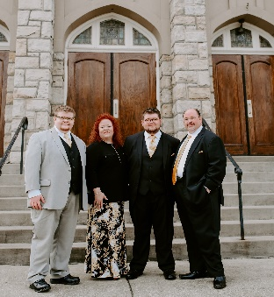

The Ollis family
News & Events
Bus Dedication Service
Benson Grove Baptist
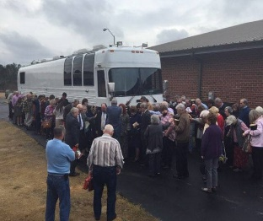

The Ollis Family
Community Outreach

Remembering Miss Jean
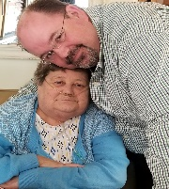
03/03/1941 – 06/02/2019

  - Mountain Ridge Ministries
“Being confident of this very thing, that he which hath begun a good work in you will perform it until the day of Jesus christ.”
Philippians 1:6

Dear Friend,

We are reminded of Paul as we write, “I thank my God upon every remembrance of you.” Believe us when we say that it would be impossible for us to do what we do without you. In saying that, we wanted to let you know what has been happening in our ministry.
First, we have to give God all the praise for the souls we have seen saved. The Lord has allowed us to present the gospel all over the US. We ALWAYS end our Concerts, Conferences and Services in the clear plan of Salvation. To be perfectly honest, sometimes we wonder what kind of effect (if any) we have in a service. However, when God moves and we see those first steps out into the isle, that hand raised, or when they come to you after the service – oh my, is it ever worth it! This is the number one mission of Mountain Ridge Ministries, to win the lost to Christ.
As you know, we were the caregivers for Eric’s mom, Jean, for a little over 4 years. She traveled every mile with us during that time.
While on a 15 day run through Kansas, Jean started seeing views from that old bus window that we can’t help but think was heaven. We brought her home from the hospital on May 27th with Hospice. She passed away on June 2nd. BUT GOD! God allowed us to clear our calendar and be home with her. God did not allow her to suffer. God filled our home and us with His peace. God taught us to love on a different level, to care for the needs of others through exhaustion. To honor our parents. To see through different views. We thought we knew this as “Special Needs” parents, but this was NEW. You all helped us pray for a larger vehicle to house her medical equipment and make her travel easier. God is always faithful and right on time! The bus came in the right season to make her last few months of travel easy. Thank you for those prayers. We are believing God will provide the funds necessary to pay the bus off quickly. Our desire is that our ministry not be in debt. God has provided thus far and He will surely not fail us now. After all, it belongs to Him. He provided it and we dedicated it back to Him and His service on Dec 29, 2019 at Benson Grove Baptist Church with Bro. Billy Cashwell. It was her maiden voyage with us. What a BLESSING she has been!

We joke about having a “Gas Station” ministry. Last August we broke down while climbing Fancy Gap Mtn. After being in the truck stop parking lot for over 24hrs and praying God would let some good come in this…he showed up. The story is quite long. He was bitter, saw our DOT number and ministry on the bus, and looking to pick a fuss. Eric led him to the Lord. He left with our CD playing and tears flowing. 45 mins later the trucker came back. He was still crying and gave us $450 to put on that repair bill! ONLY GOD!
In January, an older man was pumping full on the opposite side of us. He was inquiring about how much fuel we held, what we did, etc. We gave him a new CD and he drove off. The next morning Eric got a text on his phone. The lady explained how we didn’t know her but we had given her husband a CD the previous morning. She went on to text how miserable their life had been the past few years, things they had been through. After talking with us and praying her husband was a NEW MAN. They had been playing our CD since. ONLY GOD!

NEW Ministry Community Outreach Project! This year begins with a new outreach for our family. During the Christmas holidays we began to talk as a family about how we could give back to the communities that are so gracious to us. One thing we have noticed during the care of Jean is that the elderly are often just at or below the poverty level. Due to cost of living increase, fixed incomes, loneliness, or mental decline you will find that the kitchen cupboards of the elderly are often close to being bare. One thing we noticed is that as they fall in the Donut Hole of Medicare they tend to do without other necessities to cover the added cost of their much needed medication. We are now giving ‘The Ollis Family “SEASONED” Care Packages’– to feed the elderly. We are focusing now in this early stage at holiday deliveries. Our first boxes filled with love will be delivered to 3 elderly households on Valentines Day! They will be filled with food, necessities, love and the Gospel Message. If you would like to sponsor a box, let us know. It is as easy as a Walmart gift card. My boys are EXCITED!

Again, we just want to say Thank You for your generous support of our family and our ministry. We covet your prayers as we travel. There are so many lost and dying in America today, your support enables us to carry the Gospel of Christ throughout America. Each time we take the stage, step onto the platform, teach a conference, counsel the hurting, or kneel in prayer it is no longer about us, but about a Holy God, the Great “I AM.” It is with sincere humbleness that we serve Him.

All things through Christ,

Eric & Laura Ollis, Payton & Mikey
Mountain Ridge Ministries

Mountain Ridge Ministries www.theollisfamily.com
5337 Pea Ridge Road www.mountainridgeministries.com
Morganton, NC 28655
Eric: 910-988-5542 Laura: 910-916-3998
Eric@mountainridgeministries.com Laura@mountainridgeministries.com

