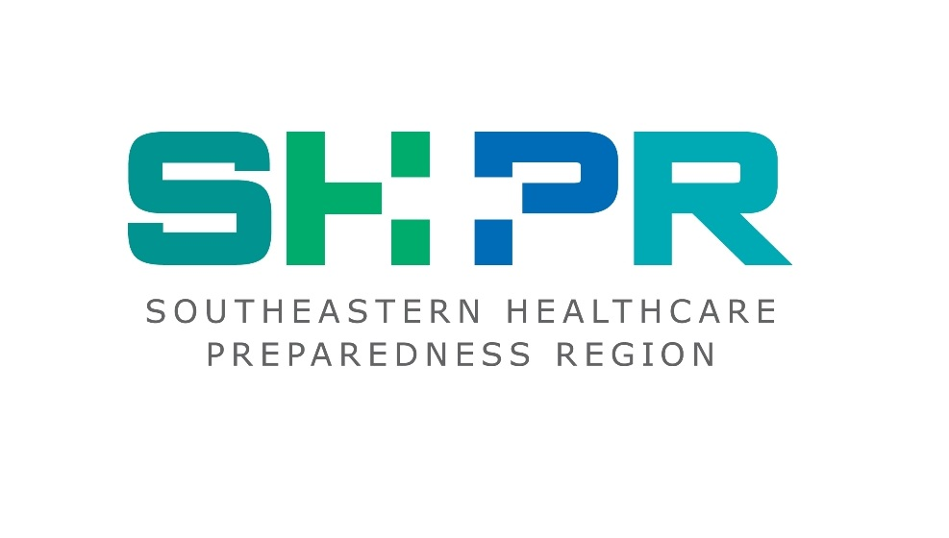

**2021**

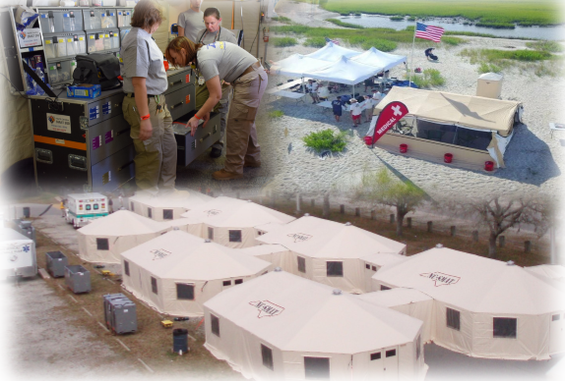

**Hazard Vulnerability & Risk Assessment**

**INTRODUCTION**

The Office of the Assistant Secretary for Preparedness & Response (ASPR) defines a hazard vulnerability assessment (HVA) as a systematic approach to identifying hazards or risks that are most likely to have an impact on the demand for healthcare services or the healthcare delivery system’s ability to provide these services.

The Southeastern Healthcare Preparedness Region (SHPR), a healthcare emergency preparedness coalition, coordinates regional preparedness, response and recovery activities with its healthcare, public health, emergency management and EMS partners. Each hospital facility regularly conducts a Hazard Vulnerability Assessment (HVA) focused on the potential impacts to that facility’s operations. Similarly, ancillary healthcare providers, public health agencies, and local emergency management agencies also assess hazards and vulnerabilities that may impact the ability of their agency to continue normal operations. This project helps us to understand the events and circumstances that may reduce the capability and capacity of healthcare provision throughout the SHPR region.

**SCOPE**

The Southeastern Healthcare Preparedness Region consists of seven Counties including Brunswick, New Hanover, Pender, Onslow, Duplin, Bladen and Columbus Counties. This HVA is based on a review of hazards across the region that have historically occurred or have the potential to occur. The assessment incorporates a review of existing county-based planning documents and existing healthcare facility HVA’s.

While the HVA process is commonly applied in healthcare to an individual organization such as a hospital, this regional HVA focuses instead upon the broad healthcare coalition. These assessments form the groundwork for prioritizing healthcare emergency management programs and identified resource needs. This HVA process is therefore unique because it seeks to establish risk from potential hazards and the associated vulnerabilities to a collective group of healthcare organizations.

**PLANNING ASSUMPTIONS**

* While there is likely significant overlap between the HVA for the SHPR and the HVA for an individual healthcare organization or jurisdiction, these are separate and distinct processes.
* A specific vulnerability may not exist across all Coalition member organizations; however, Coalition members will generally face many of the same hazards.
* The regional HVA is not a replacement for an organization or facility-specific HVA, nor for a comprehensive cross-disciplinary emergency support function regional threat/risk assessment and vulnerability analysis.
* This HVA process incorporates state and local emergency management organization assessments and other public health hazard assessments, though the primary focus of this assessment is impact to healthcare.
* This assessment does not provide details regarding the unique attributes and risks for individual counties. Threats and vulnerabilities in this assessment may appear to be more uniform throughout the region than they are at the local level.

**HVA PARTICIPANTS**

The participants in the Southeastern Healthcare Preparedness Region HVA included experts from the healthcare, public health, emergency management, and other sectors with a role in emergency preparedness, response, and recovery. Specifically, participants included representatives or provided input from:

|  |  |  |  |  |
| --- | --- | --- | --- | --- |
| **County** | **Hospital** | **EMS** | **Emergency Management** | **Public Health** |
| **Bladen** | Cape Fear Valley, Bladen Hospital | Bladen EMS | Bladen County EM | Bladen County Public Health |
| **Brunswick** | J.A. Dosher Hospital | Brunswick EMS | Brunswick County EM | Brunswick County Public Health |
|  | Brunswick – Novant Medical Center |  |  |  |
| **Columbus** | Columbus Regional Medical Center | Columbus EMS | Columbus County EM | Columbus County Public Health |
| **Duplin** |  | Duplin EMS | Duplin County EM | Duplin County Public Health |
| **New Hanover** | Novant Health - New Hanover Regional Medical Center | NHRMC EMS | New Hanover County EM | New Hanover County Public Health |
| **Onslow** |  | Onslow EMS | Onslow County EM | Onslow County Public Health |
|  | Naval Medical Center, Camp Lejeune | Camp Lejeune Fire and EMS | Camp Lejeune EM | Camp Lejeune Public Health |
| **Pender** | Pender Memorial Hospital | Pender EMS and Fire | Pender County EM | Pender Public Health |

The collective mission of these organizations is to provide point of service medical care to the population of the Southeastern Healthcare Preparedness Region. Participating organizations recognize the importance of maintaining their healthcare services during and after hazard impact and maximizing their ability to provide medical surge for those with healthcare needs from emergencies and disasters. This critical mission is just as vital to the community as the efforts of more traditional emergency response disciplines such as public safety.

**PROJECT OVERVIEW**

**Goals**

* Identify regional healthcare hazards based upon review of existing healthcare facility and regional HVAs.
* Seek participation from regional healthcare, public health and emergency management experts to validate identified hazards, compare those with population statistics and assess the regional healthcare impacts.
* Develop a Regional Healthcare Hazard and Risk Vulnerability Assessment.
* Share finding with local, regional and state partners.

**Process**

The SHPR Regional Hazard and Risk Vulnerability Assessment is used to identify the effects specific hazards have on the regional jurisdictions and populations. In order to help assure preparedness and response activities align with identified healthcare and regional vulnerabilities, the Coalition collaborated with healthcare agencies, public health, and emergency management partners to assess hazards in the Counties that make up the Southeastern Healthcare Preparedness Region. Through this process, hazards were identified and prioritized based on expert input from healthcare emergency preparedness leaders, utilizing existing facility Hazard Vulnerability Assessments (HVA), and jurisdictional population and infrastructure data.

The project facilitation began by gathering and analyzing information to better understand the vulnerabilities to the regional healthcare partners. The initial step included SHPR gathering agency-specific and facility-specific information, including HVAs from healthcare providers as well as Hazard Mitigation Plans (HMP) from the Counties in the region. As information was gathered from facility HVA’s, it was reviewed and summarized. From this information, and looking at the conditions that create vulnerability, mitigation strategies were developed.

The SHPR Regional Hazard and Risk Vulnerability Assessment is reviewed annually by the HCC executive committee and adjusted as needed based off of changes in priority ranking of risks and mitigation efforts that have been implemented.

**HAZARDS CONSIDERED**

In reviewing the facility and agency HVA’s, as well as the County HMP’s, SHPR identified an extensive list of events that may impact a healthcare facility. Within that list, facilities identified the events that present a higher relative risk to their facility and functioning capacity. The events that were most commonly identified as presenting a high relative risk to a facility were compiled. The compilation could also be described as “top facility hazards.” The HVA’s and HMP’s validated the list of commonly high-ranked facility risks as well as a list of the top risks among facilities.

In looking at potential hazards regionally, the following were most frequently identified as high-risk:

|  |  |
| --- | --- |
| * Hurricane * External Flood * Severe HazMat * Bioterrorism * Civil Disturbance * Ice Storm/Winter Weather * Labor Shortage * Physical Security Breach * Transportation Failure * Infectious Disease/Pandemic * Cyber Attack | * Radiological Exposure * Active Shooter * Mass Casualty * Chemical Exposure * Communications Failure * Infant/Child Abduction * Severe Thunderstorm/Tornado * Workplace Violence * Electrical Failure * Internal Fire * Internal Flood |

|  |  |  |  |  |  |  |  |  |  |  |
| --- | --- | --- | --- | --- | --- | --- | --- | --- | --- | --- |
| **Most common hazards in Southeastern North Carolina:**   |  |  | | --- | --- | | * Pandemic / Infectious Disease | * Flooding | | * Tornadoes / Severe Thunderstorms | * Hostage Situation | | * Hurricane | * Active Shooter | | * MCI - Trauma | * Electrical Failure/Communications | | * Bomb Threat | * Information Systems | |

**RISK ASSESSMENT**

**Human Impact Risk Assessment**

**Total Population**

Counties with higher populations face greater impacts from man-made, natural and pandemic threats. The county and region must supply the health and safety services to a greater number of people, which inherently stretches resources. Counties with higher populations are also generally at a greater risk of terrorism, man-made and health disasters. Therefore, aside from a need for more resources, counties with a higher population should place a greater emphasis on the following:

**Emergency Management**

Emergency Management leaders in higher populated counties should be aware of emergency shelters and facility agreements, including associated resources such as beds, generators and food. Higher population counties should also ensure they have enough CRPD and POD locations. Counties with lower population risks may share costs by combining shelters if adequate facilities are not available.

**Emergency Medical Services**

EMS leaders in highly populated counties will experience a higher call volume during major incidents and EMS personnel will face a greater risk of exposure during man-made disasters and pandemics. High risk counties should focus on staff management and notification policy during a large-scale incident, as well as mutual aid agreements to mitigate risk to local personnel. Personnel associated with emergency calls and 911 should ensure there are planned locations to manage call volume with sufficient land lines. This should be analyzed and adjusted regularly with population fluctuations.

**Public Health**

Counties with a higher population face greater impacts from public health threats such as pandemics. In addition to the increased impact of public health threats, it is also difficult for Public Health to maintain and manage qualified volunteer personnel, and to mobilize them to prepare for and respond to an incident. Ensure that vital services not offered by Public Health have been contracted out to either a private entity or another capable agency so as not to disrupt the response. COOP, Evacuation, EOP and POD plans should be adjusted for population, need, growth and movement.

**Hospitals**

Hospitals face greater surge volume in all emergencies, which can expose the staff to greater risk of contamination or contagion. It also requires larger caches and priorities for high-demand pharmaceuticals. Staff management in large population centers is especially difficult as region-wide disasters will tie up personnel in surrounding jurisdictions. Mutual aid and staff agreements with other hospitals outside of the general health services region can be beneficial in these situations. Evacuation, medical surge, and alternate care facility plans should be adjusted for population fluctuations.

**Population Density**

Population density is generally used as an indicator of urbanization, a variable showing heightened probability. Urban areas are at a significantly greater risk of terrorism and pandemic threats. Population density, which shows human impact cost, also coincides with critical infrastructure calculations showing economic costs. Urbanized areas should show a particular focus on the following:

**Emergency Management**

In urbanized areas, a large-scale disaster stands a greater chance of affecting local offices, since all operational centers for the locality may be grouped in the same place. EM should emphasize the necessity of back up locations both inside and outside the immediate urban zone and should ensure that other offices involved in response also have back up locations available. EM should also ensure it has sufficient transportation and administration resources to set up a new location.

**Emergency Medical Services**

In urban areas, EMS faces greater challenges from infrastructural damage to stations and equipment and, interruptions in roadways and supply chains because stations, suppliers, vendors and personnel are grouped closer together. EMS stations should be prepared to safely store and release back up equipment and resources in preparation for an emergency. Less densely populated counties can face challenges such as greater travel distances to provide services, which can tax ambulances if trauma patients need to be taxied to a distant facility. Having mutual aid agreements in place can ease those burdens.

**Public Health**

Public health providers in urban areas must be equipped to confront faster spread and greater affects from pandemic and man-made contamination threats, as a single point source can affect a greater number of people. Areas with lower population density, however, may have a greater number of contamination sites, like bodies of water or ground wells.

**Hospitals**

Hospitals in urban areas face greater staff exposure and management challenges in medical surge situations. In rural areas with few facilities, however, the same challenges will need to be addressed without the added diversity of possible alternate medical care facilities. The cost and probability of an evacuation scenario is heightened in denser areas, as well. It is also important for hospitals to identify alternate care facilities that are equipped to handle those affected by the incident. Hospitals should also identify secondary vendors, transportation routes, and support services.

**Per Capita Income**

Per capita income was used as a rough estimate for private assets in each County. For this variable, as well as healthcare assets in the Critical Infrastructure category, a higher value equals lower risk. For instance, for the purposes of overall scoring, New Hanover County which has the highest per capita income value would be given a rating of one to preserve the assumption that lower overall risk scores equal lower risk.

**Emergency Management**

Budgetary challenges are obvious risk factors in terms of available personnel and resources. Per capita income rates also give a general idea of available facilities in the region. Areas with higher per capita income likely have more facilities that may serve as shelters, staging areas, or alternate care sites. Consider mutual aid agreements between rural and urban counties both inside and outside of the region.

**Emergency Medical Services**

EMS also faces budgetary constraints much like EM. However, EMS assets, such as ambulances, first responder vehicles, employee training and communication technology, are often very expensive, and grant availability has been substantially affected in the past few years. Counties with lower per capita income tend to be more rural and less dense, meaning a greater coverage area. These types of counties should routinely verify personnel and resource mutual aid agreements.

**Public Health**

Public health agencies with lower per capita rates may need to agree or contract with other public and private entities to provide certain services. It would be wise to use contractors or agencies outside of the region in case the county is impacted by a large-scale disaster. For smaller scale events, regional SHPR resources would be particularly helpful. Cashes of medical equipment, such as masks, and other public health response assets as well as shelter sites are also of concern.

**Hospitals**

Counties with lower per capita income rates are far more likely to have fewer hospitals per population and coverage area (given in the health services impact section). Both public and private hospitals are affected by this measure. As with other agencies, hospitals in those regions have fewer available alternate care facility sites that they may have to share with other agencies. Diverting patents and evacuation may greatly disrupt care if ambulance services are already taxed and local facilities (such as schools and public transit) cannot contribute enough transportation to move patients. In the hurricane context (such as Hurricane Katrina) transportation for patients, including establishing and exercising mutual aid agreements was a huge issue for lower income areas.

**Poverty**

Poverty rates provide a different measure than per capita income by showing what percentage of the population is considered poor, and thus more susceptible to being negatively affected by a disaster. Disasters of any kind disproportionately affect the poor for various reasons. Economic disruptions have a greater effect on low-income individuals because they likely miss out on hourly wages. The poor are also likely to live in sub-standard housing that has a greater chance of being damaged in a disaster.

**Emergency Management and Public Health**

The needed number of shelter sites as well as points of distribution and resources may be determined by several variables including population, population density, and coverage area. However, poverty rates are perhaps the most critical variable to consider. In widespread disasters like hurricanes and storms, or more localized disasters like tornados and hazmat incidents, those living in sub-par housing are more likely to lose substantial assets, creating a greater demand for prolonged sheltering and provisions of resources beyond food ( such as clothing, medicine, etc). Ensure that sheltering and distribution points for relief resources are considered in light of poverty rates.

**Hospitals and Emergency Medical Services**

During large-scale events, those living below the poverty level are less likely to be able to evacuate. Therefore, injuries and illness occur disproportionately in this segment of the population. Besides affecting billing for services, this may also affect the ability to manage patients whose homes are destroyed, or who do not have the assets to purchase basic health care resources such as pharmaceuticals and equipment or may have no means of transportation. Ensure that plans are in place to address this issue, including volunteer forces, contacts with other EM and PH shelters, and appropriate agencies to contact to give aid.

**Elderly and Disabled Population**

**Emergency Management and Public Health**

All nursing homes and specialized care facilities are required to keep an evacuation plan. Emergency Management and Public Health local leaders should ensure that these plans are regularly updated and kept on file. A substantial portion of the elderly and disabled population may be unable to drive due to eye-sight or qualification concerns. If there is not a program in place to offer help and services to this portion of the population, consider integrating specialized provisions into existing plans. Public notification to the elderly populations is also an issue, as they historically have less exposure to the internet, social media, cell phone alerts, and other information outlets. Ensure that information affecting these populations is released via more traditional mediums. Also, see that a wide range of outlets are used to account for the blind, deaf and hard of hearing portions of the population.

**Hospitals and Emergency Medical Services**

Many elderly constituents may  require  specialized  transportation or care. This will turn assets away from response and hospital evacuation. Make sure to account for this in emergency operation and evacuation plans. The elderly and disabled who are admitted to hospitals are also more likely to have attending family members with them who would need to be notified of critical changes to care. Ensure that there is a policy for informing and sustaining these individuals.

**Human Impact Risk Score**

|  |  |  |  |  |  |  |  |
| --- | --- | --- | --- | --- | --- | --- | --- |
|  | |  |  |  |  |  |  |
| **County** | **Population** | **Density** | **Per Capita** | **Poverty** | **Elderly** | **Disability** | **Risk Score** |
| **Bladen** | 1 | 1 | 6 | 7 | 6 | 7 | **4.7** |
| **Brunswick** | 5 | 5 | 2 | 2 | 7 | 3 | **4.0** |
| **Columbus** | 2 | 2 | 7 | 6 | 5 | 6 | **4.7** |
| **Duplin** | 3 | 4 | 5 | 5 | 4 | 2 | **3.8** |
| **New Hanover** | 7 | 7 | 1 | 4 | 2 | 1 | **3.7** |
| **Onslow** | 6 | 6 | 4 | 1 | 1 | 5 | **3.8** |
| **Pender** | 4 | 3 | 3 | 3 | 3 | 4 | **3.3** |

The higher the overall risk score, the greater the risk for that county in that category.

**Health Services Risk Assessment**

**Coverage Area**

Coverage area is an important factor to consider when assessing the delivery of services in an emergency. The implications of coverage area for decision-making are similar across EM, PH, EMS, and hospital sectors. Greater coverage area means a more substantial and variable scope of resources and services are required for the county and region. It also means a larger fleet and larger fuel resources for each agency to effectively deliver services. It may also necessitate more points of distribution and shelter sites.

**Licensed Hospitals per Population and Coverage Area**

Fewer  hospitals  within  a  given  jurisdiction  heightens  risk,  but a more meaningful measure is the segment of the population each hospital may be expected to cover. This variable shows the probability of a medical surge situation. The numbers given above DO NOT represent the total number of expected surge in such a scenario, but the segment that each hospital would consider in calculating the impact of a surge. Note that this measure only considered standard types of care and does not take into account specialized services only offered at certain hospitals. Licensed hospitals per population coincide closely with population density or urbanization but represents specialized interests for the health care sector. This stands to effect local EM personnel but not as strongly as it does other entities.

**Emergency Medical Services**

EMS agencies who serve areas with a very high population rate per hospital may be required to divert patients to secondary hospitals more often, increasing transport time. Increased transport times results in fewer patients served per operational period. In large scale incidents, when patients are diverted to more distant facilities, personnel organization may have to be adjusted to ensure maximized delivery of services by the greatest number of personnel. This includes using more mass transit vehicles or minimal personnel to a unit. Organizing these efforts would require more testing of staff management and communication protocols with hospitals. Ambulance services are also extremely affected by the number of hospitals per coverage area.

**Public Health**

For PH agencies, a greater number of people served per hospital may lessen the basic public health support in the region. If a greater number of health personnel are devoted to delivering private care rather than assisting with public health strategy, this would lessen the options and delay delivery. Ensure that PH agencies take this overlap into account. This variable is a substantial factor in volunteer management for qualified health care professionals during an event. Larger populations per hospital may also spread public health resources thinner in those areas. Adjust cashes and vendor agreements accordingly. The number of hospitals per coverage area would also greatly affect public health agencies, as they would require a reasonable number of shelters and distribution locations disbursed over the area.

**Hospitals**

Hospitals have to take into account the many risk variables in determining how many alternate care facilities to open, how to manage staff, and how to allocate resources. This variable is extremely critical in making the overall determination with a Healthcare Coalition region as to how hospitals must manage their agreements within the region. Hospitals expected to deliver services to greater numbers may find it beneficial to confer with jurisdictions at the other end of the spectrum to determine possible mutually beneficial arrangements. Fewer hospitals per area or greater population per hospitals would also require more Alternate Care Facility locations and substantially increase the risk of surge and morgue overflow. Implement routine and thorough testing of these procedures.

**Square Miles Covered Per Hospital**

**Federally Declared Disasters**

Federal natural disaster declarations were included under the health services impact section even though it is a discrete specific probability variable affecting cost variables in the human impact, health services, and critical infrastructure categories. All variables are, to some degree, interconnected, which affects predictability. The nature of the variable, however, is specific to health services for two reasons. First, federally declared natural disasters are large-scale, region-wide, and overly burdensome in terms of cost and resources which creates a greater risk of prolonged disruptive effect on health care services.

There are two problems with this variable as a measurement that should be considered in decision making. There is some uncertainty in the presumption that past natural disaster activity will be reflected in future natural disaster activity. Unlike man-made incidents and terrorism, for which there are no meaningfully prior illustrative instances in North Carolina’s history, preparing for and responding to a very wide range of natural disasters is a huge consideration and in most cases, the primary threat. Terrorism and man-made incident risk must be inferred from other variables like population, population density, and critical infrastructure assets. Natural disaster risk is much more arbitrary and may only be measured by past instances.

**Emergency Management**

Natural disaster risk is one of the most critical considerations for Emergency Management agencies who are responsible for the large-scale set up, preparation, and management of all agencies involved in response. Jurisdictions that experience a greater number of natural disasters per measured period should engage in more frequent exercises, updates, plan and asset adjustments, and test technology and notification systems more frequently.

**Emergency Medical Services**

EMS agencies in more disaster-prone areas may require more specialized training or infrequent updates for these particular scenarios or procedures associated with them. For instance, in many counties, shelters are opened for the families of public personnel while they respond to disasters. These locations should be known and exercised. Natural disasters also have more frequent operational periods and may activate more stringent personnel management protocols and accountability measures. Accountability is extremely important in these incidents, as well as policies for diverting patients.

**Public Health**

Major pandemic events are also dependent on other variables like population density and poverty rates. Public Health considerations are especially pertinent in recovery when both environmental contamination and other health factors are heightened.

**Hospitals**

Like the other agencies, hospitals in regions with greater frequency of natural disasters must have

policies conforming to the entire possible range of natural threats including snow storms, tropical

thunderstorm events, flooding, tornadoes, and any other past incidents.  However,  where  an  all

hazards  approach  is  possible  and  cost  efficient  for  most  other  agencies,  the  health  services

consequences  of  different  types  of  incidents  are  highly  variable  and  require  response  and

preparation  by hospitals to be highly variable. In the trauma context, the type of event might have

the greatest effect on patient volume (hurricanes, for instance, would lead to a greater surge than

tornadoes)  and  type  will  affect  care  and  therefore  staffing  required  (for  instance,  extreme   cold events  versus  destructive  wind  events).­­­­­­­­­­­

**Registered Shelter Sites per Population and Coverage Area**

Registered shelter sites per population and coverage area has separate implications from the bare measure of population and coverage area discussed earlier. Population and coverage area determines the delivery of all services for all four functions. Shelter sites per population and coverage area represents the risk of delivery of a single highly important service, if not the most important during a disaster scenario. Planning for, setting up, and managing shelters is a critical aspect of all four emergency health functions.

**Hospitals and** **Emergency Medical Services**

Shelter sites are separate from alternate care facilities for hospitals, so the number of shelter sites has greater implications for Emergency Management and Public Health. However, the number of shelter sites per population and area will affect the delivery of health services and resources, by EMS and hospitals to those separate sites, so the more people per site heightens risk for these two functions because they may have to divert more personnel and resources to those sites.

**Emergency Management and Public Health**

Opening and managing shelters is a critical function of local EM and PH agencies. Shelter sites per population and coverage area is a vitally important measurement of risk to these two disaster response functions. Note that the shelter site per population graph shows the portion of the county population that may come to depend on that shelter site, not the actual numbers that will take advantage of the service. The number given in the graph is the portion of the population that each individual shelter site would consider when calculating needed space and resources. To estimate what percentage of this number would actually take advantage of shelter services, EM and PH would consider other human impact risk factors such as percentages of elderly, impoverished, and disabled populations. This is an uncertain calculation requiring a consideration of several risk measures.

Counties whose registered shelters are expected to provide for a greater population will necessarily need more resources, including food, beds, generators, and all associated supplies. Counties with higher population per shelter measurements may either have a much larger population than the average, or much fewer available shelter sites. The end need for more resources overall is the same. Greater coverage area per shelter site has different implications. Care facilities evacuating residents to a shelter site may need more transportation resources to carry out the move. Transporting resources may take longer and require more fuel.

**EMS Stations per population and Coverage Area**

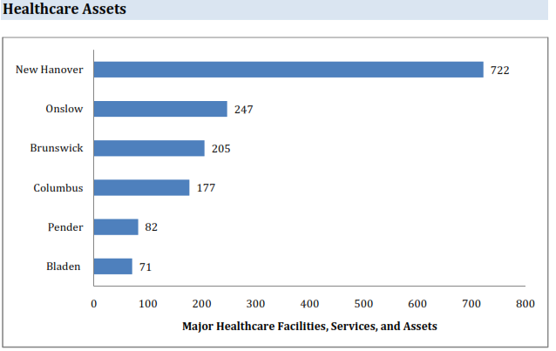

The available health care assets within each county include all health care provision facilities, including hospitals, short‐term care, long term care, dialysis and any center of a federally defined size equipped to deliver health care services. A greater number of health care assets concentrated in the region lowers risk across all four disciplines. EM and PH have greater access to these resources, though communication and coordination efforts may need to be more stringently exercised. Hospitals and EMS have more available staff and resources. In the alternative, if a part of the HCC with more substantial overall health care assets is seriously affected by an incident, it may greatly affect the HCC’s ability to apportion resources or act as intermediary in allocating assets across the entire area. HCCs should ensure that plans exist to subsist without the assistance of the most resource‐rich jurisdictions if necessary. Take care not to place an overwhelming emphasis or dependence on their availability.

**Hospitals and Emergency Medical Services**

EMS stations with both a greater risk of large natural disaster disruption and higher population per station are much more likely to face the scenario of maintaining full‐scale delivery of services at high call volume across several operational periods with heightened likelihood of injury and fatigue to personnel. Mutual aid agreements are critical. Note that this variable does not take into account the number of ambulances or staff per station, or the travel distance each unit would have to the hospital. These risks are moderately represented in the “healthcare assets” portion of critical infrastructure and “hospitals per coverage area” considered earlier in this section.

Hospitals operating in counties with a higher risk, in terms of EMS stations per population and coverage area should consider the implications in a surge or evacuation scenario. There may not be sufficient EMS personnel or transport resources to maintain response to the population and to account for evacuation and surge needs. Hospitals in these jurisdictions should regularly consider the sufficiency of their mutual aid agreements and ensure that they do not rely too heavily on taxed EMS personnel.

**Health Services Risk Score**

|  |  |  |  |  |  |  |  |  |  |
| --- | --- | --- | --- | --- | --- | --- | --- | --- | --- |
| **County** | **Area** | **Hos./Pop** | **Hos./Area** | **Nat. Disaster** | **Shel/Pop** | **Shel/Area** | **EMS/Pop** | **EMS/Area** | **Risk Score** |
| **New Hanover** | 1 | 7 | 1 | 6 | 6 | 1 | 6 | 1 | **3.6** |
| **Onslow** | 2 | 6 | 3 | 7 | 7 | 7 | 5 | 2 | **4.9** |
| **Pender** | 5 | 4 | 5 | 6 | 4 | 5 | 1 | 3 | **4.1** |
| **Duplin** | 3 | 3 | 4 | 3 | 1 | 2 | 3 | 4 | **2.9** |
| **Columbus** | 7 | 2 | 7 | 3 | 3 | 4 | 2 | 5 | **4.1** |
| **Brunswick** | 4 | 5 | 2 | 6 | 5 | 3 | 4 | 6 | **4.4** |
| **Bladen** | 6 | 1 | 6 | 3 | 2 | 6 | ? | ? | **4.0** |

**Critical Infrastructure Risk Assessment**

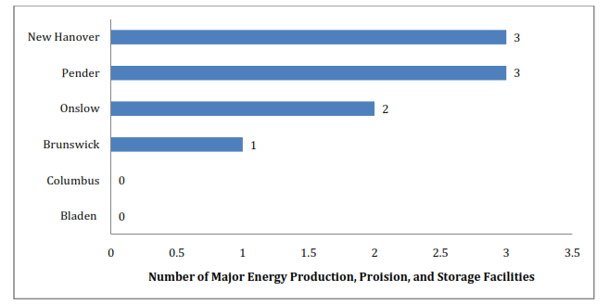**Energy, Utilities, and Transportation Assets**

Energy assets include federally defined major repositories of critical energy sources including mining, oil, natural gas, production, preparation, provision and storage centers. Utilities include critical water and power facilities who serve a statistically significant portion of the population (Figure 4.2 below). Transportation centers represent critical assets both in the economic context and in the preparedness context.

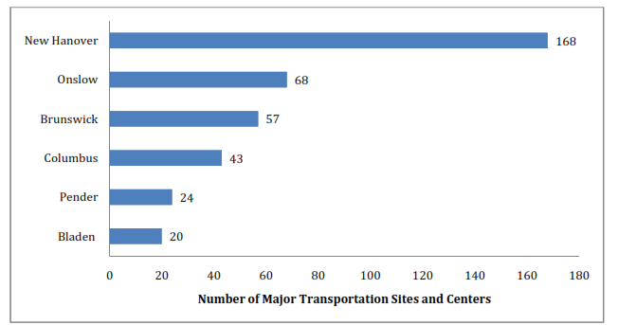These variables affect human impact in that, if compromised, populations would be forced to depend on their own resources or publicly provided resources for provision of services. They affect health care delivery in that EM, PH, EMS, and hospitals are expected to keep providing services once they are compromised but must also have back up plans and technology such as water purification policies, generators, stock pile procedures (in the case of oil and gas) and alternative plans for mass transit if necessary post‐event. Fewer centers within the jurisdiction means less redundancy in the provision of these services, requiring more secondary assets and more frequent attention to back‐ up plans. However, these variables also serve partially as a determinant of terrorism and man‐made hazard risk, as all three types of critical infrastructure correlate with greater likelihood of a contamination incident (nuclear, oil, gas) or a terrorism target.

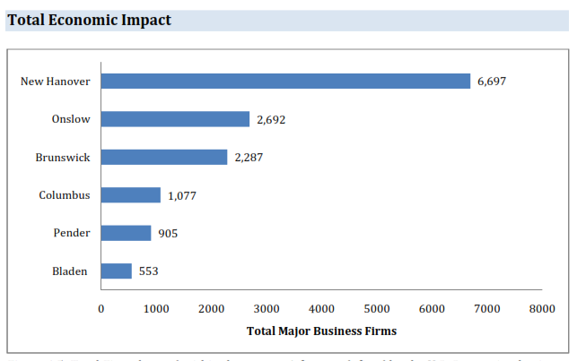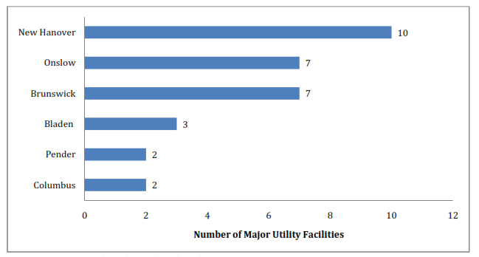

A firm, as defined by the U.S. Census, is a business organization consisting of one or more domestic establishments in the same state and industry that were specified under common ownership or control. The firm and the establishment are the same for single‐establishment firms. For each multi‐establishment firm, establishments in the same industry within a state will be counted as one firm‐ the firm employment and annual payroll are summed from the associated establishments.

This variable was included as a measure of total economic impact. If a highly commercial region is affected, the cost of the incident would be substantially higher for that region. A greater number of employees and services would be disrupted. This would affect EM, PH, EMS, and hospitals equally in terms of a lack of services, inability to deliver or maintain normal operations, and would substantially increase the dependency of affected populations on their services. As stated before, large economic centers are also comparatively at a greater risk from man‐made disasters like hazardous materials spills or industrial incidents and acts of terrorism. It is critical to note that there are very few past incidents of either type in North Carolina. Once again, this is an internal measurement within the HCC and does not represent the county’s risk within the national as a whole. Actual risk value within the context of the country would be very small to almost nonexistent. However, counties with greater overall economic value and more energy and transportation assets may consider more regular update and exercise of their anti‐terrorism plans. These counties should definitely maintain well‐exercised hazardous materials and industrial accident plans. Maintain communications with the private sector 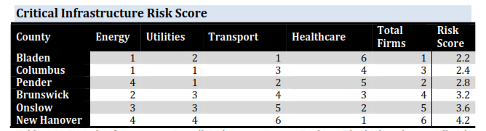on their emergency response and recovery plans.

**OVERVIEW OF RISK SCORES**

|  |  |  |
| --- | --- | --- |
|  | **Risk Scores** | |
|  | **County** | **Human Health Critical**  **Impact Services Infrastructure** |
| **Bladen** | | 4.7 4.0 2.2 |
| **Brunswick** | | 4.0 4.4 3.2 |
| **Columbus** | | 4.7 4.1 2.4 |
| **New Hanover** | | 3.7 3.6 4.2 |
| **Onslow** | | 3.8 4.9 3.6 |
| **Pender** | | 3.3 4.1 2.8 |
| **Duplin** | | 3.8 2.8 |

**Next Steps**

The Southeastern Healthcare Preparedness Region and associated partners will continue to provide feedback and content to the Hazard and Risk Vulnerability Assessment. As the vulnerabilities and mitigation strategies are further defined, the SHPR partners will begin to develop tactics to implement the mitigation strategies.