

**Multi-Regional Healthcare Coalition**

**ESF#8 Information Sharing Plan**

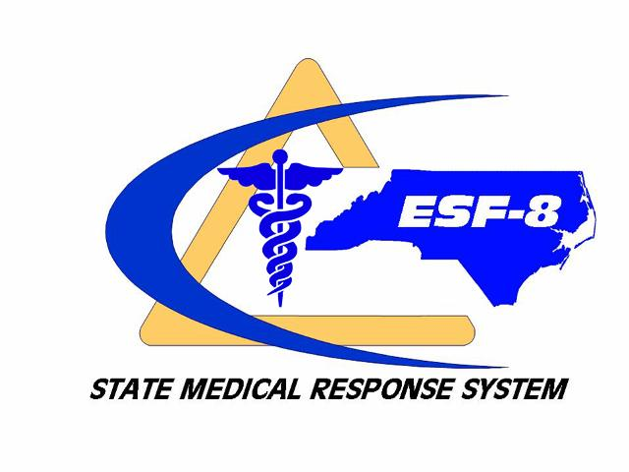

***Updated: February 2020***

TABLE OF CONTENTS

Introduction 2

Assumptions 2

Objective 2

I. Situation Reporting 2

II. Reporting Hierarchy 3

III. Healthcare Coalition Notification of Incident 4

IV. Information Sharing 4

V. Incident-Specific Information 4

VI. Information Validation 5

VII. Dissemination of Information 5

A. Local Information 5

B. Regional Information 5

C. State Information 6

VII. Information Systems 6

IX. Confidentiality 7

Attachments 8

Attachment 1: North Carolina Regional Advisory Committee (RAC)/ Healthcare Coalition Map 9

Attachment 2: Statewide Coalition VIPER Talk Groups 10

Attachment 3: SHPR Regional Contact Information by County & Discipline 11

Attachment 4: Situation Report (Sitrep) 19

# Introduction

The ability to effectively provide and sustain healthcare operations throughout a disaster or significant event is largely dependent on coalition partners establishing a timely and accurate common operating picture. This document outlines the Southeastern Healthcare Preparedness Region Information Sharing Plan. The goal of this plan is to provide information to support effective communication among Coalition partners during times of disaster, as appropriate.

Southeastern Healthcare Preparedness Region members are expected to share information through situation reporting whenever an emergency or other event triggers the activation of this plan (refer to Notification-Triggers). The Healthcare Preparedness Coordinator (HPC) or their designee will initiate situation reporting at the Coalition-level.

The Southeastern Healthcare Preparedness Region (SHPR) has adopted this plan which serves as a unified strategy to establish and maintain a common operating picture. This document will be reviewed annually and updated as needed.

# Assumptions

* Local mutual aid will be established prior to notification to the coalition.
* The effects of a disaster or significant event may cross coalition boundaries.
* The effects of a disaster or significant event may exceed the capabilities of a single coalition.
* The assets, resources, and capabilities of Healthcare Coalitions may vary over time and from one coalition to another.
* Effective operations are dependent on a timely and accurate operating picture.
* This document will be reviewed annually and updated as needed.

# Objective

Provide a framework for the exchange of timely, relevant, and actionable public health and medical related information leading to the development of a common operating picture among relevant response agencies and partners of southeastern North Carolina during a major event or disaster.

# Incident Reporting

In accordance with local emergency operations plans and/or protocols, the initial report of an incident or event shall be made by the agency, facility, or jurisdiction impacted to the Local County Emergency Management. It will be escalated as necessary to the Healthcare Coalition and State Medical Response System (SMRS) if local indicators and trigger points occur requiring outside local resources. Indicators and trigger points during an incident will vary based on the specific agency’s usual resources and demand capacity. Indicators can stem from a slow-onset (pandemic Influenza) or no-notice (Earthquake) incident.

The Healthcare Coalition has developed a standardized Situation Report (SitRep)that will be utilized and requested of coalition members during an event. SHPR will then aggregate the pertinent information on response needs from across the region. This report will be disseminated throughout the SHPR region and as well as other stakeholders as necessary.

# Reporting Hierarchy

***Indicator:****A measurement, event, or other data that is a predictor of change in demand for health care service delivery or availability of resources. This may warrant further monitoring, analysis, information sharing, and/or select implementation of emergency response system actions.*

***Trigger:****A decision point based on changes in the availability of resources that requires adaptations to health care services delivery along the care continuum (contingency, crisis, and return toward conventional.*

***Action to be taken****: Action that will be taken to respond to event.*

**Healthcare Coalition Actions:**

*(Each coalition member will need to develop indicators and triggers specific for their internal usage)*

|  |  |  |
| --- | --- | --- |
| **Indicator** | **Trigger** | **Action to be Taken** |
| National Weather Service (NWS) issues a watch/ warning | NWS predicts severe weather event within 96 hours. | Require SHPR staff member to be on-call to assist coalition partners if necessary. |
| Incident occurs at local facility/ agency | SHPR receives notification or request for assistance of/for an incident that has occurred, but no assistance is needed from outside of the region. | Require SHPR staff partners to be available. Establish situational awareness with individual facility or agency regarding incident. Make contact with the NC OEMS duty officer. |
| Incident occurs locally or regionally | Assistance is needed across the region or from outside the region. | Establish situational awareness and coordination with regional partners and NC OEMS Duty Officer. |
| Pre-planned event | Pre-planned events that may require additional medical support to lessen surge of existing facility. | SHPR staff meet with event staff and planning committee, local emergency management, hospital(s) and EMS agencies during the planning phase. NC OEMS will be notified in a timely manner of the event. |
| Potential Public Health Emergency | Public health emergency that may impact the region/state/nation. | Initiate and coordinate a regional information sharing/meeting to address needs of partners. This may or may not be hosted by the SHPR. Information received by the SHPR staff will be shared as available. |

*Reference: (Crisis Standards of Care; The National Academies;* [*http://www.nap.edu/search/?term=Crisis+Standards+of+Care*](http://www.nap.edu/search/?term=Crisis+Standards+of+Care)*)*

# III. Healthcare Coalition Notification of Incident

In the event that an agency needs additional resources are needed outside of the capabilities of the local jurisdiction that may warrant assistance from within the region. SHPR staff should be notified by contacting the New Hanover Regional Medical Center Regional Communications Center at **(1-800-282-5465),** or via VIPER talk group **VMK 79201**. Upon notification, the regional communications center will page the on-call SHPR staff member.

# IV. Information Sharing

# Relevant event information should be shared with the following stakeholders from SHPR:

* Local and State Emergency Management
* Healthcare organization (e.g., hospitals, clinics, large corporate medical provider organizations and urgent care centers)
* Local and State Emergency Medical Services
* Local and State Public Health
* Local and State Law Enforcement
* Fusion centers
* Tribal Organizations
* Organizations managing functionally or medically frail populations
* Fire Services
* Federal Agencies
* American Red Cross
* Non-Government Agencies

# V. Incident-Specific Information

Essential Elements of Information to be provided in a Situation Report (SitRep) may include but is not limited to:

* Agency or jurisdiction emergency activation level
* Health and safety concerns
* Facility or agency operating status
* Points of contact and operational communications system(s) to include telephone number, email, and alternate contact
* Facility structural integrity
* The status of evacuations/shelter in-place operations
* Critical medical services (e.g., trauma, critical care)
* Critical service status (e.g., electric, water, sanitation, heating, ventilation, and air conditioning)
* Critical healthcare delivery status (e.g., surge status, bed status, deaths, medical and pharmaceutical supplies, and medical equipment)
* Staffing status
* Emergency Medical Services (EMS) status involving patient transport, tracking, and availability
* Other applicable information

# VI. Information Validation

A common operating picture is initially established at the lowest operational level of incident management in accordance with the Regional Response Plan. Coalition partners should utilize the following process for gathering, validating, and providing disaster-related information at their respective level of hierarchy:

1. Information relative to the event is identified and gathered.
2. Information is validated by the source agency.
3. Information is transmitted or otherwise delivered from the source agency to the appropriate local, regional, or state partners.
4. Confirmation of delivery should be provided at each level when possible.

# VII. Dissemination of Information

The dissemination of information to the public through press release or other media shall be at the discretion of each agency or jurisdiction of the coalition. Healthcare Coalition partners are urged to establish and maintain policies, procedures, and qualified personnel to provide inform to the public. Whenever possible, a Joint Information Center should be utilized.

While the coalition possesses no authority to restrict the release of information to the public by an agency or organization, it is the intent of the coalition to promote and support the sharing of accurate, relevant, and timely incident-specific information resulting from a unified coalition perspective.

It is not the intent of the SHPR to release information to the media.

The HPC shall be responsible for final validation of information and completion of the SitRep, establishing the distribution list and distribution of document(s), and maintaining documents for record. All information will be validated before distribution. An email distribution list has been developed, and records regarding distribution will be maintained with SHPR.

Healthcare partner representatives to the Coalition shall be responsible for the dissemination of information to relevant personnel within their facility or agency.

## Local Information

Local information should be shared with a predetermined list of stakeholders. Information will be shared with the following agencies:

* Healthcare Coalition members
* Local Emergency Management
* Additional local and state partners such as public health, healthcare organizations, law enforcement, etc.

## Regional Information

The Southeastern Healthcare Preparedness Region will share critical information with regional partners and the North Carolina Office of Emergency Medical Services (NCOEMS).

## State Information

The North Carolina Office of Emergency Medical Services (NCOEMS), will share information regarding the status of ESF-8 assets, resources, or other health and medical support infrastructure with:

* State ESF-8 and ESF-6 partner organizations,
* Other state and Federal agencies

Information will be shared:

* As necessary and appropriate to the given situation as determined by the ESF-8A Lead or their designee.
* In coordination with the State Emergency Response Team (SERT), and
* Utilizing appropriate communication systems and in accordance with established NCOEMS emergency response and recovery plans.

# VII. Information Delivery Systems

Information may be delivered by any number of available pre-established systems or services and may include:

* Web and Phone Conferencing
* Voice Interoperability Plan for Emergency Responders (VIPER)
* NC Healthcare WebEOC / County WebEOC
* Organization-supported email systems
* Continuum, bed reporting system
* Training, Exercise, Response Management System (TERMS)
* NC Health Alert Network (HAN)
* [www.SoutheasternHPR.org](http://www.SoutheasternHPR.org)
* NC Patient Tracking System, DMS
* Everbridge
* Amateur radio
* Other appropriate systems or services

In incident-specific communications plan for the transmission of two-way, real-time messaging should be established at the onset of an incident and continually updated with any changes using an ICS form 205 in accordance with the Regional Response Plan. The regional partners will share the appropriate parts of their communications plan with the Healthcare Coalition staff.

The time and method of a regional coordination call will be provided at the onset of an event that warrants the call. This notification may occur via phone, email or text.

1. **Web and Phone Conferencing**

The Healthcare Coalition maintains a web and phone conferencing platform that will be accessed as needed during an incident. Regional Healthcare Coalition web and phone conferencing will occur at the time established following local and state level conference calls. Regional web and phone conferencing should occur during each operational period at a time established during the event. This call will be used to gather situational awareness and determine reporting needs.

The static information for the web and phone conference are listed here:

**WEB:** <http://tinyurl.com/SHPR-EVENT>

**PHONE:** (510) 338-9438 **ACCESS CODE** 622 371 661

1. **Voice Interoperability Plan for Emergency Responders (VIPER)**
2. The VIPER network should be utilized by responders in regional responses to incidents, with talkgroups being assigned by **NC VIPER Network Operations Center (919-662-4440**).
3. **VMK 79201** is the pre-assigned talkgroup for the NHRMC Communications Center and will be monitored 24/7 by the NHRMC Regional Communications Center. Healthcare Coalition staff will be notified by Regional Communications of any need to assist with an event in the region.
4. **VIPER Medical Network (VMN)**
5. **VMG57552 & VMG57553** VIPER talk groups assigned to SHPR by NC OEMS. These talkgoups are available for operational interoperability when multiple jurisdictions are responding across county lines.
6. All Community Health Centers (CHC) that have VMN VIPER radios are assigned a statewide common channel **VMA50043**

|  |  |  |  |
| --- | --- | --- | --- |
| **Decimal** | **Hex** | **VM Code** | **Assigned Facility** |
| 52,372 | CC94 | VMA50043 | Community Health Center (CHC) Statewide Contact |
| 52,379 | CC9B | VMG57552 | **SHPR Disaster** |
| 52,380 | CC9C | VMG57553 | **SHPR OPS** |

1. **Redundant Radio Communications Systems**
2. CARES Amateur Radios for Hospitals, CARES is a backup emergency communications service operated jointly by volunteer licensed amateur radio operators and CCHA member hospitals to address public health communication needs in times of crisis
3. **WebEOC**

North Carolina Office of Emergency Medical Services (NCOEMS) maintains the Healthcare WebEOC information sharing platform for communications during both planned and unplanned events. Hospitals and EMS agencies should update their specific dashboards at least once per operational period as well as when needed.

# IX. Confidentiality

Incident-specific information is distributed for the purpose of accomplishing the mission, goals, and objectives of agencies and organizations of the coalition and is not intended for any other purpose.

While this information is unclassified, it will be considered FOR OFFICIAL USE ONLY (FOUO).

# 

# Attachments

## Attachment 1: North Carolina Regional Advisory Committee (RAC)/ Healthcare Coalition Map

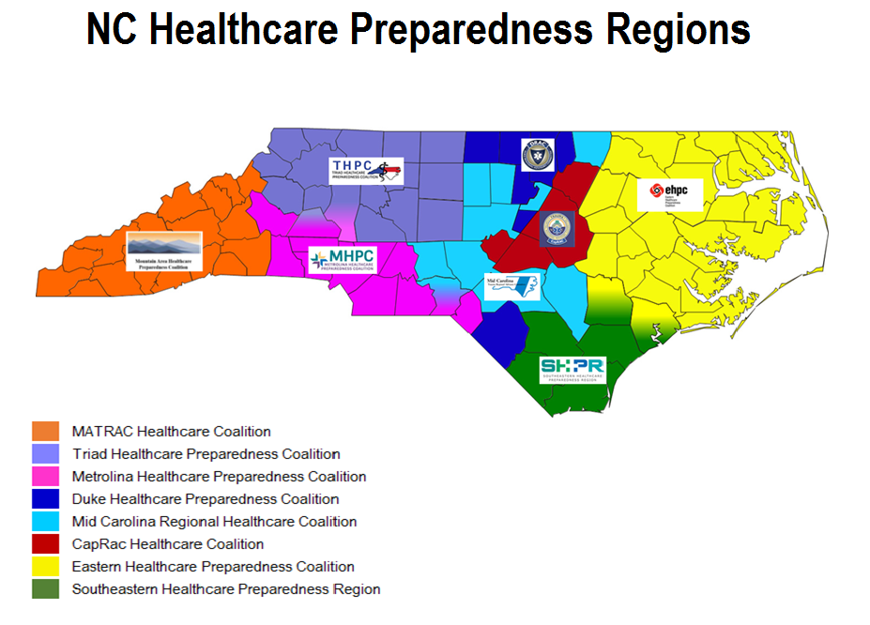

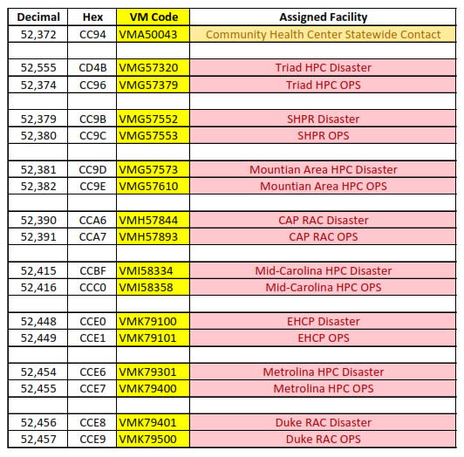**Attachment 2:**

## Statewide Coalition Talk Groups

## 

## 

## 

## Attachment 3:

## SHPR Regional Contact Information

## by County & Discipline

Updated 11-20-19 - HG

**Emergency Management Contacts**

|  |  |  |
| --- | --- | --- |
| **BLADEN** | **Primary** | **Secondary** |
| 5853 US 701N  Elizabethtown, NC 28337  County EOC Main: 910-862-7834  IC Phone Direct: 910-862-7830  Satellite Phone: 877-820-4135 | **Nathan Dowless**  Emergency Services Director  [ndowless@bladenco.org](mailto:ndowless@bladenco.org)  Office: 910-862-6761  Mobile: 910-874-1137 | **Jeff Singletary**  Captain, Sheriff's Department  [jsingletary@bladenco.org](mailto:jsingletary@bladenco.org)  Office: 910-862-6941  Mobile: 910-876-0588 |
| **BRUNSWICK** | **Primary** | **Secondary** |
| PO Box 249  3325 Old Ocean Highway  Bolivia, NC 28422  County EOC Main: 910-253-5383  IC Phone Direct: 910-253-5383  County EOC Fax: 910-253-4451 | **Edward Conrow**  Emergency Services Director  edward.conrow@brunswickcountync.gov  Office: 910-253-2569  Mobile: 856-457-0864 | **Scott Garner**  EM Coordinator  [scott.garner@brunswickcountync.gov](mailto:scott.garner@brunswickcountync.gov)  Office: 910-253-2577  Mobile: 910-515-4900 |
| **COLUMBUS** | **Primary** | **Secondary** |
| 608 N. Thompson Street  Whiteville, NC 28472  County EOC Main: 910-640-6610 x 223  Operations EOC: 910-840-4077  Satellite Phone: | **Kay Worley**  Emergency Services Director  [kworley@columbusco.org](mailto:kworley@columbusco.org)  Office: 910-640-6610  Mobile: 910-840-4077 | **David Ransom**  Deputy EM Director  [wdransom@columbusco.org](mailto:wdransom@columbusco.org)  Office: 910-640-6610  Mobile: 910-840-2020 |
| **DUPLIN** | **Primary** | **Secondary** |
| 209 Seminary St  Kenansville, NC 29349   County EOC Main: 910-862-7834  IC Phone Direct: 910-862-7830  Satellite Phone: 877-820-4135 | **Matt Barwick**  EM Director  [matthew.barwick@duplincountync.com](mailto:matthew.barwick@duplincountync.com)  Office: 910-296-2160 x 231  Mobile: 910-289-7605 |  |
| **NEW HANOVER** | **Primary** | **Secondary** |
| 230 Government Center Dr. Suite 115  Wilmington, NC 28403  County EOC Main: 910-798-6808  County EOC Fax: 910-452-6161 | **Steven Still**  EM/911 Director  [sstill@nhcgov.com](mailto:sstill@nhcgov.com)  Office: 910-798-6910  Mobile: 910-520-9603 | **Anna McRay**  EM Deputy Director  [amcray@nhcgov.com](mailto:amcray@nhcgov.com)  Office: 910-798-7446  Mobile: 910-391-9965 |
| **ONSLOW** | **Primary** | **Secondary** |
| 1180 Commons Dr. N  Jacksonville, NC 28546  County EOC Main: 910-347-4270  County EOC Fax: 910-455-6767 | **Stacie Miles**  Deputy EM Director  [stacie_miles@onslowcountync.gov](mailto:stacie_miles@onslowcountync.gov)  Office: 910-347-4270  Mobile: 304-237-8588 | **Norman Bryson**  ES Director  [norman_bryson@onslowcountync.gov](mailto:norman_bryson@onslowcountync.gov)  Office: 910-347-4270  Mobile: 910-340-5033 |
| **PENDER** | **Primary** | **Secondary** |
| 805 Ridgewood Avenue  Burgaw, NC 28425      County EOC Main: 910-259-1210 | **Charles Tear**  EM Director  [ctear@pendercountync.gov](mailto:ctear@pendercountync.gov)  Office: 910-259-1210  Mobile: 910-470-4728 | **Tommy Batson**  Assistant EM Director / Fire Marshal  [tbatson@pendercountync.gov](mailto:tbatson@pendercountync.gov)  Office: 910-259-1210  Mobile: 910-470-4721 |

**EMS Contacts**

|  |  |  |
| --- | --- | --- |
| **BLADEN** | **Primary** | **Secondary** |
| P.O. Box 1646  292 Ben Green Industrial Dr.  Elizabethtown, NC 28337 | **David Howell**  EMS Director  [dhowell@bladenco.org](mailto:dhowell@bladenco.org)  Office: 910-862-6738  Mobile: 910-876-0513 | **Heather Ellis**  EMS Division Assistant Chief  [hellis@bladenco.org](mailto:hellis@bladenco.org)  Office: 910-862-6776  Mobile: 910-874-1398 |
| **BRUNSWICK** | **Primary** | **Secondary** |
| PO Box 249  3325 Old Ocean Highway, Building C  Bolivia, NC 28422 | **Lyle Johnston**  Deputy Director EMS  lyle.johnston@brunswickcountync.gov  Office: 910-253-2564  Mobile: 910-352-3005 | **Kat Corrigan**  EMS Operations Manager  [kat.corrigan@brunswickcountync.gov](mailto:kat.corrigan@brunswickcountync.gov)  Office: 910-253-2974  Mobile: 910-352-2340 |
| **COLUMBUS** | **Primary** | **Secondary** |
| 608 N. Thompson Street  Whiteville, NC 28472 | **Kay Worley**  Emergency Services Director  [kworley@columbusco.org](mailto:kworley@columbusco.org)  Office: 910-640-6610  Mobile: 910-840-4077 | **David Ransom**  Deputy EM Director  [wdransom@columbusco.org](mailto:wdransom@columbusco.org)  Office: 910-640-6610  Mobile: 910-840-2020 |
| **DUPLIN** | **Primary** | **Secondary** |
| 209 Seminary St  Kenansville, NC 29349      Main number - 910-296-2160 | **Brandon McMahon**  EMS Operations Manager  [brandon.mcmahon@duplincountync.com](mailto:brandon.mcmahon@duplincountync.com)  Office: 910-296-2160  Mobile: 910-271-2359 | **Mark Casey**  EMS Training Officer  [mark.casey@duplincountync.com](mailto:mark.casey@duplincountync.com)  Office: 910-296-2160  Mobile: 910-271-4144 |
| **NEW HANOVER** | **Primary** | **Secondary** |
| 5305 Wrightsville Ave  Building J  Wilmington, NC 28401 | **Rick O’Donnell**  EMS Director  [rick.odonnel@nhrmc.org](mailto:rick.odonnel@nhrmc.org)  Office: 910-452-8789  Mobile: 910-367-1440 | **Aaron Kasulis**  EMS Field Operations Manager  [aaron.kasulis@nhrmc.org](mailto:aaron.kasulis@nhrmc.org)  Office: 910-343-4809  Mobile: 910-508-4793 |
| **ONSLOW** | **Primary** | **Secondary** |
| 1180 Commons Dr. N  Jacksonville, NC 28546 | **David Grovdahl**  EMS Division Head  [david_grovdahl@onslowcountync.gov](mailto:david_grovdahl@onslowcountync.gov)  Office: 910-347-4270  Mobile: 910-750-1733 | **Norman Bryson**  ES Director  [norman_bryson@onslowcountync.gov](mailto:norman_bryson@onslowcountync.gov)  Office: 910-347-4270  Mobile: 910-340-5033 |
| Camp Lejeune | **Eric Baker**  EMS  [Eric.m.baker1@usmc.mil](mailto:Eric.m.baker1@usmc.mil)  Office: 910-449-9493  Mobile: 910-320-5482 |  |
| **PENDER** | **Primary** | **Secondary** |
| 805 Ridgewood Avenue  Burgaw, NC 28425  Main Phone: 910-259-0891  **Woodie Sullivan - Chief**  [wsullivan@penderems.com](mailto:wsullivan@penderems.com) | **Stacy Wright**  Battalion EMS/Fire  [swright@penderems.com](mailto:swright@penderems.com)  Office: 910-675-9198  Mobile: 910-470-0982 | **David Dudding**  EMS/Fire  [ddudding@penderems.com](mailto:ddudding@penderems.com)  Office:  Mobile: 910-470-8018 |

**Public Health Contacts**

|  |  |  |
| --- | --- | --- |
| **BLADEN** | **Primary** | **Secondary** |
| P.O. Box 189  300 Mercer Mill Rd  Elizabethtown, NC 28337 | **Teresa Duncan (Terry)**  Health Director  [Tduncan@bladenco.org](mailto:Tduncan@bladenco.org)  Office: 910-872-6253  Mobile: | **Tiffany Pait**  Clinical Educator/EM Coordinator  [tpait@bladenco.com](mailto:tpait@bladenco.com)  Office: 910-872-6214  Mobile: 910-872-9166 |
| **BRUNSWICK** | **Primary** | **Secondary** |
| PO Box 9  25 Courthouse Dr. Building A  Bolivia, NC 28422 | **Cris Harrelson**  Health Director  [cris.harrelson@brunswickcountync.gov](mailto:cris.harrelson@brunswickcountync.gov)  Office: 910-253-2298  Mobile: 910-840-4607 | **Lisa Brown**  PH Preparedness Coordinator  lbrown@nhcgov.com  Office: 910-798-6761  Mobile: 573-647-6092 |
| **COLUMBUS** | **Primary** | **Secondary** |
| P.O. Box 810  304 Jefferson Street  Whiteville, NC 28472 | **Kim Smith**  Heath Director  [kim.l.smith@columbusco.org](mailto:kim.l.smith@columbusco.org)  Office: 910-640-6615 x 7016  Mobile: 910-770-2060 | **Patti Nance**  Director of Nursing  [patti.nance@columbusco.org](mailto:patti.nance@columbusco.org)  Office: 910-640-6615 x 7019  Mobile: 910-770-2061 |
| **DUPLIN** | **Primary** | **Secondary** |
| 340 Seminary St  Kenansville, NC 29349 | **Tracey Simmons-Kornegay**  Health Director  [Tracey.s.kornegay@duplincountync.com](mailto:Tracey.s.kornegay@duplincountync.com)  Office: 910-296-2130  Mobile: 910- | **Beth Ricci**  Director of Nursing  [bethr@duplincountync.com](mailto:bethr@duplincountync.com)  Office: 910-296-2130 x 8150  Mobile: 910-284-2116 |
| **NEW HANOVER** | **Primary** | **Secondary** |
| 2029 S. 17th Street  Wilmington, NC 28401 | **Phillip Tarte**  Health Director  [ptarte@nhcgov.com](mailto:ptarte@nhcgov.com)  Office: 910-798-6591  Mobile: 704-575-4510 | **Lisa Brown**  Preparedness Coordinator  [lbrown@nhcgov.com](mailto:lbrown@nhcgov.com)  Office: 910-798-5022  Mobile: 573-647-6092 |
| **NHRMC - Epidemiologist** | **Pamela Firetti**  Public Health Epidemiologist  [pamela.firetti@nhrmc.org](mailto:pamela.firetti@nhrmc.org)  Office: 910-667-3536 | **Cheryl Schmitter**  Infection Prevention & Control Manager  [Cheryl.schmitter@nhrmc.org](mailto:Cheryl.schmitter@nhrmc.org)  Office: 910-667-4099  Mobile: 910-341-5658 |
| **ONSLOW** | **Primary** | **Secondary** |
| 612 College Street  Jacksonville, NC 28546 | **Alyssa Antczak**  Preparedness Coordinator  [alyssa_antczak@onslowcountync.gov](mailto:alyssa_antczak@onslowcountync.gov)  Office: 910-347-2154  Mobile: 607-643-6011 | **Victoria Reyes**  Community Relations Officer  [Victoria_reyes@onslowcountync.gov](mailto:Victoria_reyes@onslowcountync.gov)  Office: 910-347-2154  Mobile: 361-774-9758 |
| Camp Lejeune |  |  |
| **PENDER** | **Primary** | **Secondary** |
| 803 S. Walker St.  Burgaw, NC 28425 | **Carolyn Moser**  Director  [cmoser@pendercountync.gov](mailto:cmoser@pendercountync.gov)  Office: 910-259-1499  Mobile: 910-471-3257 | **Shirley Steele**  Director of Nursing  [ssteele@pendercountync.gov](mailto:ssteele@pendercountync.gov)  Office: 910-259-1207  Mobile: 910-219-3212 |

**Hospital Contacts**

|  |  |  |
| --- | --- | --- |
| **BLADEN** | **Primary** | **Secondary** |
| **Cape Fear Valley, Bladen Hospital**  501 S. Popular Street  Elizabethtown, NC 28337  Emergency Dept. Phone: 910-862-1190  ED Charge Nurse Phone: 910-862-1201 | **James Bullard**  [jbullard@capefearvalley.com](mailto:jbullard@capefearvalley.com)  Office: 910-988-8871  Mobile: 910-615-5696 | **Bridgette Bowen**  Emergency Department Manager    Office: 910-862-1273  Mobile: 910-918-1552 |
| **BRUNSWICK** | **Primary** | **Secondary** |
| **Dosher Memorial Hospital**  924 N. Howe St, Southport, NC 28461  ED Phone: 910-457-3925  ED Charge Nurse Phone: 910-862-1201  Command Ctr: 910-457-3910/Fax: 910-457-3931 | **Joan Alsbury**  Director of Emergency Services  [joanalsbury@dosher.org](mailto:joanalsbury@dosher.org)  Office: 910-457-3818  Mobile: 910-443-2533 | **Harold Johnson**  Hospital EM  haroldjohnson@dosher.org  Office:  Mobile: |
| **Novant Health - Brunswick Medical Center**  240 Hospital Drive, NE, Bolivia, NC 28422  ED. Phone: 910-721-1700  ED Charge Nurse: 910-721-1500  Command Ctr: 910-721-1471/Fax: 910-721-1459 | **Mike Jackson**  Hospital EM  [cmjackson@novanthealth.org](mailto:brian.watts@brunswickcountync.gov)  Office: 910-721-1060  Mobile: 704-575-6445 | **Jill Ward**  Chief Nursing Officer  ljward@novanthealth.org  Office: 910-721-1129  Mobile: 910-414-3399 |
| **COLUMBUS** | **Primary** | **Secondary** |
| **Columbus Regional Healthcare System**  500 Jefferson Street  Whiteville, NC 28472  Emergency Dept. Phone: 910-642-1799  ED Charge Nurse Phone: 910-642-1090 | **Jeremy Jernigan**  Hospital EM  [jjernigan@crhealthcare.org](mailto:jjernigan@crhealthcare.org)  Office:  Mobile: 910-398-0223 | **Donna Hill**  ED Manager  [dhill@crhealthcare.org](mailto:dhill@crhealthcare.org)  Office:  Mobile: 336-302-3824 |
| **NEW HANOVER** | **Primary** | **Secondary** |
| **NHRMC – Main -** 24/7: 800-282-5465  2131 South 17th Street, Wilmington, NC 28401  ED Phone: 910-343-2440  ED Charge Nurse: 910-343-7987  HCC: 910-667-4860 / Fax: 910-343-3421 | **Paul Carr**  Hospital EM  [paul.carr@nhrmc.org](mailto:paul.carr@nhrmc.org)  Office: 910-667-2883  Mobile: 910-408-8806 | **Catrina Streba**  EM Coordinator  [catrina.streba@nhrmc.org](mailto:catrina.streba@nhrmc.org)  Office: 910-667-2767  Mobile: 910-431-6028 |
| **NHRMC - Orthopedic Hospital**  5301 Wrightsville Avenue  Wilmington, 28402  ED. Phone: 910-667-8750  ED Charge Nurse: 910-667-8996 | **Paul Carr**  Hospital EM  [paul.carr@nhrmc.org](mailto:paul.carr@nhrmc.org)  Office: 910-667-2883  Mobile: 910-408-8806 | **Catrina Streba**  EM Coordinator  [catrina.streba@nhrmc.org](mailto:catrina.streba@nhrmc.org)  Office: 910-667-2767  Mobile: 910-431-6028 |
| **NHRMC - ED North**  151 Scotts Hill Medical Drive  Wilmington, NC 28411  ED Phone: 910-662-9000  ED Charge Nurse: 910-662-9027 | **Paul Carr**  Hospital EM  [paul.carr@nhrmc.org](mailto:paul.carr@nhrmc.org)  Office: 910-667-2883  Mobile: 910-408-8806 | **Catrina Streba**  EM Coordinator  [catrina.streba@nhrmc.org](mailto:catrina.streba@nhrmc.org)  Office: 910-667-2767  Mobile: 910-431-6028 |
| **ONSLOW** | **Primary** | **Secondary** |
| **Naval Medical Center Camp Lejeune**  100 Brewster Blvd.  Jacksonville, NC 28546 | **Mark Starnes,** Hospital EM  [mark.s.starnes2.civ@mail.mil](mailto:mark.s.starnes2.civ@mail.mil)  Office: 910-450-3797  Mobile: 910-389-1765 | Hospital Communications Center  Office: 910-450-4910 |
| **PENDER** | **Primary** | **Secondary** |
| **Pender Memorial Hospital**    507 E. Fremont Street  Burgaw, NC 28425 | **Carolyn Davis**  Emergency Management  [carol.davis@nhrmc.org](mailto:carol.davis@nhrmc.org)  Office: 910-300-4278  Mobile: 910-789-1497 | **Ruth Glaser**  President  [Ruth.Glaser@nhrmc.org](mailto:Ruth.Glaser@nhrmc.org)  Office: 910-300-4004  Mobile: |

**911 Center Contacts**

|  |  |  |
| --- | --- | --- |
| **BLADEN** | **Primary** | **Secondary** |
| P.O. Box 1646  299 Smith Circle  Elizabethtown, NC 28337  Non-Emergency: 910-862-8142 | **Melanie Duncan**  911 Supervisor  [mduncan@bladenco.org](mailto:mduncan@bladenco.org)  Office: 910-862-6707  Secondary: 910-862-8142  (non-emergency 911 line) |  |
| **BRUNSWICK** | **Primary** | **Secondary** |
| BCSO - 911 Communications  70 Stamp Act Dr. NE  Bolivia, NC 28422      Non-Emergency - 910-253-7490 | **Tom Rogers**  911 Communications Director  [bcsotomrodgers@gmail.com](mailto:bcsotomrodgers@gmail.com)  Office: 910-253-2578  Secondary: 910-253-7490  (non-emergency 911 line) | **Kim Lewis**  911 Operations Manager  [bcsoklewis@gmail.com](mailto:bcsoklewis@gmail.com)  Office: 910-253-2570  Secondary: 910-253-7490  (non-emergency 911 line) |
| **COLUMBUS** | **Primary** | **Secondary** |
| 608 N. Thompson Street  Whiteville, NC 28472      Non-Emergency - 910-640-1428 | **Kay Worley**  Emergency Services Director  [kworley@columbusco.org](mailto:kworley@columbusco.org)  Office: 910-640-6610  Cell: 910-840-4077 | **Valecia Jacobs**  911/Operations Chief  [vpike@columbusco.org](mailto:vpike@columbusco.org)  Office: 910-642-2063  Cell: 910-234-5621 |
| **DUPLIN** | **Primary** | **Secondary** |
| 209 Seminary St  Kenansville, NC 29349      Main number - 910-296-2160 | **Chris Vernon**  911 Director  [chris.vernon@duplincountync.com](mailto:chris.vernon@duplincountync.com)  Office: 910-296-2169  Cell: 910-296-2160 | **Brian Kelly**      Office:  Cell: |
| **NEW HANOVER** | **Primary** | **Secondary** |
| 230 Government Center Dr.  Wilmington, NC 28409    Non-Emergency - 910-452-6120 | **Steven Still**  EM/911 Director  [sstill@nhcgov.com](mailto:sstill@nhcgov.com)  Office: 910-798-6907  Mobile: 910-520-9603 | **Debora Cottle**  911 Manager  [dcottle@nhcgov.com](mailto:dcottle@nhcgov.com)  Office: 910-798-6931 |
| **ONSLOW** | **Primary** | **Secondary** |
| 1180 Commons Dr. N  Jacksonville, NC 28546  Non-Emergency: 910-347-4270  Fax: 910-455-6767 | **Ray Silance**  911 Supervisor  [ray_silance@onslowcountync.gov](mailto:ray_silance@onslowcountync.gov)  Office: 910-989-5013  Secondary: 910-455-9119 | **Norman Bryson**  ES Director  [norman_bryson@onslowcountync.gov](mailto:norman_bryson@onslowcountync.gov)  Office: 910-347-4270  Cell: 910-340-5033 |
| **PENDER** | **Primary** | **Secondary** |
| 805 Ridgewood Avenue  Burgaw, NC 28425 | **Jackie Ezzell**  Communications Director  [jackie.ezzell@pendersheriff.com](mailto:jackie.ezzell@pendersheriff.com)  Office: 910-259-1515 | **Sharon Rowell**  911 Supervisor  [sharon.rowell@pendersheriff.com](mailto:sharon.rowell@pendersheriff.com) |

## Attachment 4

## Situation Report (SitRep)

## 



|  |  |  |
| --- | --- | --- |
| Agency Name: | Prepared by: | Date/Time Prepared: |
| Incident/Situation Name: | | |
| **Status Reports:** Indicate the condition at the time of this report and as anticipated throughout the covered period. | | |
| Current Primary Contact (name, phone, email, radio, etc.):  Current Secondary Contact (name, phone, email, radio, etc.): | | |
| Agency Operational Status: | | |
| Staffing Issues: | | |
| Equipment/Supply Issues: | | |
| Facility/Infrastructure Issues: | | |
| Utilities Issues: | | |
| Anticipated Needs in the next 12 hours: | | |
| Other issues, comments or notes: | | |