Preparedness Plan

Southeastern Healthcare Preparedness Region
Fiscal Year 2017 - 2022

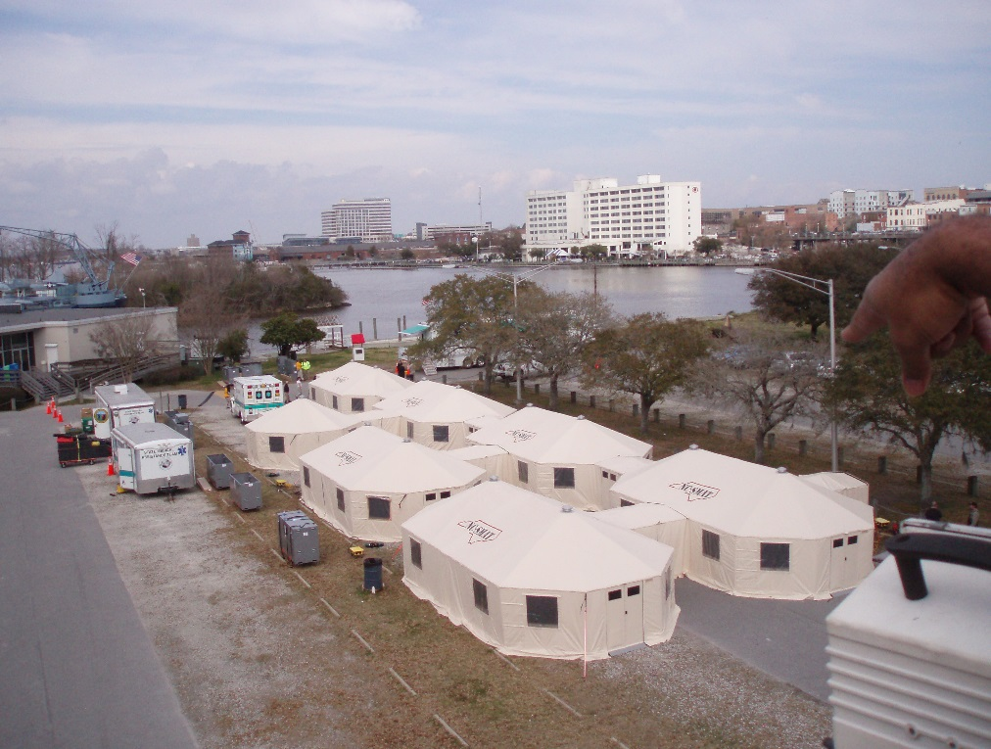

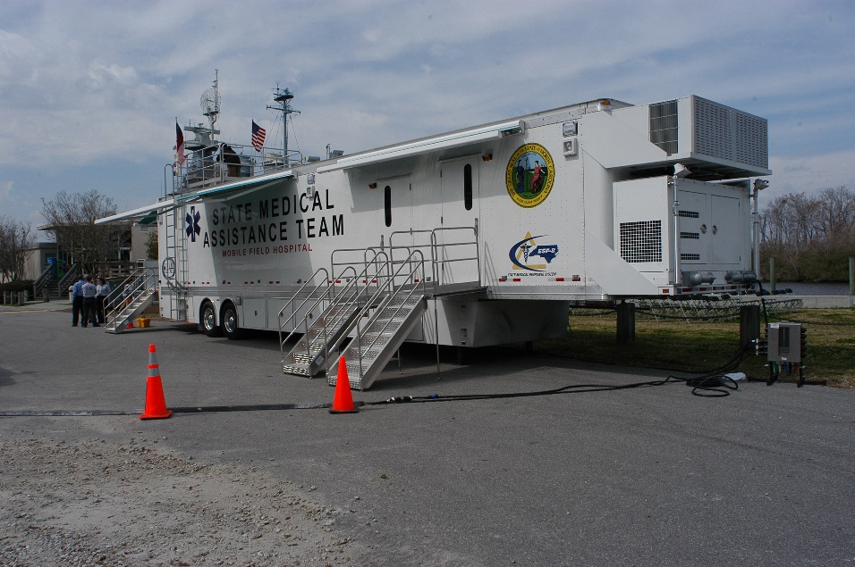

Updated: December 2019

This plan has been approved by the governing bodies of the Southeastern Healthcare Preparedness Region, in accordance with their respective bylaws and guidelines.
Revised plans will be distributed electronically annually.

Record of Changes to Base Plan

Date of Revision | Recommended Changes | Initials
6/3/2019 | Budget Details and Membership Changes | HG
12/12/2019 | Budget Details | HG

Record of Distribution

Person/Title/Agency | Method of Delivery | Date
Coalition Members by Discipline | Electronic and Hard Copy | 5/16/18
Coalition Members by Discipline | Electronic | 6/1/19

Table of Contents

Contents
Introduction 1
Purpose and Scope of Plan 1
Administrative Support 1
Coalition Overview 2
Mission & Vision 2
Coalition Boundaries 2
Coalition Members 2
Organizational Structure/Governance 3
Roles and Responsibilities of Coalition Partners 3
Summary of Risk 5
Gaps 6
Compliance Requirements/Legal Authorities 6
Coalition Strategic Plan & Objectives 6
Coalition Support Plan 7
Workplan 7
Attachment A: SHPR Membership Agencies 9

Introduction

The Healthcare Preparedness Program (HPP), which is managed by the NC Office of Emergency Medical Services (NCOEMS), utilizes eight healthcare coalitions to facilitate and support local and regional partners in developing the following capabilities:
- Foundation for healthcare and medical readiness,
- Healthcare and medical response coordination,
- Continuity of healthcare service delivery, and
- Medical surge.
This plan describes the roles and responsibilities of the Southeastern Healthcare Prepared Region (SHPR) in responding to regional health care emergencies primarily within Southeastern North Carolina including the counties of Brunswick, New Hanover, Columbus, Bladen, Pender, Duplin and Onslow. The coalition can further support response activities in other regions of the state if needed.
When effectively implemented, the health care coalition provides the mechanisms for individual health care organizations to coordinate information sharing and other response capabilities using efficient response processes and procedures.

Purpose and Scope of Plan
The purpose of this preparedness plan is to establish and describe the emergency response framework that will guide the Southeastern Healthcare Preparedness Region (SHPR) as it activates to protect the health, safety and well-being of the citizens and visitors of Southeastern North Carolina.
The work activities listed in this plan are aimed to complement and enhance each coalition members’ emergency management program for the purpose of ensuring optimal utilization of resources and disaster support to the Southeastern Healthcare Preparedness Region.
This plan is intended to provide SHPR leadership, steering committee members, and other coalition members with clear guidance on committee structure, committee coordination efforts, and project development. This plan is not intended to supersede any municipal, private agency, county or state emergency preparedness plans.

Administrative Support
This plan will be reviewed and distributed at least annually to ensure that it meets the intended scope, purpose and goals of the Coalition. This plan is a living document and will be updated as necessary after training exercises as well as planned and real-world incidents.
This plan has been approved by the governing bodies of the Southeastern Healthcare Preparedness Region, in accordance with their respective bylaws and guidelines. Revised plans will be distributed electronically annually.

Coalition Overview

Mission & VISION
The mission of the Southeastern Healthcare Preparedness Region (SHPR) is to facilitate coordination and cooperation for all-hazards emergencies throughout the Southeastern region to ensure partners have the capability and capacity to mitigate against, prepare for, respond to, and recover from emergent health and medical events that affect the residents and guests of North Carolina.
SHPR works to enable healthcare organizations to provide uninterrupted, optimal medical care to all populations in the face of damaged or disabled healthcare infrastructure. SHPR assists in providing training, education and equipment to prepare healthcare workers to care for patients in an emergency.
SHPR strives to enhance the emergency preparedness and response capabilities of healthcare entities through:
- Building relationships and partnerships
- Facilitating communication, information and resource sharing
- Promoting situation awareness among HCC members
- Coordinating training, drills and exercises
- Strengthening medical surge capacity and capabilities
- Assisting emergency management and Emergency Support Function (ESF) #8 partners

Coalition Boundaries
The Southeastern Healthcare Preparedness Region is composed of Brunswick, New Hanover, Columbus, Bladen, Pender, Onslow and Duplin in southeastern North Carolina. The region has a full time population of approximately 776,400 people with about 5296 square miles of coverage area.

Coalition Members
Southeastern Healthcare Preparedness Region members include a diverse membership to ensure a successful whole community response. A current roster of member organizations, including core or partner designation and contact information, will be maintained. (Refer to Appendix A)
Core HCC members include, at a minimum, the following:
- Hospitals
- EMS (including inter-facility and other non-EMS patient transport systems)
- Emergency management organizations
- Public health agencies
Additional HCC members may include but are not limited to the following:
- Law Enforcement, Fire Departments, Social Services, Public Works, Transportation Services, Military Installations, etc.
- Mental and Behavioral Health Services, Long Term Care facilities, Primary Care Providers, specialty service providers, support service providers, private entities associated with healthcare, Red Cross, Educational Institutions, or any volunteer agencies;
- Regional agencies and non-governmental organizations that would assist in healthcare response to an event, incident, or disaster;
- Healthcare and Emergency Management planning regions and associations that support healthcare preparedness. (i.e. NCEM Domestic Preparedness Regions (DPR), Public Health Preparedness & Response Regional Representatives, NC Association of EMS Administrators, NC Hospital Association, NC Emergency Management Association, NC Association - Long Term Care, NC Assisted Living Association, NC Law Enforcement Officers’ Association, etc.)
- Any State Agency (i.e. NC Department of Public Safety – Emergency Management, NC Office of EMS, NC Hospital Association, NC Public Health) who would assist in the planning or response may be included as non-voting members.

Organizational Structure/Governance
The Southeastern Healthcare Preparedness Region operates as an independent coalition of healthcare partners and stakeholders charged with facilitating healthcare preparedness in the region that is determined serves the same designated area as the Southeastern Regional Advisory Committee on Trauma. This coalition is charged with identifying the health care disaster preparedness and response needs and facilitating the development of projects, plans and educational programs to mitigate those needs.

Roles and Responsibilities of Coalition Partners
Agencies that participate in the Southeastern Healthcare Preparedness Region may request educational programming offered by the SHPR; seek consultative services of SHPR staff, particularly in the areas of disaster preparedness & response; and utilize disaster response assets managed by SHPR.
Individuals and organizations working collaboratively across a spectrum of disciplines to develop and maintain disaster health and medical capabilities will help to clarify roles, responsibilities and assumptions about response and recovery.
HOSPITALS
- Provide community and regional medical care and support in response to a disaster.
- Develop and maintain a disaster preparedness plan and program.
- Participate in the statewide Hospital Mutual Aid Agreement.
- Plan and prepare for medical surge incidents
- Develop and maintain standard operating guidelines for mental health operations during emergency/ disaster situations.
- Plan for coordination of triage operations with EMS systems and other response agencies.
- Coordinate transport of patients and bed capacity with other hospitals in the region.
- Identify alternate care facilities, plan for staffing of facilities, and maintain resource capabilities for these facilities.
- Provide support to SMAT II, including providing staffing to alternate care sites and extended care sites.
EMS AGENCIES
- Provide out-of-hospital acute medical care to patients with injuries and illnesses within their respective counties.
- Transport to definitive care facilities patients with illnesses and injuries.
- Participate in mutual aid in support of other counties within the region or state.
- Develop and maintain standard operating guidelines for emergency medical service activities during emergency and disaster situations.
- Plan for coordination of ambulance/rescue activities including medical surge throughout the region during disasters and mass casualty incidents.
- Identify equipment and manpower limitations.
- Develop mutual aid agreements for needed resources during emergency and disaster events.
- Coordinate with regional hospitals concerning receipt of mass casualties during emergency and disaster events.
- Coordinate with the county health director and social services director to determine emergency transportation needs for special needs populations.
- Support regional or state ambulance strike team initiatives.
EMERGENCY MANAGEMENT AGENCIES
- Serve as the lead agency within the local emergency operations center.
- Serve as the requesting agency for resources and support.
- Initiate local state of emergency declarations.
- Activate and manage local emergency operations centers.
- Coordinate emergency sheltering operations with human service agencies for general and functional/special needs populations.
- Provide support to cities and towns in their respected Counties.
- Coordinate implementation of a county plan for medical evacuation and local medical support shelters.
- Support SMAT III when applicable.
PUBLIC HEALTH AGENCIES
- Respond to disease outbreaks by characterizing the outbreak, implementing containment actions, providing treatment and protection methods including PPE and pharmaceutical interventions, providing guidance on these measures, and implementing recovery plans for individual and community health.
- Protect and improve the health of their respective county.
- Assist with coordination of clinical healthcare in such areas as children’s health, maternity care, communicable diseases, immunizations, women’s health, and family planning.
- Develop and support a public health response to natural or human-made disasters.
- Provide sheltering support during disasters.

ANCILLARY HEALTH CARE ORGANIZATIONS AND OTHER STAKEHOLDERS
With proper training, coordination and planning, Ancillary Heath Care Agencies and other stakeholders can provide local situational awareness, surge capability, and staffing resources.

Summary of Risk
A regional healthcare system HVA is a systematic approach to identifying hazards or risks that are most likely to have an impact on the demand for health care services or the health care delivery system’s ability to provide these services. SHPR defines, identifies, and prioritizes risks, in collaboration with the ESF-8 lead agency, by conducting assessments or using and modifying data from existing assessments for healthcare readiness purposes. These assessments help the Coalition to determine resource needs and gaps, identify individuals who may require additional assistance before, during and after an emergency, and highlight applicable regulatory and compliance issues. The Coalition uses the information about these risks and needs to inform training and exercises and to prioritize preparedness strategies.
SHPR members assisted with the completion of a full regional Hazard Vulnerability Analysis (HVA) in 2013 completed by the vendor EnviroSafe, and have followed up with an annual HVA and Risk Assessment for the region. The most recent update completed in 2019. Most recently, SHPR took a broad look at the hazards that were identified as being “High Risk Hazards” from both county and healthcare facility partners, along with conducting an internal Hazard Vulnerability Assessment, measured the results of all three assessments to conclude the following as to be the hazards that pose the highest risk to the SHPR region.

Events commonly identified as high-risk by facilities:
- Hurricane  - External flood  - Severe HazMat  - Bioterrorism  - Civil disturbance  - Ice storm  - Labor shortage  - Physical security breach  - Transportation failure  - Infectious disease  - Cyber attack | - Radiological exposure  - Active shooter  - Mass casualty  - Chemical exposure  - Communications failure  - Medical Gas failure  - Severe thunderstorm  - Workplace violence  - Electrical failure  - HVAC failure  - Internal flood

Gaps
In the risk assessment / gap analysis process, SHPR compared available resources with current risks in order to identify gaps and inform prioritization of coalition activities, such as preparedness initiatives and the purchase of additional coalition resources that have been distributed throughout the region.
A risk assessment / gap analysis is conducted annually and any newly identified gaps will be incorporated into the work plan for each upcoming year.

Compliance Requirements/Legal Authorities
The HCC is informed of state and federal emergency management resources and support, as well as the authorities under which response operations may be conducted. The HCC, in collaboration with the lead ESF-8 agency, the NC Office of EMS, have assessed and identified the regulatory compliance requirements that are applicable to day-to-day operations and may affect planning for, responding to, and recovering from emergencies. The HCC will leverage members’ existing facility preparedness plans as required by various regulatory agencies (NC Division of Health Service Regulation, Centers for Medicare and Medicaid (CMS) Emergency Preparedness Requirements for Medicare and Medicaid Participating Providers and Suppliers, The Joint Commission Standards).
The HCC and NCOEMS understand the legislation and related programs that will allow for response during times of crisis knowing that certain liabilities have been waived, and much-needed human and material resources will be more readily available.

Coalition Strategic Plan & Objectives

The Southeastern Healthcare Preparedness Region meets annually to review and update its strategic plan and objectives. The following have been identified by regional staff and partner stakeholders as the priority for the Coalition:
- Continuity of Health Care Service Delivery
- Healthcare System Delivery Integration
- At Risk Populations Identification and Planning
- Medical Surge Planning
- Healthcare Coalition Enhancement and Sustainability
(Refer to the SHPR Strategic Plan for FY2017-2022)

Coalition Support Plan
The Southeastern Healthcare Preparedness Region Support Plan provides a basic organizational structure with operational guidelines for the provision of ESF #8 support across the Healthcare Coalitions in in southeastern North Carolina. It is built upon a scalable, flexible, and adaptable coordinating structure to align key roles and responsibilities of the Healthcare Coalition and its partners. The plan details how they share information, coordinate activities and resources during an emergency and plan for recovery.
The goals of the Southeastern Healthcare Preparedness Region are to:
- Facilitate information sharing among healthcare organizations and jurisdictional authorities to promote common situational awareness.
- Facilitate resource support by expediting the mutual aid process or other resource sharing arrangements among Coalition members, and supporting the request and receipt of assistance from local, State, and Federal authorities.
- Facilitate the coordination of incident response actions for the participating healthcare organizations so incident objectives, strategy, and tactics are consistent for the healthcare response.
- Facilitate the interface between the Healthcare Coalition and relevant jurisdictional authorities to establish effective support for healthcare system resiliency and medical surge.
(Refer to the SHPR Support Plan for full content)

Workplan

The Southeastern Healthcare Preparedness Region membership will review the strategic plan annually in February to determine the priority capability areas for the upcoming year. Capability prioritization is determined based on the annual gap analysis review. Capability priorities, objectives, workplan activities are proposed and vetted by the coalition membership annually. The workplan is coordinated with the spending plan to determine if tasks require funding.

FY 2020/2021 PROPOSED Work Plan and Spending Plan
 | Budget Amount | Budget Details
Program Administration | $278,053.00 | - Regional staff salaries, benefits, travel and office supplies
Capability 1 – Foundation for Health & Medical Readiness | $32,000.00 | - Regional Stakeholder Travel  - Healthcare Coalition Education & Training  - Hazard Vulnerability Assessment  - Coalition Clinical Advisor  - Regional Exercise Development & Conduct  - Regional Governance Update  - North Carolina Disaster Symposium
Capability 2 – Healthcare and Medical Response Coordination | $19,000.00 | - Regional Communications Testing  - Hospital Command Center Sustainment  - Mission Ready Packages Sustainment  - Situational Awareness and Information Sharing
Capability 3 – Continuity of Health Care Service Delivery | $5,000.00 | - Provide CISM/Peer Support training  - Responder Health & Safety
Capability 4 – Medical Surge | $271,000.00 | - SMRS Operational Readiness Warehouse Lease & Utilities  - SMRS SMAT II and SMAT III Sustainment  - SMRS Ambulance Strike Team Sustainment  - Burn Surge and Pediatric Response Plan Annexes  - Assess Supply Chain Integrity  - Ambulance Bus Sustainment  - Portable Desalination Unit  - Surge O2 Distribution Equipment  - ADA Compliant Shower Trailer
TOTAL Budget | $605,053.00

Attachment a: SHPR Membership Agencies
The following Hospitals, EMS Systems, and Public Health are listed as Essential Stakeholders for SHPR Region:

County | Hospital | EMS | Emergency Management | Public Health
Bladen | Cape Fear Valley, Bladen Hospital | Bladen EMS | Bladen County EM | Bladen County Public Health
Brunswick | J.A. Dosher Hospital | Brunswick EMS | Brunswick County EM | Brunswick County Public Health
 | Brunswick – Novant Medical Center
Columbus | Columbus Regional Medical Center | Columbus EMS | Columbus County EM | Columbus County Public Health
Duplin |  | Duplin EMS | Duplin County EM | Duplin County Public Health
New Hanover | New Hanover Regional Medical Center | NHRMC EMS | New Hanover County EM | New Hanover County Public Health
Onslow |  | Onslow EMS | Onslow County EM | Onslow County Public Health
 | Naval Medical Center Camp Lejeune | Camp Lejeune Fire and EMS | Camp Lejeune EM | Camp Lejeune Public Health
Pender | Pender Memorial Hospital | Pender EMS and Fire | Pender County EM | Pender County Public Health

