**Strategic Plan**

Southeastern Healthcare Preparedness Coalition  
Fiscal Year 2017 - 2022

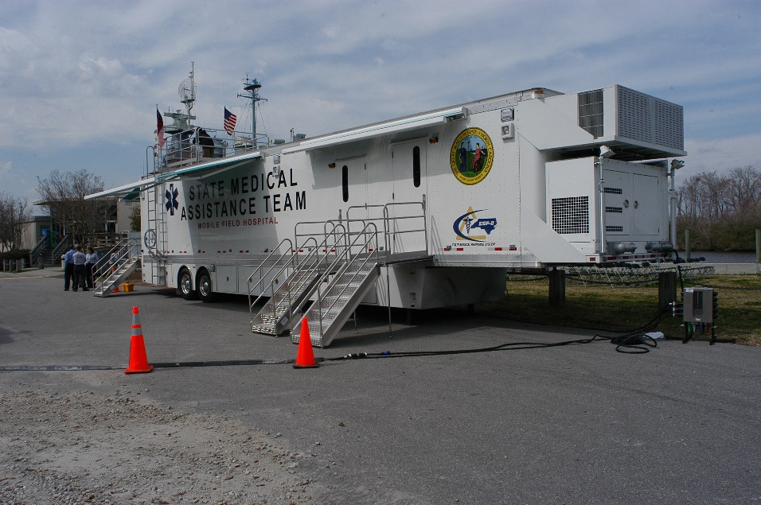

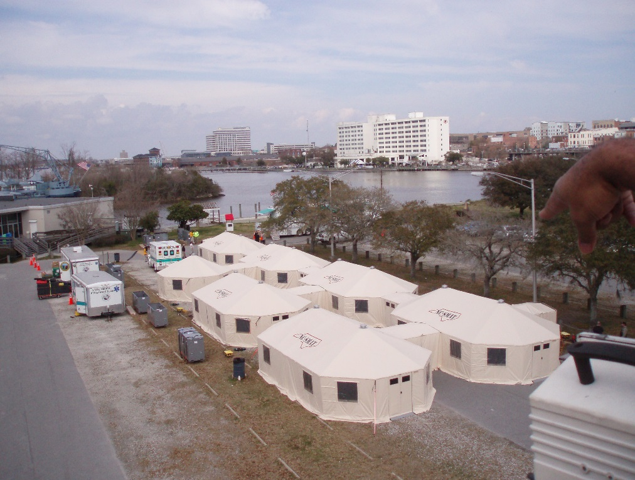

Updated: December 2019

# Table of Contents

Table of Contents 2

Executive Summary 5

Purpose of Strategic Plan 5

Development and Implementation of the SHPR Strategic Plan 5

Goals and Activities 6

**Goal 1:** Develop and grow a foundation for Health Care and Medical Readiness through developing strong relationships, identifying hazards and risks, and prioritizing and addressing gaps through planning, training, exercising, and managing resources. 6

Objective 1: Identify regional hazards and risks to be used as a basis for coalition and sector planning purposes. 6

• Activity 1.1 - Complete and Review Annually the SHPR Hazard Vulnerability Analysis 6

Objective 2: Identify and address coalition and sector identified gaps through planning, training, exercising, and managing resources. 6

• Activity 2.1 - Annual HSEEP Course 6

• Activity 2.2 - Annual COOP Training for partners 6

• Activity 2.3 - Pediatric Preparedness and Response Courses 6

• Activity 2.4 – ABLS/ADLS and Train the Trainer Courses 6

• Activity 2.5 - CMS Emergency Preparedness Rule training and education 6

• Activity 2.6 – Attend and assist during healthcare agency exercises as requested 6

• Activity 2.7 – Attend Eastern Branch Office Training Week 6

Objective 3: Identify and develop relationships between healthcare and response agencies. 6

• Activity 3.1 – Annual North Carolina Disaster Symposium 6

• Activity 3.2 - Attend and Support Stakeholder travel to annual conferences 6

• Activity 3.3 - Support Quarterly Coalition Meetings 6

• Activity 3.4 - Support Quarterly Subcommittee Meetings 6

• Activity 3.5 - Continue building Email distribution list 6

• Activity 3.6 - Attend Sector Meetings as requested 6

Objective 4: Engage stakeholder membership and executive committee in the development and maintenance of the SHPR Coalition. 6

• Activity 4.1 - Develop new initiatives relevant to members’ needs 6

• Activity 4.2 – Facility outreach and coalition overview presentations 6

**Goal 2:** Develop and grow the healthcare and medical response coordination throughout southeastern North Carolina. 7

Objective 1: Serve as a resource to coalition members for situational awareness and operational support 7

• Activity 1.1 - Monthly Communications Testing 7

• Activity 1.2 - WebEOC Training 7

• Activity 1.3 - Continued Update of SHPR Website 7

Objective 2: Develop and Enhance a Healthcare Coalition that is considered essential to emergency preparedness and response and engage in sustainment efforts 7

• Activity 2.1 - Partner with neighboring Healthcare Coalitions to better leverage planning and education resources. 7

• Activity 2.3 – Regional Response Plan and Support Plan Update 7

Objective 3: Engage clinical leadership and garner executive level engagement 7

• Activity 4.3 - Develop initiatives relevant to members’ needs 7

• Activity 4.4 – Agency outreach and coalition overview presentations 7

**Goal 3:** Develop and support continuity of health care service delivery methods to assist in providing uninterrupted, optimal medical care to all populations in the face of damaged or disabled health care infrastructure. 7

Objective 1: Serve as a regional resource for Responder Safety & Health Training and Exercises for coalition partners. 7

• Activity 1.1 - Annual Critical Incident Stress Management Course 7

Objective 2: Assist partners with COOP Planning that addresses essential healthcare services 7

• Activity 2.1 – Develop SHPR COOP plan 7

Objective 3: Integrate capability assessments and resource assessments into resource planning to identify or develop processes to address gaps or limitations. 8

• Activity 3.1 - First Receiver Decontamination Training 8

• Activity 3.2 - Decontamination Capability Assessment 8

• Activity 3.3 - Supply chain assessment 8

• Activity 3.4 – Regional Response Plan Update 8

• Activity 3.5 – Coalition Capability Assessment 8

• Activity 3.6 - Healthcare Evacuation Toolkits 8

• Activity 3.7 - Annual COOP Training for partners 8

• Activity 3.8 - Annual Critical Incident Stress Management Course 8

**Goal 4:** Evaluate medical surge capabilities and Support and Coordinate Medical Surge Planning and Response operations. 8

Objective 1: Evaluate the regional medical surge capabilities. 8

• Activity 1.1 - Annual Coalition Surge Test 8

• Activity 1.2 - Regional Exercise Series (120 to Landfall Continuation) 8

Objective 2: Assist healthcare agencies with surge capacity and capability. 8

• Activity 2.1 - Regional Patient Coordination Planning 8

• Activity 2.2 - SMAT III Operational Support 8

• Activity 2.3 - AST Operational Support 8

• Activity 2.4 – Distribute capabilities document 8

• Activity 2.5- Regional capabilities assessment 8

**Goal 5**: Assist in the identification and planning efforts for at risk populations located in southeastern North Carolina. 8

Objective 1: Enhance preparedness of Licensed Care Facilities. 8

• Activity 1.1 - Regional Exercise Series 8

Objective 2: Integrate planning and training that addresses the appropriate care of at-risk individuals with special medical needs. 9

• Activity 2.1 - Offer training with a focus on at-risk individuals 9

• Activity 2.2 – Update the coalition preparedness plan and regional response/support plan. 9

Outcomes 9

Appendix A: Acronym List 10

# Executive Summary

The Southeastern Healthcare Preparedness Region (SHPR) is a network of health care organizations, providers and regional partners that are committed to strengthening the resiliency of the healthcare community in southeastern North Carolina. The purpose of the Coalition is to develop a coordinated and effective response to all hazards through the following:

* Creating a foundation for health care and medical readiness.
* Improving health care and medical response coordination.
* Improving continuity of health care service delivery.
* Improving medical surge capabilities.

Membership in the Coalition is open to southeastern North Carolina health care providers and partner organizations who agree to work collaboratively and coordinate prevention, mitigation, preparedness, emergency response and recovery activities. The Coalition’s work to develop emergency preparedness and response systems and resources will be of benefit to the entire community, not just Coalition members.

# Purpose of Strategic Plan

The purpose of this strategic plan is to guide the work of the Southeastern Healthcare Preparedness Region from the fiscal years 2017 - 2022. It is intended to be a dynamic document which will continue to evolve as necessary to ensure the Coalition is effective and able to sustain its efforts.

# Development and Implementation of the SHPR Strategic Plan

The SHPR Strategic Plan is guided by the priorities of the coalition members and approved by the coalition executive committee. All SHPR partners were leveraged in the initial development of this strategic plan and each partner continues to play a critical role in supporting and developing the plan. All elements of this strategic plan align with and support the capabilities as listed by the Assistant Secretary of Preparedness and Response (ASPR). SHPR collaborates across all operating coalition partners to integrate preparedness into the daily routine of the healthcare community.

SHPR will implement this strategic plan with full leadership involvement and commitment to transform the strategy into action, tracking progress, and implementing course correction as needed. The strategic plan maps out the organizations broad direction, and the action plan provides detailed actions and outcomes that are needed to achieve the goals as described. This strategic plan will be published online and updated annually to reflect evolving activities and progress towards goals.

# Goals and Activities

## **Goal 1:** Develop and grow a foundation for Health Care and Medical Readiness through developing strong relationships, identifying hazards and risks, and prioritizing and addressing gaps through planning, training, exercising, and managing resources.

## Objective 1: Identify regional hazards and risks to be used as a basis for coalition and sector planning purposes.

## Activity 1.1 - Complete and Review Annually the SHPR Hazard Vulnerability Analysis

## Objective 2: Identify and address coalition and sector identified gaps through planning, training, exercising, and managing resources.

## Activity 2.1 - Annual HSEEP Course

## Activity 2.2 - Annual COOP Training for partners

## Activity 2.3 - Pediatric Preparedness and Response Courses

## Activity 2.4 – ABLS/ADLS and Train the Trainer Courses

## Activity 2.5 - CMS Emergency Preparedness Rule training and education

## Activity 2.6 – Attend and assist during healthcare agency exercises as requested

## Activity 2.7 – Attend Eastern Branch Office Training Week

## Objective 3: Identify and develop relationships between healthcare and response agencies.

## Activity 3.1 – Annual North Carolina Disaster Symposium

## Activity 3.2 - Attend and Support Stakeholder travel to annual conferences

## Activity 3.3 - Support Quarterly Coalition Meetings

## Activity 3.4 - Support Quarterly Subcommittee Meetings

## Activity 3.5 - Continue building Email distribution list

## Activity 3.6 - Attend Sector Meetings as requested

## Objective 4: Engage stakeholder membership and executive committee in the development and maintenance of the SHPR Coalition.

## Activity 4.1 - Develop new initiatives relevant to members’ needs

## Activity 4.2 – Facility outreach and coalition overview presentations

## **Goal 2:** Develop and grow the healthcare and medical response coordination throughout southeastern North Carolina.

## Objective 1: Serve as a resource to coalition members for situational awareness and operational support

## Activity 1.1 - Monthly Communications Testing

## Activity 1.2 - WebEOC Training

## Activity 1.3 - Continued Update of SHPR Website

## Objective 2: Develop and Enhance a Healthcare Coalition that is considered essential to emergency preparedness and response and engage in sustainment efforts

## Activity 2.1 - Partner with neighboring Healthcare Coalitions to better leverage planning and education resources.

## Activity 2.3 – Regional Response Plan and Support Plan Update

## Objective 3: Engage clinical leadership and garner executive level engagement

## Activity 4.3 - Develop initiatives relevant to members’ needs

## Activity 4.4 – Agency outreach and coalition overview presentations

## **Goal 3:** Develop and support continuity of health care service delivery methods to assist in providing uninterrupted, optimal medical care to all populations in the face of damaged or disabled health care infrastructure.

## Objective 1: Serve as a regional resource for Responder Safety & Health Training and Exercises for coalition partners.

## Activity 1.1 - Annual Critical Incident Stress Management Course

## Objective 2: Assist partners with COOP Planning that addresses essential healthcare services

## Activity 2.1 – Develop SHPR COOP plan

* Activity 2.1 – Assist partner agencies with COOP plan development and training

## Objective 3: Integrate capability assessments and resource assessments into resource planning to identify or develop processes to address gaps or limitations.

## Activity 3.1 - First Receiver Decontamination Training

## Activity 3.2 - Decontamination Capability Assessment

## Activity 3.3 - Supply chain assessment

## Activity 3.4 – Regional Response Plan Update

## Activity 3.5 – Coalition Capability Assessment

## Activity 3.6 - Healthcare Evacuation Toolkits

## Activity 3.7 - Annual COOP Training for partners

## Activity 3.8 - Annual Critical Incident Stress Management Course

## **Goal 4:** Evaluate medical surge capabilities and Support and Coordinate Medical Surge Planning and Response operations.

## Objective 1: Evaluate the regional medical surge capabilities.

## Activity 1.1 - Annual Coalition Surge Test

## Activity 1.2 - Regional Exercise Series (120 to Landfall Continuation)

## Objective 2: Assist healthcare agencies with surge capacity and capability.

## Activity 2.1 - Regional Patient Coordination Planning

## Activity 2.2 - SMAT III Operational Support

## Activity 2.3 - AST Operational Support

## Activity 2.4 – Distribute capabilities document

## Activity 2.5- Regional capabilities assessment

## **Goal 5**: Assist in the identification and planning efforts for at risk populations located in southeastern North Carolina.

## Objective 1: Enhance preparedness of Licensed Care Facilities.

## Activity 1.1 - Regional Exercise Series

## Objective 2: Integrate planning and training that addresses the appropriate care of at-risk individuals with special medical needs.

## Activity 2.1 - Offer training with a focus on at-risk individuals

## Activity 2.2 – Update the coalition preparedness plan and regional response/support plan.

# Outcomes

Outcome 1: Increased and strengthened relationships between regional healthcare agencies and regional response agencies in southeastern North Carolina

Outcome 2: Hazard and risk identification that is able to be used for regional planning purposes.

Outcome 3: Regional collaboration and information analysis during planning, preparedness, and response to an emergency or a planned event.

Outcome 4: Regional coordination of resources and strategies which deliver medical care to all populations during emergencies and planned events.

Outcome 5: Emergency Response and Health Care workers are well trained, well-educated, and well-equipped to care for patients during emergencies.

Outcome 6: Simultaneous response and recovery operations result in a return to normal or, ideally, improved operations following an emergency.

Outcome 7: Deliver timely and efficient care to patients even when the demand for healthcare services exceeds available supply during an emergency.

Outcome 8: Information and resource coordination throughout the region to maintain conventional surge response during an emergency.

Outcome 9: Support of the health care delivery system’s transition to contingency and crisis surge response during an emergency.

Outcome 10: Timely returns to conventional standards of care as soon as possible following an emergency.

Outcome 11: Increased preparedness for Licensed Care Facilities with consideration to the CMS Emergency Preparedness requirements.

Outcome 12: Increased engagement and participation in the coalition by Licensed Care facilities.

# Appendix A: Acronym List

|  |  |
| --- | --- |
| Acronym | Meaning |
| ABLS | Advanced Burn Life Support |
| ADLS | Advanced Disaster Life Support |
| ASPR | Assistant Secretary of Preparedness and Response |
| AST | Ambulance Strike Team |
| CMS | Centers for Medicare and Medicaid Services |
| COOP | Continuity of Operations Planning |
| HSEEP | Homeland Security Exercise and Evaluation Program |
| SHPR | Southeastern Healthcare Preparedness Region |
| SMAT | State Medical Assistance Team |