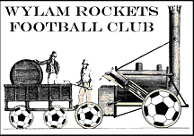 Complaints Policy
In the event that any member of the club feels that he or she has suffered discrimination in any way or that the club’s Policies, Rules or Codes of Conduct have been broken, they should follow the procedures here.
1. They should report the matter to the Club Secretary or another member of the Club Committee. The report should include:
• details of what, when and where the occurrence took place;
• any witness statement and names;
• names of any others who have been treated in a similar way;
• details of any former complaints made about the incident, date, when and to whom;
• a preference for a solution to the incident.

2. The Club’s Management Committee will sit for any hearings that are required.

3. The Club’s Management Committee will have the power to:
• warn as to future conduct;
• suspend from membership;
• remove from membership any person found to have broken the Club’s Policies or Codes of Conduct.

If the complaint is in regard to the Club’s Management Committee, the member has the right to report the discrimination to the Northumberland FA.

