Croatia Cruise
MS Arca
September 17-27, 2025

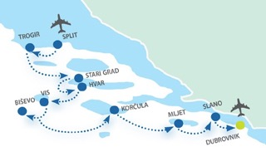  Pricing: 2 nts pre stay, 7 nts cruise, tour pkg; per person based on 2/room  Lower deck (double) $3200.00  Lower deck (twin) $3200.00  Main deck (double) $3600.00  Main deck (twin) $3600.00  Upper deck (double) $3900.00  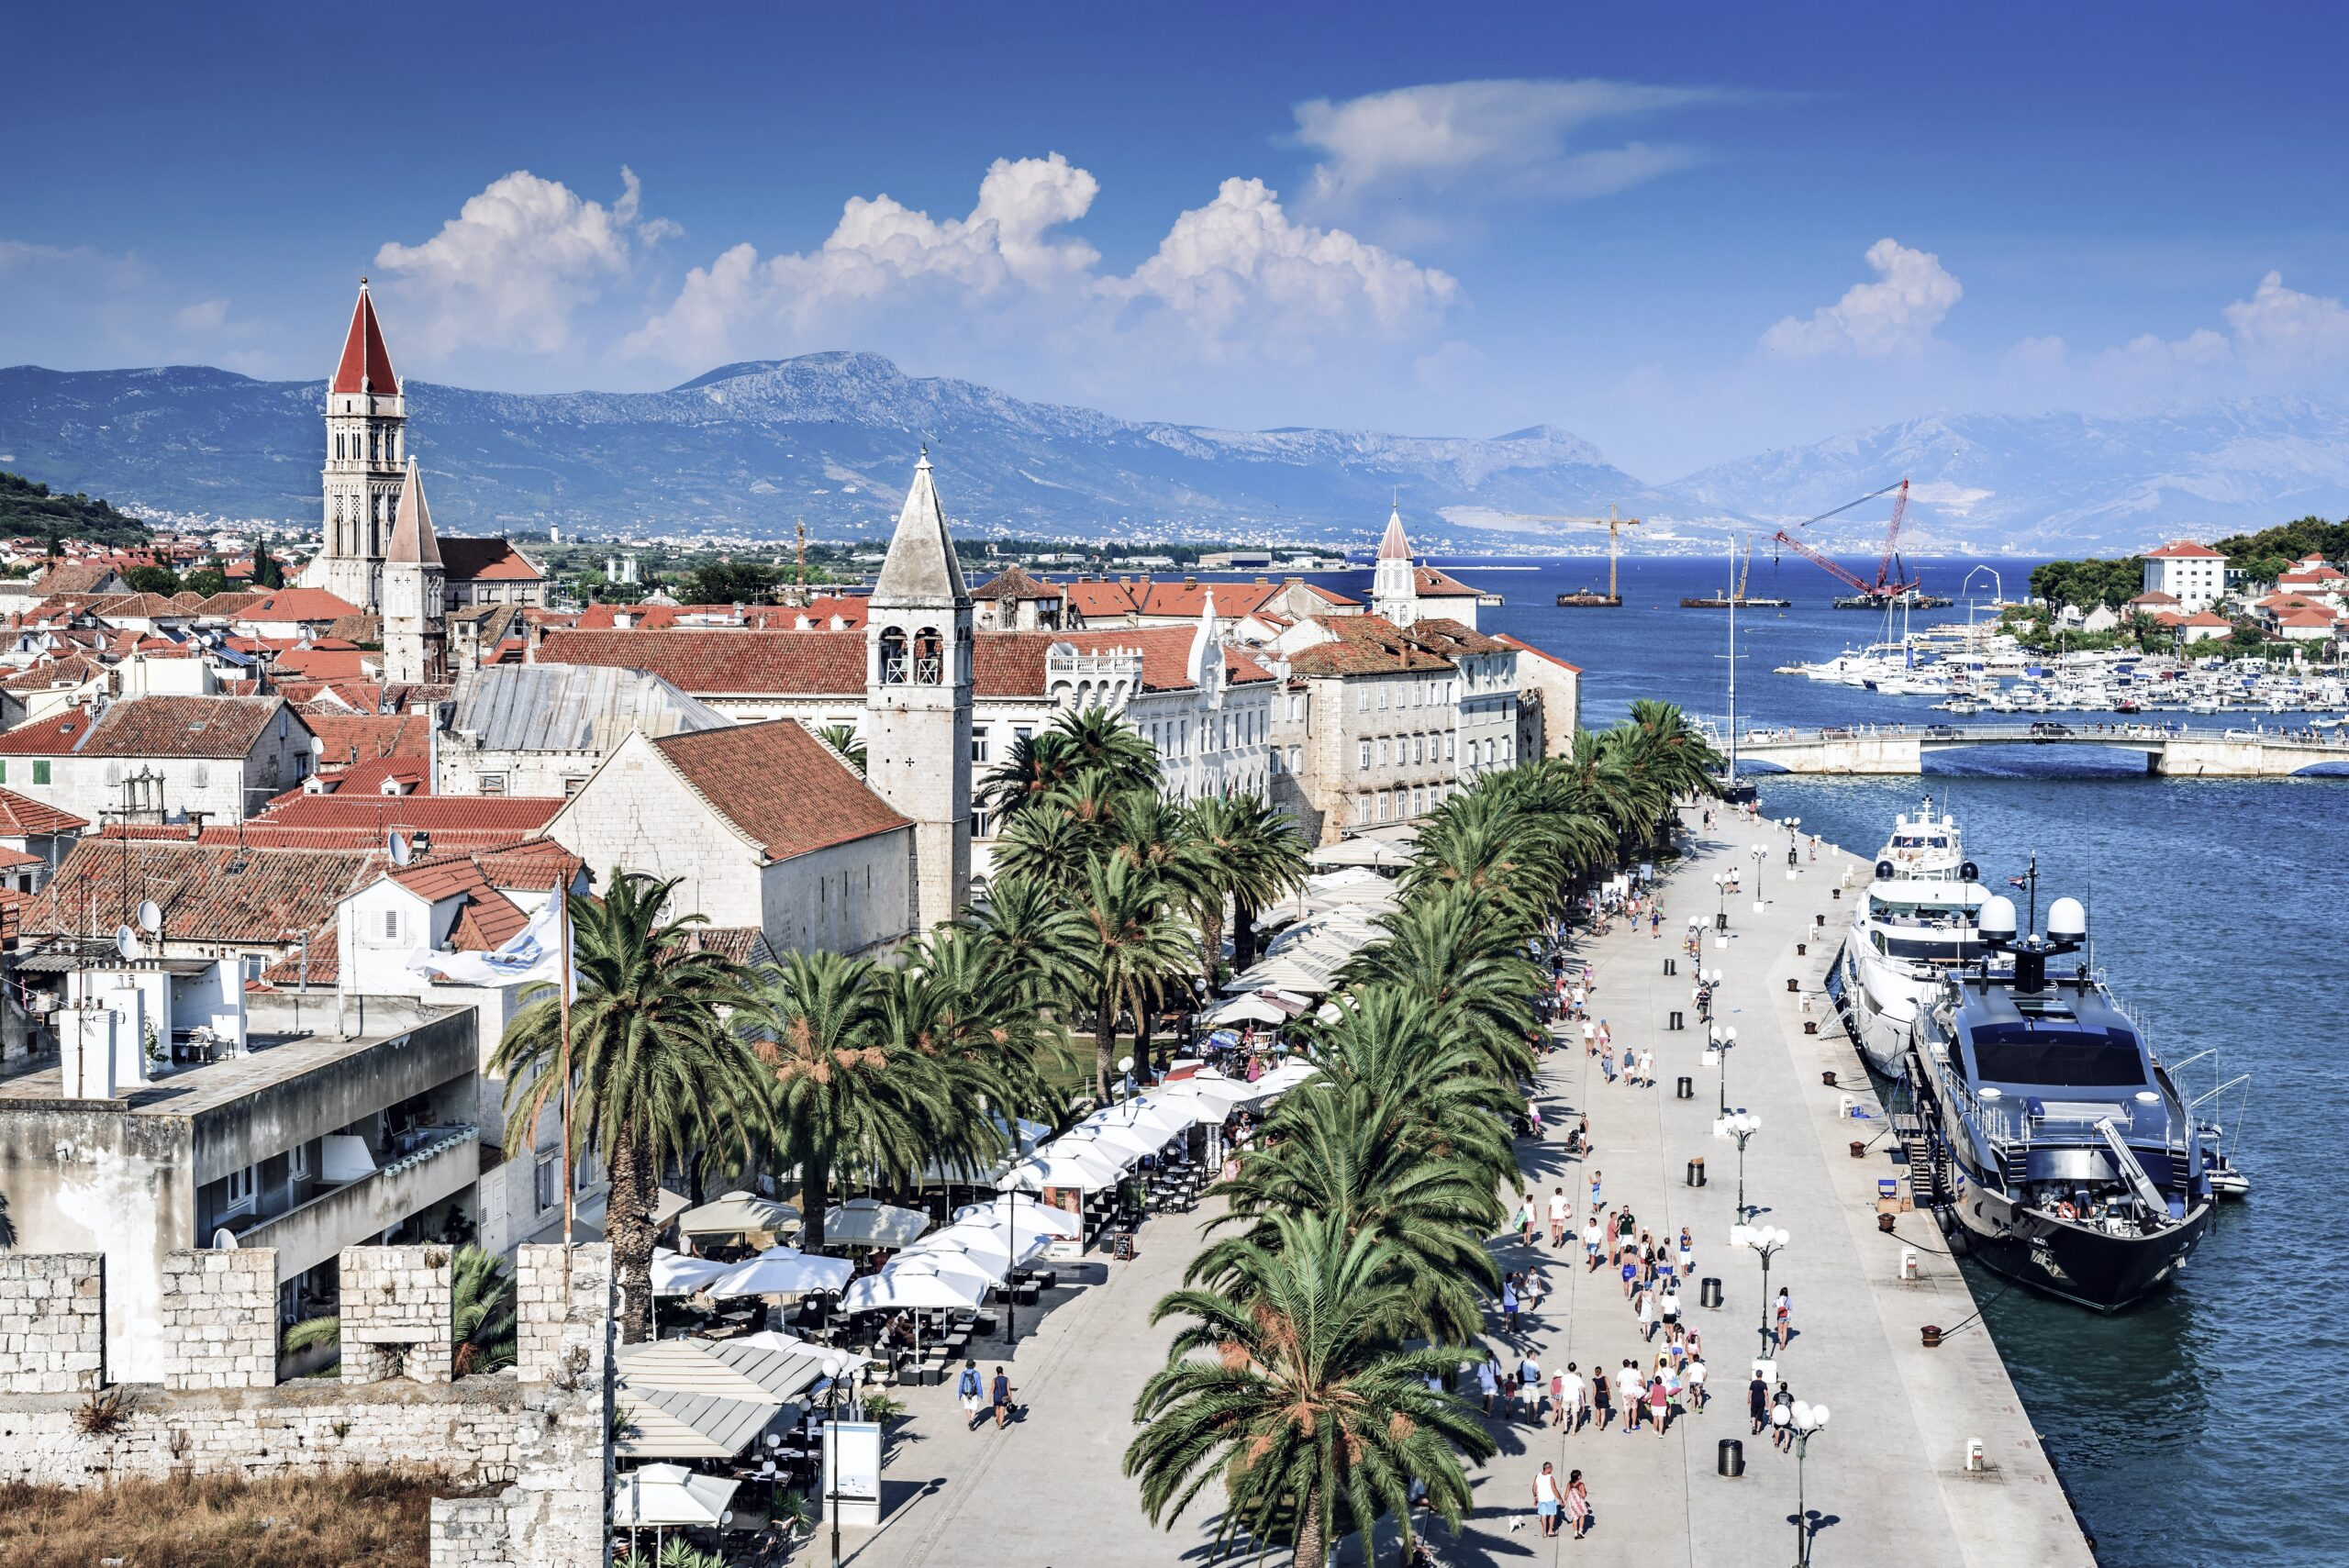 |  |  |  | Features:  Depart USA on September 17 (airfare info TBA and not incl in pricing)  Arrival transfer from Dubrovnik to hotel on September 18, 2025  - 2 nights pre-cruise in Dubrovnik, at Valamar hotel, 4 star incl breakfast  7 nights cruise from Dubrovnik to Split on MS Arca.  Transfer from hotel to port on Sept 20, including luggage handling.  Daily buffet breakfast 6 lunches (3 course meal and salad bar)  Welcome dinner and Captain’s dinner with live music  Complimentary coffee, tea, and fresh fruits available daily  Professional English-speaking Cruise Manager throughout  Daily cabin servicing, fresh bed linen and towels midweek  One beach towel per person per week  Complimentary Wi-Fi on board  Sightseeing Tours Included:  Professional English-speaking guide for Mljet, Vis WWII Miliatry tour, Hvar, Trogir, and entrance to Krka National Park  Oyster tasting in Ston (Bus incl)  Optional tour package ($88 additional)  - 2 hour walking tour of Dubrovnik, Korcula & Split  Not included: Airfare, trip insurance, gratuities, additional drinks, optional excursions, port tax
DUNWOODIE TRAVEL BUREAU, LTD
125 Corporate Blvd Yonkers NY 10701
(914) 969-4200 alesia@dunwoodietravel.com

ITINERARY
Day 1 DUBROVNIK ARRIVAL, Saturday (WR, D)
You will be transferred from Dubrovnik hotelt to the port, where embarkation begins at 14:00h. Get settled in your cabin before going on an optional* walking tour of Dubrovnik around 17:00h, the “Pearl of Adriatic”. Walk through Stradun – both a street and a square, the most famous place inside the town walls, enlisted as UNESCO’s World Heritage site, where your guide will show you the most interesting sights of Dubrovnik and visit the Franciscan Monastery with its Pharmacy. After returning to ship enjoy a Welcome reception followed by dinner this evening.

Day 2 DUBROVNIK - ELAPHITI ISLANDS – SLANO (Oyster Tasting), Sunday (B, L, T, CD)
Early in the morning enjoy the magic scenery as the ship cruises around Dubrovnik city walls to continue to one of the Elaphiti islands for a swim stop. Afternoon arrival in Slano, a peaceful fishermen’s village and our starting point to Ston, situated on Pelješac peninsula and once fortified small village famous for its oysters. Pelješac peninsula is known as one of the best wine-producing regions in Croatia. After exploring the town, we leave to a small nearby village to enjoy the authentic local oyster tasting. Overnight and Captain’s dinner on board in Slano.

Day 3 SLANO - MLJET – KORČULA, Monday (B, L)
In the morning, we head north to the Island of Mljet. Join the Cruise Manager for a stroll to the famous salt lakes in the Mljet National Park. Continue our cruise towards Korčula island, best known as the birthplace of Marco Polo. Afternoon arrival in Korčula followed by an optional* guided walking tour of this enchanting town surrounded by walls, which is one of the best-preserved medieval cities in the Mediterranean. Overnight in Korčula where you can enjoy a gourmet experience at the multiple restaurants and bars.

Day 4 KORČULA – BIŠEVO – VIS, Tuesday (B, L)
Early in the morning we sail to the small island Biševo to visit the Blue Cave (entrance to be paid on the spot), a magnificent natural phenomenon. As sometimes weather conditions can be very unpredictable, the possibility of our visit will depend on those conditions, however you will be notified of this on time. Cruise towards the island of Vis, once a strategic naval Yugoslav base and restricted to the public. Due to this isolation, Vis has a special charm – “the Mediterranean as it once was” making it interesting to visit. Free time on own, you may try some exquisite wine sorts in one of the Vis traditional wineries, visit city Museum or simply take a walk enjoying the views. Overnight in the port of Vis.

Day 5 VIS – STARI GRAD (Hvar sightseeing), Wednesday (B, L)
In the morning head further towards Stari Grad on the island of Hvar, the longest and sunniest island in the Adriatic, with a swim stop and lunch on board. After disembarking in Stari Grad we will take the bus to visit the town of Hvar, which will show you many historical sights of the town, such as St Stephen’s Square and Cathedral, the Arsenal with the theatre built on its first floor, the first municipal theatre in Europe. Above Hvar Town is the impressive fortress Fortica offering magnificent views over the bay and Pakleni islands. In the evening, arrival by bus to the boat in Stari Grad. Overnight in Stari Grad.

Day 6 STARI GRAD – TROGIR (Krka National Park excursion), Thursday (B, L)
Early morning departure to the old Dalmatian town Trogir. After docking join a guided tour of Trogir with a local tour guide. Trogir is sometimes referred to as “miniature Venice” or a “mini-Dubrovnik” because of its ancient walls, or a “floating museum town” - as it has a masterful architecture including some stunning Venetian palaces. Afterwards, you will discover the beauty of the Krka National Park and the small access port of Skradin where the flora and fauna are exceptional. Overnight in Trogir.

Day 7 TROGIR – SPLIT, Friday (B, L)
In the morning set sail to Split with a stop along the way to swim and relax, if the weather permits, with lunch on board. In the late afternoon we arrive at Split to spend the night. Arriving in Split, join an optional* guided tour of the city, visit the seafront promenade and Roman Emperor Diocletian’s Palace. The historical center of the city is listed as a UNESCO World Heritage site. Your evening is free in Split.

Day 8 SPLIT departure, Saturday (B)
After breakfast it’s time to disembark. You will be transferred to Split airport.

B-Breakfast, L-Lunch, D-Dinner, WR-Welcome Reception, CD-Captain’s dinner, T-Tasting

