*To those who helped me find my wings*

*when I thought they were lost forever.*

*To those wayward, scratched, and bloodied-kneed trailblazers*

*…thanks for showing me the way.*

Introduction: How to Use This Guide

Before you read anything else, let me tell you what “Steps to Adventure” is NOT. It is NOT a replacement for a licensed therapist. It is NOT a guide on how to land your dream home, job, car, etc. It is NOT a guide that will tell you how to pick up everything and move to the mountains of Colorado (though it may help- in the past 4 years that I’ve been working on this, I’ve moved from Northeast Ohio to Boulder, Colorado). This is also not a guide that will teach you how to rock climb in Yosemite, kayak in Yellowstone, or climb Mount Everest. Those are skills I have not yet acquired. But please don’t let that deter you…

Now let me tell you what this guide IS. This guide IS a tool, a map if you will, on how to live life as an adventure. Its purpose is to help you live every day with a renewed sense of enthusiasm, no matter what mountain you find yourself before. What is taken from this guide will undoubtedly be different for everyone. While some may find themselves inspired to renew and revitalize the path they are currently on, others may decide it’s time to venture down a new path altogether. And yes, some may just find themselves packing their bags and heading to the mountains.

When practicing the “Steps to Adventure”, please take your time. If you need a month to focus on just one step, then take a month! If one step doesn’t resonate with you, feel free to skip over it (just don’t lie to yourself!). Pull in a friend to go on the journey with you, or do it solo. It’s your adventure, so it’s up to you.

Finally, have fun with this. Enjoy the process. Dig into it. Get dirty. You might dig up something you didn’t want to, but it’s all good. Remember, trees aren’t perfect. Their boughs can break and their trunks can lean sideways. Similarly, mountains can present themselves to be rocky and jagged. But we don’t judge them. We find them beautiful, despite their abrasive surfaces. (Tree or mountain pose anyone?)

I wish you the best on your wonderful, daring adventure!

Rachel

# Table of Contents

Table of Contents

Steps to Adventure

Pre-Work 1: Commit to Live Your Adventure

Pre-Work 2: The “Why?” Game-

A Game to Take a Step Back Before Going Forward

Step 1: Choose to Live Life as an Adventure*:

Acknowledge and Accept Responsibility for Your Life

Step 2: Know Your Roots:

Growing from Your Values

Step 3: Follow Your Compass:

Follow Your Passions and Understand Everyone’s Path is Unique

Step 4: Decide on a Destination:

Discover your purpose. Where do you want to go?

Step 5: Map Your Route:

What path will guide you to your destination?

Step 6: Pack the Right Gear:

Are You Carrying Extra Baggage?

Step 7: Make Hills into Opportunities:

Let Challenges Make You Stronger

Step 8: Enjoy the Journey:

Explore your surroundings and live in the present

Step 9: Inspire Others, Be the Change:

Share your trail lessons and help others live life as an adventure too.

Step Every Single Day: Believe in Yourself

Acknowledgments

About the Author

# Steps to Adventure

· Choose to Live Life as an Adventure (Acknowledge and accept responsibility for your life.)

· Know Your Roots (Use your values and morals to guide decisions.)

· Follow Your Compass (Follow your passions and understand everyone’s path is unique.)

· Decide on a Destination (Figure out where you want to go. What is your purpose? What will you do when you get there?)

· Pack the Right Gear (How much “stuff” do you really need? Are you carrying any extra baggage? Leave behind the negativity in your life.)

· Map Your Route (Have an action plan (goal set) to guide you to your destination)

· Learn from Getting Lost (Learn from you failures and mistakes. Reframe.)

· Make Hills into Opportunities (Have a positive perspective.)

· Enjoy the Journey (Explore your surrounding s and live in the present.)

· Inspire Others, Be the Change (Share your trail lessons and help others live life as an adventure too.)

AND, ABOVE ALL…

• Believe in Yourself

# Pre-Work 1: Commit to Live Your Adventure

It’s amazing what you can learn about yourself when you allow your guard to come down. Allow yourself to be open to new ideas- and then leave yourself the time to think.

For example, I am a commitment-phobe. I never knew that until the other day. I realize that even though I’ve read several self-help/inspirational/happiness books and articles in the past few years looking for tools and techniques I could use in my own life, I never actually committed myself to the task. Instead, I was always looking for some secret, some magic trick, despite knowing there was never going to be one. This left me a “mediocre-happy” at best. In other words, there was quite a bit of room to grow.

I figured it was one of two things: either the people I read about had been blessed with better lives, better happiness genes, or better whatever…or, I was simply missing the point.

When I gave myself time to think about it, I realized it was the latter. I knew the journey had to start with me, and I was failing to take that first step. Yes, I had read the books, articles, and tried a few programs, but, as personal trainers would say, I was still in the preparation phase. I had never actually COMMITTED to the task.

When giving myself the time and space to think, I realized that “commitment” meant so much more than I had previously thought. It meant full body, mind, and spirit immersion. If I was going to live happy, to live purposely, to live my best life possible, I was going to have to live every moment of my life with that intent. That is what commitment really means.

Here are the three reasons why I believe people don’t commit:

1. People don’t really want to

2. They are afraid to close a door

3. They don’t actually believe change is possible

Find out what your excuse is. Note how you avoid commitment. Think about how it has held you back. Ask yourself: Are you ready for change?

If the answer is “yes”, you’re ready to begin your adventure.

# Pre-Work 2: The “Why?” Game-

# A Game to Take a Step Back Before Going Forward

Did you ever play the “Why?” game as a kid? You know, that game where you ask a series of endless “whys?” to any and every response you get?

Or maybe you have kids now, and they quickly discovered it’s the perfect game to drive you crazy… it’s almost as annoying as the question “Are we there yet?” that starts just 15 minutes into a two hour drive.

Have you ever been asked one of the most classic of all “why?” questions, “Why is the sky blue?”? You might have decided to play along at first, and make up some answer about color pigments and the reflection of water (that answer is a bit off, but you are on the right page…see the scientific answer here: <http://spaceplace.nasa.gov/blue-sky/>), but before you can even finish, you get another “Why?”, followed by at least five more. Finally, throwing your hands up in the air (unless you are driving), you answer “because God made it that way, that’s why!” You might think that answer would ultimately end the game, but, sadly, it does not…you get another “why?” and all you can do is shake your head and attempt to keep your sanity.

While the game may be highly frustrating at times, it can also be a highly effective tool in your adult life. Why? (Sorry, I had to). Because it can make you dig deep to get the root of a real answer.

Here is where we need to take a step back in order to go forward. That was not my original intention when I started scripting this page. I was simply going to start out with my “Steps to Adventure”, until I realized when reading Unlimited by Jillian Michaels how impossible…or at least unhelpful…that would be if our goal was really to move forward/upward towards our peak. After all, trees can’t grow strong without their roots being planted in deep nutrient rich soil.

If you have already battled and defeated the demons of your past, go ahead and stop reading. For the rest of you, it is vital you read on.

This is YOUR chance to ask the “why?” questions. Yes, it is going to be hard, but aren’t you worth it? Is 30-60 minutes of work too much to ask of yourself in your quest to be better?

Let’s begin:

Think of what is bothering you in your life. It might be a problem at work or in a relationship, or a bad habit you can’t shake. It might be a defeating thought in your head that constantly arises, like “I’m not good enough” or “I couldn’t possibly do that”. What is it that you feel is holding you back in life? Take time with this part. Analyze every aspect of your life. You may come up with a few things.

Then, start the game. Ask yourself why you act or think the way you do. Ask yourself your role in creating the problem at hand. Ask yourself why you can’t stop that bad habit, and when it started. And then ask yourself “why?” again. This is something you have probably avoided for quite some time, so it make take some time to peel back the layers with multiple “whys?”. The key is just to be honest and take responsibility for your past and current actions.

If you’re still reading, that’s a very promising sign. It means you have the will to change. Not all people do, or at least don’t yet. I am a key example.

After being diagnosed with Anorexia Nervosa in 7th grade, I was sent to a psychologist. In theory, it was a great idea. The problem was that I loathed the idea of going. I don’t think I ever really gave the poor woman a chance.

Instead, we ended up playing UNO every visit for 45 minutes straight…if I was in a good mood. Otherwise there was a whole bunch of silence on my part. And if she asked me any personal questions, I’d immediately shut down. Up until a few weeks ago, I was oblivious of the trigger of my eating disorder and depression.

So yes, my parents ended up paying hundreds of dollars for me to play UNO every other week.

Then, when completing a journal entry from “Unlimited”, I let myself dig deep. After a few pages, I ended with two sentences that almost shocked me with their truth:

* Maybe my guilt (guilt that was “taught” and nothing that was my fault) led to my eating disorder.
* Maybe my fight to be perfect was because the world around me wasn’t.

While those two tiny sentences took almost 13 years for me to unravel, I knew I had reached a breakthrough moment. It felt like the rope that had been tied to my wings for so long was beginning to unravel as well.

As the saying goes (my chance to be corny!): The truth will set you free.

So ask yourself “Why?” again and again and again. Do it as many times as it takes. Get the hard work done now and put it behind you. Then, get ready to starting moving forward!

(When you are done, feel free to go have some fun and channel your inner child. Drive someone else nuts and play the silly version of the “Why?” game with them.)

# Step 1: Choose to Live Life as an Adventure*:

# Acknowledge and Accept Responsibility for Your Life

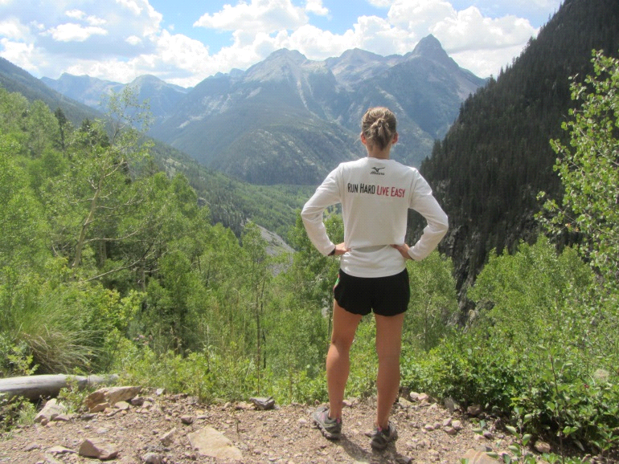

*“Life is either a daring adventure…or nothing.” –Helen Keller*

**Tools:** Responsibility (Ability to Choose), Perspective (Optimistic vs. Pessimistic), Mindfulness

**Objective:**

● To take ownership for one’s life

One of Helen Keller’s famous quotes is “Life is either a daring adventure…or nothing”. How is life either an adventure or nothing? Simple. We choose. Every person chooses how they live their life. We choose our actions, how we do things, how we see/perceive things. We choose whether to react or act to any given situation. Ultimately, we choose our life, making us responsible for ourselves and our past, present, and future. That responsibility is hard for many to accept, especially if he or she is not where they want to be in life. However, it is relatively simple (not necessarily easy) to flip that mindset, or any negative outlook. All it takes is a different way of perceiving things, or choosing to see things in a different, positive light. The basis for all this, as for almost all the steps to living life as an adventure, is mindfulness. In order to change our thoughts, we must be aware of our thoughts. When we (re)gain control over our minds, accept responsibility for our lives, choose to live adventurously, and commit ourselves to the task, we become powerful. It is only then where we will truly be free, making us the ultimate trailblazer in our own lives.

**Personal Examples:**

1. On a beautiful, warm and sunny day, I was on a training run at Mohican State Park in Ashland County, Ohio. I was feeling pretty good, and at the last water stop I still had a half bottle, which I figured was enough to get me through the last 3-4 miles. However, 2.5 miles later I found out that I had misjudged the distance, and actually had 6 miles left (another 3+ if I settled on a shortcut, but that only crossed my mind for about .5 seconds). By then, I was just about out of water, save for a few drops, and it was growing increasingly warmer. At that point (with the short cut option out of the picture), I could have done one of two things. A) Get mad at myself for being really stupid when I should have known better (the trail is always unpredictable) or B) Laugh at myself, get dehydrated, and keep running the best I could and finish with a smile on my face. I CHOSE B…and almost passed out at my car while trying to be polite and talk to people when all I really wanted to do was drive to the gas station and fill up on water. Still, I look back at that memory fondly. I guess you can say I chose to look at my water-bottle as half full and not as half empty…I know, not funny Rach!

2. This is a bit more of a serious example. It is the story on the decision I made to change my life and make it into an adventure. As many of my friends know, I started to suffer from depression in junior high (now called middle school) though the warning signs were apparent much earlier. It plagued me through high school and my first years of college. In the evening I would do my best to keep to myself in the dorm and away from social interactions, which was somewhat unnatural, even for my natural introversion. I won’t get into all the details, but I remember one time struggling to keep it together in class, and another time frozen in a fetal position on my futon. I saw myself as a failure with no reason to go on. Then one summer, with the quote “life is what you make of it” playing over and over again in my head, I realized I had a choice to make. I could give everything I had into making my life better, or the alternative …which I rather not talk about. I even wrote down a plan to help guide me. I’m not sure if I followed it completely, but the main part was that I had finally acknowledged my part in making the change, and I committed myself to it. Not so coincidently, this was also the time I began volunteering. My twin sister Sandi came to me with the idea to start Students Making a Difference (SMAD), a volunteer group for other college students that incorporated running. Research now shows that both can be used as tools to increase happiness. I’m not saying things were all rainbows and butterflies after SMAD took flight…I had days where I struggled, and still do. But, those days are decreasing every year. When I became aware of my choice to live life as an adventure, it helped me to become mindful of my decisions, and I regained power over my life.

**Adventure Meditation:**

This can be the hardest Step to Adventure. Committing to change one’s life can be scary. However, it is also the most important step as it is absolutely necessary to move forward and begin the climb.

1) Reflect: What is your definition of adventure? What does adventure mean to you?

Adventure as defined by Merriam-Webster:

1ad·ven·ture noun \ad-ˈven-chər\

1a: an undertaking usually involving danger and unknown risks b: the encountering of risks <the spirit of adventure>

2: an exciting or remarkable experience <an adventure in exotic dining>

2) On a long hike or run, imagine yourself in the following scenario or recall a similar situation from your past and ask yourself the following questions:

-Scenario: You are alone in the wilderness and it is 20 miles to the nearest town. You have all the basic supplies you need to make it through the day, but nightfall will bring the need for additional food and shelter. (If you’re a runner, this is the perfect meditation for a long solo run). Ask yourself:

* Are you going to reach your destination before nightfall?
* Is your speed too fast or too slow?
* Are you doing your best and enjoying the journey?
* Can you make it over all the hills?
* What will you do if you fall and get injured? Or make a wrong turn? Will you choose to get frustrated or react positively and learn from the experience?
* What kind of mood have you chosen to be in? Will you keep a positive or negative attitude?
* Are you tempted to give up on you adventure?
* What responsibilities do you have in the scenario? How does it mimic your daily life?

**Journal Questions:**

Take time to reflect on Helen Keller’s quote “Life is either a daring adventure…or nothing”. This is a great time to get out your journal and start writing.

* What does the quote mean to you?
* Will you choose adventure, or nothing (a life without change, risks, and excitement)?
* What are you going to do to make your life an adventure?

**Additional Resources:**

My favorite book on this subject is Viktor Frankl’s *Man’s Search for Meaning*. Jillian Michaels’ *Unlimited: How to Build an Exceptional Life* is also a great personal guide and tool with steps on how to make the most out of one’s life.

**Other fun reads:**

*Wild: From Lost to Found on the Pacific Crest Trail*- Cheryl Strayed

*Becoming Odyssa: Adventures on the Appalachian Trail*- Jennifer Pharr Davis

*Adventure is not about where you live, but how you think. It is not about what you do, but how you do things.

# Step 2: Know Your Roots:

# Growing from Your Values

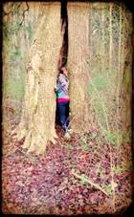

*“A tree with strong roots laughs at storms.” -Malay Proverb*

*“There are two gifts we should give our children; one is roots and the other is wings.” -Anonymous*

**Tools:** Mindfulness, Reflection, Responsibility

**Objectives:**

● To uncover one’s own personal values

● Examine how these values make up who we are and help us grow

● Review the role that our conscience and morals play

**Definition**:

**Values** are deeply held beliefs that guide our behaviors and decisions. They reside deeply within the subconscious and are tightly integrated into the fabric of everyday living. We make decisions and choose behaviors, friends, employment, and entertainment based, in large part, on our values.

(<http://suite101.com/article/development-of-personal-values-a33585>)

**Further Explanation**:

To rephrase in my own words, values are the center of who a person is and tie deeply in with one’s morals and conscience. When intact, values keep us grounded like the roots of a tree. The deeper our roots, the stronger we become and the higher we can grow.

Most of us developed our values in childhood from parents, religious groups, schools or friends. If we weren’t around people with good values, we may have had to weed them out as we grew up. On the other hand, we may have picked up some not-so-great values ourselves growing up, and they may still be clinging to us, weakening our true selves and suffocating our lives.

This is where self-reflection comes into play. If everyone takes time to look at their beliefs and what truly matters to them and why, we can rid ourselves of any negative things we picked up on, and continue to blossom in a positive direction.

**Summary:**

In order to grow high and full, extending all our branches, we must first know and deepen our roots, or personal values. When we obtain that deeply-rooted understanding of our values, that understanding can serve as a guide on how to live our lives and make the choices that are right for us. In difficult times, this helps ensure that we will always stay in line with who we truly are. We can always stand tall with whatever important life decisions we make, because we know that decision came from our very core. I’m not saying everything will always work out the way we want it to, but knowing we made the right choice for us, at that time, can keep us from looking back with guilt or shame (two very unnecessary and unhelpful emotions!).

Picture a tree with shallow roots in a flood. It easily gets swept away by the raging water. Then picture a tree with roots that go deep into the ground. When the flood passes, it is still there, just as strong as before.

**Adventure Meditation:**

On this hike, take your journal or a piece of paper and a pencil along with you. Hike as long as you want or until you find a strong, sturdy, beautiful tree that speaks to you.

Spend a few minutes sketching the tree in your journal, leaving space at the bottom for later on. It doesn’t have to be perfect!

**Journal Questions:**

Part 1:

* What is the first thing you see on the tree?
* What part(s) of the tree don’t you see?
* How is this tree comparable with a human? How is the tree like you?

Part 2:

* What does a tree need to grow?
* What do you need to grow? How can you feed your roots?

Part 3:

* Why is understanding and strengthening your values important? How can your values help you grow?
* What are your values?

(If you need some help, click on the following link:

<http://www.mypersonalimprovement.com/personalcorevalues.shtml>. It lists over 400 values!)

Finally, finish the sketch of the tree by putting your personal values at the bottom as its roots.



# Step 3: Follow Your Compass:

# Follow Your Passions and Understand Everyone’s Path is Unique

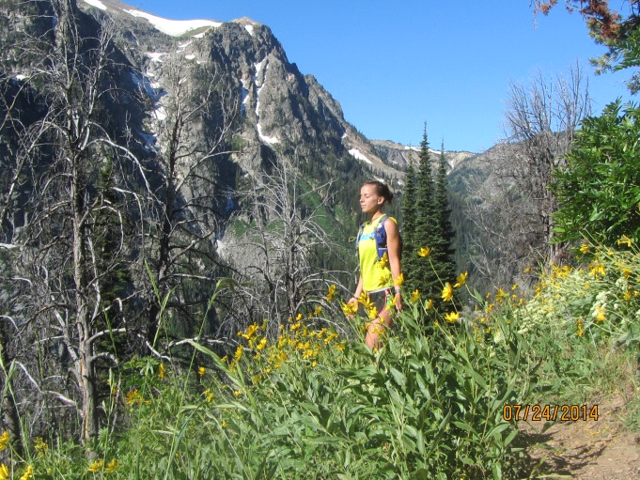

*“Do not go where the path may lead, go instead where there is no path and leave a trail.”*

*-Ralph Waldo Emerson*

**Tools:** Mindfulness, Awareness, Reflection, Decision Making, Trust, Inner Compass

**Objectives:**

* To discover your true passions
* To uncover your talents
* To realize that your passions and talents will lead you down a unique and beautiful path meant solely for you.

And Finally:

* To learn how to use your Inner Compass.*

*This is the first lesson where I’ve mentioned the tool “Inner Compass”, but it won’t be the last. While it is one of the most important tools we all have, it’s often forgotten. You might also refer to it as Spirit or Inner Guide (or ~ing if you’re a Gabrielle Bernstein fan).

This adventure is designed to help you understand and accept that everyone’s path, including your own, is unique and beautiful. An individual’s trail is created by their own passions and natural talents. This step requires bravery, as it is never easy stepping off what seems to be the main path, which is often flat and safe. However, when you decide to follow your own path, it will lead you on a journey in harmony with who you truly are. This will not only maximize the gifts you have to share with the world, but guide you towards personal fulfillment.

**Examples:**

First, I wanted to share an article I found while doing some research on the internet for this step. I thought it was a perfect example of what the goal of this lesson is: <http://www.dreammanifesto.com/hash-house-harriers-true-trail.html>

The second example is my personal one. It summarizes how I ignored my talents and strayed away from my passion (definitely not practicing mindfulness), becoming unhappy, and then how I was lead towards my true path and started to become happy (I am still working on it!).

From middle school thru my first two years of college, I let the game of basketball control my life. I worked at it as hard as my body and mind would let me. For a few years, it looked like all those extra sprint drills, free throws, and hours spent conditioning and practicing on my own were going to pay off. Then reality struck: I was only 5’3” and without any *natural* quickness and agility. I came to the heartbreaking realization that my dreams of playing in the WNBA weren’t very achievable. As a result, my mood and outlook on life took a nosedive. I ignored my values, strengths and what was really important. I failed to realize then that turning away from basketball to move on to activities that were more in line with who I was did not make me a quitter. It helped me grow.

Because my mind was so focused on only one objective, I ignored several hints and opportunities that would have gotten me back on track to finding my true trail a little sooner. For example, since age 8, Sandi and I would ride our bikes 20+ miles on the towpath with our dad. By middle school, I’d go for runs to stay in shape, relieve stress and simply because I enjoyed it. Then, when having to run multiple suicides during basketball practice, I’d often end up mid pack the first round. But by the end, I’d be finishing first (save for maybe my twin sister), seeming to gain speed as I went. There it was. I had endurance, and I had the potential to be an amazing runner, but I didn’t see that just then. Maybe I should have…looking back, I realized that one of the most profound decisions I made was declining my high school’s cross country coach’s offer to run for the team. He still jokes with me about it (he recently won his age group at my iBelieve 5k)!

While trail/ultra running for me certainly hasn’t been easy (I think that would be a contradiction in itself), it feels right. It makes me better, and does not leave my crying at night. Actually, I think it has saved me from depression. Instead of repeatedly running into a wall, I am moving forward…often uphill, but forward nonetheless.

**Additional Notes:**

Following you passions and talents to you rightful path should enliven and expand you. When you’re on the wrong path, you might feel depressed and fatigued. We know that being on the right path isn’t always easy, though. You still may second guess yourself, and you’ll have to learn to decipher the difference between your fearful ego and your true voice. The key is to just trust yourself. Listen to your heart first, then your head. With that, there are still going to be challenges, because that is how we grow (we’ll get more into that later). However, these challenges should no longer feel burdensome, but exciting to overcome. Be mindful that for some, there is no path to follow. You have to create your own.

Finally, I should mention the hardest part: letting go. You need to let go of any pre-conceived notions of what you should be doing and any other external factors. Just give it up. Easier said than done, right? Believe me, I know. The first step is to quiet your mind, relax, and ask your Inner Compass to point you in the right direction. We’ll get into more detail later.

**Meditation/Hike:**

1. Besides picking a trailhead, leave the route for the day’s adventure unplanned. Forget about mileage, pace, and leave the Garmin at home (and if possible, your phone and normal watch too). When you come to a fork in the trail, just pick the one you naturally go to. Just let your legs move and your mind relax and enjoy the surroundings. As you “go to your happy pace” (I have a *Girls on the Run* shirt top that says that!) let your mind drift and reflect on your life. Ask yourself what makes you happy, what motivates and inspires you, what you would do all day if money weren’t a concern. The key is to be honest with yourself. There is no one there to judge you, so leave the “this should make me happy” and the “this makes others happy” behind. The people who truly love you just want you to do what makes you happy anyway.

2. This is a great day/step to do volunteer work for your local park with trail maintenance. If you’ve gotten off your true trail, it probably needs to get cleaned up a bit. Sometimes a little bushwhacking is necessary to find it, garbage needs to be thrown out, or some invasive species removed. Plus, volunteering for a good cause always seems to help me keep things in perspective.

**Journal Questions:**

There are a ton of sites and books that can help a person uncover their passions. I’ve used Jillian Michael’s book “Unlimited” myself, but Gretchen Rubin’s blog (author of The Happiness Project) has a good list as well: [http://www.happiness-project.com/happiness_project/2013/05/how-well-do-you-know-yourself-take-this-quiz/.](http://www.happiness-project.com/happiness_project/2013/05/how-well-do-you-know-yourself-take-this-quiz/.%20) The most extensive is the Values in Action (VIA) questionnaire and probably extremely helpful for many people. This site requires creating a login and a password, as the results of the quiz (or other quizzes) may be used as part of a research study. However, it is a very safe site. <http://www.authentichappiness.sas.upenn.edu/Default.aspx>

Here are some other questions to consider:

* Are you on YOUR trail?
* If not, why not?
* What things have led you off your path?
* What are you passionate about? What activities do you look forward to doing?
* What motivates and inspires you?
* If you had one day to do anything you wanted, wherever you wanted, what would it be?
* What are your strengths? (You don’t have to think big on this one. For example: Are you a good listener? Can you empathize with people well? Do people rave about your granola bars? Do you always remember to send cards on birthdays? )
* Can you think of some people that are already on their true path?
* How can you get back on your trail? (What choices do you need to make? Are there activities you should get involved in? People you need to talk to? Etc.)

If you’re having trouble answering any of these questions, turn inward and let your Inner Compass guide you.

*“Let your heart sweetheart be your compass and your guide.” Lady Antebellum*

# Step 4: Decide on a Destination:

# Discover your purpose. Where do you want to go?

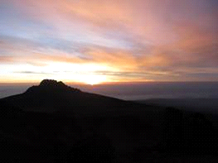

*“The clearest way into the Universe is through a forest wilderness.” –John Muir*

**Tools:** Introspection, Belief, Courage

**Objectives:**

* To examine what life is about
* To examine one’s own unique purpose
* To decide on a personal mission statement

**Destination Defined:**

Destination (<http://www.merriam-webster.com/dictionary/destination>)

1: the purpose for which something is destined

2: an act of appointing, setting aside for a purpose, or predetermining

3: a place to which one is journeying or to which something is sent <kept their destination secret>

A destination is much more than a goal, or where a person ends up. As stated in the above definition, it involves a *purpose*. For some, especially younger people, this is a potentially difficult concept to understand. However, this lesson will help one begin to think about the meaning of life, and in particular the purpose of one’s own journey.

The previous Steps *Use Your Roots and Find Your Trail* should have helped build the foundation for this lesson and have you facing in the right direction. Still, some may feel they are not ready for this step. I can understand that. If needed, take a few more weeks to focus on the past steps. Just don't simply stop short and skip this lesson because it is too challenging. This lesson is not about what you are going to do with the rest of your life, what your career should be, how many kids you should have, etc. Eventually these things will tie in, but it’s not necessarily right now. This step is about finding your destination, to reach the peak of WHO you are, not WHAT you are, and how that ties in with the universe.

**Examples:**

The story of John Muir is a perfect example of a man following his own trail (even when advised to do something else), finding harmony by living in tune with himself and nature, fulfilling his purpose, and reaching his destination.

Open the link below to view a brief summary of his life:

<http://ecotopia.org/ecology-hall-of-fame/john-muir/biography/>

After reading Muir’s biography, consider these questions:

* What signs did Muir have from a young age that led him to his path?

(Take note: He did make a wrong turn as a young man and it took a scary incident to get him back on the right trail. In other words, it’s okay if we fall off our paths. It just takes some tuning inwards to re-focus and get back on.)

* What was Muir’s goal when he set out on his first journey?
* What were some obstacles he had to overcome?
* By sticking to his trail, what did Muir end up accomplishing?
* What do you believe was John Muir’s purpose in life?

**Meditation/Hike**

1. Adventure Hike- Visit a Graveyard

(This may sound a bit morbid, but this is a great teaching from the late Stephen Covey.)

On today’s hike, visit a graveyard and check out some of the tombstones. Look at the dash between the person’s year of birth and year of death. What filled those years? See if you can read anything written on the tombstone. What does it say about that person? Despite not knowing the person who is buried there (assuming you did not find a relative), and despite them never becoming famous, do you think their life still had meaning?

2. Going back to the story of John Muir, take a break and sit down in any place in nature that feels comfortable to you. Take time to analyze your surroundings and how you feel in them. Muir also kept a nature journal, where he wrote down his observations. This helped connect him further to himself and the life around him. For a few more minutes, just take some time to describe what you’ve noticed and how being in nature makes you feel. This activity is meant to help you feel more connected to the universe, and your part in it (see quote at the beginning of this Step).

**Journal Question:**

Now it’s time to focus inward. Ask yourself: What do I want written on my tombstone? This should be a simple statement, one or two sentences. You can use a drawing of a tombstone to write inside, or just write it in your journal. Then, if you want to elaborate, write out your obituary. This is your personal mission statement. By knowing this and having it written down, you can live purposely en route to your destination.

With both meditations, you’ll need time to just sit in solitude and peace. Don’t rush this step. Let it come to you. It may come quickly for some but for others it will take much thought. Again, remember this is about the WHO and not the WHAT.

**Additional Example:**

Instead of closing, I figured I’d first share with everyone my personal mission statement. As it is personal, it can be a bit hard to share, so don’t feel the need to do so yourself, at least right away. On the other hand, sometimes I think sharing can help strengthen a purpose. Sharing your mission statement with a friend or significant other can also deepen the bonds in a relationship by examining how the two paths intertwine and examining the opportunity for mutual growth. Without further ado, here is my personal mission statement:

*To live an adventurous life of wild freedom, wings open. To empower others to spread their wings, realize their strength and beauty, and reach their highest peak.*

…Okay, now we have the groundwork done. You should be feeling pretty rooted right now and have a stronger sense of self.

The next few steps will focus on continuing to clear out unnecessary negative emotions and building up our strengths for a successful journey.

**Additional Resources:**

*7 Habits of Highly Successful People*- Stephen Covey

*Finding Your Own North Star: Claiming the Life You Were Meant to Live*- Martha Beck

# Step 5: Map Your Route:

# What path will guide you to your destination?

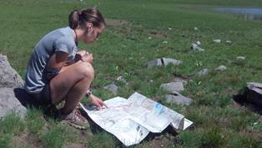

*“If one advances confidently in the direction of his dreams, and endeavors to live the life which he has imagined, he will meet with a success unexpected in common hours.”-*Henry David

Thoreau

*“You have brains in your head. You have feet in your shoes. You can steer yourself in any direction you choose. You're on your own, and you know what you know. And you are the guy who'll decide where to go.”-*Dr. Seuss

**Tools:** Goal Planning, Intuition (Inner Compass), Trust (Leading with Feeling), Surrender

**Objectives:**

● Acknowledge and understand the correlation between destiny and effort

● Activate one’s ability to move away from negative feelings and towards positive ones

● Create an action plan to reach your goal

**Destiny Defined** (defined by me):

Destiny-a predetermined event, situation, or future outcome controlled by a higher power designed for a specific person. Destiny is a given, but it’s much easier when you are in the flow.

This can be (and has been for me) a confusing concept to understand. Most of us have grown up believing that hard work will get us where we want (or think we want) to go. That modern belief usually doesn’t acknowledge how happy or fulfilled we feel at the present, just the future result of our hard work. If there is a setback or a door slammed shut, we have failed.

If you truly want to live your life as adventure, it’s time to change that perspective and how you define success.

It’s a challenging process, but the good news is that you already know your destination. You know who you want to be and how you want to feel. In this step, we are going to further develop your balance between destiny and the hard work you put into your journey. Then, we are going to map your route (though thanks to destiny, a lot more of it is complete than you might think).

**Example:**

Let’s go back to my personal mission statement (destination):

*To live an adventurous life of wild freedom, wings open. To empower others to spread their wings, realize their strength and beauty, and reach their highest peak.*

With my whole body and spirit, I know that is the key to my purpose in life. Once I had my statement down, I had to figure out the “how”.

Only I didn’t have to figure it out, I just had to be patient.

One night in a cottage in North Carolina, feeling slightly desperate for a job, I happened upon a job opening at Girls on the Run (GOTR) of Greater Summit. I submitted my resume and heartfelt (not exactly professional) cover letter right then and there. Long story short…within weeks I was working for my favorite for-purpose organization. Guess what their mission and vision statement is?

GOTR Mission: We inspire girls to be joyful, healthy and confident using a fun, experience-based curriculum which creatively integrates running.

GOTR Vision: We envision a world where every girl knows and activates her limitless potential and is free to boldly pursue her dreams.

Destiny? Absolutely.

**Reflection:**

Can you remember a time when someone in your life, or perhaps you, planned out a day or entire vacation only to have it completely fall to pieces? Maybe the weather didn’t work out, a person didn’t oblige, you got a flat tire, etc. How did you or the planner feel at the end of the day?

Now go back to a different memory. Can you remember a time when everything seemed to effortlessly go your way? Maybe it was the time you met the love of your life, or how you landed the career you were dreaming of. Or maybe it was a run, where you felt strong, fast, and free. You were in the flow.

When you are in the flow, things feel easy. You’re not pushing and running into brick walls nor are you constantly stressed with a growing to-do list. When you’re in the flow, you are coasting down the river in your kayak towards your destination.

That’s a sign that you are on the right path.

**Flow Defined:**

Flow (by Mihaly Csikszentmihalyi)- a state of consciousness where people are completely absorbed in an activity, especially an activity which involves their creative abilities. During this “optimal experience” they feel “strong, alert, in effortless control, unselfconscious, and at the peak of their abilities”.

**Further Explanation:**

In your adventure/life, things aren’t always going to go as planned. Just like the weather on a mountain camping trip, life is unpredictable. All you can really choose is your attitude and how you act in the given situation. And sometimes, you just have to surrender*.

This does not mean you can just sit on the couch and read a book. You will still hit rocks and possibly flip your kayak over. There is work involved, and hard work at that. Most people just have it a little backwards.

As mentioned above, many people work hard to try and force things to happen. They end up running into a brick wall again and again, and then want to slam their head into it. If I’m describing you, that’s a sign that it’s time to review and probably re-route the journey on your current map.

When you’re on your true path, you’ll know. The hard work isn’t really work. It’s play. Stress takes a backseat as you enjoy the journey. In addition, you might often feel as if you are being assisted along the way. The right person will appear, ideas flash into your mind, or a sign appears in a store front window.

That’s a tell-tale sign that you are not only in the flow, but in sync with your destiny.

*More on surrender in Step 7

**Meditation Hike:**

Now it’s time for you to map out the route for your next hike or run, preferably one of your longer runs or a multi-day backpacking trip. Before you leave, ask yourself these questions:

* What route will you take?
* What is your goal?

Remember to always keep your destination in mind.

**Post Hike:**

* Did your hike/run go as planned?
* Was the sun out the whole time or was there a torrential downpour?
* What was out of your control?
* What was in your control?
* Were you prepared?
* Did you enjoy the journey (present moment)?

**Journal Questions:**

Review your personal mission statement. In what ways are you already fulfilling that statement? How do you envision yourself living to further abide by that statement (your purpose)?

Once you have that vision in mind, we can finally start mapping your route.

The #1 key is to start from a place of Truth. That is why we did all the pre-work on your roots and destination. Your true path will come from your core, your passion, and what makes you feel alive.

You have two options to choose from. One is a bit more structured where you write out your goals and the other is a bit more free flowing where you get to cut pictures and post them on your Adventure (or Dream) Board. You can do a hybrid too!

Whatever you choose, I highly suggest writing down your goals and putting them in view. By keeping them in focus, you are also attracting your desires.

Option 1: Peak Goal Setting Model

The Peak Goal Setting Model will help you write out and clarify your goals. There are some instructions at the bottom to help you fill it out as well. As a heads up, we’ll go over the “obstacles” section more in the next steps. The peak goal setting model is attached.

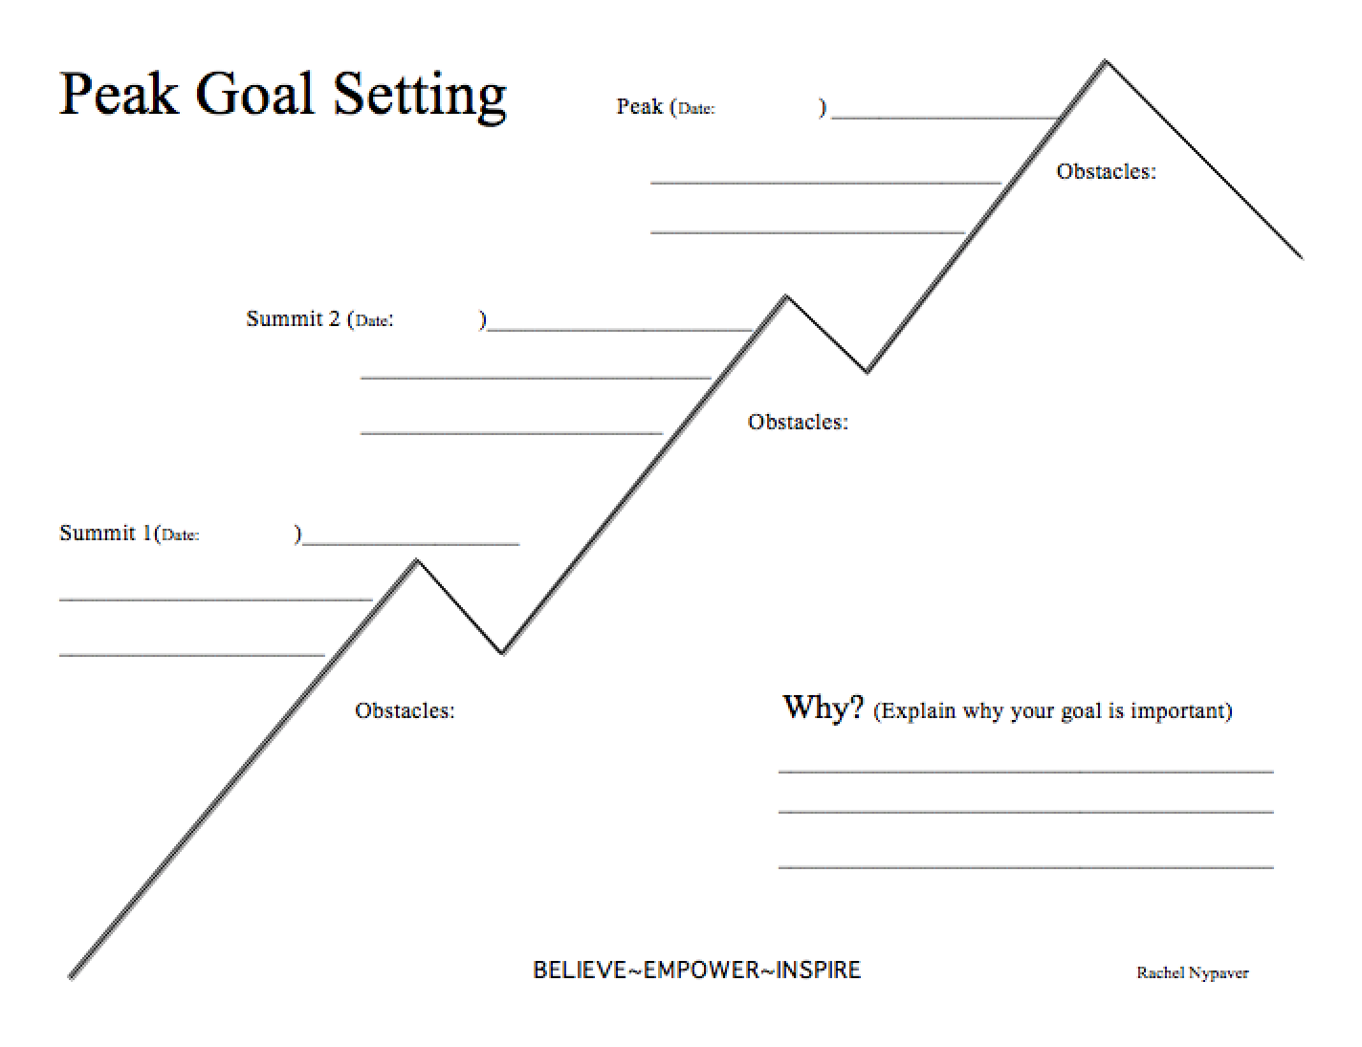

Peak Goal Setting Instructions:

Why/Explanation (top left side): The "why" is really the most important part. I would start with writing the goal in the elongated fashion and in the present tense ("to) and then why the goal is important to you. To get even more advanced, write how this goal matches with your values. Example: To run a 5k (present) because it will strengthen my ability to overcome adversity (why) and help me grow as a person (value).

PEAK (top of mountain): The long-term goal. For the picture's purpose, it can be written down in its simplest form. Write deadline underneath.

Summit 1 and 2: Short term goal that will help lead to the accomplishment of Peak Goal. (A summit goal may be all that is necessary for some). These should have deadlines as well.

Obstacles/Downfalls: It's important to know the possible barriers in the way of accomplishing your goals. The barriers could be external or internal. By being aware of them, you'll be better prepared to climb, go under, or go through them. These will also help you create the steps for your climb. (Ex. Busy schedule, kids, lack of motivation, bad weather)

The Climb/Action Steps: This is the active and "how" part. Write down all the steps on how you will actively climb to reach your goal. This is also can be used as a way to overcome the obstacles. Example: Meet with a friend to run, pack clothes and healthy snack to run after work.

Bottom: Just for fun and extra inspiration, write down your personal motto, favorite quote, or inspirational words.

Option 2: Adventure Board

This is a fun, crafty project that will not only help you map your route but also envision where you are headed. Get out some poster board or buy a tack board for a few bucks. From there, just grab some magazines or surf the internet for pictures of what you want to be doing as well as how you want to feel. Feel free to add on to this whenever you wish. Just make sure you stick it in a place where it’s easily visible to you.

*“Stay true to yourself. Never follow anyone else’s path. Unless you’re alone in the woods and you’re lost and you see a path. Then by all means, you should follow it.”* –Ellen DeGeneres

Additional Resources:

*Flow: The Psychology of Optimal Experience (Harper Perennial Modern Classics)* – Mihaly Csikszentmihalyi

*Steering by Starlight: Finding Your Right Life, No Matter What! -* Martha Beck

# Step 6: Pack the Right Gear:

# Are You Carrying Extra Baggage?

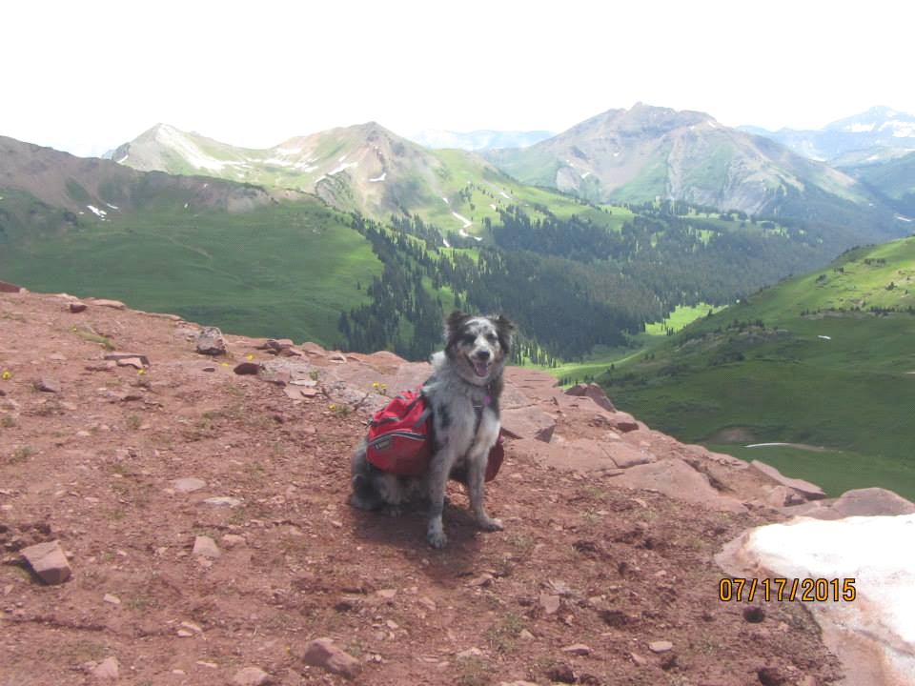

*“Simplicity is making the journey of this life with just baggage enough.”-* Charles Dudley Warner

*“Simplify, simplify.”*

- H.D. Thoreau

*“One “simplify” would have sufficed.”*

- Ralph Waldo Emerson in response

**Tools:** Reflection, Balance, Releasing, Being Present

**Objectives:**

● To acknowledge any extra “baggage” one is carrying, such as negative emotions from past experiences.

● To feel these negative emotions, then release them

● To start finding a healthy balance of wants and needs for growth and happiness

● To welcome and experience new positive emotions and feelings that enter your life

Now that you have a destination in mind, it’s time to start preparing for your adventure. You may have some special supplies, friends, and emotions to help you on your newly designed journey, but to fit it all in your pack you might have some letting go to do first.

We all know that carrying any extra weight on the trail is no good. Whether you are hiking or running, it can slow you down, be very uncomfortable, or be a downright pain in your back! On the other hand, not carrying enough isn’t good either. Running out of supplies with miles to go can lead to a very grumpy hiker/runner.

Finding that balance between having too much and not having enough isn’t always easy. For most, it takes a lot of trial and error and reflection on what went right and wrong. Example: “Okay, next time I run for two hours I only need to carry one water bottle and one gel.” Eventually, you’ll figure out what works for you. Just remember, what works for you may not work for someone else, and vice versa. Just keep in mind: if you don’t take the time to reflect, you’re not going to figure out what works and what doesn’t. Same goes for that other baggage we all carry…

The past is important and there is much to learn from it. It is not, however, meant to be dwelt upon. Once you take your lessons from it and reflect on some of the good memories, it’s time to be present. No need to worry about the future either, just keep a gentle gaze toward those distant mountains.

The problem is most of us are too stuck in the past or working so hard for the future that the present moment is all but forgotten…and then we wonder where the time went!

**Example Scenario:**

Pretend you are going on a weekend hiking trip with two friends in a beautiful mountain range. At the trailhead, everyone gets out of the car and grabs their packs. You notice your one friend’s pack is bursting at the seams, while the other has a pack that is smaller than your old book bag. Still, you figure it’s best not to say anything.

Within a few hours, things start to go awry. Your friend with the small pack is moving fast, not even taking a break at the overlooks to check out the amazing light and shadow display on the mountains. Your other friend is moving slightly faster than a snail’s pace, slowed down by the weight of the pack and already complaining of an aching back.

Fast forward to the next day, and everyone wants to quit. The friend with the small pack is trying to mooch off of everyone else and has missed all the views. The friend with the big pack is in pain. You are stuck in the middle, also not having fun being “weighted down” by the negativity of your buddies.

**Meditation Hike:**

You can do the meditation below literally or figuratively using mental imagery. I will use the word hike, but please feel free to interchange this with “run”.

*As you start off your hike, imagine yourself carrying a heavy backpack. Each step feels heavy and weighted. Not long into your hike, your back starts to ache from the heavy weight. The straps start cutting into your shoulders. Your breathing may even become shallow and labored.*

*Finally, you come to a halt. You cannot take any more of the pain caused by the heavy weight you are carrying. You take off your pack and open it. It is full of rocks. The rocks represent the extra weight you have been carrying around with you for the past year, 5 years, 10 years, 20 years, etc.*

*Put on the heavy backpack one more time. Feel its full weight. Take a moment to let it sink in.*

*Then, reach into your pack and take one rock out. It is labeled “guilt”. Hike with the rock in your hand for a few minutes. Feel its heaviness. Then begin to think about where your guilt has stemmed from. Maybe you feel you haven’t lived up to someone’s expectations, maybe those expectations are even your own. Or maybe you hurt someone, or someone else’s hurt was put on you. Whatever it is, let yourself feel it fully. Then let it go. Swing your arm back and hurl that rock as far as you can. It is no longer attached to you.*

*You pull out the next rock. It is labeled “unworthiness”. In your hand, this rock not only feels dense but sharp. With it come thoughts like “you’re not good enough”, “you can’t” and “you’re not worth it”. Reflect on when your feelings of unworthiness first began to creep up. Take a few minutes and just walk with these words and the feelings they conjure. Then release them. Take that stone and throw it through the trees and out of site. You are free from its weight.*

*Keep taking out the rocks in your pack. Do this exercise with each one. Feel its weight, think of where the feeling stemmed from, and then release it from yourself.*

*As you empty the rocks in your pack, feel yourself become lighter and lighter.*

*You hike on happily until you realize you feel empty. Something is missing. At first you can’t figure out what it is, but eventually it comes to you.*

*All the extra unwanted feelings and emotions you’ve been carrying around had left no room in your pack for the good ones. You missed out on letting in love, compassion, beauty, and grace. It’s time for you to let those in.*

*As you continue hiking, you see a tiny ball of light coming toward you through the trees. You are not afraid, and you let this brilliant light come through your chest and fill your body with love. Take in this feeling. It is yours to keep.*

*Continue letting in these little balls of light. They are full of kindness, compassion, strength and whatever else comes to you that you may have neglected. Feel their lightness, and their fullness.*

*You are full, but not weighed down. This type of fullness leaves you feeling happy and complete.*

*Your stride is no longer heavy and slow, but light and strong.*

*The energy is yours to keep for the rest of your journey.*

**Journal Questions:**

* What extra baggage (negative emotions/thoughts/experiences) have you been carrying? What about any people or things in your life?
* How did it feel to release them in the meditation? Do you need to do any additional exercises?

(Writing through them is a great start and enough for some, but a licensed therapist might be needed for others.)

* What do you need more of?

# Step 7: Make Hills into Opportunities:

# Let Challenges Make You Stronger

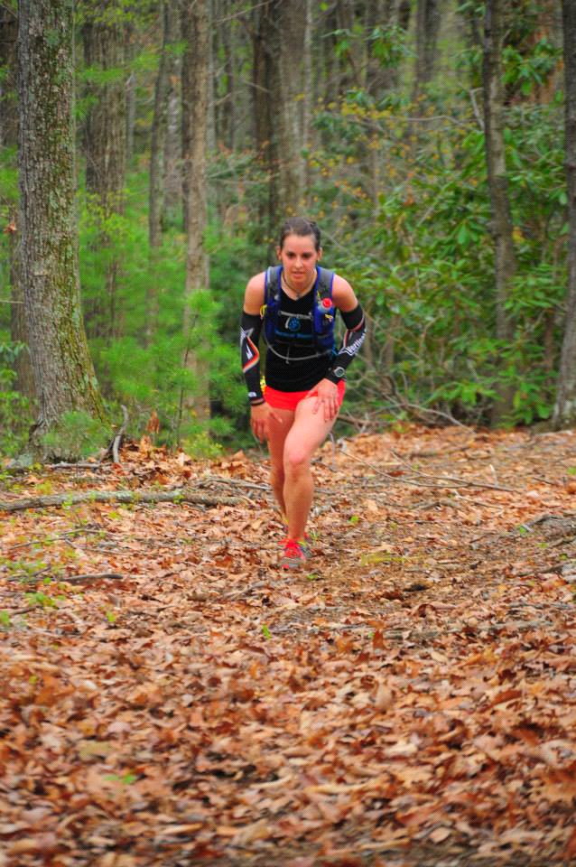

*Hills make you stronger- My Road ID*

*“It's our challenges and obstacles that give us layers of depth and make us interesting. Are they fun when they happen? No. But they are what make us unique. And that's what I know for sure... I think.” -Ellen DeGeneres*

**Tools:** Perspective, Flow, Surrender, Overcoming Obstacles

**Objectives:**

● To change one’s perspective on life’s hills

● Learn how to lean into the flow

● Re-define “surrender” and how to do it

**Flow and Surrender Definitions** (defined by me):

Flow- A liberating feeling when one is completely engrossed in activity, losing sense of time and ego and giving in to the present moment.

Surrender- letting go of preconceived notions, ideas, and events beyond one’s control to allow one to live freely. To do all you can, then give control to a higher power and let destiny take its course.

So now that you know your destination and have your route all mapped out, it’s all easy hiking from here, right?!

Yep, you are already calling my bluff (I’d be a terrible poker player).

While it is true that things will be simpler, less stressful, and enjoyable once you are firmly on your correct and destined path, it still won’t be easy.

You are still going to be faced with hills, or challenges in life that you must overcome. These hills are not a bad thing. They are going to make you a stronger, smarter, better person. Next time you’re faced with a new challenge, don’t get distraught. Change your perspective and get excited. This is where you get a chance to define yourself.

**Example:**

Many runners do a workout simply called “hill repeats”. It involves picking a hill (usually especially unforgiving) and running up and down it over and over again. Sounds crazy, but it’s one of my favorite workouts.

Why is this an effective workout? Because by running uphill repeatedly, the runner is breaking down his/her leg muscles so they can grow and heal stronger, making him/her a more powerful runner. In addition, when nearing a hill in a race his/her mental pattern will change (aka perspective) from “oh sh**” to “I’ve got this” from doing it repeatedly before.

On the other hand, it is possible to do too many repeats. Eventually, one can break down his/her leg muscles so much so that is takes weeks to recover from the workout. It makes the runner weaker, not stronger, and sets the training back.

How do you know when to push and when to pull back? How do you know when a challenge is an opportunity to grow stronger on your path, or when it is a sign that you need to stop and let go?

By staying connected to your true self and letting your inner compass guide you.

**To Climb or Not to Climb?**

When to ACCEPT the Challenge?

I love climbing up 14ers. I loved climbing up Mt. Kilimanjaro back in 2012. I also loved hiking the nearly 500 mile Colorado Trail (CT).

Funny thing about the word “love”… It doesn’t mean you enjoyed all of it, or even most of it. It doesn’t mean you were always happy or that it was easy. Often times you were quaking at the knees. Think of one of your strongest personal relationships. Is it always smooth and without conflict? I doubt it, but you still love the person.

Why do I love climbing 14ers when my quads are burning and I’m being whipped by a cold wind? Why did I love hiking the CT, despite getting lost, fighting exhaustion, getting stuck in hail, and not showering for weeks?

Because the hills and challenges I faced made me stronger and therefore made me grow mentally and spiritually. It is only when you put yourself out there, when you do something hard, that you can truly see and appreciate the beauty of your surroundings, the beauty within, and the beauty of your accomplishment.

As French Philosopher Andre Gide said: *“Men cannot discover new oceans unless he has the courage to lose sight of the shore”.*

Before I face obstacles, like a 14,000ft mountain, I’m excited. My energy is balled up within me, ready to complete the task at hand. It is something I want to do, though I may fear it.

When to SURRENDER?

Surrender seems like a big, scary word. Most people have come to find the word synonymous with failure*. Luckily, more and more researchers and public speakers are using it and people are beginning to realize how powerful surrender is.

So what does surrender mean? Wave the white flag? Give up? Absolutely not.

Surrender actually means to do everything you can, and then let go of the outcome. You give the outcome to the universe, or in adventure’s sake, Mother Nature.

* We’ll come back to failure in Step 8

**Last examples for Step 7 (I promise!):**

In July, when hiking Mt. Yale with my dog Pacer, we broke out of tree line to a gray sky and a bone chilling wind. As we continued to climb, it began to rain and I put on my poncho. We reached 14,000 ft and it was snowing. We tried to find the summit, but my hands were numb and I was stumbling on the rocks with the beginning stages of hypothermia. The summit was no longer important, as I simply cared for my own and my dog’s safety. We turned and ran back down, surrendering to the mountain, knowing we did our best and made the right decision. It will be there next year when we try again.

On the CT, Pacer and I were nearing the high point of the trail at 13,200+ ft in the evening. All afternoon I had been watching the clouds, debating if I should pitch my tent for shelter. When we got within a mile and half, dark clouds were building in the distance. Having no control over the weather, I didn’t know whether we should continue or hike to lower ground, so I surrendered to Mother Nature and prayed for a sign. Minutes later, the sky broke to my right and the sun’s rays formed a magnificent rainbow to my left. We had a calm and clear passage the rest of the way up.

**Meditation Hike:**

If you’re lucky enough to live in the mountains, plan to go up one for this hike. If that’s not an option, choose your hilliest route OR make it a hill repeat day.

In your journal, note beforehand how you feel. What sensations are arising in your body? What thoughts are going through your mind?

**Journal Questions:**

Now that you’ve overcome the climb, or at least did your best trying, again note your emotions* and your body’s sensations.

* Was the work and pain worth it? Why?
* Take a few minutes to write how this can translate into your everyday life.

*If you are feeling sad or disappointed from having to surrender your goal, or because the “big event” is over, take note of that too. Examine those emotions and where your thoughts are stemming from. Once you find their root, detach yourself from your emotions and regain your control over them.

**Final thoughts:**

Learning to overcome challenges is also working on perspective. Hills are no longer a reason to be frozen by fear, but an obstacle to move towards and overcome. This allows you to grow stronger, become a better person, and realize your potential as true mountain climber.

**Additional Reading:**

*Called Again: A Story of Love and Triumph*- Jennifer Pharr Davis

For more on surrender and racing, check out my blog: <http://rachelnypaver.blogspot.com/2014/03/surrender-sensitivity-strength-how.html>

# Step 8: Enjoy the Journey:

# Explore your surroundings and live in the present

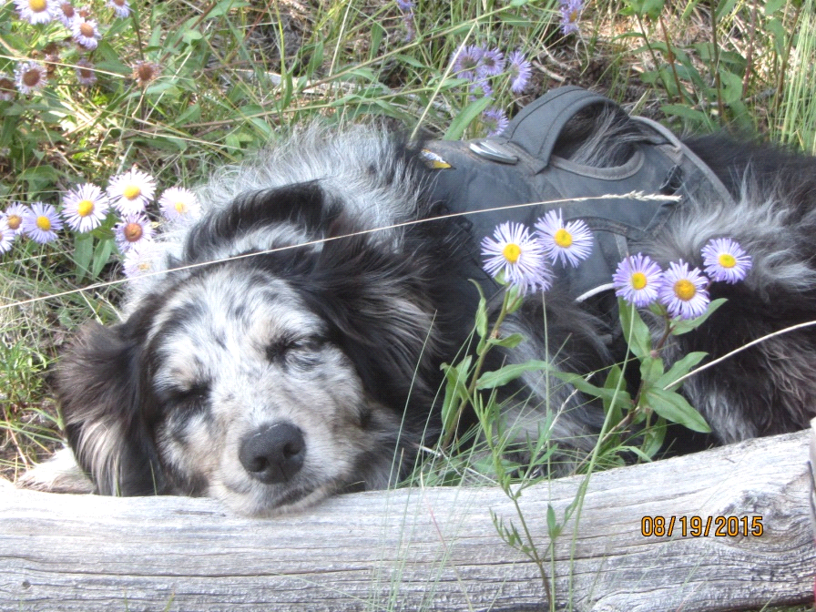

*“Hiking is, by definition, simply walking in a natural setting. But in reality, it is far more than that. It is a time of preparation and renewal. And in my opinion, the more fast-paced and overstimulated the world becomes, the more important it will be to take a walk in the woods.”-Jennifer Phar Davis*

*“Strange, what being forced to slow down could do to a person.”*

*― Nicholas Sparks, The Last Song*

**Tools:** Being Present, Centering, Self-Compassion

**Objectives:**

● Learn to live in the present moment

● Reclaim your innate “childish” inquisitiveness

● Acknowledge and accept when it’s time to slow down

You are nearing the end of this adventure’s trail. Most of the work is behind you. There’s no need to rush now. It’s simply time to slow down and enjoy what you have accomplished. Notice how the trees sway, how the sun’s rays sparkle in the creek. Hear the song of the birds, the buzzing of the bees. Take in today’s sunset because tomorrows won’t be the same.

Here’s the funny thing: while this is the simplest step, it will be the hardest for most people.

We live in a world where we are constantly wired in. Emails are always flooding your inbox, your phone lights up with texts, and Facebook’s newsfeed is constantly streaming. How are you supposed to stay present?

According to the Anxiety and Depression Association of America, 40 million American adults suffer from an anxiety disorder. Everyone is always thinking about the past and worrying about the future. Are you one of the 40 million?

Luckily, Mother Nature has your back. If you listen to her, she’ll give you a remedy on how to slow down and enjoy the now.

**Example:**

In the last week of my Colorado Trail Thru-Hike my dog and I were able, or rather forced, to slow down. In part it was because I was a bit ahead of schedule and had no reason to finish earlier as I didn’t have a ride home until Saturday. The other part is because on day 25 the rain continuously poured from the Heavens, leading into day 26.

Even after spending the better part of three days at 12,000+ ft in the San Juans, I felt like Day 25 was the peak/climax of my adventure. I was doing what I was most afraid of...hiking in the cold rain, in conditions that for me most likely lead to hypothermia. I made it through, smiling to myself at times with pride. However, on the morning of Day 26 it continued to rain and I had little motivation (or need) to go back out and hike in nature’s cold tears. As usual after the climax, this ended up being my time to process and learn. Here’s my journal excerpt from that morning:

“...Pacer and I decided to stay in our tent as it continued to rain and the clouds hung low. I ended up doing things slowly- braiding my hair, examining a bruise on my back, and brushing Pacer. I finally took some time to meditate too, mainly my own version of the Loving Kindness Meditation. Finally, I decided to crawl back into my sleeping bag and Pacer cuddled next to me. We simply laid there as the rain went tap, tap, tap on our tent. I wondered if everyone else had the chance to be so lucky...simply to be still and listen to nature with someone they love, maybe or maybe not a dog, or simply with the peace of their own spirit.”

And so it was, on Day 26, that Mother Nature forced me to stop, breathe, and enjoy the beauty of the world. Ironically, the beauty I needed to see most was not in the majestic views I witnessed climbing over each pass, but the beauty within my tent, within myself.

**Meditation Hike:**

For this meditation, your goal is to do as little as possible. Simply find a spot in nature that calls to you and find a space to sit quietly. (I realize you may already be squirming right now, so I’ll allow you to hike or run to your quiet spot in nature. Still try to do this movement meditatively, using all of your senses.)

If you are so inclined, feel free to bring a loved one along , whether it be your dog, spouse, best friend, etc., just as long as they too can be at peace with the stillness within.

In the next 10 minutes, hour, or whatever spare time you have, take this time to let your body and mind be still and just notice your surroundings. Most likely, you’ll start with the larger expanse then whittle things down to the swaying of the trees, the bee buzzing nearby, and finally the subtleties of the flower or blade of grass right next to you. Just do what feels right for you. Your mind may wander and that’s okay. When you realize it, just let the wind pick up the thought and carry it away for the time being. Feel free to close your eyes. Let your sense of smell and hearing increase or just focus inward. If compelled, feel free to go into a favorite guided meditation or the Loving Kindness Meditation (link below).

When finished, move slowly, thoughtfully, and with reverence.

**Journal Questions:**

For this journal entry, there are no specific questions. Just write what you feel. It might describe the scene in nature you have meditated on, how you’re feeling within, or a new insight that has come to mind. Whatever it is, just write it.

Later on, if you have thoughts and ideas on what “enjoying the journey” and “slowing down” mean to you and ways to improve on either, jot those down too.

**Additional Resources:**

*The Power of Now: A Guide to Spiritual Enlightenment* - Eckhart Tolle

Loving Kindness Meditation <http://palousemindfulness.com/docs/lovingkindness-med.pdf>

# Step 9: Inspire Others, Be the Change:

# Share your trail lessons and help others live life as an adventure too.

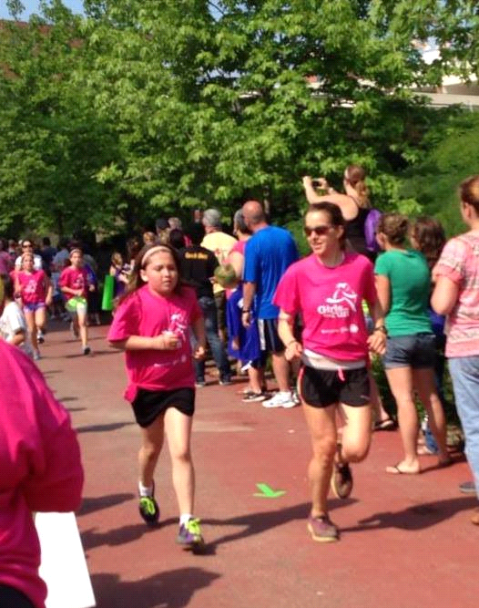

*“Be the change you wish to see in the world.”- Mahatma Gandhi*

**Tools:** Compassion, Spreading Your Light

**Objectives:**

* To share your Inner Light and new wisdom with the world
* Encourage and help others live life as an adventure
* Spread compassion

This is truly the most beautiful step. It’s the last few strides of your current “trials and trails” adventure and the first few for someone else. This is also the beginning of a new cycle for you, a new adventure. Each cycle is one of continual exploration, learning and compassion, each one building upon the next. It’s your time to create a ripple around the world.

Remember though, the ripple can be subtle and it often starts small. But it is still creating change. Do you remember the starfish story? If not, it’s time to revisit it:

**The Starfish Story**

A young man is walking along the ocean and sees a beach on which thousands and thousands of starfish have washed ashore. Further along he sees an old man, walking slowly and stooping often, picking up one starfish after another and tossing each one gently into the ocean.

"Why are you throwing starfish into the ocean?" he asks.

"Because the sun is up and the tide is going out and if I don’t throw them further in they will die."

"But, old man, don’t you realize there are miles and miles of beach and starfish all along it! You can’t possibly save them all, you can’t even save one-tenth of them. In fact, even if you work all day, your efforts won’t make any difference at all."

The old man listened calmly and then bent down to pick up another starfish and threw it into the sea. "It made a difference to that one."

(Adapted from *The Star Thrower* by Loren Eiseley)

**Meditation Hike:**

This hike or run is all about reflection. As you’re moving down the trail, begin to think about all the lessons you’ve learned about yourself in the past few weeks, months, and years. There will probably be a few that really stand out. How have they caused a ripple in your life?

As you think about you new knowledge, start to think about how you can share this “gift” with others. You don’t have to come up with anything concrete right now. Just brainstorm issues you are passionate about and possible ways you can give back.

**Journal Questions:**

Give yourself some time after your hike to let your mind settle. When you’re ready, write down the reflections of your journey, highlighting the main lessons you’ve learned. The lessons may have led to a change of perspective or new way of doing something. Just let it your hand flow!

**Take Action:**

Now it’s time to BE the change. Schedule time to volunteer at a for-purpose organization (charity) with a cause that is close to your heart. It can be a one-time opportunity, like helping to build a house with Habitat for Humanity or serving dinner at homeless shelter, or a long-term commitment such as coaching for Girls on the Run or joining a tutoring program for inner-city kids. Or, schedule a two in one: finally schedule that adventure to Africa or Nepal that you’ve always wanted to take and volunteer at an organization in conjunction with your explorations. (When I went to Tanzania, Africa I went through Cross Cultural Solutions. The program included food and board, cultural lessons and side trips, tutoring at an elementary school for three weeks, and visiting other non-profits. I finished the trip off with a hike up Mt. Kilimanjaro and exploring a nearby village.)

**Additional Resources (just to get you started):**

*A Path Appears: Transforming Lives, Creating Opportunity* - Nicholas D. Kristof & Sheryl Wu

*Making Kind Choices: Everyday Ways to Enhance Your Life and Avoid Cruelty to Animals*

-Ingrid E. Newkirk

# Step Every Single Day: Believe in Yourself

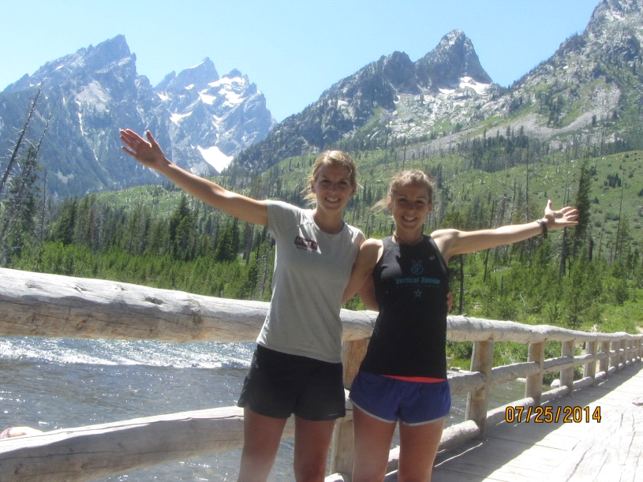

*“The future belongs to those who believe in the beauty of their dreams.” -Eleanor Roosevelt*

*“The greatest gift you can ever give someone is to believe in them.*

*The greatest gift you can ever give yourself is to believe in yourself.” -Me*

Life changes when you have someone who believes in you. It transforms when you begin to believe in yourself.

The power of belief is stronger than many imagine. It is the power of belief that causes people to run marathons, climb mountains, leave steady jobs to pursue passions, and chase the life they always imagined.

Personally, my life changed when my best friend and twin sister told me she believed in me. Because of her, I ran my first marathon and then my first 100 mile ultra-marathon just over a year later. She inspired me with her endurance feats and trekking across the Baffin Islands with Impossible to Possible. Even more so, she impressed me with her drive to make a difference and give back to the world.

As I began to take more chances and gain confidence, I ran more ultras, took a trip alone across the world, and thru-hiked the Colorado Trail with my dog. I no longer see my life as confined to a straight and narrow path, but as a huge expanse of mountains and valleys.

You have now completed the Steps to Adventure. Where is your inner compass pointing to now? What excites you and sets a fire in your belly? Your feet, mind, and heart are ready to take the next step. So...

Where will your daring adventure take you?

Additional Resources:

<https://www.youtube.com/watch?v=8BPZNy0mzMU>

<http://rachelnypaver.blogspot.com/>

# Acknowledgments

As with most creative works, there are more people I wish to thank then I can possibly type in one page. If you are one of those people, please know that I am forever in awe of you and continually feel the blessings you have left in my life.

However, there are a few people I must name…

First and foremost, I thank my sisters. Thank you for standing beside me, as best as we all knew how, through a somewhat emotionally tumultuous childhood. Sandi, my twin, my other half, my soul, my spiritual guru…I don’t know where I would be without you. Thank you for helping me re-learn how to fly. Amanda, this book would not have been complete without you. Please share your intelligence beauty with the world. I love you both more than I could ever express in words.

My parents, who gave me life. Mom, thank you for letting me run wild as kid, letting me get lost and scraped. Dad, the biggest kid I know, you’ve given me everything you could and more. Thanks for giving me your blessing despite my untraditional path.

Julie, my soul twin (just swapping out the trail shoes for a mountain bike and brown hair for curly blond hair!), I thank you for the light you have shed on my life, despite are short interactions. I’m certain are paths will align again in the future.

I of course can’t go without thanking my dog, Pacer. You drive me crazy (and can’t read) but you have been one of my greatest teachers and companions. We may both have our flaws, but that is okay. Our love is unconditional.

Steve, thank you for giving me time to work on this. I will forever be grateful.

Finally, to my newest friend. Thanks for the final vote of confidence.

# About the Author

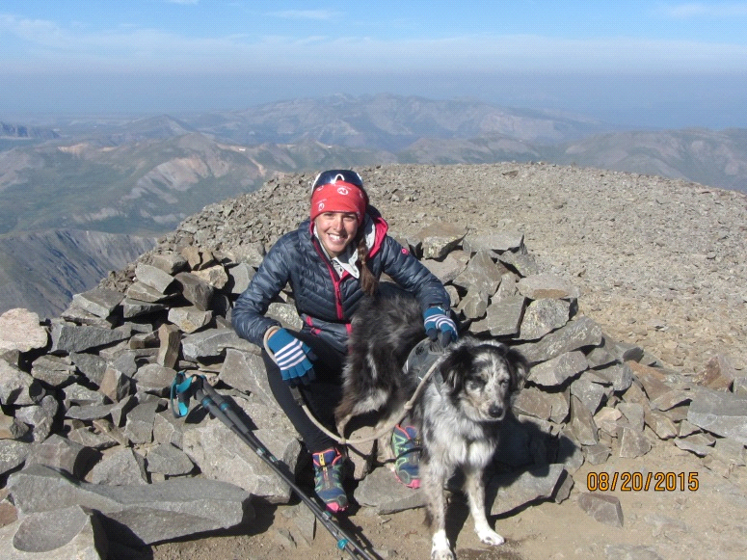

**Rachel A. Nypaver** currently lives in Boulder, Colorado with her daughter, an Australian Shepard named Pacer. This fall, she will attend Naropa University to pursue a Master’s Degree in Clinical Mental Health Counseling with a concentration in Transpersonal Wilderness Counseling.