
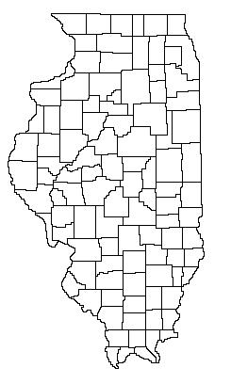
Illinois Prosecutor Services, LLC
Don Hays
PO Box 722
Carlinville, Illinois 62626
Office Phone: (217) 854-8041 Fax: (217) 854-5343
Webpage: www.ipsllconline.com
Email: don.ipsllc@gmail.com

LEGISLATIVE ANALYSIS OF THE MONTH – December 2018

New Illinois Law Synopsis
On January 1, 2019, all vehicles who drive on Illinois roads, even vehicles registered in foreign states, must be covered by liability insurance or they will violate this subsection of the Vehicle Code. Public Act 100-828 will require that all persons who operate a motor vehicle on Illinois roads must be covered by a liability insurance policy and must also carry proof of that insurance within their vehicle. This legislation removes all doubt that the Liability Insurance requirement of the Illinois Vehicle Code now applies to drivers who are driving vehicles that are registered in another state on Illinois roads.

ILLINOIS VEHICLE CODE – Liability Insurance – LEGISLATIVE ANALYSIS

Vehicle Code

HB-4472 Short Description: VEH CD-LIABILITY INSURANCE

STATUS: Public Act: 100-0828. Eff: January 1, 2019.

Statutes Amended: 625 ILCS 5/7-601
Synopsis as Amended: Amends the Illinois Vehicle Code.

1. Provides that no person shall operate a motor vehicle registered in another state upon the highways of this State without a liability insurance policy.

2. Provides that the operator of the vehicle shall carry within the vehicle evidence of the insurance.

3. Makes conforming changes.
VEHICLE CODE – Liability Insurance - STATUTORY TEXT
Section 5. The Illinois Vehicle Code is amended by changing Section 7-601 as follows:

(625 ILCS 5/7-601)

Sec. 7-601. Required liability insurance policy.

(d) No person shall operate a motor vehicle registered in another state upon the highways of this State unless the vehicle is covered by a liability insurance policy. The operator of the vehicle shall carry within the vehicle evidence of the insurance.

