Modern Slavery Statement | 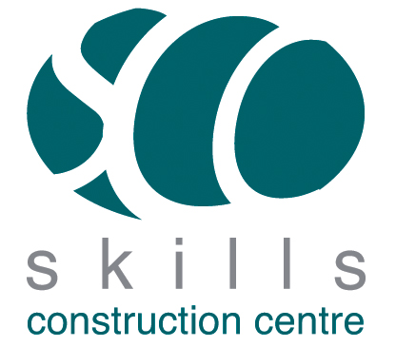

The following policy applies to all core business as well as ESF projects and provision.

Modern Slavery and Human Trafficking

Skills Construction Centre will comply with the laws and regulations relevant to our business, but we will also constantly seek to go beyond these standards.
Skills Construction Centre has a zero tolerance approach to modern slavery and human trafficking. Skills Construction Centre is an ethical company that strives to maintain integrity, transparency and respect throughout our business practices.
In developing our strategy and policy in relation to modern slavery and human trafficking, we take the following actions:
- Skills Construction Centre carry out Right to Work and Pre-Employment checks on all employees that join the company. This includes checking their personal identification documentation. Any discrepancies identified are thoroughly investigated and appropriate action is taken. We aim to encourage openness and support anyone that suspects modern slavery associated with the company or our supply chain, by confidentially speaking direct to our HR department. The Government also provide a 24-hour modern slavery helpline and the number is available to all company employees.
- We are fully committed to working with our stakeholders, employers and our supply chain partners to support human rights and the welfare of their employees, our learners engaged in apprenticeships, work experience and learning in centre. Skills Construction Centre will provide support and work to develop our stakeholder and employer partnerships to ensure that they also commit to our transparent strategy of anti-slavery through a robust learner safe guarding approach. We strive to take measures to prevent the occurrence of modern slavery in our company or within our stakeholder partnerships by monitoring the effectiveness of these measures.
- Skills Construction Centre will ensure that we identify modern slavery and human trafficking risk within our business ,partnerships and where applicable supply chain which will remain under review. Skills Construction Centre will implement this Modern Slavery and Human Trafficking Policy by communicating it to our employees, suppliers, subcontractors and external stakeholders.

This policy will be reviewed on a bi-annual basis except where legislative or changes to business require.

