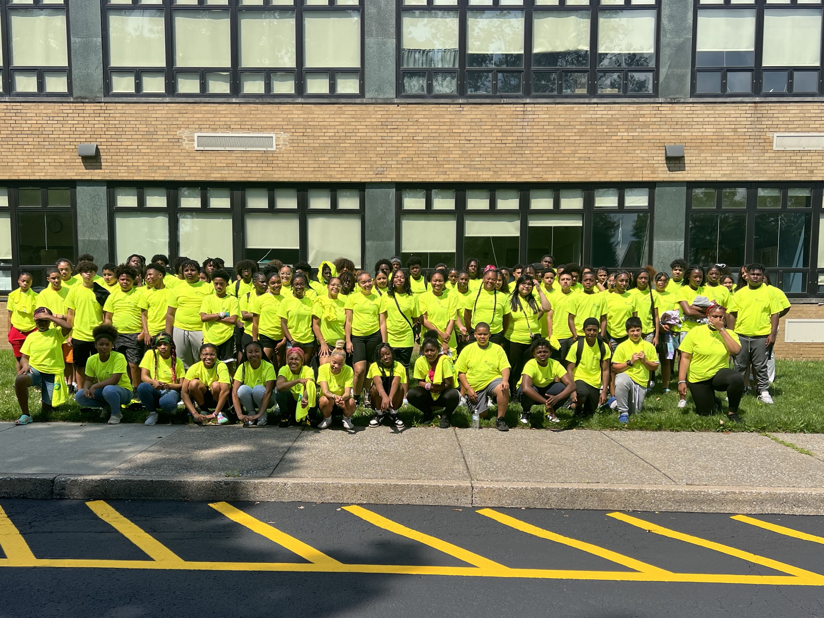  summer growth program’s  environmental teen corp  LEARN AND EARN  The Harrisburg Housing Authority and the City of Harrisburg is again gearing up for the award-winning Summer Growth Program. We would like to invite your teenager(s), ages 13 to 16 years of age (as of July 1, 2026), to participate in this years annual Summer Growth Program for teenagers. This program will provide an experience in which your child/children will get the opportunity to learn and earn while, also, helping improve their community as well as the City of Harrisburg. The teenager will receive a $1,500 stipend for his/her completion and successful participation in the program. The program will begin on July 6 and run through August 11.  For more information contact Clarence Watson, Program Director.  Email: clarencew@harrisburghousing.org  Cell: (717) 503-8066  Website: www.authorityteen.com
  CONNECTING TEENS TO THE COMMUNITY AND TO A BETTER FUTURE
  How do I get my teenager registered?
  Fill out the registration and consent form. Submit the completed form to any HHA Community Offices
  HHA Community Office Locations
  HHA Leasing Office Hall Manor Hoverter Homes William Howard Day
  You Have Room for Another One Here!
  Deadline for applications friday, june 19th

