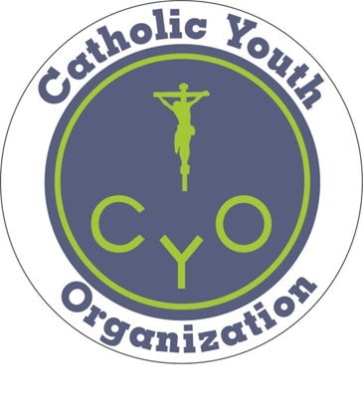
FINAL
7/20/2018
ROMAN CATHOLIC DIOCESE OF ALBANY
CATHOLIC YOUTH ORGANIZATION (CYO)
CODE OF CONDUCT

TROY AREA CYO LEAGUE ABIDES BY THE DIOCESAN CODE
1. COACHES
Acceptable Standards of Coaching Behavior include:
- Set a good example for players and fans to follow, exemplifying the highest moral and ethical behavior;
- Respect the judgment of the officials, abide by game rules;
- Treat opposing coaches, players, and fans with respect; shake hands after the game;
- Instruct players in sportsmanship and have them display good sportsmanship;
- Coach in a positive manner, reflecting Christian values.
Penalties:
- Any coach ejected from a game because of unsportsmanlike conduct will be suspended for the next two games and may be subject to additional penalties.
- CHURCH RELATED PROGRAMS: Any coach who does not abide by the Diocesan Safe Environment Program which includes a Criminal Background Check Virtus Training, Standard Code of Conduct, and Technology and Social Media Policy may be suspended for the remainder of the season and may be disqualified from CYO participation.
- NON AFFLIATED PROGRAMS: (AGENCIES, PUBLIC SCHOOLS ETC) All coaches, volunteers should have background checks as part of your program criteria.

2. PLAYERS
Acceptable Standards of Player Behavior include:
- Treat opponents with respect; shake hands after the game;
- Respect the judgment of officials and abide by the rules of the game;
- Accept seriously the responsibility of representing the parish by displaying positive behavior at all times;
- Play in a positive manner, reflecting Christian values.
Penalties:
- Any player ejected from a game because of unsportsmanlike conduct will be suspended from the next game and may be subject to additional penalties.
- Any player who intentionally harms another player, participant or official may be suspended from play for the remainder of the season and may be disqualified from CYO competition.

3. SPECTATORS
Acceptable Standards of Spectator Behavior include:
- Remember that the players are children and are playing for their enjoyment, not yours;
- Respect decisions made by the officials;
- Be a role model by positively supporting teams and by not shouting instructions or criticism to the players, coaches, or officials. Do not coach from the stands;
- Make no derogatory comments or gestures to players, coaches, other spectators, officials, or league administrators.
Penalties:
- Participating teams and their coaches are responsible for the conduct of their spectators.
- Any spectator who displays poor sportsmanship may be removed from the facility by an official, their team coach, a league official, or the host gym person-in-charge.
- Any spectator who interferes with a CYO activity may, at the discretion of the parish, league, or the Diocese, be barred from attendance at subsequent CYO activities.

4. GAME CLOCK & SCORE BOOK VOLUNTEERS
Acceptable Standards of Scoring Volunteer Behavior include:
- Remain neutral and only interact with referees upon request (e.g. - game rule situations; number of team fouls, etc.);
- Do not interact with either team unless requested to do so (e.g. – coach asks for number of time outs left, how many fouls by a player, etc.);
- Do not coach from the scorer’s table;
- Make no derogatory comments or gestures to players, coaches, parents, officials, or league administrators.
Penalties:
- Participating teams and their coaches are responsible for the conduct of their volunteers.
- Any volunteer who displays poor sportsmanship may be removed from the facility by an official, their team coach, a league official, or the host gym person-in-charge.
- Any volunteer who interferes with a CYO activity may, at the discretion of the parish, league, or the Diocese, be barred from volunteering or attending subsequent CYO activities.

5. ENFORCEMENT
The league and parishes, under the supervision of the Diocesan CYO Director, Area CYO Directors, and the CYO Commission, shall enforce this code. Complaints regarding violations of this code shall be first brought to the attention of the Athletic Directors of the parishes involved. Coaches, players, or spectators may be barred from participating in or attending CYO activities for their actions.

Revised 7/20/2018

