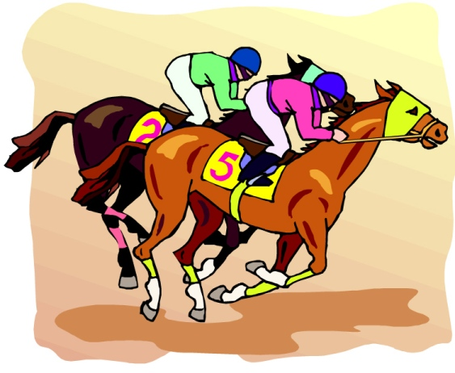
This Photo by Unknown Author is licensed under CC BY
TROY CYO CENTER FUNRAISER
NITE AT THE RACES
SATURDAY March 23rd
AT
THE TROY CYO CENTER
237 4TH STREET
TROY NY 12180
DOORS OPEN AT 6PM
$10.00 BUYS YOU HORSE & YOUR ADMISSION THAT EVENING
WINNING HORSE WINS $40.00
FREE BEVERAGES, GAMES OF CHANCE, POPCORN, PIZZA. PULL TABS, BETTING WINDOWS, little hot dogs, CHINESE AUCTION..
FEEL FREE TO BRING YOUR OWN BEVERAGES & FOOD.
FOR TICKETS & MORE INFO PLEASE CONTACT THE CYO CENTER 518-274-2630 OR KELLY 518-495-1583
ID# 22 220 3966 TROY YOUTH ASSOC INC
This Photo by Unknown Author is licensed under CC BY

