2ND Annual Humble/Kingwood VFW
Car & Truck Show

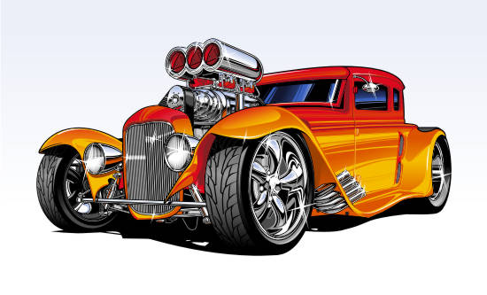
Kingwood Harley Davidson
November 3, 2018
10am-2pm
Dedication Ceremony & Awards at 3:00pm

50/50 Drawing, Door Prizes, Music, Food,
Silent Auction, HUGE raffle section
Dash plaques & goodie bags for the first 100 entrants

Entry fee $25 before Oct.25, $30 after Oct.26/day of event

Trophies-Cars judged by crowd, plus add’l VFW trophies

*This car show is being dedicated in memory of
Capt. Randy Eaves of the
Montgomery County Sherrifs Dept.

Visit www.VFWHumble.com for more info!

