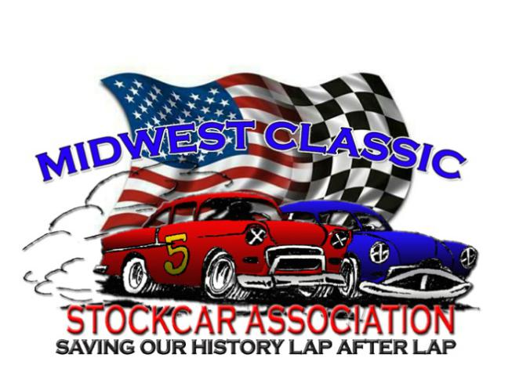PD_______
2022 REGISTRATION FORM $25 Fee

NAME: _____________________________________________________________________________

ADDRESS ____________________________________________________________________________

CITY, STATE, ZIP _______________________________________________________________________

BIRTHDATE: _____/______/_______ Nickname____________________________________

PHONE NUMBER(S) _____________________________Cell #__________________________________

EMAIL ADDRESS _______________________________________________________________________

YEAR/Make/Model ________________________________________________ Car#________________

Eric Cerny Cell: 402-615-2840 Email: MCSA00@live.com SSN:_____________________________

I hereby allow MCSA to use my information and images for the purpose of promoting the series:

MCSA Rules of Conduct and Competion
- Have FUN!!! That’s what we’re here for!
- Remember this. This is not the class for the person who has to win all the time; it’s for the guy who just has to RACE! We are here to have FUN and put on a show for the fans in the stands.
- Rough Driving will absolutely NOT be tolerated!! We do understand accidents happen, but if you make contact with a person to pass them, you must give back the position for a lap or you will be disqualified!
- We do love close racing, but please give cars sufficient room. Do NOT dive under a car unless you are sure you can hold your line and not slide up into them.
- If a car is trying to pass you, give them a fair line. If they are to your door they have position, do not pinch them down. Not saying you have to move over and give them the position, but don’t try to push them down if they’re alongside you.
- Yes, we do allow mirrors, this is for 2 reasons. So you know if you’ve checked out on the pack, and so you are not sliding up into a car behind you or pinching them down. They are NOT for blocking.
- Penalties for rough/over aggressive driving will be as follows: 1st offense, Loss of money for the night. Will go to Banquet Fund. 2nd offense, 2 race suspension. 3rd offense, Banned from all MCSA events!
- Once you have won a race, the Driver and Car are ineligible to win the next 2 events they attend! Not saying you can’t run 2nd and challenge leader, but if something happens to them, you better be prepared to pull off or let someone by. Race Director will use judgment if needed.
- Failure to obey this rule will result in your immediate disqualification from the event and a minimum of 2 races added to your non-winning time. 2nd offense will be suspension. 3rd Expulsion from the group
- All Cars MUST pass a pre-race check before being allowed to compete. Especially for safety! We may grant you a few races to change other faults on your car. Top 4 cars WILL weigh after the feature and report to Tech. Failure to do so will be immediate disqualification. Any car found illegal in Tech will be DQ’ed . 2nd offense will result in Suspension
- ALL Drivers, including subs, must read and sign this BEFORE being allowed to compete.
- In the event of an ON track altercation, STAY IN YOUR PITS after the race! Do NOT confront the other Driver! This includes your Pit Crew. You ARE Responsible for your Pit Crews actions!! This includes ANYONE that comes into the pits with you!! Bring your concern to the Promoter/Race Director. We will review the situation and handle it! We definitely will NOT tolerate on track retaliation or threatening another Driver! These are nice cars; we want them to stay that way!
- Remember this. YOU are what make the show! YOU are what keep this group going! We know it’s impossible for all of you to make every race, but we really need you at these shows! Please try to let us know if you are attending an event, so we can try to all park together
- Pit meeting is MANDITORY and will try to be held before Hot Laps
- NO FIGHTING, YELLING, OR WHINING.. We are Adults, let’s act like it. This includes Social Media! You have a problem with someone; come talk to Promoter/Advisory Board. Remember this is supposed to be FUN!
I have read and fully understand all the above rules and guidelines and accept any and all consequences for my failure to follow any of the rules and guidelines.

Signed: _____________________________________________________Date:_________________

