***2022 MCSA Race Schedule***

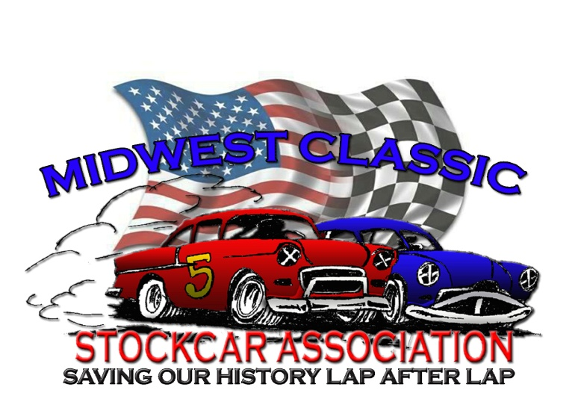

**Saturday, May 21 Park Jefferson Speedway, Jefferson, SD**

**Friday, June 3rd Boone Co. Raceway Albion, NE**

**Saturday, June 11th Off Road Speedway Norfolk, NE**

**Thursday, June 16th US 30 Speedway Columbus, NE**

**Saturday, June 25th Junction Motor Speedway McCool Junction, NE**

**Friday, July 1rst Boone Co, Speedway Albion, NE**

**Saturday, July 2nd Lincoln Co. Raceway EXPO North Platte, NE**

**Sunday, July 3rd Dawson Co. Raceway Lexington, NE**

**Saturday, July 16th Off Road Speedway Norfolk, NE**

**Sunday, July 31th Raceway Park Jefferson, SD**

**Saturday August 6th Off Road Speedway Norfolk, NE**

**Friday, August 12th Thayer Co, Speedway Deshler, NE**

**Saturday, August 13th Junction Motor Speedway McCool Junction, NE**

**Saturday, September 17 US 30 Speedway (Abe Memorial) Columbus, NE**

**Saturday, October 1 I 80 Speedway Greenwood, NE**