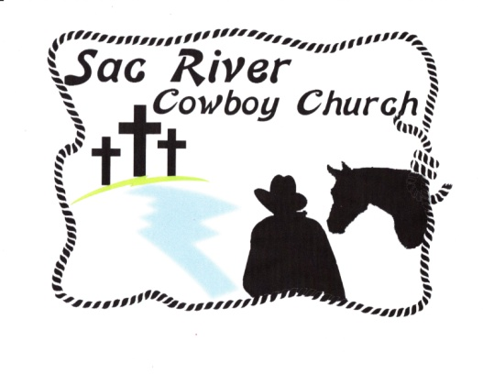

**BUNKHOUSE GAZETTE**

**AUGUST 2020 issue**

**Calendar of Events**

**August 2020**

Every Monday Line Dancing Class Event Center

3 p.m. Beginners 4 p.m. Advanced

Alice Detherage: H: 417-742-3883

C: 417-861-3908

Dee Strong: 417-742-3291

Every Monday night: CIRCLE of SISTERS

Bonita Hines, 817-228-6654 6:00 p.m. Event Center

Mar 20 Deadline for Gazette articles

**The Ranch Hands**

**(Board of Directors**)

Charles Turk-Chairman 742-4482, 576-5549

Danny Slatten-Vice Chairman 207-1434

Sandy Gold 849-5639

Jeff Farabee 833-8857

Norm Elliott 368-2080

Tami Greene 861-8922

Pat Didia 350-5643

**Circuit Ridin’ Preachers**

Scotty Killingsworth, Pastor 399-3791

Gary Killingsworth, Associate Pastor 880-8903

Billy Epperson, Circuit Ridin’ Preacher 838-5329

**Benevolence**

Tweety Fraker 417-399-3791

**Card Ministry**

Virginia Andrews 214-293-5945

Sally Ray 417-886-9164

Bonnie Hauxwell 417-501-1635

**Contact Information**

Church Website: www.SacRiverCowboyChurch.com

Gazette Editor: Fran Black: 417-631-5898

frances_b_65705@yahoo.com

Event Center Reservations: Pat Didia, 417-350-5643

Event Center Physical Address: 6448 W. State Hwy EE

Springfield, MO 65802

Sac River Cowboy Church: I-44 and Exit 70

Physical address: 6821 W. Independence Drive Springfield, MO

Mailing address: c/o Nancy Hall, Treasurer

P.O. Box 130

Willard, MO 65781

417-844-4569 (cell)

417-742-1040 (office)

**Service Times**

Sunday Services: 8:30 a.m. and 10:30 a.m. at SRCC

11:30 at SRCC Event Center

Thursday Services: 6:00 p.m. at SRCC

Mar

**STAY SAFE – STAY WELL**

It is especially important for everyone to be aware of others around you. SRCC has been meeting now for several weeks and though no one who attends has tested positive for the virus, as we shop and go about living our lives, we are constantly coming into contact with strangers, who may be infected. Since it is very difficult to social distance in our church settings, let’s abstain from hugging and shaking hands. The wearing of masks while at church services is an extra protection. This is not an order nor are we trying to be mask police. If you want to wear a mask and do not have one, the church will provide one for you. Thank you for your consideration in this trying time. God bless you all and STAY SAFE.

**Bible Trivia**

From John: What teaching of Jesus did the Jews not understand?

**Cowboy Wisdom**

Just 'cause trouble comes visiting doesn't mean you have to offer it a place to sit down.

**Sunday School Bible Class**

No Sunday School until further notice.

**Quote of the Month**

Peace is what I leave with you; it is my own peace that I give you. I do not give it as the world does. Do not be worried and upset; do not be afraid.

Jesus [*John 14:27*](https://www.biblestudytools.com/john/14-27.html)

**Worry is like a rocking chair: It gives you something to do but never gets you anywhere.**

*Erma Bombeck*

**Inspiration**

Why art thou cast down, O my soul? and why art thou disquieted within me? hope thou in God: for I shall yet praise him, who is the health of my countenance, and my God. *Psalms 42:11 KJV*

**Bible Trivia Answer:**

I am the Bread which came down from heaven.

*John 6:41*

**SPECIAL THANKS to the CARD MINISTRY**

Thanks to Virginia Andrews, Sally Ray, and Bonnie Hauxwell for sending cards to all in the church for whom we had addresses during the time church services were suspended.

Several cards were returned, so if your address has changed, please let us know.

**PRAYERS for the PRIEBE Family**

Please continue to pray for the Priebe family—Mark, Heather, and the children. Mark continues to re-hab in Colorado and hopes to return to Missouri in August. Heather is still receiving chemo.

If you would like to send a card:

Mark Priebe & family

P.O. Box 422

Republic, MO 65738

SRCC sent a $1000.00 check in support of the family.

**PRAYER SHAWL MINISTRY**

We hope to be a blessing to others by giving to those who are homebound, suffering from an illness, in nursing facility, a loss etc. a shawl. We need your help to identify those.

If you have someone we could bless with a shawl, we can bring to you for delivery or we can deliver.

You may bring your shawls or request to any service.

Some ladies do meet at SRCC Event Center at 6:00 on Sunday nights and work on shawls.

Contacts

First Service- Sherry Runion

Second Service- Doris Dyal

Third Service- Dianne Ivey, 844-9126, [byhisgrace1953@yahoo.com](mailto:byhisgrace1953@yahoo.com)

**SOMETHING TO THINK ABOUT……..by Larry Whiteley**

WHAT ARE YOU DOING FOR HIM?

Hank Parker was once a drunk, thief, cheater, liar and sinner. Today he is a 2-time Bassmaster Classic Champion, hosts three outdoor TV shows, is a member of numerous Fishing Hall of Fame’s and is a sought after speaker. He enjoys and is thankful for all that God has blessed him with but Hank’s passion is to tell others about Jesus.

At an event in Springfield back in February, Hank told the story of a guy that came up to him quoting bible verses. The man said, “I read my Bible every day Hank and I know it inside out.” Hank said, “That’s great but do you really know Jesus and tell me what you are doing to bring the lost to Jesus?”

Hank told of another man coming to him and saying, “I am in church every Sunday. Same row, same seat, same people sitting next to me.” Hank says, “That’s really good but you do know going to church doesn’t mean you are going to heaven don’t you? Are you coming to hear the music or learn and grow by listening to God’s word? Tell me what you are doing to make visitors or people you don’t know feel welcome? What are you doing to reach the lost?”

Another man says to Hank, “God has blessed me with a good living. I tithe what I am supposed to. I give to programs to help those in need.” Hank says, “That is tremendous but are you investing time telling others about Jesus?”

Another man speaks up and says, “I do all those things Hank and I have been going to church since I was a kid and I have been a good person all my life.” “That is awesome,” Hank says, “But just being good won’t get you to heaven you know. Can I tell you about Jesus”?

In closing Hank looked out at all of us and said, “Even if you believe in Him, confess your sins and accept him as your Lord and Savior, He doesn’t want you keeping Him to yourself. What are you doing to bring others to Jesus? He died for you on a cross. What are you doing for Him?”

**Letter from Pastor Scotty**

In 1966 I started working in church at the Crane Baptist Church as their music director.  I was 19 years old.  I start with this information to say I have been working for the Lord ever since in one capacity or another.  In all those 54 years I have never before experienced anything like 2020.  The change curve this year has been very steep.   Things have changed so quickly it has been difficult to stay ahead and lead us into the future.

When the Lord handed me leadership of the SRCC he had prepared my heart for a model of church that was old and very new at the same time.  It was called “Simple Church”.  In a day when churches were trying to be, “Seeker Friendly” or “Purpose-driven”, my heart heard a still, but insistent voice that said - dare to be different.  Instead of being a church that seeks to meet all the needs of contemporary culture narrow your target group and simplify your approach.  It was from this urging I led SRCC to the narrow focus of loving God and each other without other emphases.  It surprised me and others how well it worked.  We didn’t look like or act like other churches but allowed ourselves to focus on reaching people who would never step foot in a “Normal” Church.  We never felt in competition with other churches because our target group was different.  Almost immediately we began to see people show up to see how this crazy cowboy church looked and felt.  When they came to check us out many stayed and those who stayed brought their friends and family with them.  We grew quickly and God brought people into the Kingdom of God that may have never come in without a simple church approach.  We saw changed lives and families restored through our simple idea of church and a single focus on the Gospel.  It was church - just church.

Staying simple is very difficult.  The temptation to accommodate needs is what Christians do.  When other very important needs arose we wanted to start ministries to help.  So we, like other churches, looked for children leaders and student leaders to help families give Christian education to their children.  We thought about Bible studies for adults so we could be like other churches and start Sunday Schools.  Everyone else did it, we thought, so without remembering our startup  strategy and holding firmly to it we diversified and became not so simple anymore.  The more we became complicated the more we changed and not always for the good.  Many felt something was wrong but were not able to diagnose it.

Fast forward to 2020 and the unsettling events that accompanied it.  Who would have known we would not even have church for a couple of months and when we did the attendance would be much smaller?  Who would have thought administrating and maintaining diverse ministries through such a time as this would become nearly unmanageable?  Well it came and it was.  The complications stressed and stretched our leadership to the breaking point.  It was then that the Lord tapped some of us on the shoulder and said, “Remember simple church?  Why not go back to that model.  It worked for you amazingly well for more than 10 years.  It will be the best way to face the difficult years ahead.”  Don’t try to be what your not, we heard our hearts say.  So, we met, prayed and decided to seek to return to simple church.

So here we are at a very critical time in the life of SRCC.  I want to ask you to trust me and your Board as we seek to return to our original plan of simplicity.  Help us ignore the observations that people will make that we are not like other churches or that we should do this and that.  We are not like other churches.  Help us not give in and start complex and diverse ministries that require a lot of oversight and management but keep the main thing the main thing.  That main thing was  - Loving God (Worship) and Loving each other (Fellowship).  That was and must remain our mission.  This narrowing of focus will not meet the needs of some.  We get it.  It will pain us if some seek other churches with more ministries.  We will not be everything to all people and meet all needs.  We will, however, meet the biggest need of those we were put here to reach.  The need we hope to meet is the need for simple church, and a simple message - Love God completely and each other sacrificially.

What lies ahead is nearly impossible to anticipate.  We are sure of only one thing - Lord is unfailing.  If you return to *in-person-church* or remain part of us by watching us on virtual church you are important to the Lord and matter deeply to us.  We may never be the same again but we can remain simple and narrowly focused and love The Lord completely and each other sacrificially.

Scotty

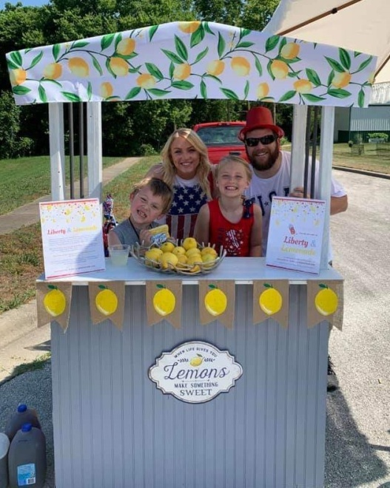

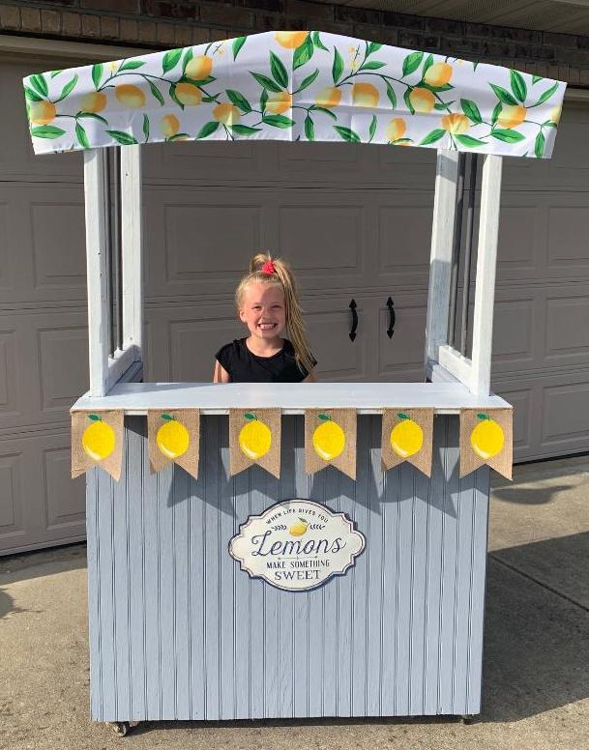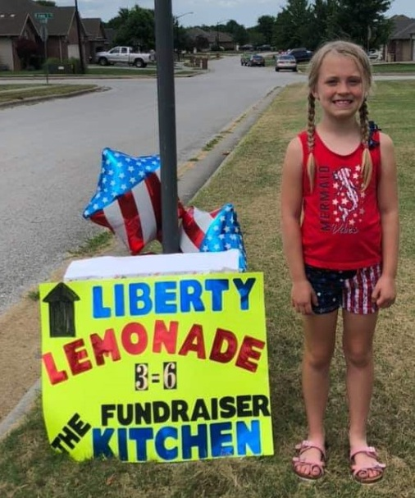

**Juni**

Seven-year-old Juniper decided she wanted to help feed the homeless so with the help of her family they made a lemonade stand. After the neighborhood Fourth of July parade, they set up the lemonade stand. Juni, (affectionately known to her family) with the help of Asher, her 4-year-old brother, started serving lemonade. Juni had a goal of $370.00 to donate to the Kitchen. By 11:00 a.m. the donations had reached $471.00. She had plans to serve lemonade again from 3:00 p.m. to 6:00 p.m. Even the rain could not stop her. At the end of the day the total donations were $1,121.25. With online donations the final total was $1,851.50. Juni wishes to thank everyone who helped her feed the homeless.

Oh, by the way Juni and Asher just happen to by our great-grandchildren so our thanks as well.

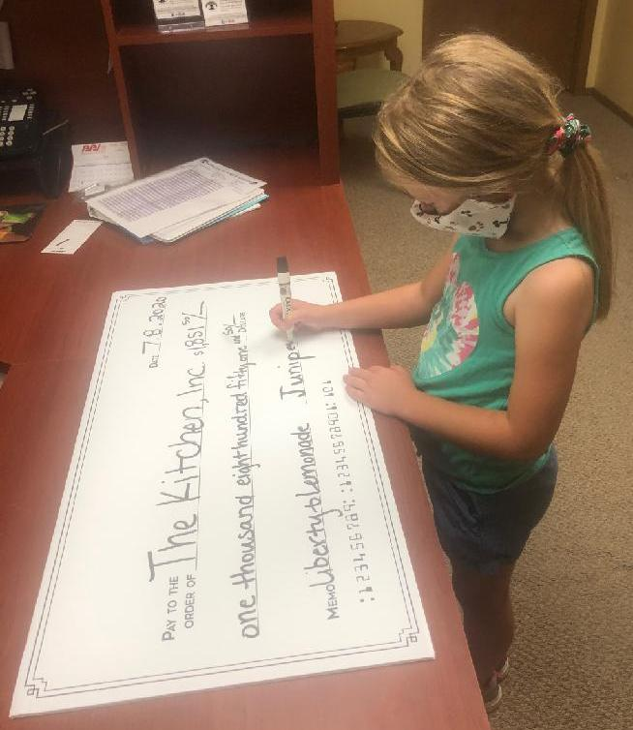Ollie and Larry Long



