Grace’s Christmas Day Service
Merry Christmas! Jesus Christ is born! In this service for Christmas Day we will sing carols, read the story of Jesus’ birth, and share what Christmas means to us. You can sing as many or as few verses of each carol that you would like. Readings can be read together or by individuals. People of all ages are encouraged to use the coloring or activity sheets during the service. Now let us celebrate Christmas Day together!

Proclamation of Christ’s Birth:
“Jesus is born! The powers tremble. Jesus is born! God is with us. Jesus is born! Peace shall come to earth. Jesus is born! God will always be with us. Jesus is born! And we are saved. Jesus is born! Now Go Tell it on the Mountain!

Sing “Go Tell it On the Mountain” with all who are gathered. Sing as many verses as you’d like!
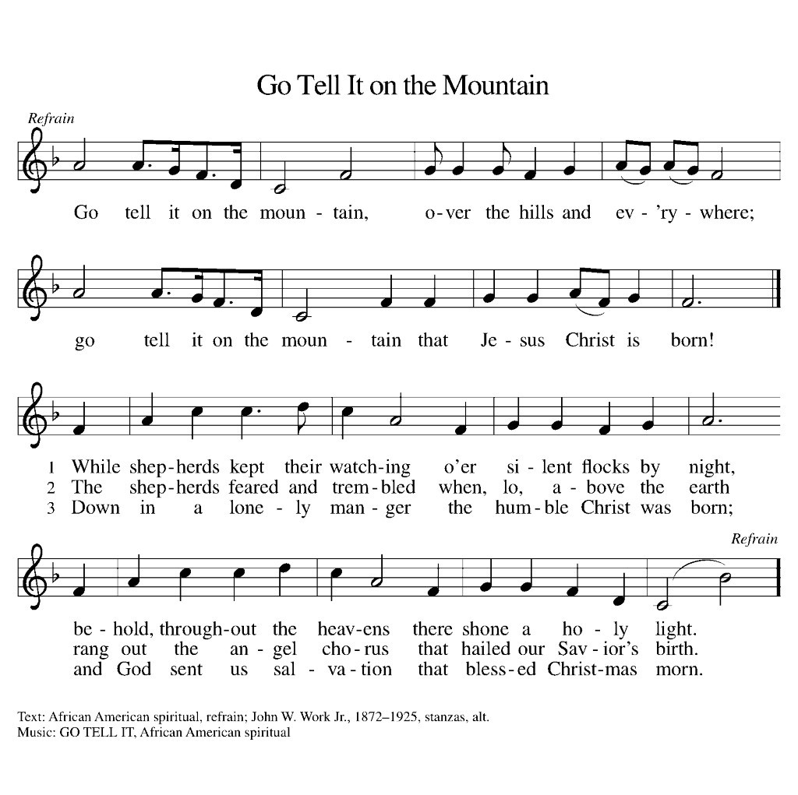

Scripture Reading: Luke 2:8-20
In that region there were shepherds living in the fields, keeping watch over their flock by night. Then an angel of the Lord stood before them, and the glory of the Lord shone around them, and they were terrified. But the angel said to them, “Do not be afraid; for see—I am bringing you good news of great joy for all the people: to you is born this day in the city of David a Savior, who is the Messiah, the Lord. This will be a sign for you: you will find a child wrapped in bands of cloth and lying in a manger.” And suddenly there was with the angel a multitude of the heavenly host, praising God and saying,
“Glory to God in the highest heaven,
and on earth peace among those whom he favors!”
When the angels had left them and gone into heaven, the shepherds said to one another, “Let us go now to Bethlehem and see this thing that has taken place, which the Lord has made known to us.” So they went with haste and found Mary and Joseph, and the child lying in the manger. When they saw this, they made known what had been told them about this child; and all who heard it were amazed at what the shepherds told them. But Mary treasured all these words and pondered them in her heart. The shepherds returned, glorifying and praising God for all they had heard and seen, as it had been told them.

Sing “Hark! The Herald Angels Sing” with all who are gathered:
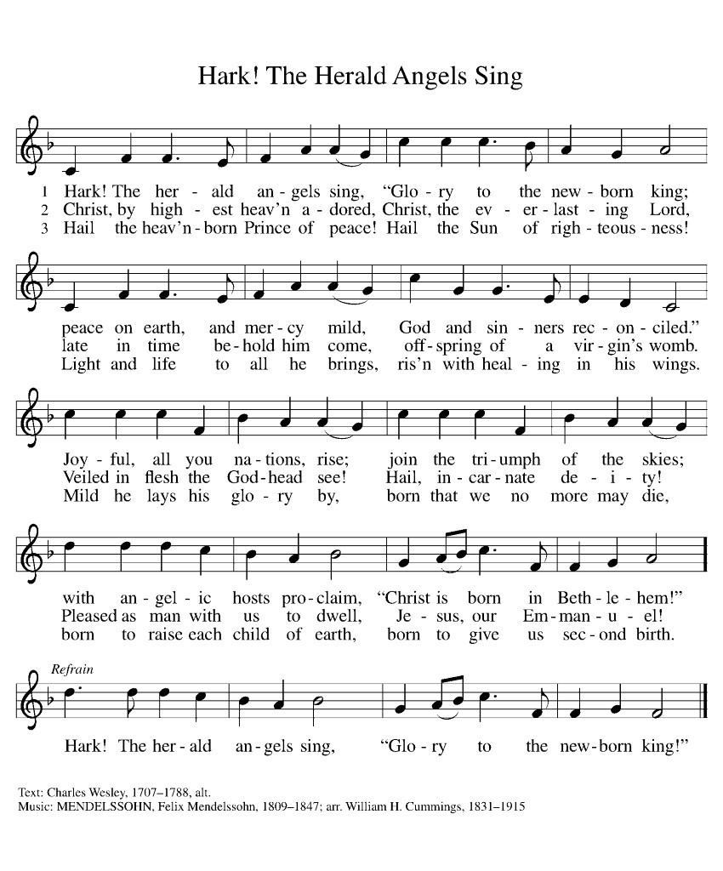

Gift Opening:
While you would have had to open the gift box once to be reading this sheet of paper, officially open the other gifts that are in your box! These are all handcrafted items by members of grace, or gifts from the Compassionate Friends of Wenatchee. They might be small, but they are made with love and care to give a boost of warmth and joy in this Christmas season, and they are meant to remind you that no matter where we are, we are church together. We are a part of one another’s lives, and we are here to provide love and support to each other no matter what we go through.
Reader: God has given us the greatest gift of Jesus Christ, who is God and human together. And for all days to come God has promised that we shall go through life accompanied by everlasting love.
All: So let us share that love with all around us on this Christmas day and every day!

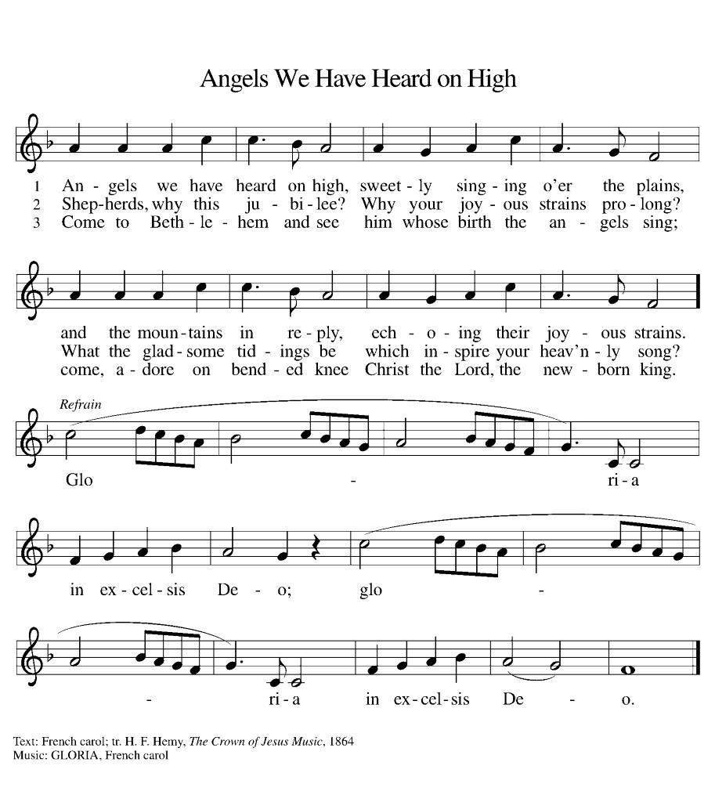

Scripture Reading: John 1:1-4; 14, 16-18
In the beginning was the Word, and the Word was with God, and the Word was God. He was in the beginning with God. All things came into being through him, and without him not one thing came into being. What has come into being in him was life, and the life was the light of all people. The light shines in the darkness, and the darkness did not overcome it.
And the Word became flesh and lived among us, and we have seen his glory, the glory as of a father’s only son, full of grace and truth. From his fullness we have all received, grace upon grace. The law indeed was given through Moses; grace and truth came through Jesus Christ. No one has ever seen God. It is God the only Son, who is close to the Father’s heart, who has made him known.

Poem:
“How the Light Comes” — By Jan Richardson
I cannot tell you
how the light comes.
What I know
is that it is more ancient
than imagining.
That it travels
across an astounding expanse
to reach us.
That it loves
searching out
what is hidden,
what is lost,
what is forgotten
or in peril
or in pain.
That it has a fondness
for the body,
for finding its way
toward flesh,
for tracing the edges
of form,
for shining forth
through the eye,
the hand,
the heart.
I cannot tell you
how the light comes,
but that it does.
That it will.
That it works its way
into the deepest dark
that enfolds you,
though it may seem
long ages in coming
or arrive in a shape
you did not foresee.
And so
may we this day
turn ourselves toward it.
May we lift our faces
to let it find us.
May we bend our bodies
to follow the arc it makes.
May we open
and open more
and open still
to the blessed light
that comes.

Come Together: A Homily for Christmas Day
You can watch Bergen present this brief homily on the Christmas webpage, or read it aloud yourself!

What does your body feel like when it’s out in the sunlight? I start by feeling a light tickle on the surface of my skin. That tickle soon becomes an even glow across my face and arms as my body enjoys the warmth of the sunlight. Then that warmth moves into my chest as my heart becomes enveloped in the joy of being outside on a sunny day. Jesus’s light in the Gospel of John is like the radiant warmth of the sun. The Gospel begins by introducing Jesus as one who radiates hope, joy, life, and love. His brilliance comforts us, inspires us to share our gifts with the world, and makes us all into children of God. Jesus’ brilliance warms us with the everlasting love that takes away our sins. Jesus's brilliance gives us everlasting life, and transforms us into people full of grace and joy.

Now, what does it feel like to know that Jesus—this person who radiates everlasting love like a star radiates heat—lived in a body like you live in your body? To know that this being of immense power lived within the limitations of a human baby. Jesus needed people to feed and clothe him when he was young. Jesus felt the warmth of the sun, got tired after a day of work, enjoyed hanging out with friends, had favorite foods and songs. Jesus being human is a bit unsettling for me to think about. Jesus has the power to transform the world within him, and yet he did normal human things and experienced normal human limitations like we do. Why would he do that when he could save the world without becoming human? Why would Jesus’ light enter into human darkness?

The beauty of Jesus’ birth is that it reveals that there is no separation between light and darkness. There is no boundary between our humanity and God’s divinity. Too often we become fixated on opposites and turn them into competitions. We assume that light and divinity must always be good, and that darkness and body must be bad. And this focus on opposites harms our self-worth, leads us to mistreat people who look different from us, and prevents us from believing that Jesus would choose to live with us. But John’s Gospel declares that there is no need for competition between light and darkness. They exist as different yet necessary parts of existence that need one another. Jesus is God's radiant light that warms and transforms us with love. We humans are the darkness of a beautiful yet sinful creation filled with so much potential for good. God could save us from a distance. But God chooses to send Jesus to unite light and darkness in the human body so that we may know that we are saved and loved and transformed by God just as we are. We don’t need to earn God’s love. We don’t need to reject others or ourselves. We don’t need to compete with others to receive God’s love. We only need to receive God’s great gift of Jesus to know that we are saved by God’s everlasting love. Jesus combines light and darkness together in his birth as a human baby to let us know that God wants to go through life together.

There is a lot of division in our world today. It is very tempting to separate the world into good versus bad where people like us are all good and people different from us are all bad. But on Christmas day we get a different message from the God who knows our worth far better than we ever will. Today we receive the promise that God looked at humanity, saw us for all our faults and our gifts and our potential and determined that we are all worth saving. So God became human through Jesus Christ so that we may know that we carry the radiant warmth of God’s love within the beautiful brokenness of our human bodies. Jesus is born on Christmas to proclaim that humans are worthy of bearing divine love. Jesus is born on Christmas to proclaim that humans are worthy of sharing divine love. Jesus is born on Christmas to proclaim that God is with us and lives with us wherever we are, wherever we go, and whatever we do. Jesus is born to proclaim that we go through our entire lives together with God. So let us find the ways to receive, carry, and share Jesus’ love together, people of Grace, today and everyday. May the peace and joy of Jesus Christ, God with us, who unites light and darkness to set us free from sin and set us free to love, be with you always.

Amen.

Sing “It Came Upon a Midnight Clear” with all gathered!
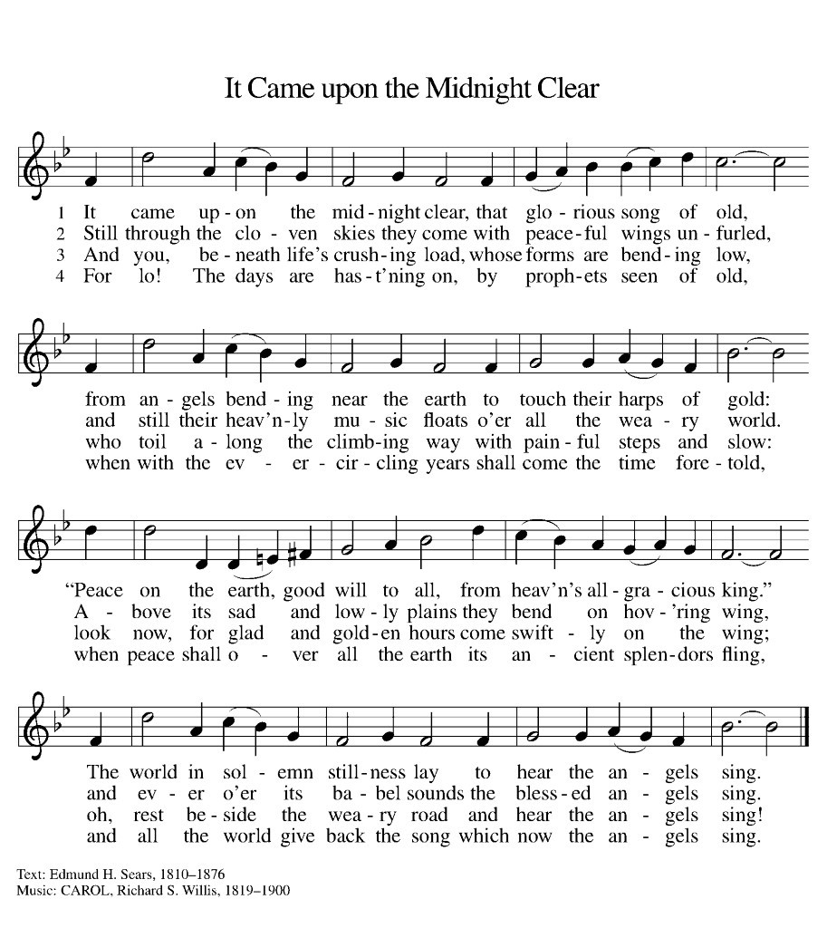
Craft
To remember that we live our lives together with Jesus Christ, we share love with one another by giving each other hope on Christmas Day. During a normal year we’d gather together to share Christ’s love, but this year we’ll need to get a bit more creative. So for a Christmas craft we’ll be making Stars of Hope to share with our Grace community.
In your gift box, you should find five paper triangles, a glue stick, and a marker. Using the marker, write down something that you are hoping for in the coming year on one side of the triangle. On the other side, write down something that has given you hope in the past year.
When you’ve written on both sides, glue the triangles on top of one another one at a time as is shown in the diagram below to create a star. Remember that it doesn’t need to be perfect! Feel free to decorate the star more if you would like, and make sure that everyone in your group is able to contribute in some way! When you are done, I invite you to deliver it to the doorstep of a family member, friend, or Grace member. If you would not like to make the delivery yourself, drop it off at Grace Lutheran Church and Bergen will deliver it to someone who needs it!
Also, this craft is optional! If you do not have the energy or desire to do the craft, please continue to the prayer below. This is just a chance for us to reflect on Jesus’ Christ’s gift of hope and togetherness with God through action and to share the message with our neighbors!
Prayer
Let us Pray,
Holy Gold, with your power as vast as all creation you chose to become human in the form of a tiny baby. As Jesus you lived with us, taught us, and loved us. Guide us to remember that you love us. Guide us to remind all those around us that they are loved. Help us live with the hope that you are working in the world just as you were on Christmas day. Keep loving us, keep renewing and changing our world, keep giving us reasons to hope. In the name of your beloved Son, born to us on Christmas Day, we pray. Amen.

Sing “O Come All Ye Faithful” with all gathered
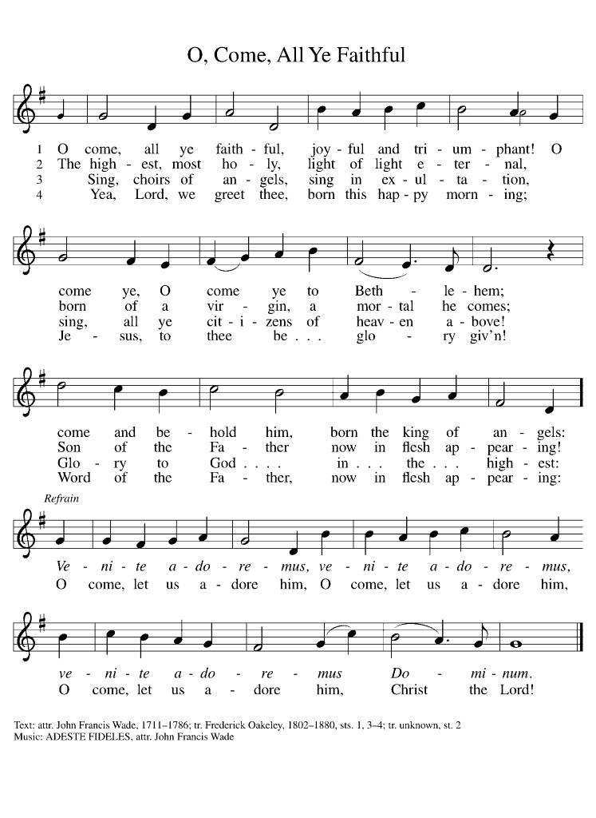
Dismissal:
Reader: God is born! Jesus’ love has made the world new!
All: Jesus is Born! Thanks be to God!

