 | Volunteer Application | 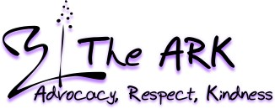

Welcome!
We would like to thank you for your interest in volunteering with The ARK Domestic Violence & Sexual Assault Shelter. Volunteers are vital to our program and to our clients. An act of domestic violence occurs every ten seconds in the United States causing emotional trauma, injury, and even death. Domestic and sexual violence are enormous social problems affecting one in four women, one in ten men, and countless numbers of children. With the help of volunteers, our program is more effectively able to meet the needs of our clients thus improving outcomes and preventing further violence in the community.
Please note that we cannot process your application unless you have all pieces of information required for your level of volunteering. For best results, turn in the following parts together:
- The entire contents of this application, including:
- |Personal Information
- |Confidentiality Contract
- |Volunteer Agreement
- |Background Check

Once your application packet is completed, please bring or mail to:
Attn: Sabrina Garza, Volunteer Coordinator 104 S Park Dr Brownwood TX, 76801
Sabrina.garza@arkshelter.org
or fax to: (325) 646-5366
It is our sincere hope you always feel appreciated by our staff, because you are! We also hope that your volunteer experience is a rewarding one. Please let the Volunteer Coordinator know if you have any questions, problems, or concerns about your role as a volunteer. No value can be placed on what you bring to our program. We can’t do it without you!
With Sincere Thanks,
Sabrina Garza
Administrative Assistant/ Volunteer Coordinator
(325) 643-2699
Brandi.steelman@arkshelter.org

Page 1

Our Policy

It is the policy of this organization to provide equal opportunities without regard to race, color, religion, national origin, gender, sexual preference, age, or disability.

Our Mission Statement
The mission of Pecan Valley Regional Domestic Violence Shelter, Inc., dba The Ark, is to provide safe shelter and comprehensive resident and non-resident services through advocacy, referrals and education to support and empower victims of domestic abuse and sexual assault, one family at a time.

Our Goals
- To provide quality shelter and support services under the guidelines of The Ark for persons who are victims of family violence and who request these services.
- Raise awareness through community education of the issues and solutions concerning family violence.
- To be an effective advocate in the effort to strengthen laws and policies concerning family violence.

Our Vision Statement
Our vision for the future is to raise community awareness through the school systems, increase services, and strengthen ties with the judicial system and the religious community

Our Statement of Philosophy
- We believe that every person has the right to live in an environment free of violence or fear.
- We believe that services should be available to victims of family violence regardless of race, national origin, age, physical handicap, religion, or sex.
- We believe that a working coalition of organizations who share a commitment to serving victims of family violence is necessary to maintain an effective and responsible program.
- We believe that community education is the key in reaching out to persons needing services and those willing to provide support.
- We believe that this organization will be best served through a volunteer policy-making body that is directly responsible to the community it serves.

Page 2

Personal Information
Full Name:
Street Address:
City, State, Zip:
Contact Phone: | Home: ( ) - Cell: ( ) -
Email address:
Date of Birth:
Gender: | Male Female
Race: | White Black Hispanic: Yes No
Marital Status: | Married Single Divorced Widowed Domestic Partnership
Spouse/Partner Name:

Person to Notify in Case of Emergency
Name:
Street Address:
City, State, Zip:
Contact Phone: | Home: ( ) - Cell: ( ) -
E-Mail Address:
Relationship:

Availability

Please indicate the specific days and times that you are available.
 | Mon | Tues | Wed | Thurs | Fri | Sat | Sun
Morning
Afternoon
Evening

Who or what prompted you to volunteer with The Ark?

____________________________________________________________________________________

Page 3

Education

Highest Level Education Completed: _______________________
Are you currently a student? ___________ Graduation date: ___________________________
School: _____________________________________ Major: ______________________________

GPA: __________ Volunteer/Internship Required? _________ How many hours? __________

Date Hours to be completed by: _____/_____/________

Fluent Languages: _____________________________________________________________________________________

Organizations: _____________________________________________________________________________________
_____________________________________________________________________________________

Previous Volunteer Experience

Summarize your previous volunteer experience.

____________________________________________________________________________________

____________________________________________________________________________________

____________________________________________________________________________________

Employment
*You may attach a resume in lieu of this section
Current Employer: ___________________________________ Job Title: ________________________
Date Started: _________________________
Previous Employer: __________________________________ Job Title: ________________________
Dates Worked: ________________________
Previous Employer: __________________________________ Job Title: ________________________
Dates Worked: ________________________

Page 4

Interests

Tell us which areas you are interested in volunteering:
____Administration ____ Advocacy ____ Crisis Hotline
____Events ____Field work ____Fundraising
____Public Relations ____Volunteer coordination

Skills and Experience

Please check all that apply to your special skills and qualifications:

____Art (Graphic or Visual) | ____Computer (Tech Support) | ____Photography
____Beauty Consultant | ____Court Advocacy | ____Professional Therapy
____Board Member Experience | ____Crisis Intervention | ____Public Relations
____Budget/Household Mgmt. | ____DV Counseling | ____Public Speaking
____Bulk Mailing | ____Educator / Trainer | ____Radio / TV
____Business Management | ____Event Planning | ____SA Counseling
____Carpentry/Building | ____Fundraising | ____Support Group Facilitation
____Catering | ____Grant Writing | ____Survivor (DV)
____Clerical | ____Health & Exercise | ____Survivor (SA)
____Committee Work | ____Health Educator | ____Telephone Counseling
____Computer (Data Entry) | ____Legal Counsel | ____Tutoring
____Computer (Excel) | ____Marketing | ____Writing/Editing
____Computer (Graphic Design) | ____Musician | ____Other:__________________

Page 5

Agreement and Signature

By submitting this application, I affirm that the facts set forth in it are true and complete. I understand that if I am accepted as a volunteer, any false statements, omissions, or other misrepresentations made by me on this application may result in my immediate dismissal.
Name (printed):
Signature:
Date:

Volunteer Agreement

I will be committed to helping reduce the adverse effects that domestic violence has on its victims. As a volunteer, however, I will not give advice, counseling, or pass judgment about clients and their cases. I will attend training sessions and volunteer meetings when they are scheduled and ask questions to be informed. I will work together with the staff to carry out the mission with the highest ethical standards. I understand that I am directly responsible to the volunteer coordinator and/or designated staff person. I will be consistent and punctual by being here on the days and times that are agreed to. I will let staff know if there must be a change in the schedule.
As a representative of The Ark, I will act with integrity and thoughtfulness. As a volunteer, I will not represent The Ark either through written or oral communications without the expressed consent of the volunteer coordinator and/or designated staff person. I understand that I am not an employee of The ARK, and that any duties that I perform are as a volunteer. I agree to abide by the procedures set forth by The Ark for my assigned work duties. It is my responsibility to update any address, emergency or other changes. I will respect each client’s right to confidentiality. In addition, I will not access confidential information without legitimate need/permission, nor in any way divulge, copy, release, sell, lend, alter, or destroy any confidential information belonging to The Ark.
I certify that all information in this form is complete and accurate to the best of my knowledge. I authorize investigation of all statements contained in this form and understand that I may be required to verify
information contained in this form.

Signature:_____________________________________________ Date:_________________________

Page 6

Understanding Internship as a Non-Paid Placement

Please skip this page unless you are applying to be an intern.

According to the Department of Labor (DOL), a person may be considered an intern or student “trainee” and not an employee entitled to minimum wage and overtime under the FLSA if all the following criteria are met:
- The training the person receives is similar to that which would be given in a vocational school.
- The training is for the benefit of the trainee or student.
- The trainee or student does not displace regular employees but works under their close supervision.
- The employer that provides the training does not derive any immediate advantage fro the activities of the trainee or student, and on occasion its operations may be impeded.
- The trainee or student is not necessarily entitled to a job at the conclusion of the training period or end of internship.
- The employer and trainee pr student understand that the trainee or student is not entitled wages for the time spent in training and with the internship as a whole.

I have read and understand my internship as a non-paid placement. I also commit to at least 50 hours of volunteer work to the agency before termination except in cases of illness, injury, incompatibility with the program, or other unforeseen circumstances.

Signature:________________________________________________________ Date:___________________________________

Page 7

CONFIDENTIALITY CONTRACT

Last Name: First Name:__ ____ ______________
Street Address:_____ ____________________________________________
City,State, Zip: _________
Date of Birth:__ _________ Social Security #:________ _______________
Phone Number: ( ) - _____________ ____________

I fully understand the need to strict confidentiality concerning all information received from or about clients of the Pecan Valley Regional Domestic Violence & Sexual Assault Shelter dba The Ark. This information includes the identity of clients, content of conversations with clients, professional opinions about clients, and materials from records of clients.
I agree to keep the location of the shelter confidential and understand by breaking this confidentiality agreement that I may endanger clients, volunteers, interns, and staff. In the event that I sever this confidentiality contract, my position in the office will be terminated.
As a member of this program, I will not discuss or reveal any information concerning clients to anyone outside the agency, without the client’s understood permission, except in the unusual circumstances of imminent danger to a client or other persons, elderly abuse, and/or child abuse.
I fully agree to contact my supervisor or the on-call staff person anytime I have questions concerning confidentiality.

Signature_______________________________________ Date:__________________________

Page 8
Release Authorization for Background Investigation
I hereby acknowledge that as a condition of my volunteer application with the Pecan Valley Regional Domestic Violence & Sexual Assault Shelter dba The Ark may conduct any or all of the following investigative measures in regard to my application:
1) Obtain and review any or all investigative records for the purpose of verifying the accuracy of criminal violation information contained on my application,
2) Require me to supply fingerprint samples and/or submit to a criminal history record check to be conducted by an approved Texas law enforcement agency,
3) Require me to attend a training program which includes adult training on recognition, disclosure, reporting and prevention of abuse and submit to character, employment, education and reference checks.
4) My signature below amounts to authorization of any and all of the above investigative measures set out in items one (1) through three (3) above.

Last Name: | First Name: |  |  | Middle Name:
Street Address: | City: |  |  | State: | Zip:
Social Security Number:  - - | Driver’s License Number: |  |  | Please circle one:  MALE - FEMALE
Place of Birth: | Birth Name: |  |  | Maiden Name:
Home Telephone: |  | Work Telephone:
Signature: |  |  | Date:

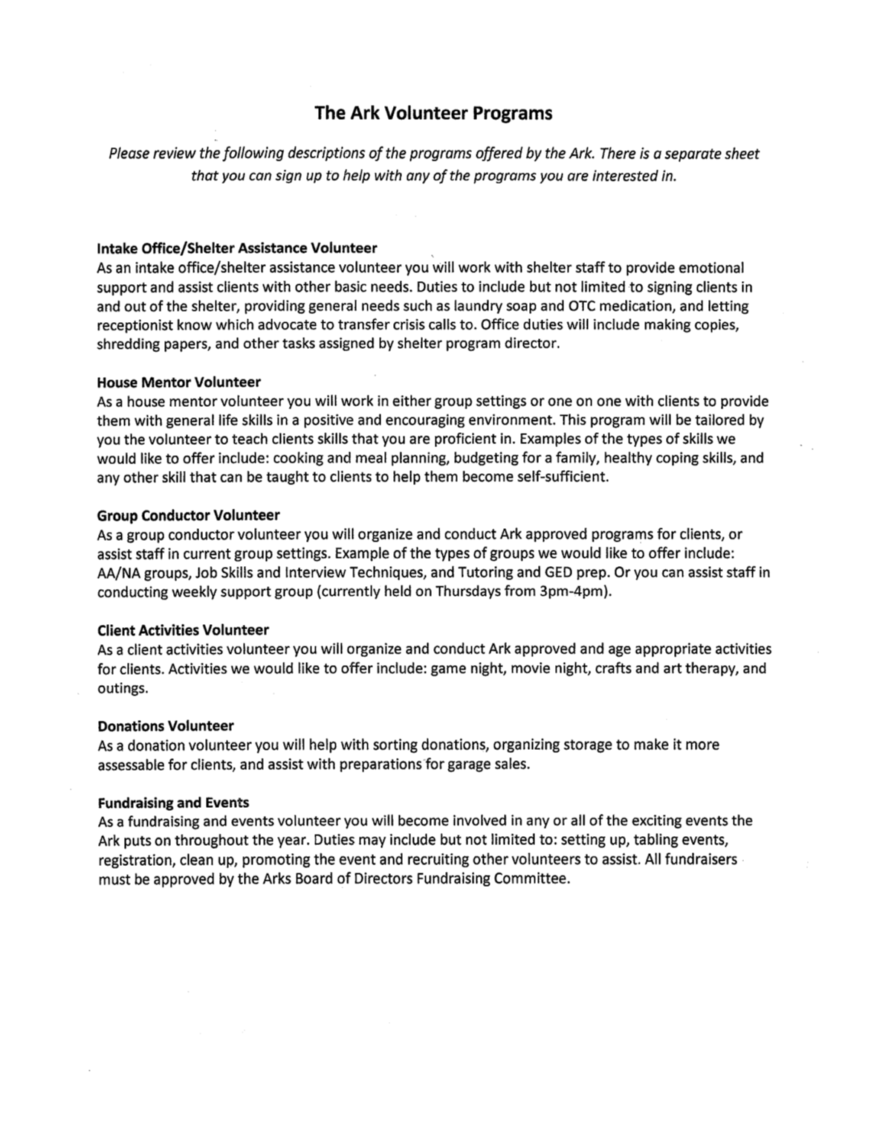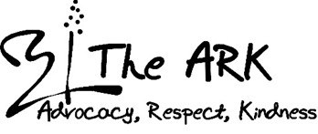
104 S. Park Dr, Brownwood, TX 76801
325
-
643
-
2699

