Holly’s Siding Getting Started Guide

Welcome
Firstly, big thanks for booking with us. This is our fourth year of running an Airbnb so we really appreciate your custom. This is a short guide to give you the basics and then you can go out and enjoy the area.
For more details about the area and cool things that people who have stayed have done, please follow and contribute to our social media pages.
Have a great time!!!
Best Wishes, Jo and Jason

Website | Facebook | Instagram
 |  | 

Checking In…

WIFI
See the board in the kitchen

Heating
There are separate thermostats upstairs and downstairs, and you can manually adjust using them, or via the Alexa in the kitchen and master bedroom.
To turn on the heating for 30 minutes, just say the following:
- Alexa, boost downstairs
- Alexa boost upstairs
To set the heating to a certain temperature for an unspecified time:
- Alexa, set downstairs to 20 degrees
- Alexa, set upstairs to 18 degrees
To turn off the heating:
- Alexa, turn off downstairs
- Alexa, turn off upstairs
If you would be so kind to remember to turn off the heating once the house has reached a suitable temperature, and when you leave, we would greatly appreciate it.

Oven and Hob
The controls for these should be self-explanatory, but the guide is in the back of the booklet on the breakfast bar if anything is unclear.
Please Note:
- If you usually use a gas hob, the cooking rings can take a bit longer to warm up
- Please refrain from putting hot pans or trays onto the worktop. There is a trivet (the wooden dog face) or wooden chopping boards available for this purpose.

Television
Feel free to login to the Netflix, Prime, Disney etc. apps available via the Home button on the remote.
Please remember to log out before you leave though as we cannot be responsible for other guests using your accounts if you forget.

Coffee Machine
The coffee machine is in the corner by the kitchen sink and takes Tassimo Capsules.
To make coffee, do the following:
- Make sure the reservoir at the back contains water
- Turn the machine on and you should see a yellow light
- Lift the lid at the top and insert your capsule. The light should turn green
- Press the round silver button and wait 30 seconds

Food Shopping
The following are available close by if you need to stock up and want to avoid going into the towns
- Churston Farm Shop and Café are a 5-minute walk from the house
- Galmpton General Store and Butchers are a 10-minute walk
- All the major supermarkets are within a 5-mile radius

Baby Equipment
We have a highchair and travel cot available for guests to use.
- The travel cot and mattress cover are stored in the ottoman in the gold bedroom
- The highchair will be in the living room if requested. Please contact your agent if not.

Refuse Collection
Our rubbish is collected on a Thursday morning. One week are the recycling boxes and the other is the general waste wheelie bin. If you would be kind enough to put those items out on a Wednesday evening for collection that would be a great help.
The boxes and bin are left against the fence on the right of the entrance to The Sidings estate.

Emergencies
In the event of any issues
- The first aid kit and fire extinguisher are in the kitchen on the breakfast bar
- The fuse box is in the downstairs coat/shoe cupboard
- The main water stopcock is under the kitchen sink

Exploring the Area
There is an enormous range of options if you want to walk or cycle around the area. For example:
- Berry Head Brixham (spectacular sea views)
- Brixham to Kingswear Coastal Path (hilly, but hidden coves aplenty)
- Galmpton Creek to Greenway (take the passenger ferry across the river Dart)
Our website contains lots of ideas for things to do, places to walk and eat.

Public Transport
The nearest bus stop is a 5-minute walk from the house next to the Churston Golf Course. The number 12 bus runs every 20 minutes and can take you to Brixham, Paignton and Torquay.
If you are travelling to Brixham, you can also take the Park & Ride bus which is a 5-minute walk in the opposite direction next to the entrance to Cayman Golf.

Steam Railway
Unfortunately, the Steam Railway will not stop at Churston Station this year as it was unfortunately closed at the time of the pandemic.
If you want to take it to Dartmouth (and then onto Totnes via boat down the river Dart), you will need to drive into Paignton (2 miles away) and catch it from Paignton Station.

Getting across the road
The road directly outside the house can get busy during the daytime, so if you want to get to the other side, please use the subway that is just past the Steam Railway bridge.

Dogs Morning Walk
This 3-mile walk is so called because we walk our dogs the same route every morning!
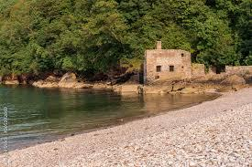
It takes place over two beaches (Elberry Cove and Broadsands) and if you are lucky, you may see dolphins or seals swimming around. There are a couple of beach cafes at Broadsands which open around 9am.
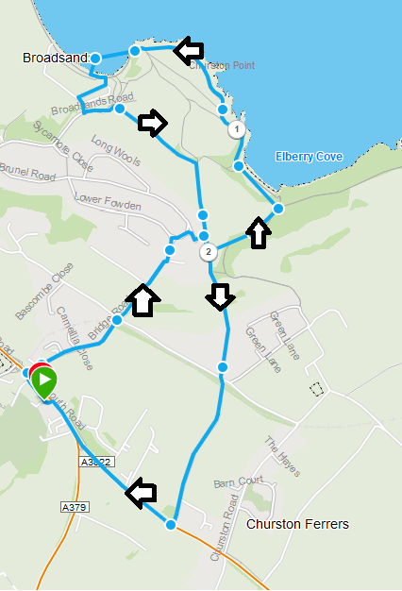

Churston to Brixham



Walk down to Elberry Cove, and then around the coast path via both Churston and Fishcombe Coves (see the picture in the single bedroom to see how lovely that looks!). You will come into Brixham to the top of the town, giving you amazing views over the port.
This walk is around 3.5 miles and has some steep uphill sections. It should take someone with moderate fitness around 1.5 hours (unless you stop for a swim).
Once in Brixham, you can either walk back on the reverse route or get the No 12 bus back to Churston Golf Course.
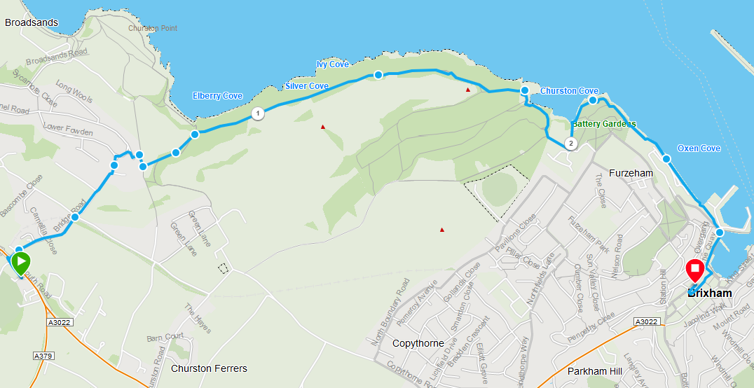

Galmpton Creek

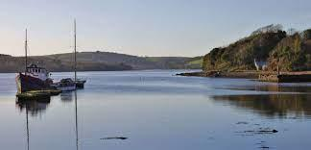
Take a left turn out of the house and pass the Railway Inn and Steam Railway. Then take another left and walk down through Galmpton village until you see the signs for Galmpton Creek. This is a beautiful, quiet little harbour.
If you follow the path around to the left, you can then loop back around into Galmpton or continue towards Greenway and catch the passenger ferry to Dittisham or Dartmouth.
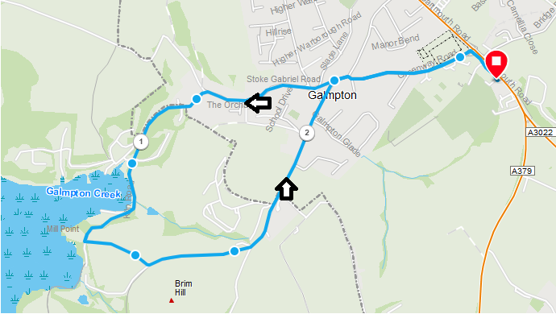

Goodrington Sands to Paignton
Drive to Goodrington Sands (look for the Waterpark on your right) and then walk through the gardens and up over the cliff (the paths up are not too steep) to Paignton Harbour and beach.
There will be lots of places to eat and drink on the way.
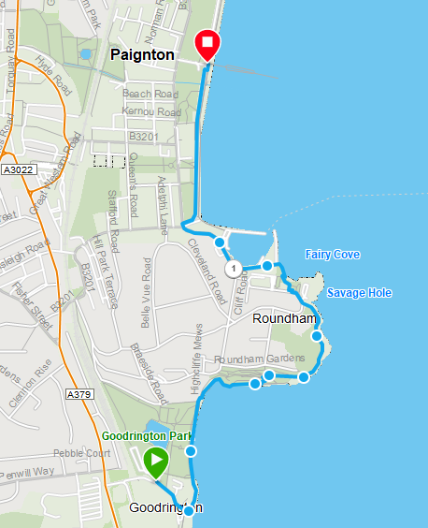

Checking Out…
Check out time is 10:00am. On your departure, we kindly ask that you…
- Leave the house in a tidy condition
- Clean the BBQ if you have used it
- Clean up any dog waste in the garden
- Remove any food/drink from the cupboards or fridge
- Log out of any TV Apps
- Check all drawers and under beds to make sure you have all your possessions
- Return the keys to the lockbox
And finally, have a safe trip home!!!

