Blue Oyster Spray & Grow Kit Instructions
FIRST: Find a Suitable Location
Blue Oyster mushrooms enjoy a growing temperature between 17 and 24 C. Select a location that receives some light, but don’t place the block in direct sunlight (this could overheat the bag). Avoid areas that experience temperature fluctuations throughout the day. The color of the mushrooms can be from a light-blue to a white/pearl or grey. Cooler temps = brighter blue. Warmer temps = more white/grey.
SECOND: Prep your block
- Once you’ve found your location, position the block so that the side with the filter patch (the white patch with writing) is facing down. (The filter patch should be down facing the surface). Using a pointy pair of scissors or a sharp knife, cut six x-shaped, evenly spaced holes in the side facing up, directly on the sawdust/mycelium part of the block. Each x-shaped hole should be approximately 2-4 cm. Try to not damage the white mycelium growing under the plastic. This will be where your mushrooms will begin forming. DO keep the block encased in its bag; the only oxygen your block should receive is through the holes you cut.
- Once your holes are cut, stand the block up and deflate the top portion of the bag, folding it tightly. Air from the bag will exhaust through the holes you cut in the block. You can tape the folded side down. This helps keep fruit from forming in air pockets under the plastic. Place the block on a cookie sheet or large plate with the holes you cut facing upwards. Mist the top of the block with water.
- Prepare your humidity tent: Cut eight to ten large 5cm holes in the humidity tent (large clear plastic bag), and place over the block. Be sure the humidity tent allows light to pass through. The holes you cut in the humidity tent will allow for air movement while also helping to maintain high humidity for the block.
THIRD: Manage your block
Mist the block with water 2 to 3 times per day. Usually within 10 days, you will begin to see small primordia (baby mushrooms) beginning to form at some or all of the holes. You will continue misting these primordia and they will grow very quickly, usually doubling in size daily. When the caps start to flatten out, they are ready to harvest. They should look like this picture:
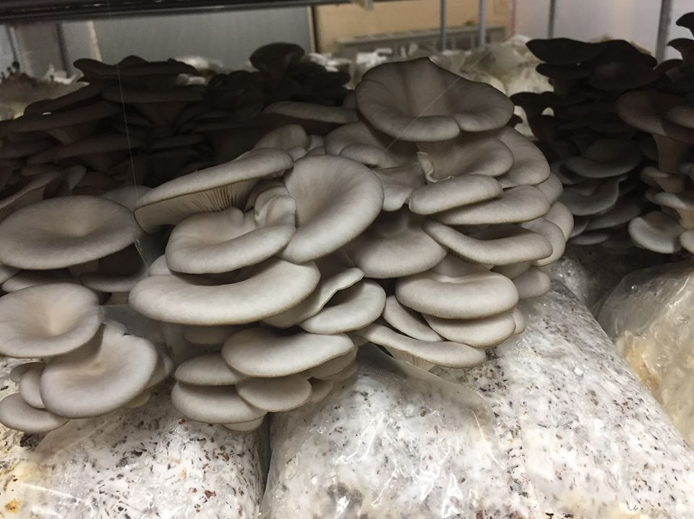
If more time passes after the caps flatten, they will begin to turn upward. They are still edible, but taste better if you harvest them before the caps start turning up. To harvest, simply break them off the block at the base of the stems. After all mushrooms have been cleanly harvested, leaving no bits of mushroom stem behind, you will continue misting the holes. The block will produce a second flush of mushrooms in 10 to 14 days, usually from a different hole. Many people keep blocks for 2-4 flushes. A block that is well-cared-for can produce over 1.5lbs of mushrooms over 4 flushes.
When your block is done, the spent mushroom substrate makes incredible compost!

