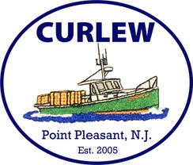

**Booking 2024 Fishing Charters on Curlew**

**Booking Dates Begin - 11/1/2022-12/31/2022**

Open to customers that booked 2 charters in 2023, one lobster and one non-lobster (Fluke, Striped Bass, Tuna, Sea Bass, etc.). Feel free to phone or email me.

**Booking Dates Begin - 1/1/2023-2/28/2023**

Customers willing to book 2 charters, one lobster and one non-lobster. First come first serve **email only** KevinFahey@JerseyShoreLobster.com. Simply send me an email with your contact information and I will contact you ASAP to arrange the dates of the 2 charters.

**Booking Begins - 3/1/2023**

Open bookings to all charter customers for all types of trips!

**Captain Kevin Fahey**

**201-407-9646**

[**KevinFahey@JerseyShoreLobster.com**](mailto:KevinFahey@JerseyShoreLobster.com)

[**www.JerseyShoreLobster.com**](http://www.JerseyShoreLobster.com)