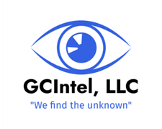
Protective Consulting Services
Empowering Individuals, Families and Businesses to Stay Safe, Aware, and Prepared
Our Mission
We provide practical, intelligence-based protective consulting and investigations to help individuals, families, and small businesses identify vulnerabilities, risks & liabilities reduction, and build confident safety habits in everyday life.
Core Services
For Individuals and Families
- Personal & Family Protective Assessments
- Situational Awareness Information
- Threat Awareness & Avoidance
For Small Businesses
- Business Protective Assessments
- Reputational Damage Avoidance
- Threat Awareness & Avoidance
Our Process
- Assessments – Identify current vulnerabilities and needs
- Full report on analysis, recommendations and follow-up
- Video Conference for discussions on findings and recommendations
Why GCIntel
40+ years of investigation, intelligence work, law enforcement, executive protection, military combat and high-risk security experience.
Custom solutions for individuals, families, and small businesses.
Local expertise and personalized service.
GCIntel, LLC
720.422.1000
451 Coyote Circle
Black Hawk, CO 80422
www.gcintelllc.com / info@gcintelllc.com

