
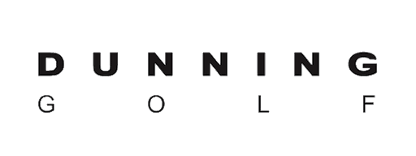

Golf Retirement Plus™ Dunning Golf Program 2025

Contribution Schedule; Based on Net Shipments

1st Contribution - January From Period- 7/1-12/31 from the prior year

2nd Contribution - August From Period- 1/1-6/30 from the current year

All contributions are added to your PGA Plus Retirement Account twice per year.

Qualifying Schedule; For the Contribution Period

If Customer Ships:

• $2,500 - $4,999 > He / She receives 1% of net shipments

• $5,000 - $7,499 > He / She receives 2% of net shipments

• $7,500 > He / She receives 3% of net shipments

OR

• If Customer ships a combined $10,000 for both contribution periods, He / She
Receives 3% of net shipments

AND

• Customer can elect to have 100% of all DG wholesale line-item discounts
Applied to their Retirement Plus Account with written approval from Club Management
or Ownership.

Golf Retirement Plus™ Dunning Golf Program Enrollment Form

PGA Golf Enterprises, Inc. requires that a signed Facility Authorization Agreement be on file at The PGA in order for your Golf Retirement Plus™ incentives to be deposited in your retirement account.

The following information is required in order for a PGA Professional to earn Golf Retirement Plus™ incentives while participating in the Golf Retirement Plus™ Dunning Golf Program. At your earliest convenience, please scan this form to the Dunning Golf person or your sales rep to forward. Please submit updated form when changes to the below information occur, as failure to do so may result in lost contributions.

Attn: Ryan Sylvester
Email: Ryan.Sylvester@tlifestyles.com

Phone: 646-494-0742

Facility Name:

Address (Include City, State, and Zip Code):

Phone:

E-mail:

PGA Member Name:

PGA Member Number:

PGA Member’s Dunning Golf Account Number:
_________________________________________________________________________________

Please select 1 of the 2 contribution options

-Option 1

By selecting this option, I am notifying DG that I elect to receive contributions based upon the volume of business I do with DG and would like to receive all wholesale order discounts associated with my business on the invoice.


-Option 2

By selecting this option, I am notifying DG that I elect to forgo all DG wholesale order discounts and would like all such percentages applied to my PGA Retirement Plus Contributions. In addition, I will receive normal contributions from Option 1.

Signature Required

Date

Neither Dunning Golf, PGA Golf Enterprises, Inc., nor The PGA of America are registered broker/dealers.

