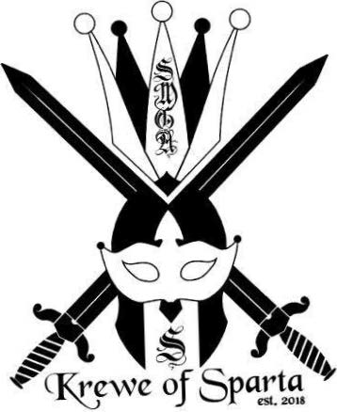

**Krewe of Sparta**

**327 Highway 43 N**

**Saraland, AL 36571**

**PARADE SPONSOR for KOS PARADE on 2/14/2026 – APPLICATION DEADLINE 2/1/2026**

**GOLD LEVEL: - 1ST RIGHT OF REFUSAL BY FOO until 9/1/2025**

**$1,500.00**

**Lead Float (1st in line for the parade) large**

**Banner**

**6 guest riders**

**Ball tickets for 3 couples**

**Top billing on marketing materials**

**Your company provided throws with your branding**

**PURPLE LEVEL:**

**$1,200.00**

**Large float (2nd float in line for parade)**

**Banner**

**4 guest riders**

**Ball tickets for 2 couples**

**Your company provided throws with your branding**

**GREEN LEVEL: 1st RIGHT OF REFUSAL BY ROUSES until 9/1/2025**

**$1,000.00**

**Large float or Band Sponsorship**

**Banner**

**2 Guest riders**

**Billing on marketing materials**

**Your company provided throws with your branding**

**ONLY 4 TOTAL FLOAT SPONSORSHIPS AVAILABLE!**

**COMPANY NAME: _________________________________________________________________**

**CONTACT PERSON: ________________________________________________________________**

**PHONE/EMAIL: ____________________________________________________________________**

**CIRCLE DESIRED SPONSORSHIP LEVEL**

**GOLD PURPLE GREEN**

**All checks should be made payable to KOS. Sponsorships will be awarded on a first come first served basis. Contact: Carol Danieli at 251-679-9216, fax to 251-679-9217 or email kos@saralandtax.com.**

**NOTE: SPONSORSHIPS ARE ON A FIRST COME, FIRST SERVED BASIS.**