Scouting America

Eagle Scout Candidate Character Reference

Coastal Carolina Council

Eagle Candidate: ____________________________ Troop 245 Low Country District

Dear: _____________________________________

I am sending this form to you because we need your opinion on how this Scout works with people and how they demonstrate living by the principles of the Scout Oath and Law in their daily life (see below). In order to become an Eagle Scout, letters of character reference are required. Eagle Scout is the highest rank in Scouting and only those of exemplary character are entitled to earn this honor.

The Scout has passed all the technical skill requirements. The Eagle Board of Review Committee is requesting you to answer a few questions about their character. In completing this form, you will help provide the committee with the needed information. Only the Eagle Board will review the reference letters. They will be kept confidential and not shown to the candidate at any time.

Respectfully yours,
Peter Brooks
District Eagle Counselor

 | Scout Oath |  |  | 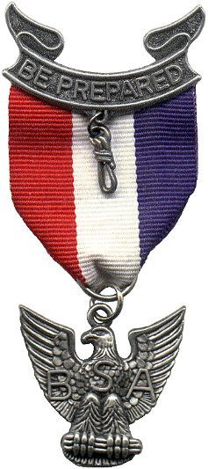
 | On my honor, I will do my best
 | To do my duty to God and my country
 | And to obey the Scout Law;
 | To help other people at all times
 | To keep myself physically strong
 | Mentally awake and morally straight
 | Scout Law
 | Trustworthy | Obedient
 | Loyal | Cheerful
 | Helpful | Thrifty
 | Friendly | Brave
 | Courteous | Clean
 | Kind | Reverent

Scouts Name: __________________________________________ Troop 245

How long have you known the candidate? ____________________

Relationship to Scout: (circle one) Parent/Guardian Employer Religious Leader

Educator Other __________________________

Describe your experience with the candidate:
________________________________________________________________________________________________________________________________________________________________________________________________________________________________________________________________________________________________________________________________________________________________________

In your experience or knowledge of the candidate, describe how they have demonstrated leadership qualities.
________________________________________________________________________________________________________________________________________________________________________________________________________________________________________________________________________________________________________________________________________________________________________

How did this candidate demonstrate to you the Scout Oath and Law?
________________________________________________________________________________________________________________________________________________________________________________________________________________________________________________________________________________________________________________________________________________________________________

Is there any significant reason you WOULD NOT recommend this scout to receive the rank of Eagle Scout? (If YES, please explain):
________________________________________________________________________________________________________________________________________________________________________________________________________________________________________________________________________________________________________________________________________________________________________

Is there any other information you feel the Eagle Board should know?
__________________________________________________________________________________________
__________________________________________________________________________________________
__________________________________________________________________________________________
_________________________________________________________________________________________

Please feel free to use additional sheets for more comments.

Evaluator Name ___________________________________________ Date ____________________________
(please print)
Email contact ____________________________________ Phone #___________________________________

PLEASE RETURN THIS FORM BY__________________________________________________________

To: District Eagle Board Counselor
c/o: Peter Brooks
98 Coggins Point Road
Hilton Head Island, SC 29928-3812

INSTRUCTIONS AND INFORMATION REGARDING THE USE OF THIS FORM

- Every Eagle candidate must have references completed by four different adults.

- These forms are to be distributed to the requested character reference persons by mail or hand delivered.

- The completed reference letters need to be mailed directly to the respective District Eagle Board Counselor.

- The Unit Scoutmaster and Committee Chair should not be asked to complete a character reference letter. Their recommendation of the candidate comes through approving the Eagle Scout application.

Eagle Candidate

- The character reference letters will only be reviewed by the Eagle Board members.
- These letters may be sent out before your project is complete. They should be received back by the Eagle Board Counselor prior to your final Eagle Board of Review appointment.
- To begin the process, select a minimum of four people for your character reference. Follow these steps:
- Send out the above two-page reference letter request to each adult character reference evaluator.
- Include an envelope with the District Eagle Counselor’s name and address on the front of the return envelope.
- Write your character reference’s name on the front of the envelope in the return address area.
  - In case all your letters are not returned, it can be determined who has not sent their letter back for follow-up.
- Write your name on the back of the envelope. In the event the Eagle Counselor is receiving letters for multiple candidates at the same time, it can be determined who each of the letters are for.
- Stamp the envelope for easy return.

.01-APR-25

