CHAPTER 8

Banja Luka

Republika Srpska

At 3:00 a.m. on Saturday, May 8, 1993, Banja Luka’s residents awoke to trembling walls and shattering windows. Perhaps the front lines of the Bosnian Civil War had come far more quickly than was expected. Or perhaps Banja Luka had been hit by an earthquake, like the one that leveled the city in 1969. Regardless of the cause, few went back to sleep.

When dawn broke, Banja Luka’s Muslims learned the horrible truth: the Ferhadija Mosque, which was built in 1579 and which was widely considered the finest mosque in Bosnia-Herzegovina, lay in rubble. Dynamited by Bosnian Serbs intent on a policy of ethnic cleansing and erasing the region’s multicultural history, Ferhadija’s fate soon befell Banja Luka’s 15 other mosques. Similarly, Bosnia’s oldest clock tower was also demolished. With the destruction of these cultural icons, Bosnian Serbs were constructing a new ethno-national narrative: because Banja Luka had no mosques, it could be defined as a purely Serbian city. Four hundred years of tradition vanished overnight.

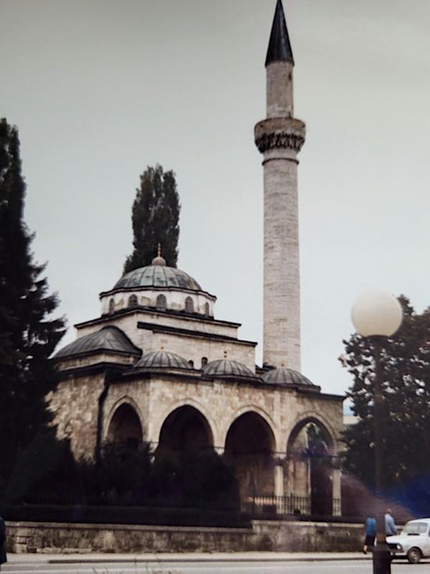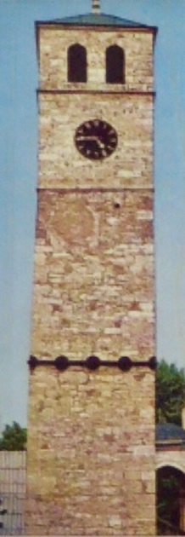

Illustration 90: Banja Luka Clock Tower, c. 1967

Illustration 89: Ferhadija Mosque in 1989.

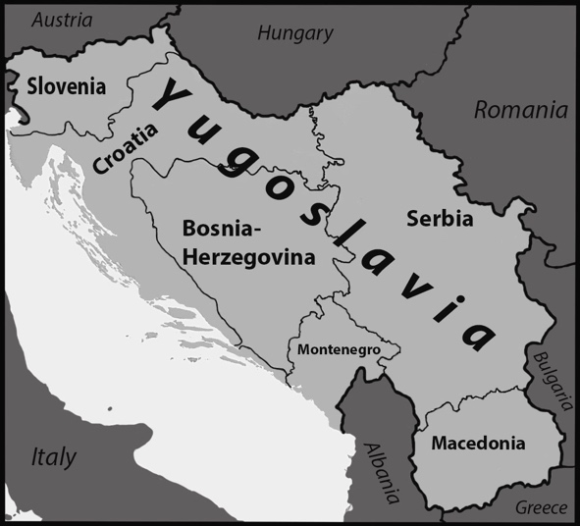

Illustration 91: Map of Yugoslavia in 1988, showing the borders of its six major constituent republics.

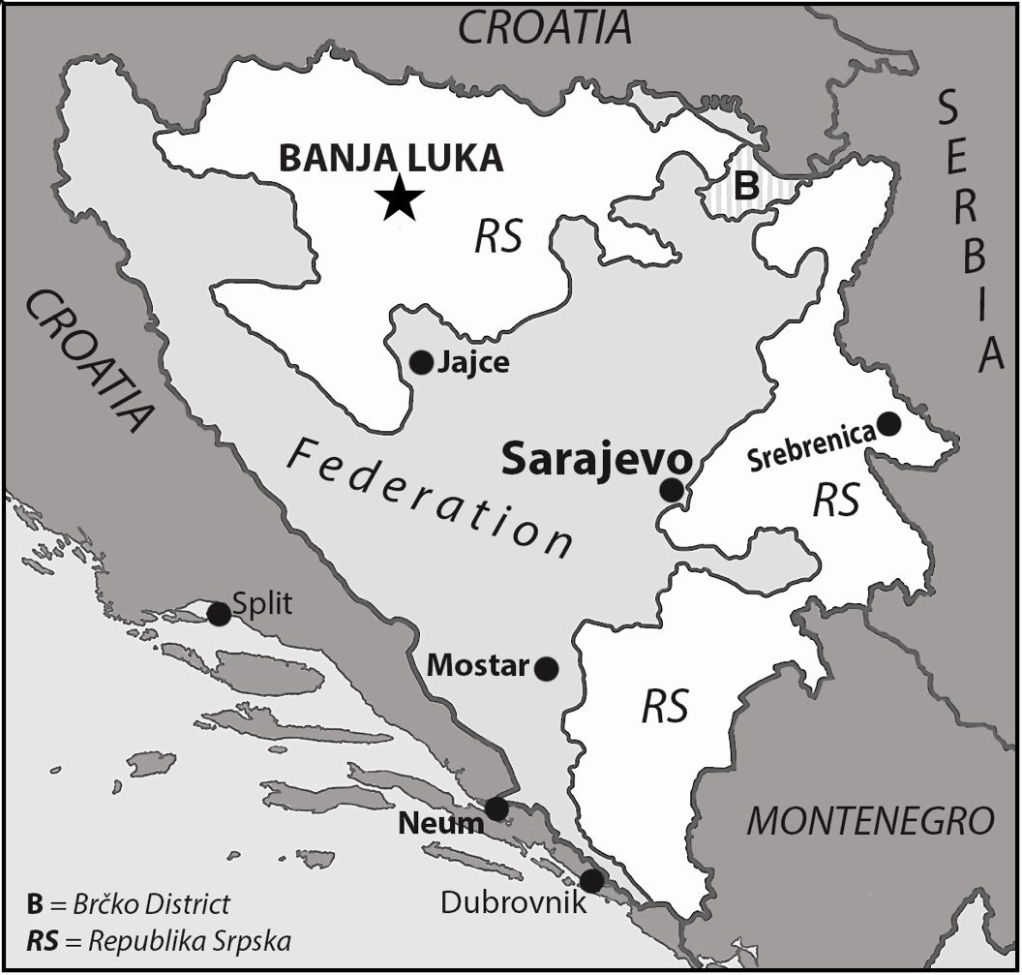

Illustration 92: Map of Bosnia-Herzegovina, showing the borders of its two components: the Federation of Bosnians and Croats and the borders of Republika Srpska in white.

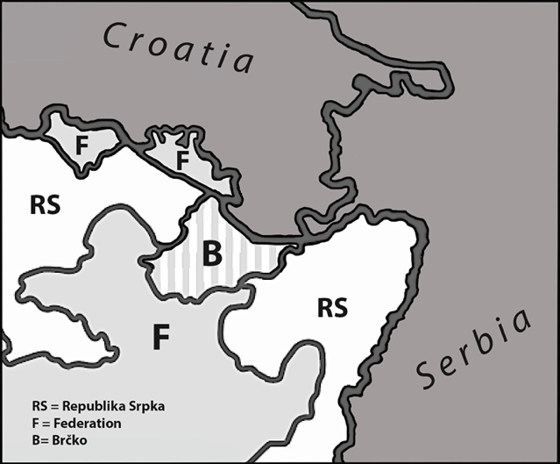

Illustration 93: Map detailing the complicated borders of the Brčko Region in 2024.

**A Little Historical Context**

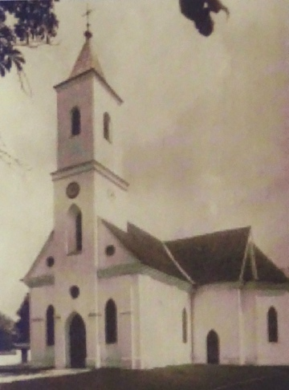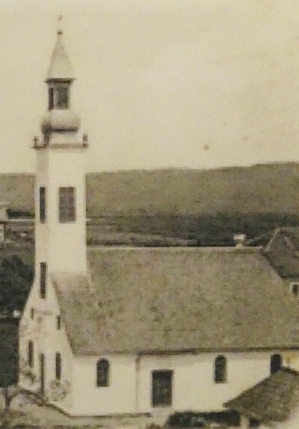In the late nineteenth century, four towering spires dominated central Banja Luka’s skyline, each representing a different element of Bosnian society. The oldest was the proud minaret of the Ferhadija Mosque, which was built in 1579 by an Ottoman general and governor, Ferhad Pasha Sokolović, and which called the Muslim faithful to prayer five times a day. The second, a wood steeple with a homage to an onion dome underneath the lantern, rose a half a mile to the northeast. It was the tower of an Orthodox Christian church, which served as the center of Banja Luka’s largest religious community. Nearby stood a Catholic church, also made of wood, whose more-stout, square pinnacle had Gothic windows. Lastly, quite near the mosque, arose a stone municipal clock tower, which had been built by Ferhad Pasha Sokolović in 1587. This square campanile, the oldest in Bosnia-Herzegovina, symbolized his hope that the newly-converted Bosnian Muslims, the Orthodox Serbs and the Catholic Croatians—all of whom were ethnically Slavs—could live aside one another in peace. After all, all three communities shared a love of minced, grilled meat (*čevapčići*) and intense Turkish coffee.

Illustration 95: Banja Luka Catholic Church, late 1800s.

Illustration 94: Banja Luka Orthodox Church, 1879.

Bosnia-Herzegovina has long been a borderland—a transitional zone where conflicts seek their resolutions. The Slavs began migrating to the area from present-day Poland in the late sixth and early seventh century as polytheists. By the end of the first millennium, they had largely converted to Christianity, with some becoming Catholics, some becoming Orthodox Christians, and still others choosing to form their own independent Christian church. These three denominations disagreed about the Trinity, the primacy of the Pope, the celibacy of priests, and a host of other theological and liturgical issues. When the Ottomans conquered Bosnia in 1463 and made Banja Luka the provincial capital, the situation became even more complex as many Bosnians voluntarily converted to Islam to be able to join the ruling class. By the eighteenth century, with the independent Christian Bosnian church having faded away, Bosnia was 33% Muslim, 43% Orthodox, and 20% Catholic. All of these people were ethnic Slavs, who essentially spoke the same language and who called themselves Bosnians. All that really separated them was their choice of faith and the fact that Orthodox and Catholic peasants usually had Muslim landlords. By the end of the nineteenth century, however, the power of nationalism and national identity movements began creeping into Bosnian culture. Orthodox Bosnians began to identify as Serbs since the independent nation of Serbia was unequivocally Orthodox. Catholic Bosnians began to identify as Croats since semi-autonomous Croatia was fervently Catholic. This change left Bosnia’s Muslims isolated because, unlike other ethnic groups in the Balkans, they did not have an historic or a modern political state, aside from Bosnia, with which to identify.

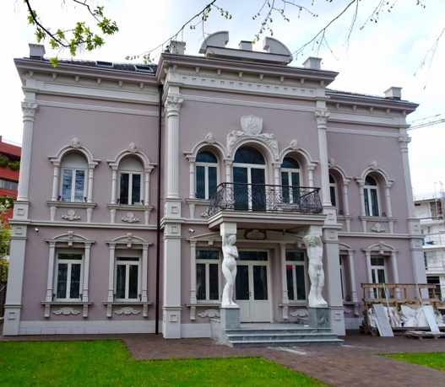Bosnia remained under Ottoman control until 1878, when it became a protectorate of the Austro-Hungarian Empire. Formal annexation followed in 1908. Before World War I, the new imperial rulers created a contemporary central square and park for Banja Luka, which was ringed by government buildings and anchored a growing commercial district. Grand new houses, a new railway station, a hospital, banks, schools, and a military command center also advanced Banja Luka’s infrastructure and modernized its appearance considerably. Many of the city’s historic buildings date to the urban design efforts of the Austro-Hungarians. For Bosnia as a whole, however, the Austro-Hungarian period was economically difficult: its mountainous terrain discouraged development, its hereditary lease-holding peasants were the most exploited in the empire, its exports were barred from the Adriatic Sea by regulation, and its vast timber resources only produced wealth for businesses in Vienna and Budapest.

Illustration 96: Mansion in central Banja Luka built during the period Austro-Hungarian rule.

The nineteenth century’s nationalism, romanticism, and radicalism all met in the imagination of Gavrilo Princip, a poor Bosnian Serb teenager who joined the underground organization Young Bosnia in 1911. The revolutionary group was dedicated to the creation of a unified Slavic state by violent means. On June 28, 1914, with the help of Serbian army officers and a bit of luck, Princip assassinated the heir to the Austro-Hungarian throne, Archduke Franz Ferdinand, and his wife, Sophie, in Sarajevo. The murder wasn’t the cause of World War I, but it was the catalyst that sent ten million men to their deaths before an armistice came on November 11, 1918. The resulting Treaty of Versailles brought the South Slavs together into a kingdom that became known as Yugoslavia, but Bosnians, Croats, Serbs, Slovens, Macedonians, and Montenegrins struggled to reach a mutual understanding.

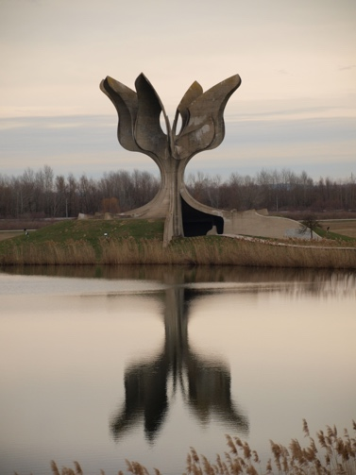Ethnic resentments grew in the Bosnian region as a result of World War II. When the Germans and Italians conquered Yugoslavia in 1941, they created the Independent State of Croatia and installed an ardent Croatian fascist to subjugate most of Croatia and Bosnia. Ante Pavelić and his followers, known as the Ustaše, killed between 300,000 and 400,000 Serbs[1] and forced hundreds of thousands of other Serbs to convert to Catholicism in the few years they were in power. The Jasenovac concentration camp fifty miles north of Banja Luka, where so many Serbs died, was every bit as gruesome as those camps Jews faced in Poland, and this is why the war fueled Croat-Serbian animosity for generations. Bosnia’s Muslims had a more complicated relationship with the Ustaše regime, for while some, including a group from Banja Luka, condemned Croatian treatment of Serbs in 1941, there were certainly other Muslims who enthusiastically welcomed the Nazis and their puppets. 21,000 Bosnian Muslims even joined the Waffen SS in an effort to combat two resistance groups: the royalist, Serbian-dominated Ćetniks and the communist Partisans, who were led by Josip Broz Tito. This active collaboration and support for the Nazis and their allies fed Serbian antipathy for Muslims as well. In fact, of the 86,000 Bosnian Muslims who died in World War II, the vast majority did so at the hands of the Ćetniks, who wanted to “cleanse Bosnia of everything that is not Serb,” according to the minutes of a Ćetniks meeting held in June 1942.

Illustration 97: Memorial monument at the site of the Jasenovac concentration camp,

Banja Luka witnessed bitter fighting during the war as the city changed hands six times between April 1941 and April 1945. Combat was particularly intense in early 1944 with house-to-house fighting, but the more lasting scar came at the start of the war in Yugoslavia, when German bombs destroyed the city’s newly-inaugurated Orthodox cathedral. That Catholic and Muslim places of worship emerged largely unscathed from the war also contributed to lasting ethnic bitterness between Catholic Croats, Orthodox Serbs and Bosnian Muslims.

Tito emerged victorious in the post-war struggle for power. He managed to suppress nationalist feelings and hold communist Yugoslavia together until his death in 1980. Over the next eight years, however, the long-simmering resentments between many of Yugoslavia’s religious groups increasingly bubbled to the surface. By the time the Berlin Wall collapsed and the Cold War ended in 1989-1990, the road to Yugoslavia’s dissolution had become quite short. This began with Slovenia’s push to create a federated republic for Yugoslavia in 1989 that was democratic, pluralistic, and based upon voluntary membership. This move was a direct threat to the power of Serbian leader Slobadan Milošević, who sought a centralized nation that the Serbs could dominate. In June 1991, both Slovenia and Croatia declared their independence. It was one thing for Slovenia to do so because it had well-defined borders and few minorities, but Croatia, with its large Serbian minority, was another matter for Milošević entirely. A vicious, six-month war ensued with the Serbs capturing large portions of Croatian territory and driving half a million people from their homes. A negotiated January 1992 cease-fire barely kept the hostilities at bay since Serbs remembered the crimes of the Ustaše regime and Croats mourned the destruction of historic cities like Dubrovnik and Vukovar.

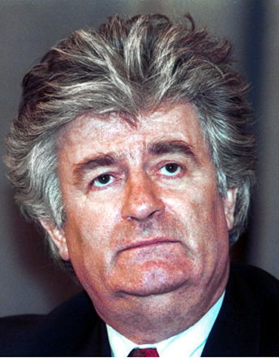This was also an important transitional period for Bosnia-Herzegovina. In late September 1991, the Bosnian parliament began proceedings to create an independent Bosnia state, with the major Muslim and Croatian political parties championing the move. The leader of the Bosnian Serbs, Radovan Karadžić, objected vigorously, however, saying that he “would never accept a document that took [Bosnian] Serbs out of Yugoslavia.”He predicted that “succession could ignite the flame of civil war in Bosnia” and that this “hell” would “possibly [cause] the Muslim nation to disappear, for the Muslim people will not be able to defend [themselves] if it comes to war.” When the parliament ignored Karadžić’s warning, the Bosnian Serbs chose to create their own assembly, the Assembly of the Serb People of Bosnia-Herzegovina, on October 24. On January 9, this assembly met in Banja Luka and declared the majority-Serbian regions of Bosnia-Herzegovina to be independent of the rest of the country. This political entity became known as Republika Srpska (RS). When 99.7% of Bosnia’s Muslims and Croats voted in a February 1992 referendum to separate from Serbian-dominated Yugoslavia, the Bosnian Serbs began pursuing military options to secure their position.

Illustration 98: Radovan Karadžić in 1994.

On May 12, 1992, the RS assembly passed a resolution at Karadžić’s behest that outlined the Bosnian Serbs’ major objectives for the war. The overarching goal was to separate Serb institutions, land, and people from the rest of Bosnia. Because of the way in which Muslims, Catholics, and Orthodox Christians had lived side by side for centuries in Bosnia, the only way to accomplish this goal was to rid Republika Srpska of all non-Serbs. The ethnic cleansing of Republika Srpska soon began.

**Banja Luka c.1993**

As the new year opened, the head of the Red Cross’ mission in Banja Luka noted that the physical ravages of war had yet to come to the city. This was because local authorities sought to preserve it as a model community and capital. Indeed, visitors to Banja Luka in early 1993 were struck with how different it felt from Sarajevo, Mostar, and other cities in Bosnia- Herzegovina. There were “no shell craters, no pitted and gouged walls, no boarded-up shop fronts, no fire-gutted houses,” an interpreter for a British military commander noted. Instead, the scars of war were psychological, for the city’s Muslims lived in constant fear that the next knock on the door would result in tragedy: a Serb coming to take the house, rape a daughter, or murder a spouse. By 1993, harassment had turned to terror. In fact, the fear had become so pervasive (and the desire to leave so great) that Muslims were arriving at the Banja Luka’s Bureau for the Removal of Populations and Exchange of Material Goods armed with documents to prove that they had surrendered the deed to their house and forfeited the contents of their bank accounts. All they wanted was a seat on one of the bus convoys. It didn’t matter where they ended up as long as they were still alive. An orderly exit was, of course, exactly what the Bosnian Serbs in Banja Luka wanted. By the end of the year, of the 350,000 Muslims who once lived in the Banja Luka region, only 40,000 remained. Two signs explained the situation succinctly. The first, hung in a Muslim neighborhood proclaimed, “Avoid the hardships of winter. Leave the area now." The second, near the door of the local office for the United Nations High Commissioner for Refugees, said, “Welcome to the Dark Side of the Moon...”

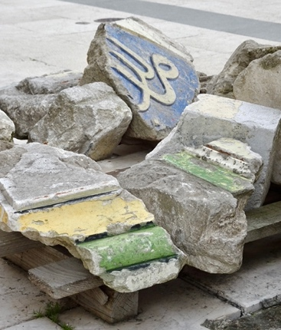Even in their desperate evacuation, the Muslims begged Bosnian Serb authorities to be allowed to collect and preserve the rubble of the Ferhadija Mosque. They hung onto the hope of one day being able to reconstruct it, but permission was refused. Instead, the remnants of the treasured building were dumped in the Vrbas River, taken to landfills, or hidden in secret locations. The site was then bulldozed into a parking lot. For the city’s Serb leaders, there was to be no going back: all evidence of Muslim participation in what was once known as Bosnia’s “common life” was to be permanently erased. That is what ethnic cleansing meant in Banja Luka.

As Muslims left, displaced Bosnian Serbs began to arrive from other parts of the country, for war had forced them to move as well. These refugees happily moved into the newly-evacuated Muslim homes, relieved to find in-tact residences with fully equipped kitchens and bedrooms. As one American journalist noted, “the toys they found…were an unexpected bonus.”

Illustration 99: Recovered fragments from the original Ferhadija Mosque, April 2023.

Just as the Republika Srpska government began to feel confidence in its ability to create a new life for Bosnian Serbs, a surprising challenge arose. In September 1993, one corps of the Bosnian Serb army seized key municipal buildings, police stations, and communication centers and closed all of the major roads into Banja Luka. This renegade unit demanded better pay from the government, as well as the end to the wartime profiteering by well-connected politicians. The soldiers wanted to benefit from some of the illegally-obtained wealth flowing into Bosnia, which one study valued to be 23% of all humanitarian aid. This graft didn’t anger the general public, however, for they remained largely unsympathetic to the soldiers’ cause. Instead, most Bosnian Serbs expected them to continue to sacrifice for the Bosnian Serb cause. Indeed, most of Banja Luka’s residents would have applauded a soldier who told *Time*:

This is a very personal war. It will decide who I shall live with, and we can never live with the Muslims again. I do not mind spending the rest of my life in the trenches if it will finally settle the question of who owns the land. Then my children can live in peace.

Without public support, the tank unit found itself in an untenable position. This fact helped RS president Radovan Karadžić quell the crisis quickly upon his arrival in Banja Luka. His ability to do so also allowed Karadžić to be generous: while he had a few of the ringleaders arrested, most soldiers returned to duty without punishment.

With the local military situation secure and the city becoming more homogeneously Serbian, Republika Srpska officials saw an opportunity to celebrate Serbian identity and values while restoring Banja Luka’s cultural heritage. War had destroyed the city’s Orthodox cathedral in 1941, but now there was the opportunity to build something triumphant—a poignant symbol of Serbian faith and the Serbian vision for Bosnia’s future. The new cathedral would be like a phoenix rising out of the fire, full of hope. Symbolically, the architectural plans specifically called for the inclusion of a campanile that was taller than either Ferhad Pasha Sokolović’s minaret or his municipal clock tower. In an elaborate ceremony watched by more than 10,000 people, the Cathedral of Christ the Savior’s foundations were consecrated on October 17, 1993. In one address, the patriarch of the Serbian Orthodox Church noted that:

Once a sin is committed, a new sin always begets. That's why everything tragic that happens in these times is a consequence of the events during the Second World War. Hence the destruction of the synagogue and so many deaths in this unfortunate war. The causes of this present-day tragedy…did not arise overnight.

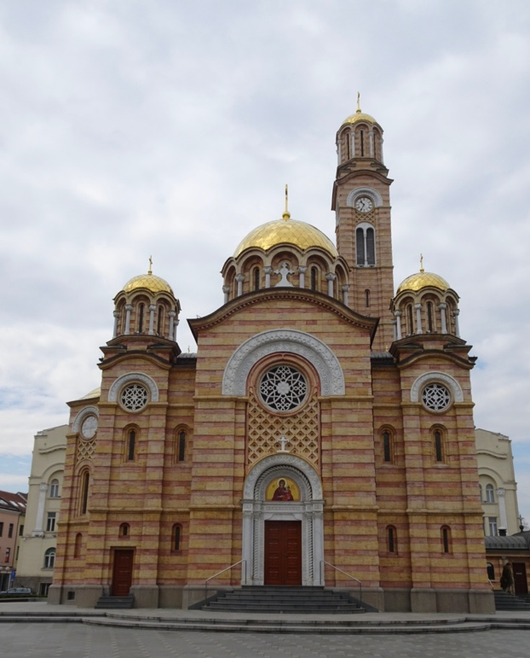

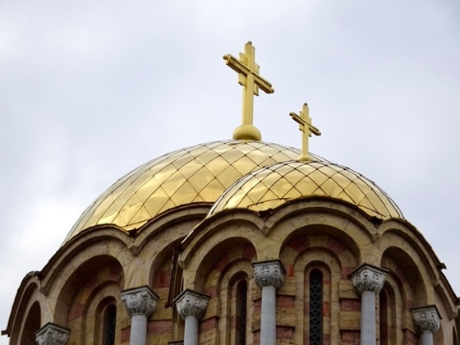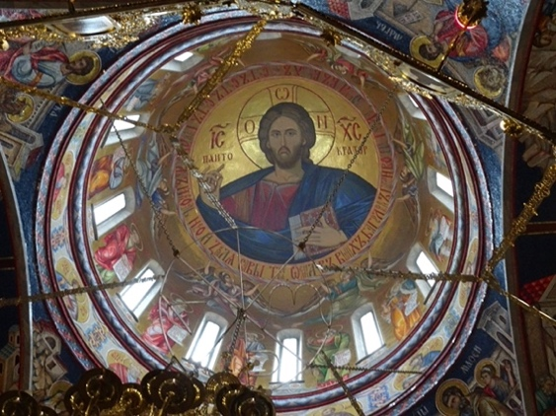

Illustration 100, 101, and 102: Facade and dome of Christ the Savior Orthodox Cathedral, Banja Luka, April 2023.

In other words, history weighs heavily and prominently in the minds of those living in the Balkans. It is omnipresent, which is why cultural symbols hold such importance. For Banja Luka, the destruction of the Ferhadija Mosque in May and the consecration of Christ the Savior in October stand as 1993’s bookends to what can only be described as an enormously complicated, repeatedly tragic history.

**A Short Postscript**

The Bosnian Civil War raged on through the rest of 1993, all of 1994, and most of 1995 with Muslims fighting Croats, Croats fighting Serbs, and Serbs fighting Muslims at different times in different parts of the country. Atrocities continued to be committed by all sides, but what happened in the UN “safe town” of Srebrenica in July 1995 remains one of the war’s most potent symbols. The attack was ordered by Republika Srpska president Radovan Karadžić and resulted in the systemic murder of approximately 8,000 Bosnian Muslim men and boys, as well as the rape of an untold number of Muslim women. Karadžić later boasted of his decision, but the massacre in Srebrenica and the capture of other UN-protected communities proved to be a serious miscalculation. The horrors were such that NATO and President Bill Clinton were finally pushed into meaningful action. After a Bosnian Serb mortar exploded in a Sarajevo market on August 28, NATO began bombing RS positions around the city. This major assault was combined with the launching of thirteen Tomahawk missiles on the Bosnian Serb army’s command center outside of Banja Luka and the unexpectedly quick advance of the Croat army to within twelve miles of Banja Luka. These developments convinced Yugoslavian president Slobadan Milošević that he had to intervene more directly and purposefully. He subsequently forced Karadžić to sign an agreement to allow Milošević to represent the Bosnian Serbs at the negotiating table.[2]

The decisive peace talks to end the Bosnian Civil War were held at an American air force base outside of Dayton, Ohio in November 1995, with Croatian President Franjo Tudjman representing the Bosnian Croats, Alija Izetbegović representing the Bosnian Muslims, and Milošević representing the Bosnian Serbs. The leading American diplomat, Richard Holbrooke, selected the site over cities like Paris or Geneva because he wanted to control the press, keep the negotiators in close proximity, and offer few distractions. The sparse accommodations would also help ensure that no one would want to linger. This worked, for by the third week of the negotiations, everyone was “sick of the confinement and the artificiality of it,” as one American official noted. That the three leading delegates—Izetbegović, Milošević, and Tudjman—hated each other also meant that everyone was eager to conclude an agreement as quickly as possible.

The final accord split Bosnia-Herzegovina into two political entities: Republika Srpska with 49% of the territory and its capital of Banja Luka and the Bosnian-Croat Federation with 51% of the territory and its capital of Sarajevo. Both entities were to be governed by a joint legislature and a presidency that rotated between the three major ethnic groups. An Office of the High Representative and 60,000 UN peacekeeping troops would enforce Dayton’s terms and ensure the peace. Because no agreement could be reached on the Brčko District, the matter was referred to arbitration.

The Dayton Agreement successfully ended the civil war, but it also created a de facto partition that some today see as rewarding the aggressors and supporting genocide. Others hold that the agreement was the best that could be achieved at the time, given the multitude of factors and perspectives. What is clear is that the serpentine borders dividing RS from the Federation (which is composed of separate Muslim and Croat cantons) make little geographical sense, for neither RS or the Federation have a contiguous border. Instead, the lines on the map reflect Bosnia’s multicultural history, ethnic cleansing, the territorial swaps made at the negotiating table, and troop positions at war’s end. It is also clear that over two million people were displaced from their homes during the conflict, 36,700 civilians were killed, and 68,000 soldiers died because of the ways in which ethnic prejudices were fueled by virulent propaganda campaigns by all sides. Even more tellingly, the various parties have never been able to reach a final agreement on the strategic Brčko District, for the governments of Bosnia-Herzegovina struggle to be effective as a result of overlapping jurisdictions, vested interests, residual suspicions, economic barriers, corrupt courts, and the nation’s fundamental constitutional structure. As one historian put it, Bosnia-Herzegovina is a “two-headed monstrosity,” within which lives a “second hybrid entity—the Muslim-Croat federation—that existed mainly in the minds of foreign diplomats.” Indeed, the war and the Dayton Accord destroyed any hope for a unified multicultural nation. The great consequence of the victory of ethnic-religious nationalism is that Bosnia-Herzegovina has yet to develop into a mature democracy with a modern economy.

Shortly after peace came to Bosnia-Herzegovina, about 500 Muslim refugees returned to Banja Luka. They quickly expressed their desire to rebuild the Ferhadija Mosque, using recovered original stones wherever possible. City officials balked at issuing a building permit, with the mayor saying in 1998 that the mosque was a symbol of Turkish occupation and oppression: rebuilding it “would be perceived by the Serbs as the darkest humiliation, which would open the old wounds and bring far-reaching consequences.” When the cornerstone was finally laid in 2001, on the eighth anniversary of the mosque’s destruction, it was clear that the mayor wasn’t exaggerating. The ceremony sparked a violent reaction from several thousand Serbian nationalists, who committed acts of arson and vandalism and imprisoned 300 people in the city’s Islamic Center, including representatives from the UN and ambassadors from Britain, Sweden, and Pakistan. By the end of the day-long riot, thirty people had been injured, including local police officers who had been unable to maintain the peace. One Muslim died two weeks later, having been beaten with his prayer rug until comatose. Dayton may have brought an official peace to Republika Srpska and its capital of Banja Luka, but the region’s long-standing prejudices continued to percolate.

Construction of the mosque proceeded in spite of the riot and the continued threat of violence, and on May 7, 2016 nearly ten thousand Bosnian Muslims gathered in front of the reconstructed Ferhadija Mosque to witness an inspiring demonstration of religious and political unity. Guarded by over a thousand Bosnian Serb police officers, an array of secular and religious officials came together to commemorate the mosque’s reopening after twenty-three years. The dignitaries included Bosnia-Herzegovina’s head of state, the nation’s Grand Mufti, the American ambassador, European bureaucrats, and representatives of the region’s Catholic, Jewish, and Orthodox Christian communities. Turkish Prime Minister Ahmet Davutoğlu gave the ceremony’s main address, which highlighted Turkey’s and Bosnia-Herzegovina’s shared cultural heritage. He proclaimed:

Those who bombed and destroyed Ferhadija Mosque 23 years ago not only destroyed a mosque, they also destroyed humanity’s conscience. Today by rebuilding this mosque, we are in fact rebuilding the conscience of humanity. Let it be known that as long as this mosque is here, prayers voicing humanity's conscience will speak to the skies in Banja Luka.”

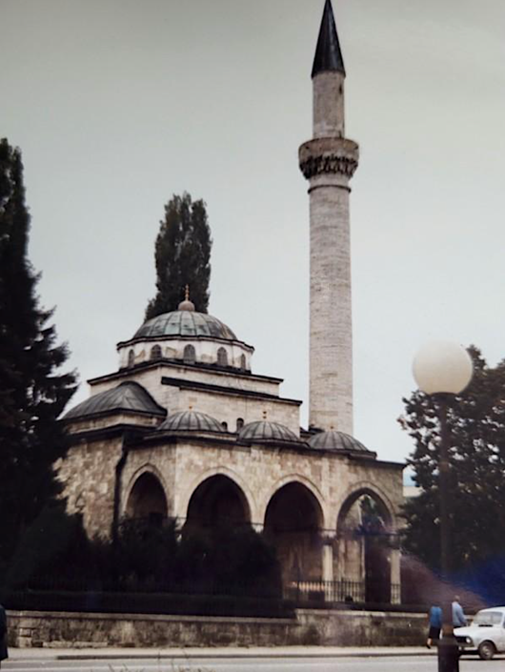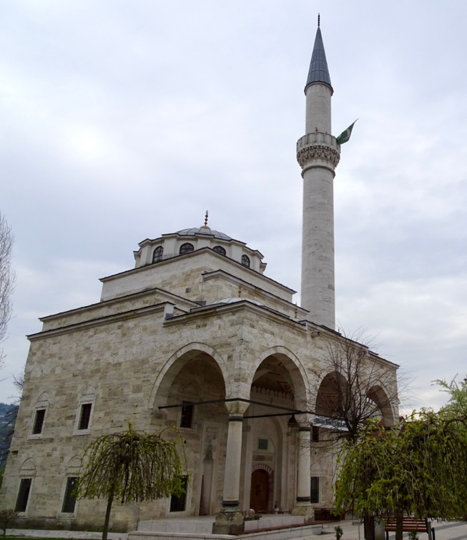It was a day of optimism, joy, and reconciliation for a city and a country struggling to come to terms with its complicated past. The air seemed full of new possibilities and new opportunities, thanks to the inspired speeches, poignant handshakes, and common prayers. As the Grand Mufti concluded, “Ferhadija was, is, and will be the magnificent witness of faith in the unity of the Creator.”

Illustrations 103 and 104: Left: Ferhadija Mosque in 1989, and, right, the mosque from a similar angle in 2023. The attention to detail in the reconstruction is clear.

Reality returned quickly enough. The next day, on May 8, a group of nationalistic Bosnian Serbs chanted a particularly hateful slogan in front of the mosque during morning prayers: “Nož, žica, Srebrenica! Nož, žica, Srebrenica!” Rhyming in Serbian, “The Knife, the Barbed Wire, Srebrenica!” is a chant that glorifies one of the civil war’s most notorious atrocities. As the hateful words ricocheted off the carefully reconstructed walls and the mosque’s single, soaring minaret, Ferhadija once again became a symbol of ethnic division in a still-troubled land.

**What Banja Luka Teaches**

The first thing that Banja Luka showcases is the way in which works of architecture hold enormous power as symbols of identity. Just as the Parthenon symbolizes Greece, the Giza Pyramids represent Egypt, and the Great Wall denotes China, the Ferhadija Mosque embodied Banja Luka’s Muslim community. After the war, the mosque’s absence personified everything that had been lost: homes and neighbors, friends and family, wealth and well-being. By rebuilding the mosque, the city’s Muslims sought to honor their past, celebrate the present, and convey their hopes for the future. They wanted to express their long-standing civic membership, as well as the promise of future civic participation. But because architecture is a material expression of power, this objective sparked a violent reaction from radicals within Banja Luka’s Serbian community, who wanted to define citizenship as being exclusively Orthodox. As with Mostar’s Old Bridge, Ferhadija’s destruction and eventual rebuilding became a potent representation of the conflict and its partial resolution.

The second lesson shows how binary thinking limits understanding. Americans are particularly prone to this trap, for they tend to categorize their world as being one thing or the other: good or bad, black or white, North or South, domestic or foreign, Democrat or Republican. This was particularly true during the Cold War because of the way the threat of nuclear annihilation was added to the mix. The problem for American officials in the early 1990s was that having lost the Cold War as an organizing principle, they were paralyzed with indecision. Unable to determine decisively who was an ally and who was an enemy in a nation with three adversaries, American officials dithered as the Bosnian Civil War developed. They didn’t see the conflict as being important enough to risk American lives. They especially struggled to read the lay of the land because Catholics, Orthodox Christians, and Muslims could all point to multiple atrocities having been committed against them, as well as to evidence of members of their own communities overcoming circumstances and prejudice to help people of different faiths in times of crisis. Were the Americans able to overcome the limitations of binary thinking and come to a consensus faster, as their NATO allies begged them to do, Bosnia-Herzegovina would be a happier place today.

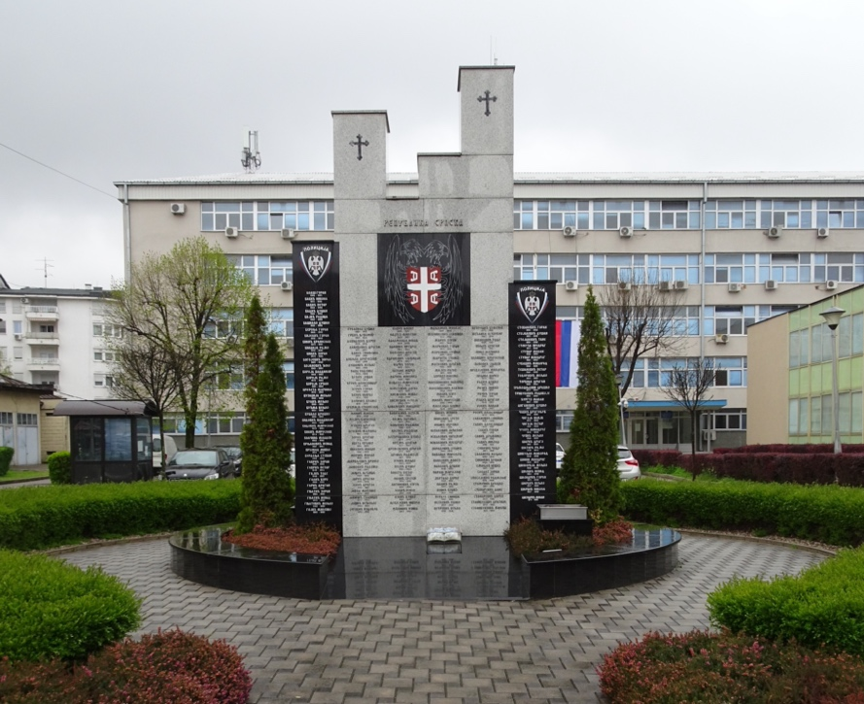

Illustration 105: Memorial to the Bosnian Serb police officers who died during the civil war, which stands in front of Banja Luka’s main police station.

**Curated Bibliography for Chapter 8**

*2016 European Islamophobia Report*. Enes Bayrakli and Farid Hafez (eds.) Istanbul: SETA, 2017.

Andrić, Ivo. *The Bridge on the Drina*. Chicago, IL: University of Chicago Press, 1977.

Bal, Mustafa. “Romantic Piers of *The Bridge on the Drina*.” *Serbian Studies*. Vol. 21, No. 1 (2007).

Barnes, Edward. “Behind the Serbian Lines.” *Time.* May 17, 1993, 32-35.

*Battling Over the Balkans: Historiographical Questions and Controversies*. John R. Lampe and Constantin Iordachi (eds.). New York: Central European University Press, 2020.

Bennett, Christopher. *Bosnia’s Paralysed Peace*. New York: Oxford University Press, 2016.

Biondich, Mark. “Religion and Nation in Wartime Croatia: Reflections on the Ustaša Policy of Forced Religious Conversions, 1941-1942.” *The Slavonic and East European Review*. Vol. 83, No. 1 (January 2005), JSTOR.

Björkdahl, Annika and Johanna Mannergren Selimovic. “A Tale of Three Bridges: Agency and Agonism in Peace Building.” *Third World Quarterly*. Vol. 37, No. 2 (2015).

Bose, Sumantra. *Bosnia After Dayton: Nationalist Partition and International Intervention*. New York: Oxford University Press, 2002.

“Brčko.” *Columbia Electronic Encyclopedia*. 6th Edition (2021). EBSCOhost.

Broz, Svetlana, Laurie Kain Hart, and Ellen Elias-Bursać*. Good People in an Evil Time: Portraits of Complicity and Resistance in the* Bosnian War. New York: Other Press, 2004.

Carney, James. “Finally, the Leader of NATO Leads.” *Time*. September 11, 1995, 54.

Chazan, Yigal. “Vice Tightens in a Town of Hard Choices: Banja Luka In Bosnia Has Escaped the Worst of Serbian Ethnic Cleansing, but the Pressure is Growing on the Muslims and Croats There.” *Guardian* [London]. January 8, 1993. Gale Health and Wellness.

*Church of Christ the Savior, Banja Luka*. <https://hhsbl.org/sr/istorijat-hrama?start=9>

Čuvalo, Ante. *Historical Dictionary of Bosnia and Herzegovina*. Lanham, MD: Scarecrow Press, 2007.

“Davutoğlu Attends Reopening of Historic Bosnian Mosque.” *Daily Sabah*. May 07, 2016.

“Details about the Opening of Ferhadija in Banja Luka.” *Sarajevo Times*. May 7, 2016.

Donia, Robert J. *Radovan Karadžić: Architect of the Bosnian Genocide*. New York: Cambridge University Press, 2015.

Drašković, Branislav. “Urban Expansion of the Largest Cities in Bosnia and Herzegovina Over the Period 2000-2018.” *Geographica Pannonica*. Vol. 25, No. 4 (December 2021).

Duggal, Hanna. “Infographic: 30 years since the Bosnian War.” *Al Jazeera*. April 6, 2022.

Dzidic, Sanin. “Homage to Prof. Dr. Ismet V. Tahirovic: Some Structural Undertakings for Preservation of Historical Monuments in 20th Century Bosnia and Herzegovina.” *Research Gate*, 2017.

Fedarko, Kevin. “A Bosian Peace Deal in Dayton is ‘Inches Away.’” *Time*. November 27, 1995, 40-41.

Fedarko, Kevin. “Louder Than Words.” *Time*. September 11, 1995, 50-59.

Glenny, Misha. *The Balkans: Nationalism, War, and the Great Powers, 1804-1999*. New York: Penguin Press, 2001.

Gordon, Michael R. “U.S. Finds Serbs Skimming 23% Of Bosnian Aid.” *The New York Times*. January 13, 1993. Gale Opposing Viewpoints.

Hamilton, Daniel S. “Fixing Dayton: A New Deal for Bosnia and Herzegovina.” *NextEurope*. No. 1 (November 2020).

Hayden, Robert M. *Antagonistic Tolerance: Competitive Sharing of Religious Sites and Spaces.* New York: Routledge, 2016.

“Half of Nazi Base Is Seized by Tito.” *New York Times*. January 4, 1944, 6. ProQuest Historical Newspapers.

Husarska, Anna. "Without A Prayer?: Rebuilding a Muslim Temple is a Test of Bosnia's Peace." *The Washington Post.* May 10, 1998. C1. ProQuest Historical Newspapers.

Jankovic, Aleksandar. “Nationalism as a Structural Obstacle to Democratization of Bosnia and Herzegovina Society.” *Sociologija*. 61 (2019). ResearchGate, 10.2298/SOC1901087J.

Jankovic, Aleksandar. “On the Road From Socialism to Capitalism: Attitudes of Young People in Bosnia and Herzegovina on Economic Role Of The State.” *Sociologija*. Vol. LXVI, No. 2 (2024).

Jelavich, Barbara. *History of the Balkans: Eighteenth and Nineteenth Centuries.* Vol. 1. New York: Cambridge University Press, 1983.

Jones, Paul. *The Sociology of Architecture : Constructing Identities*. Liverpool, UK: Liverpool University Press, 2011). EBSCOhost.

Judah, Tim. *The Serbs: History, Myth, and the Destruction of Yugoslavia*. New Haven, CT: Yale University Press, 2009.

Kann, Robert. A. *History of the Habsburg Empire, 1526-1918, A*. Berkeley, CA: University of California Press, 1974.

Kaplan, Robert D. *Balkan Ghosts: A Journey Through History*. New York: Picador, 2005.

Karčič, Hikmet. “Uncovering the Truth: The Lake Perućac Exhumations in Eastern Bosnia.” *Journal of Muslim Minority Affairs*. Vol. 37, No. 1 (2017).

Levy, “‘The Last Bullet for the Last Serb’: The Ustaša Genocide Against Serbs, 1941-1945.” *Nationalities Papers*. Vol. 37, No. 6 (November 2009).

Maass, Peter. *Love Thy Neighbor: A Story of War.* New. York: Alfred A. Knoff, 1996.

Motadel, David. “The ‘Muslim Question’ in Hitler’s Balkans.” *The Historical Journal*. Vol. 56, No. 4 (December 2013). JSTOR.

*Muslims of Bosnia-Herzegovina, The: Their Historic Development from the Middle Ages to the Dissolution of Yugoslavia*. Mark Pinson (ed.). Cambridge, MA: Harvard University Press, 1996.

Palowitch, Stevan K. *Tito: Yugoslavia’s Great Dictator: A Reassessment*. Columbus, OH: Ohio State University Press, 1992.

Packer, George. *Our Man: Richard Holbrooke and the End of the American Century.* New York: Alfred A. Knopf, 2019.

Pejanović, Mirko. *Through Bosnian Eyes: A Political Memoir of a Bosnian Serb*. West Lafayette, IN: Purdue University Press, 2004.

Perić-Romić, Ranka. “Rehabilitation of Urban Heritage in the Service of Ethno-National Divisions on the Example of Sarajevo and Banja Luka.” *Politeia*. Vol. 10, No. 20 (2020).

Robinson, Guy M. and Alma Pobric. “Nationalism and Identity in Post-Dayton Accords: Bosnia-Hercegovina.” *Tijdschrift voor Economische en Sociale Geografie*. Vol. 97, No. 3. Blackwell Publishing.

Strachan, Hew. *The Outbreak of the First World War*. New York: Oxford University Press, 2004.

Stokes, Gale. *The Walls Came Tumbling Down: Collapse and Rebirth in Eastern Europe*. 2nd ed. New York: Oxford University Press, 2012.

Stankovic, Milos. *Trusted Mole: A Soldier’s Journey into Bosnia’s Heart of Darkness*. New York: HarperCollins, 2000.

“Tito Expelled from Banja Luka by Strong Nazi Reinforcements.” *New York Times*. January 8 1944, 4. ProQuest Historical Newspapers.

Toal, Gerard and Carl T. Dahlman. *Bosnia Remade: Ethnic Cleansing and Its Reversal*. New York: Oxford University Press, 2011.

Thurow, Roger. “Desperate Muslims Eek Way Out Bosnia: Poster Urging People To ‘Avoid The Hardships Of Winter. Leave The Area Now’ May Sound Like A Travel Promotion. But The Real Message Is One Of Life And Death.” *Globe & Mail.* November 23, 1993. Gale Health and Wellness.

Wald, Patricia M. “Forward: War Tales and War Trials.” *Michigan Law Review*. Vol. 106:901 (April 2008).

“Yugoslavs Battle Foe in Banja Luka.” *New York Times*. January 5 1944, 5. ProQuest Historical Newspapers.

1. The Ustaše also were responsible for the murder of the vast majority of Bosnia’s 14,000 Jews and numerous members of the region’s Roma and gay communities.
2. Karadžić’s political career came to an end shortly after surrendering to Milošević’s demands. He remained in hiding for many years, but was finally arrested and put on trial for war crimes and genocide. In 2016, Karadžić was found guilty by the International Criminal Tribunal for the former Yugoslavia (ICTY) and was sentenced to life imprisonment.