Lohani MICA Product Catalog
- Phlogopite Mica Washer | 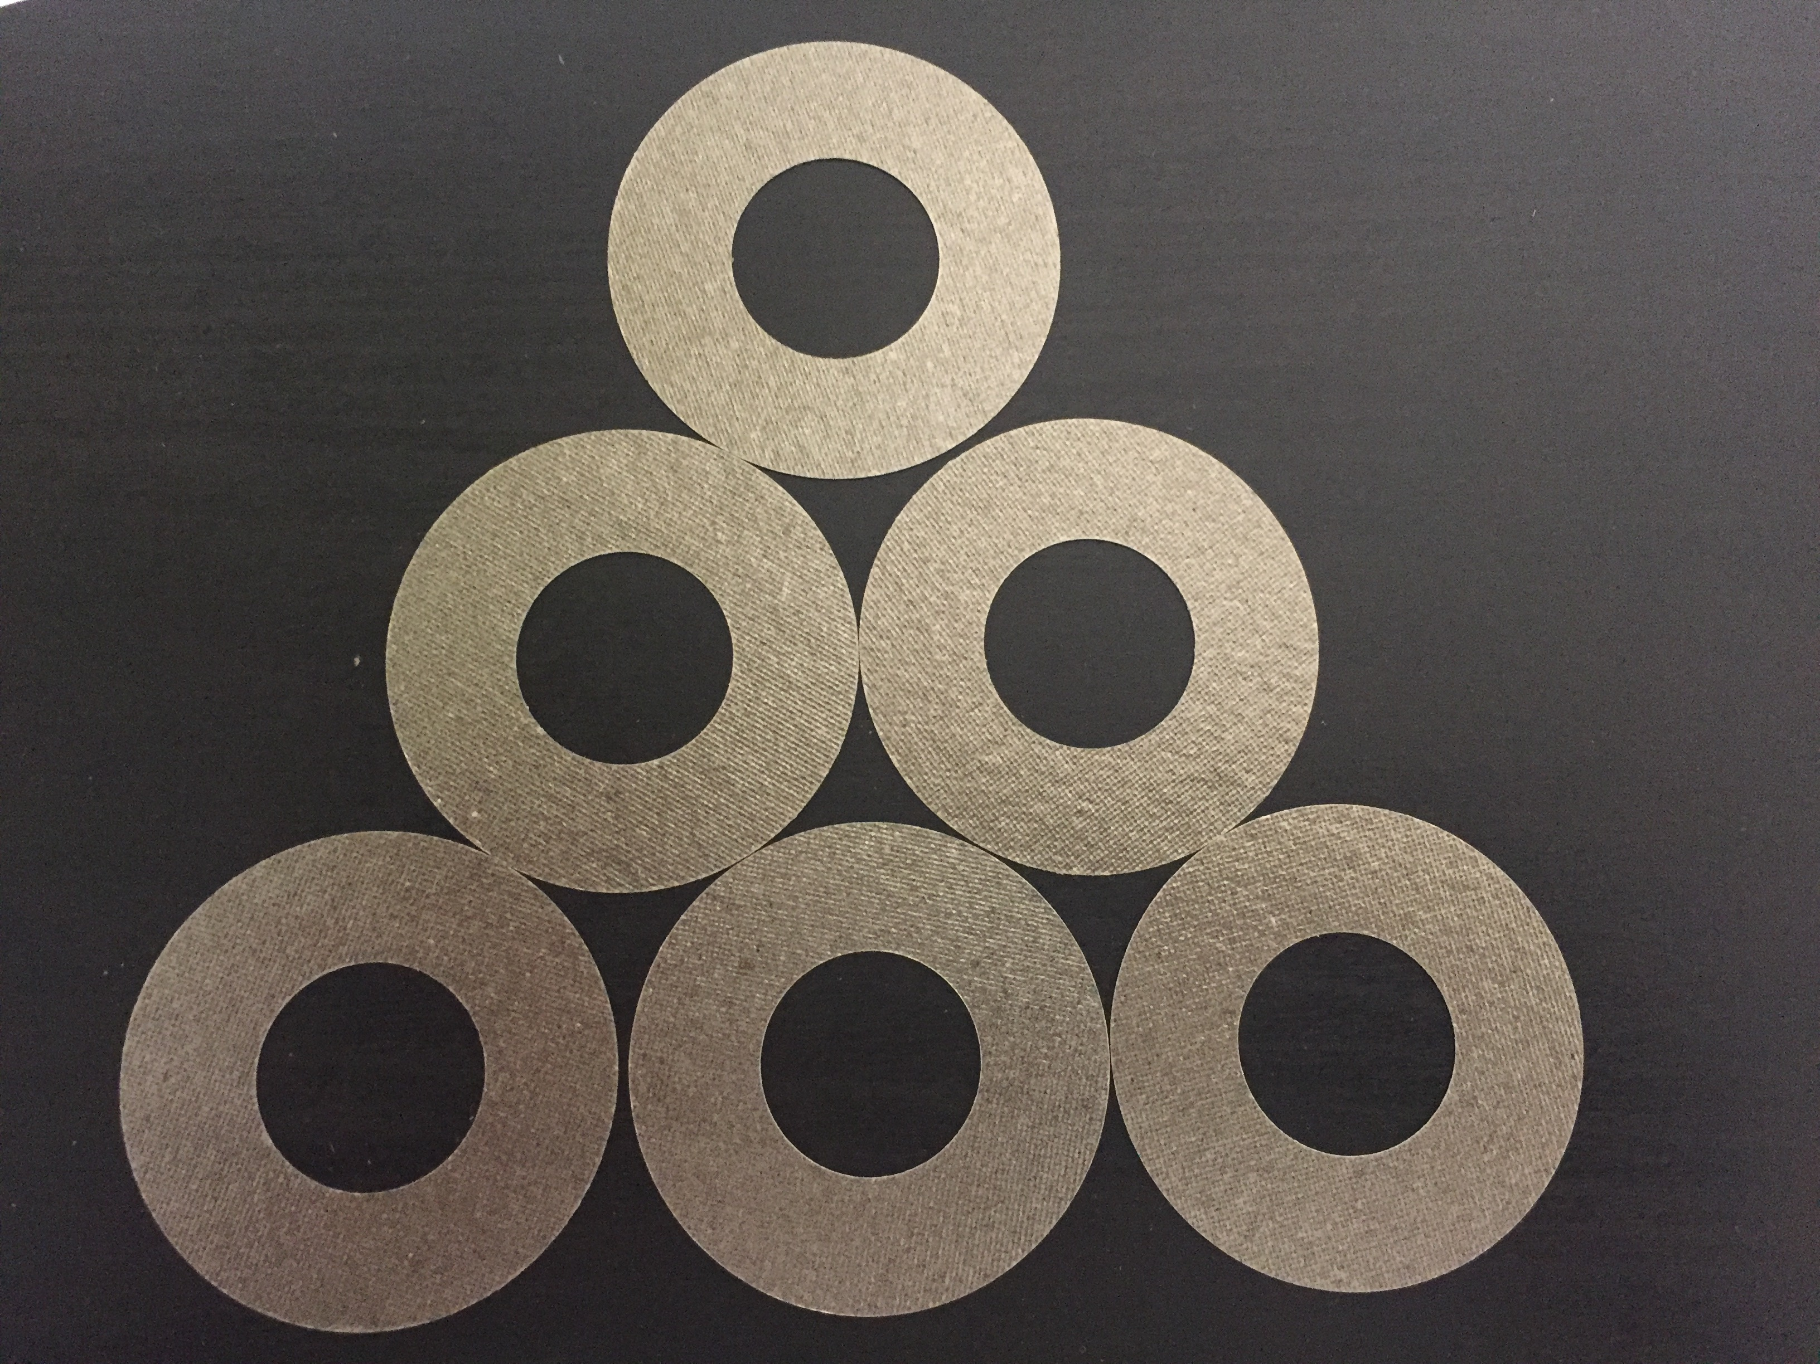
- Fabricated Mica Transistor Washer | 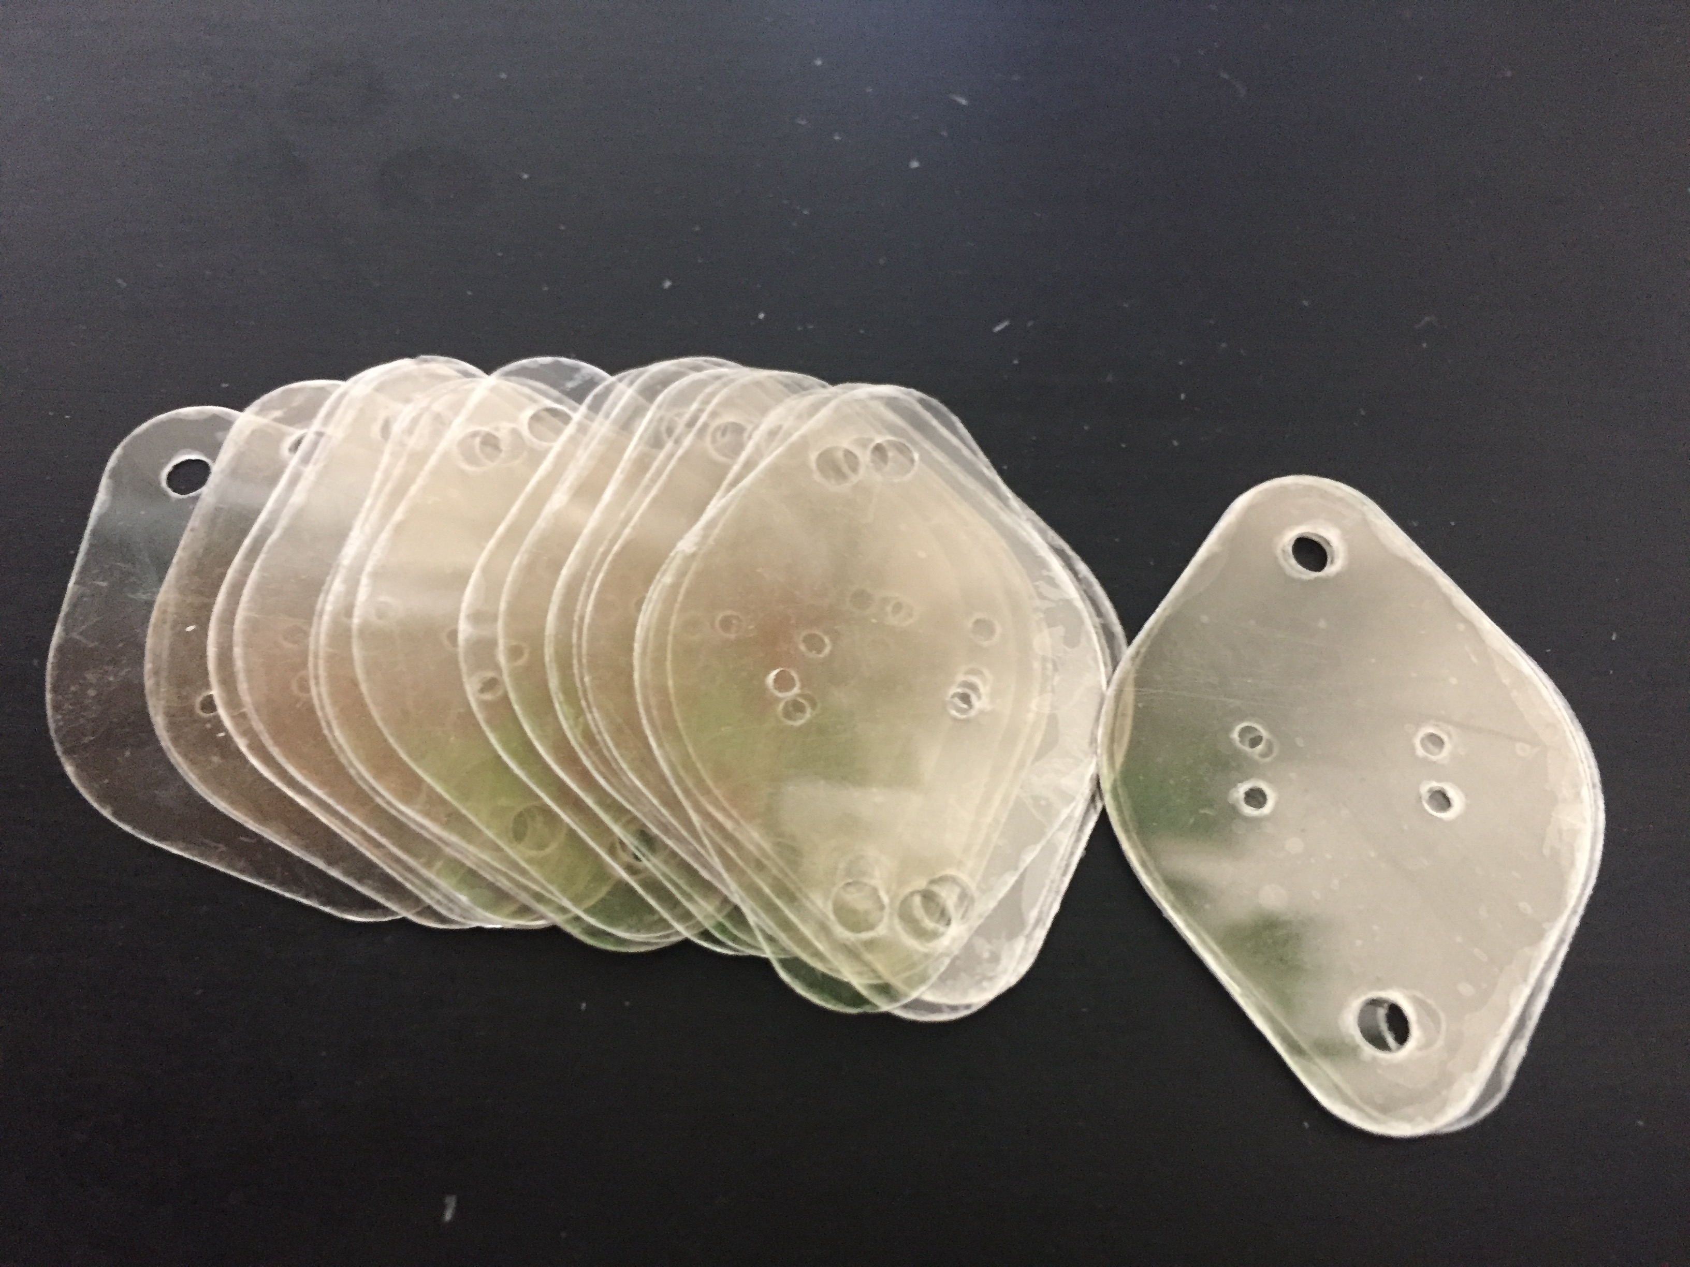
- Fabricated Mica Washer 16MM | 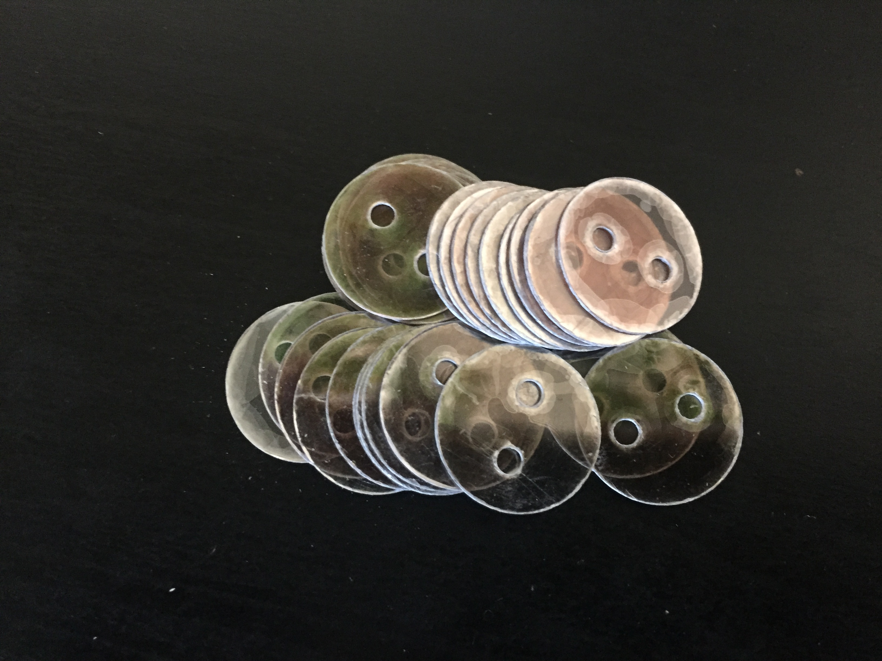
- Fabricated Mica Washer Quality V-4 | 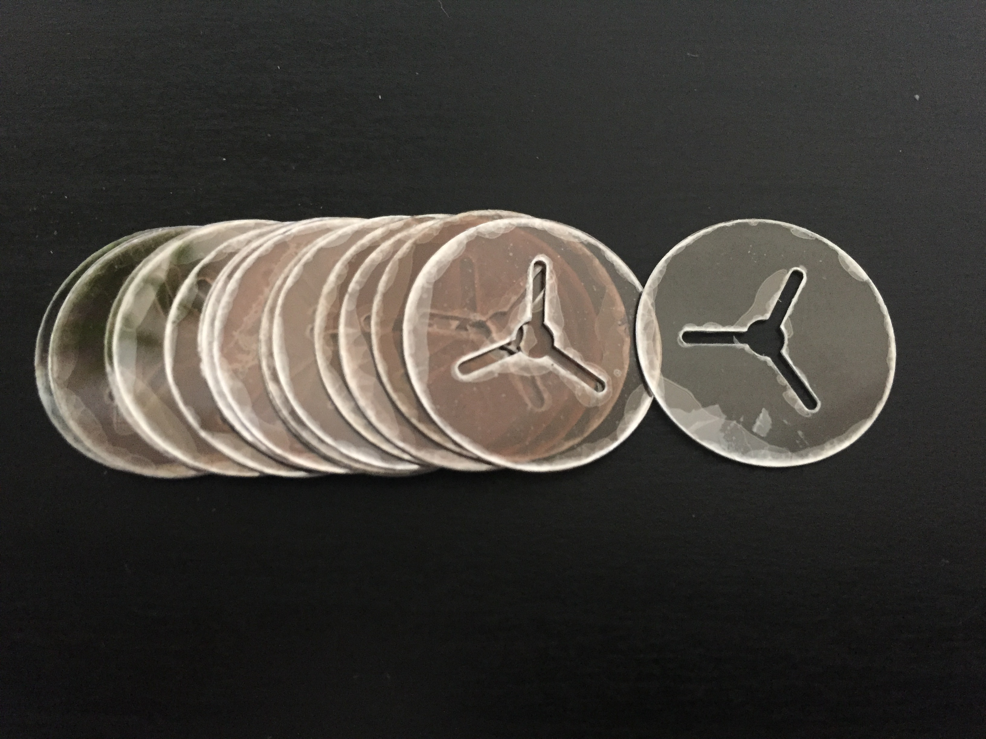
- Fabricated Mica Washer Quality V-4 | 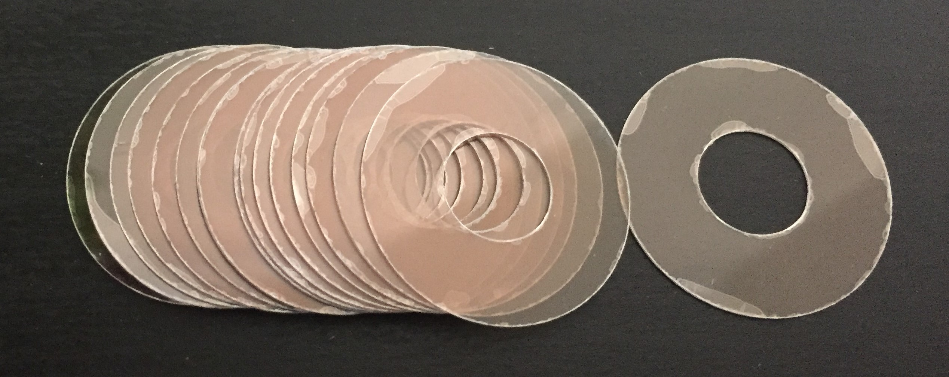
- Fabricated Mica Washer Quality V-6 | 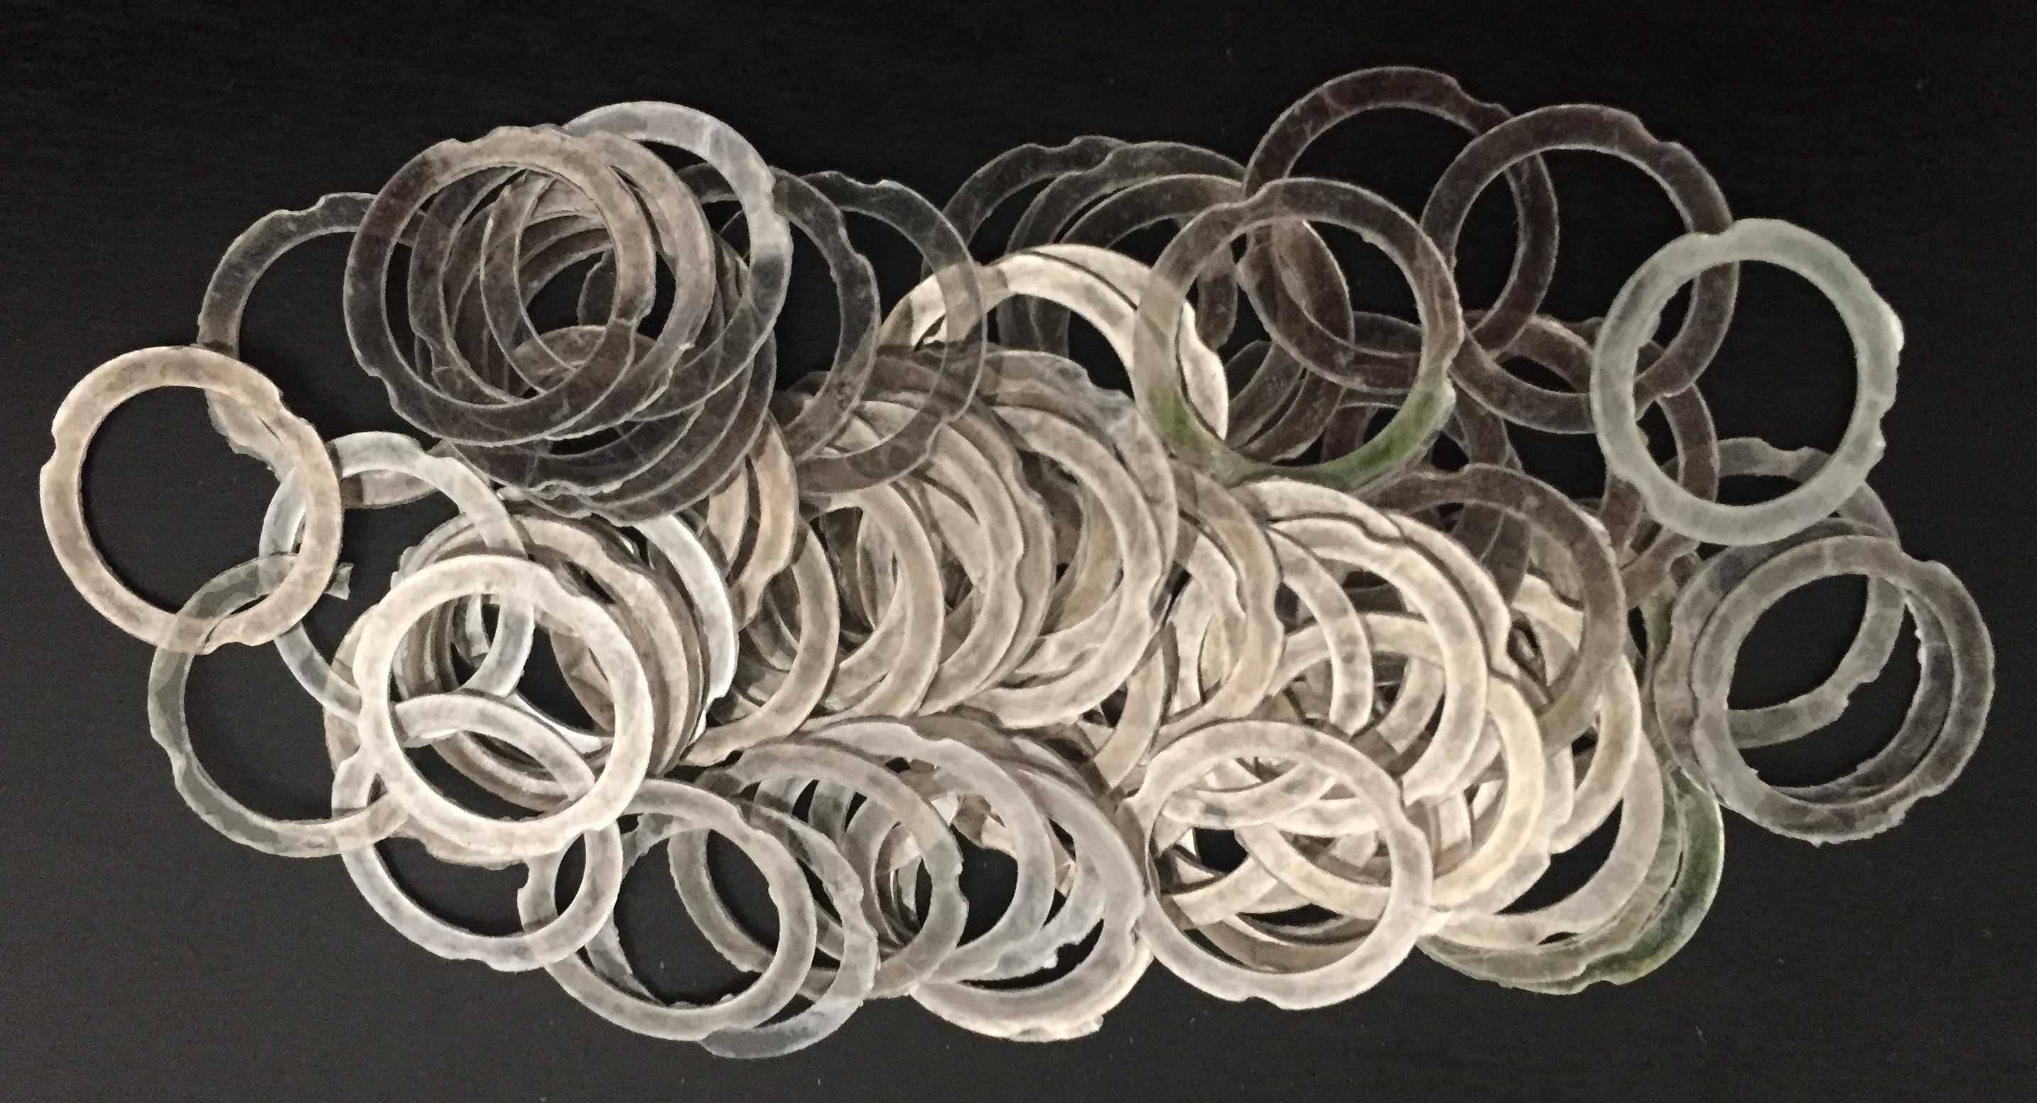
- Fabricated Mica Plate | 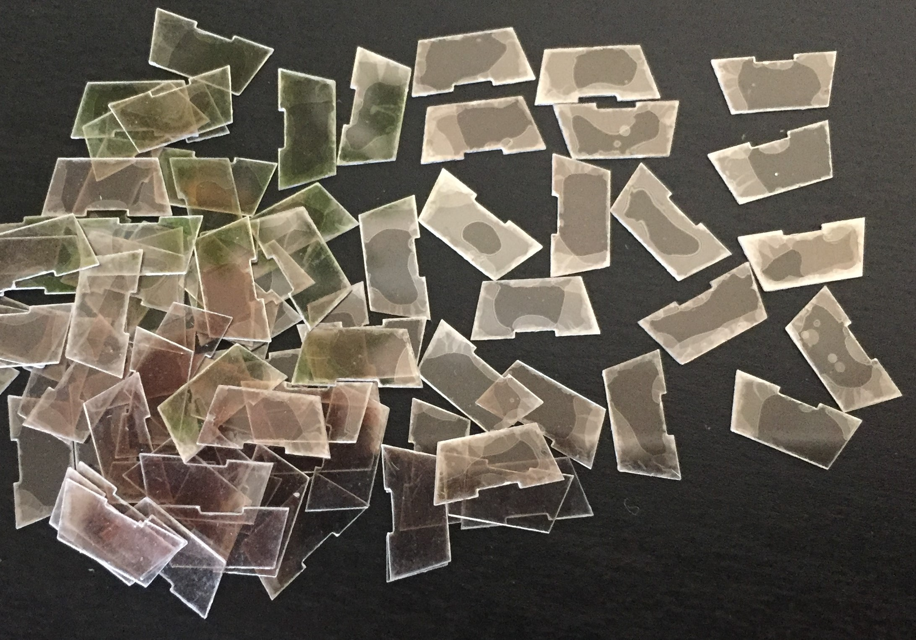
- Ruby cut Mica Discs quality V2 | 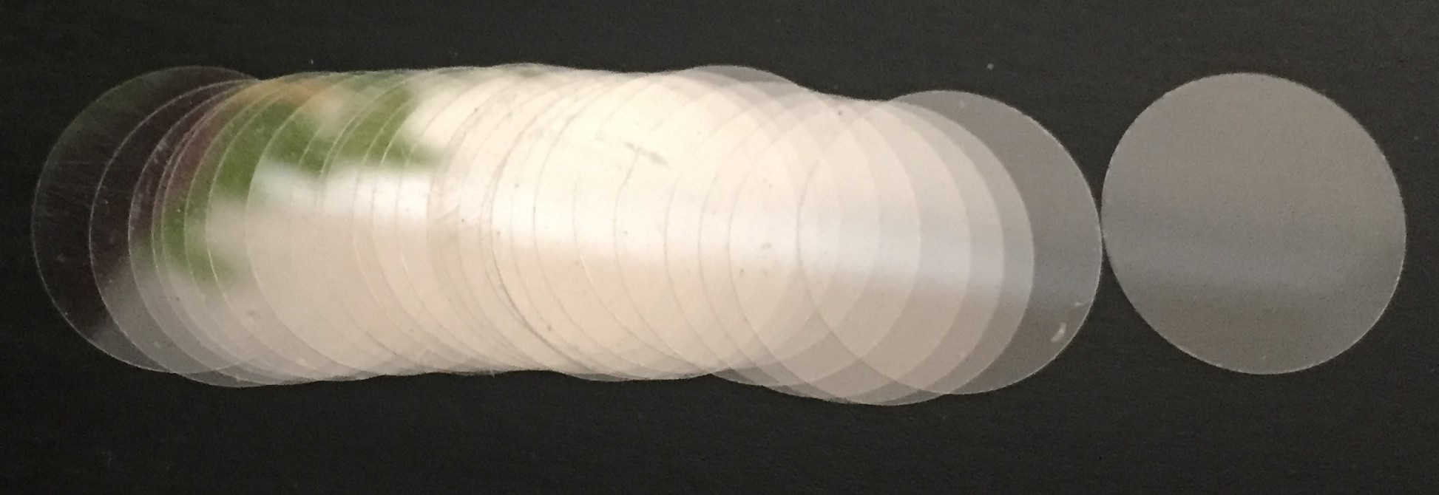
- Ruby cut Mica Discs quality V3 | 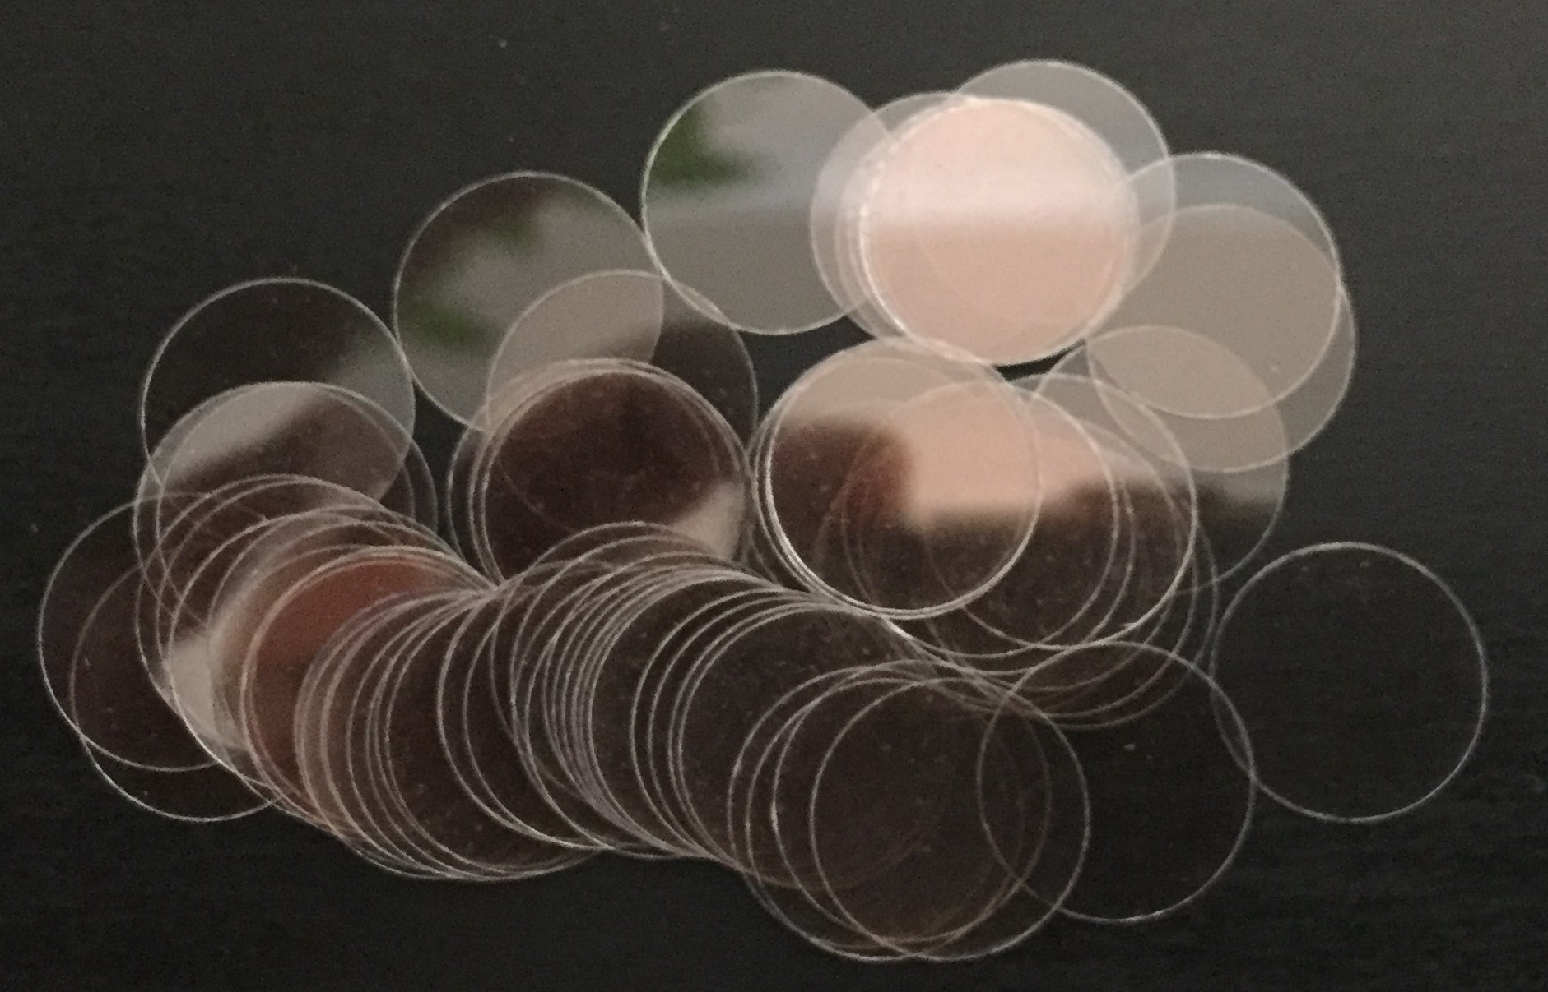
- Ruby cut Mica Discs quality V4 | 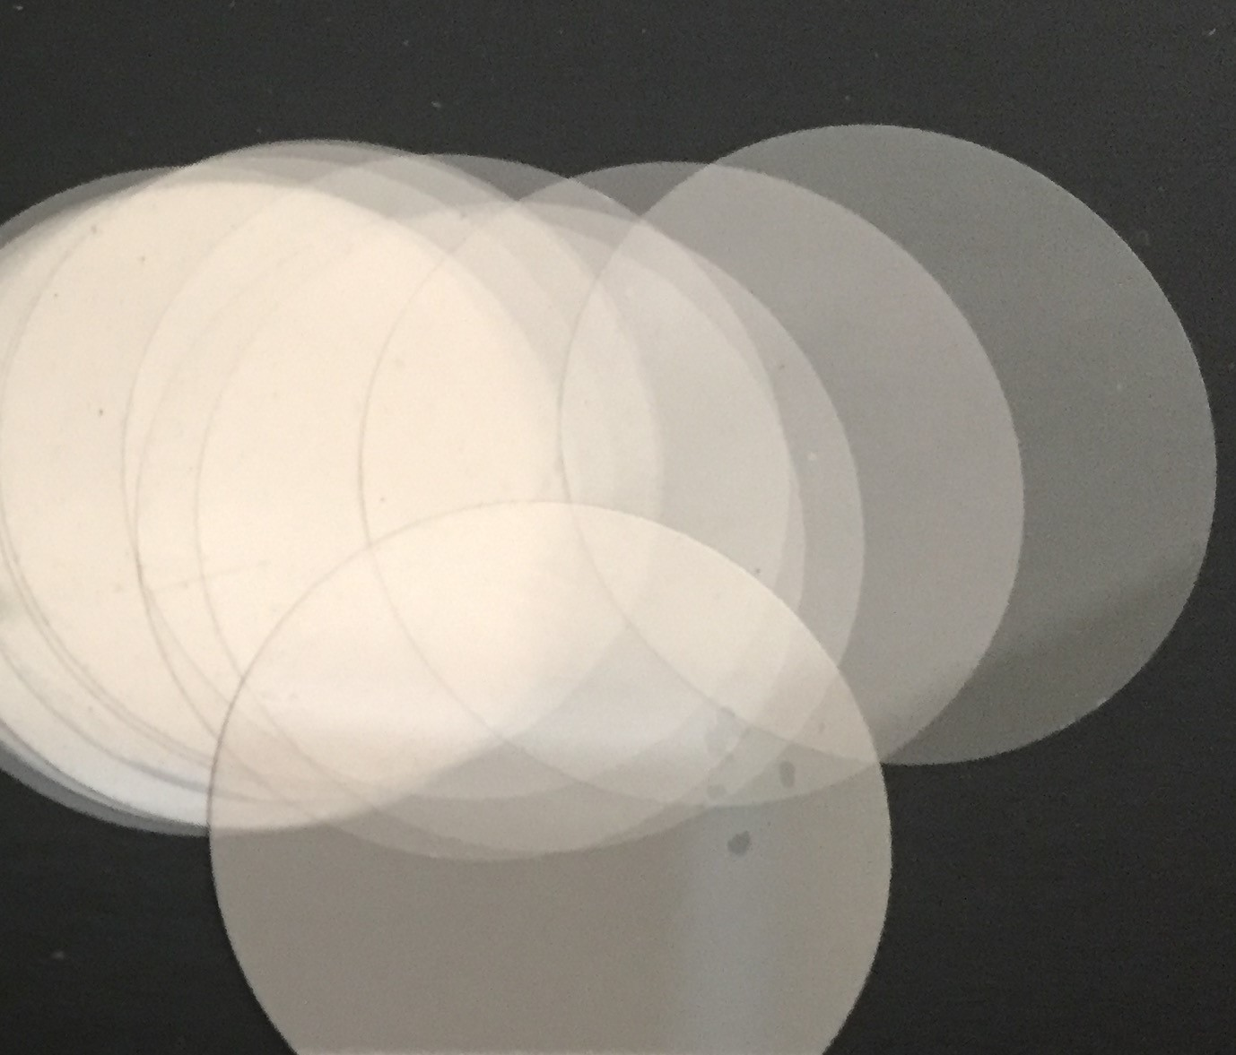
- Ruby cut Mica Washer quality V4 | 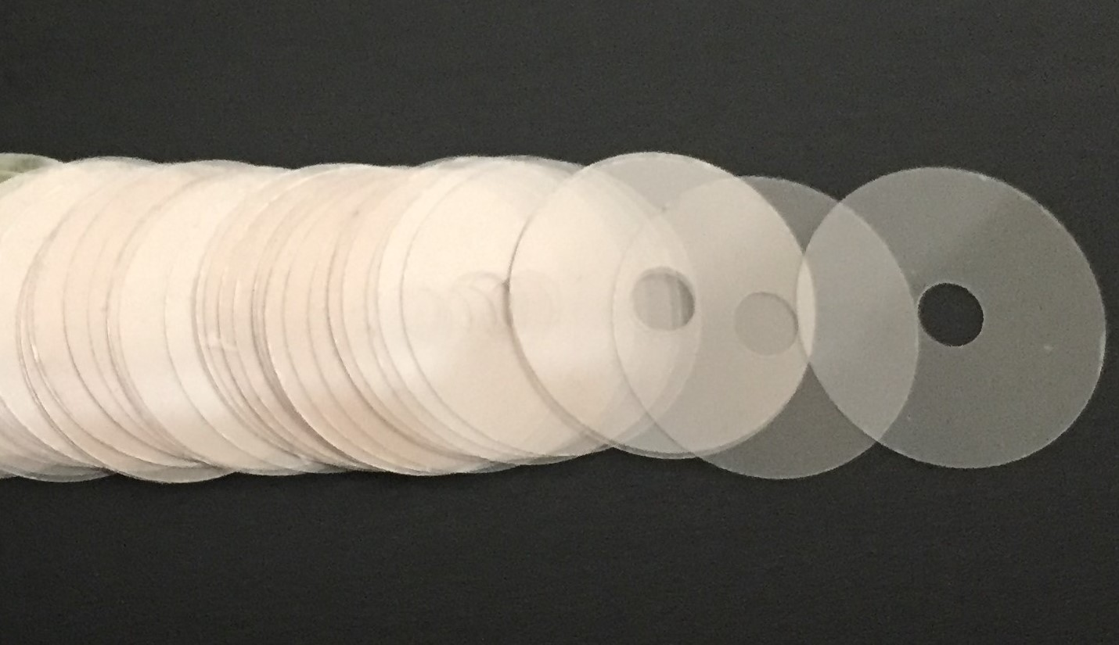
- Ruby cut Mica Washer quality V6 | 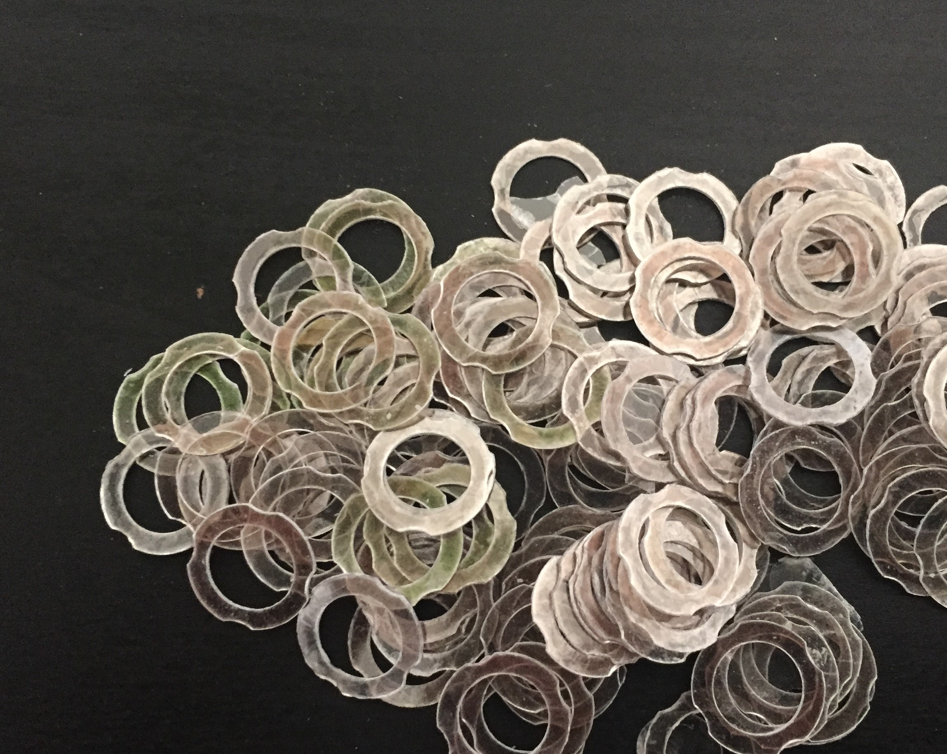
- Fabricated Mica  Size: 13X18MM  Thickness: 60/100 Microns | 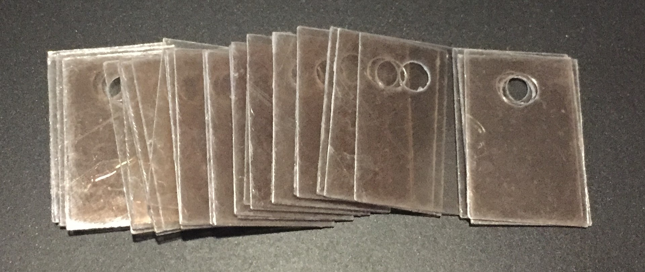
- Fabricated Mica  Size: 13X18MM  Thickness: 60/100 Microns | 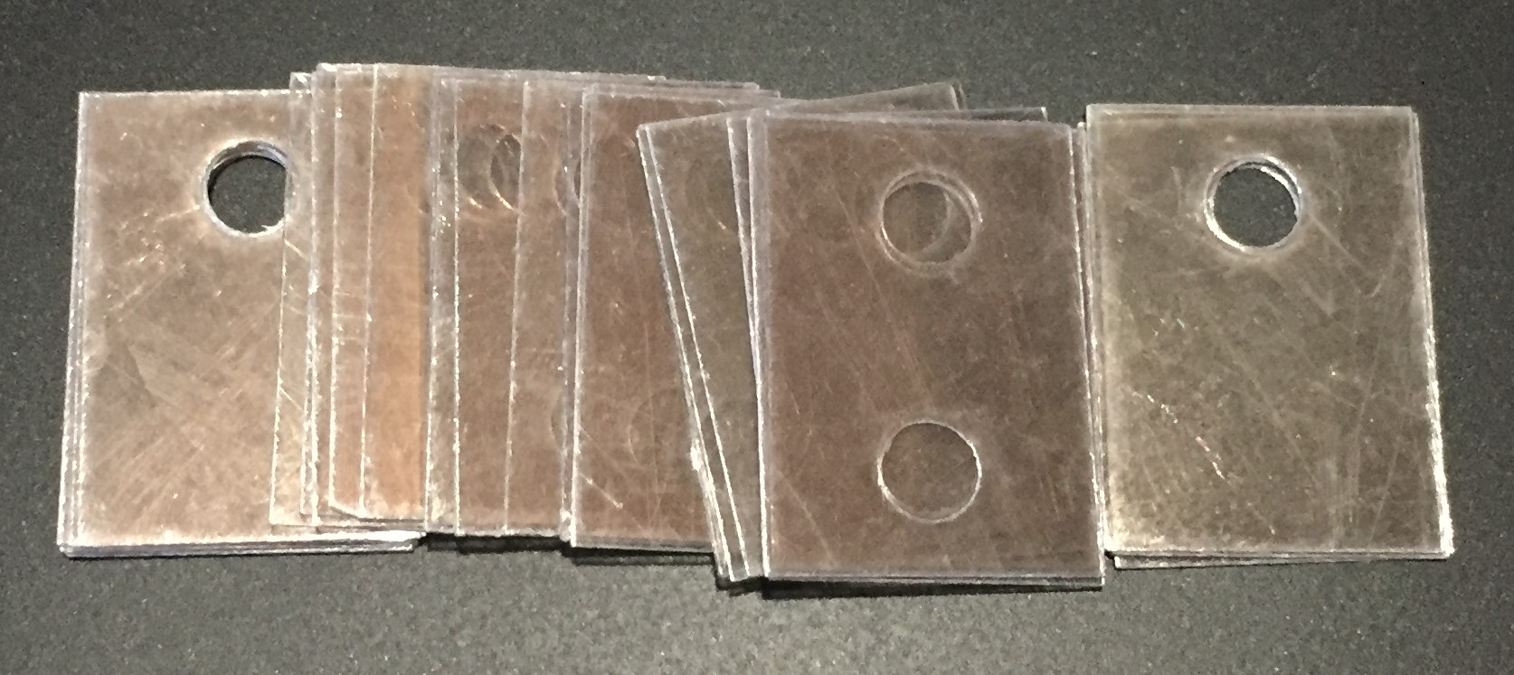
- Fabricated Mica  Size: 13X18MM  Thickness: 60/100 Microns | 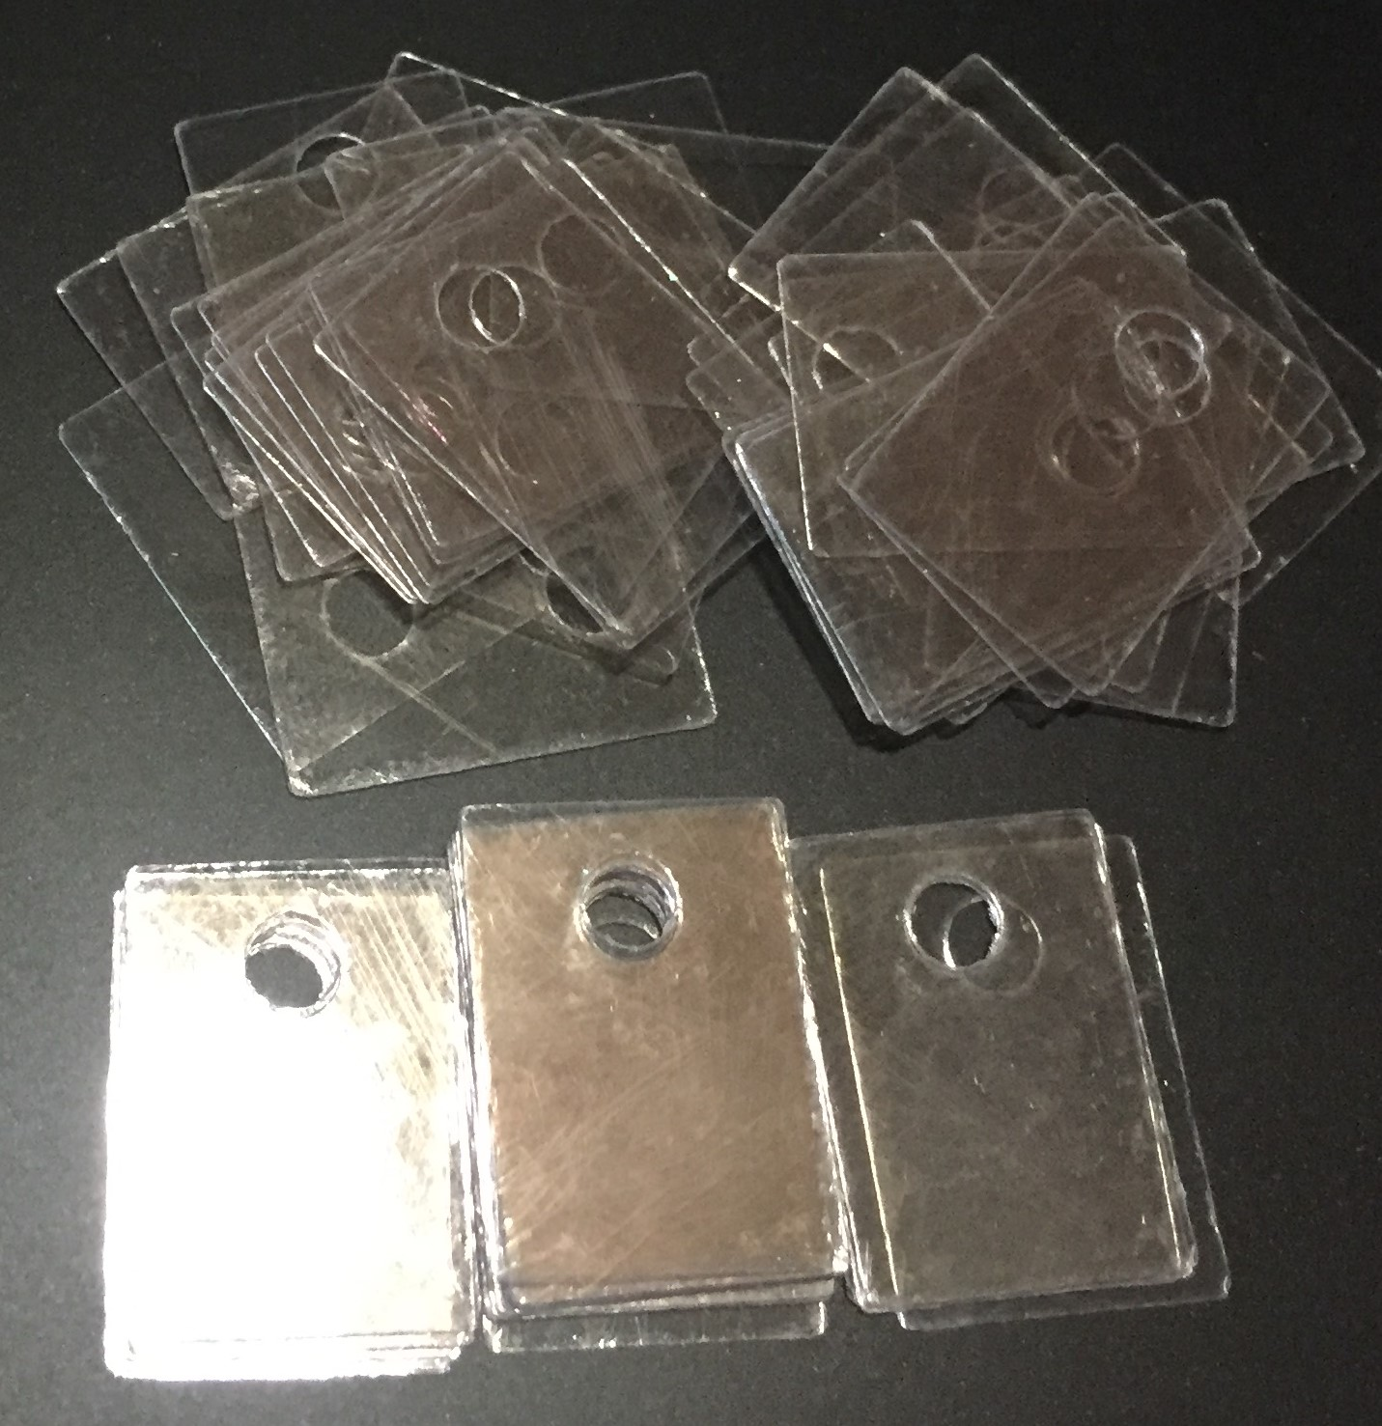
- Fabricated Mica  Size: 14X25MM  Thickness: 60/100 Microns | 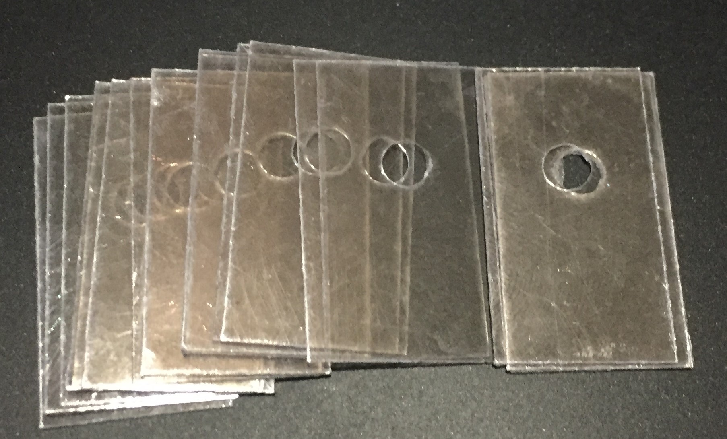
- Fabricated Mica  Size: 18X20MM  Thickness: 60/100 Microns | 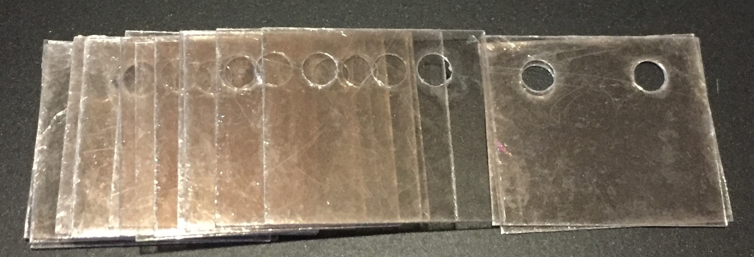
- Fabricated Mica  Size: 18X22MM  Thickness: 60/100 Microns | 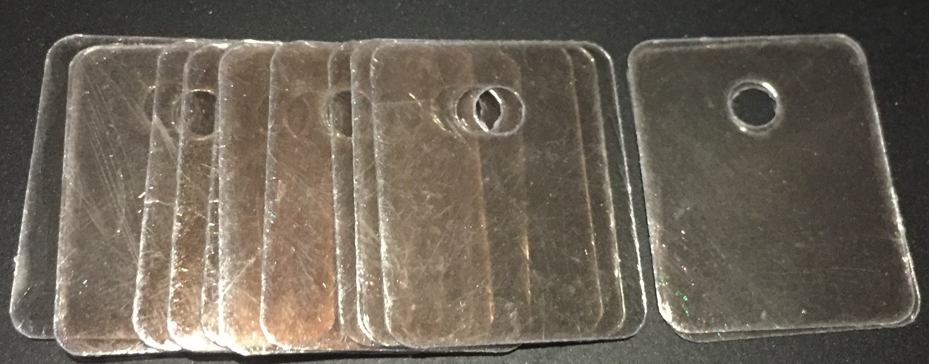
- Fabricated Mica
Size: 18X22MM
Thickness: 60/100 Microns
- Fabricated Mica  Size: 20X24MM  Thickness: 60/100 Microns | 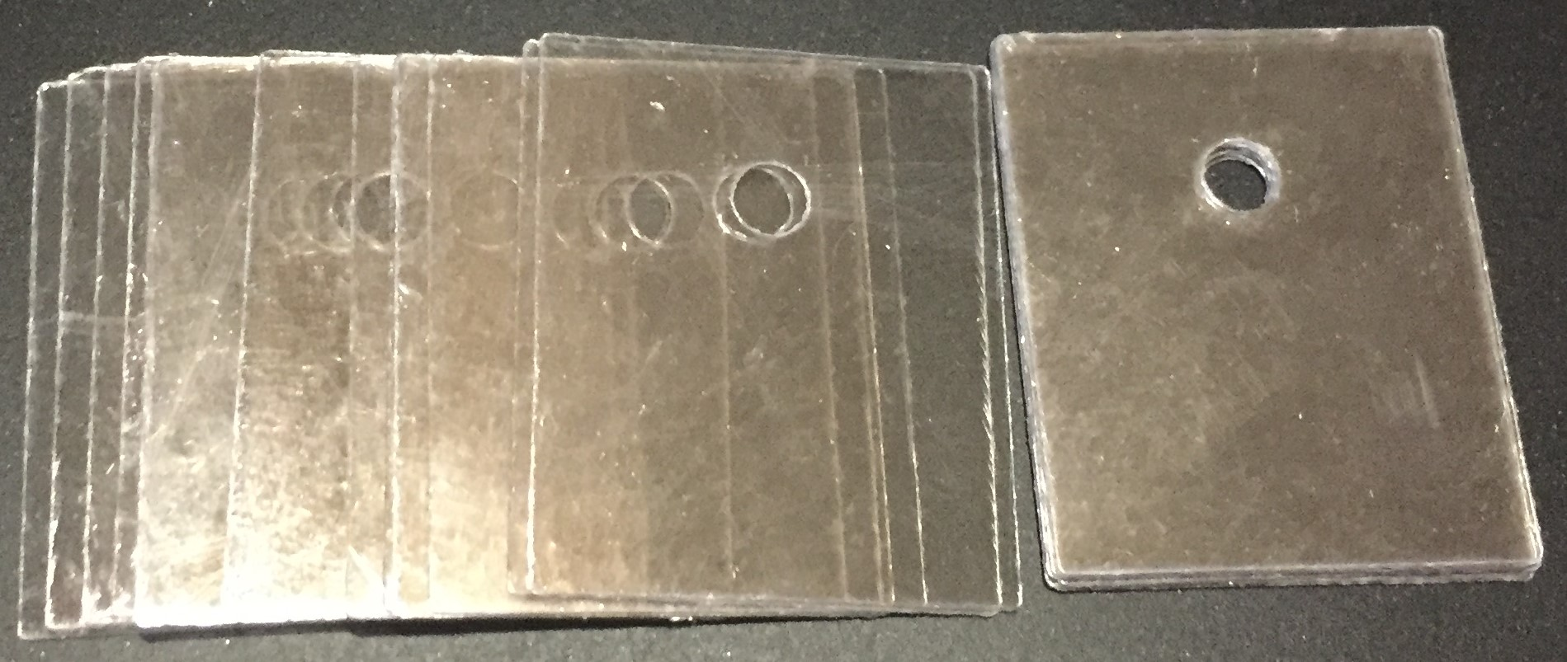
- Fabricated Mica  Size: 20X25MM | 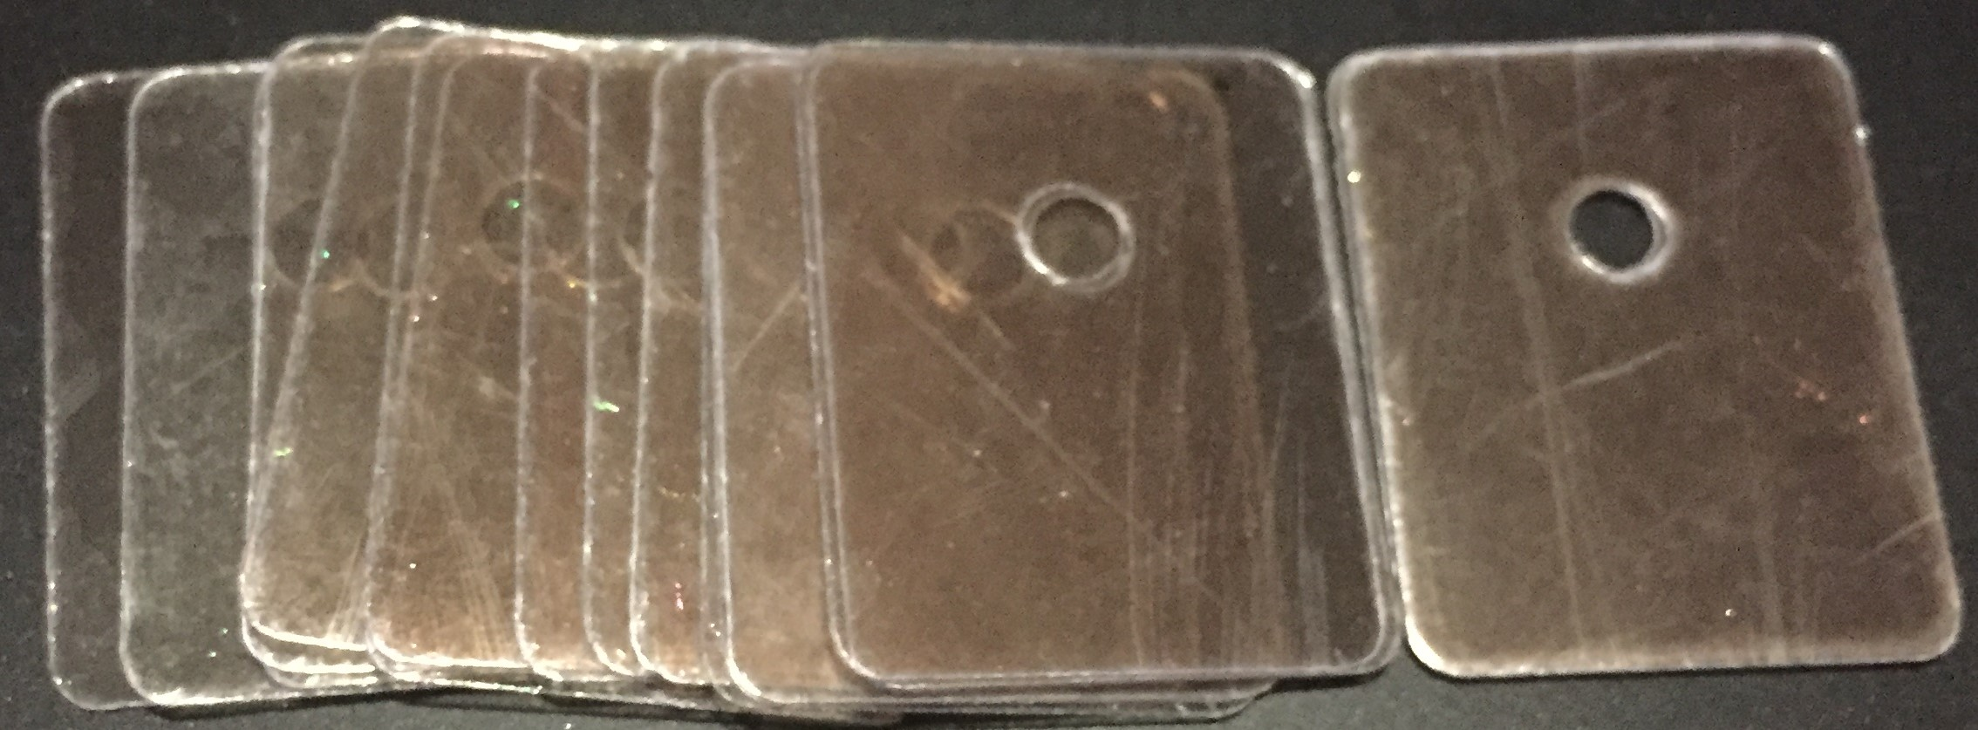
- Fabricated Mica  Size: 20X25MM  Thickness: 60/100 Microns | 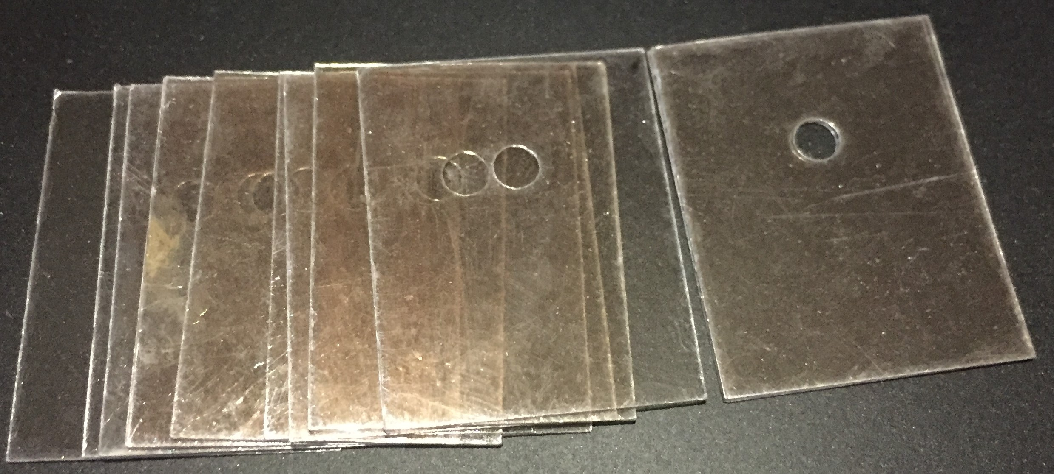
- Fabricated Mica  Size: 22X28MM | 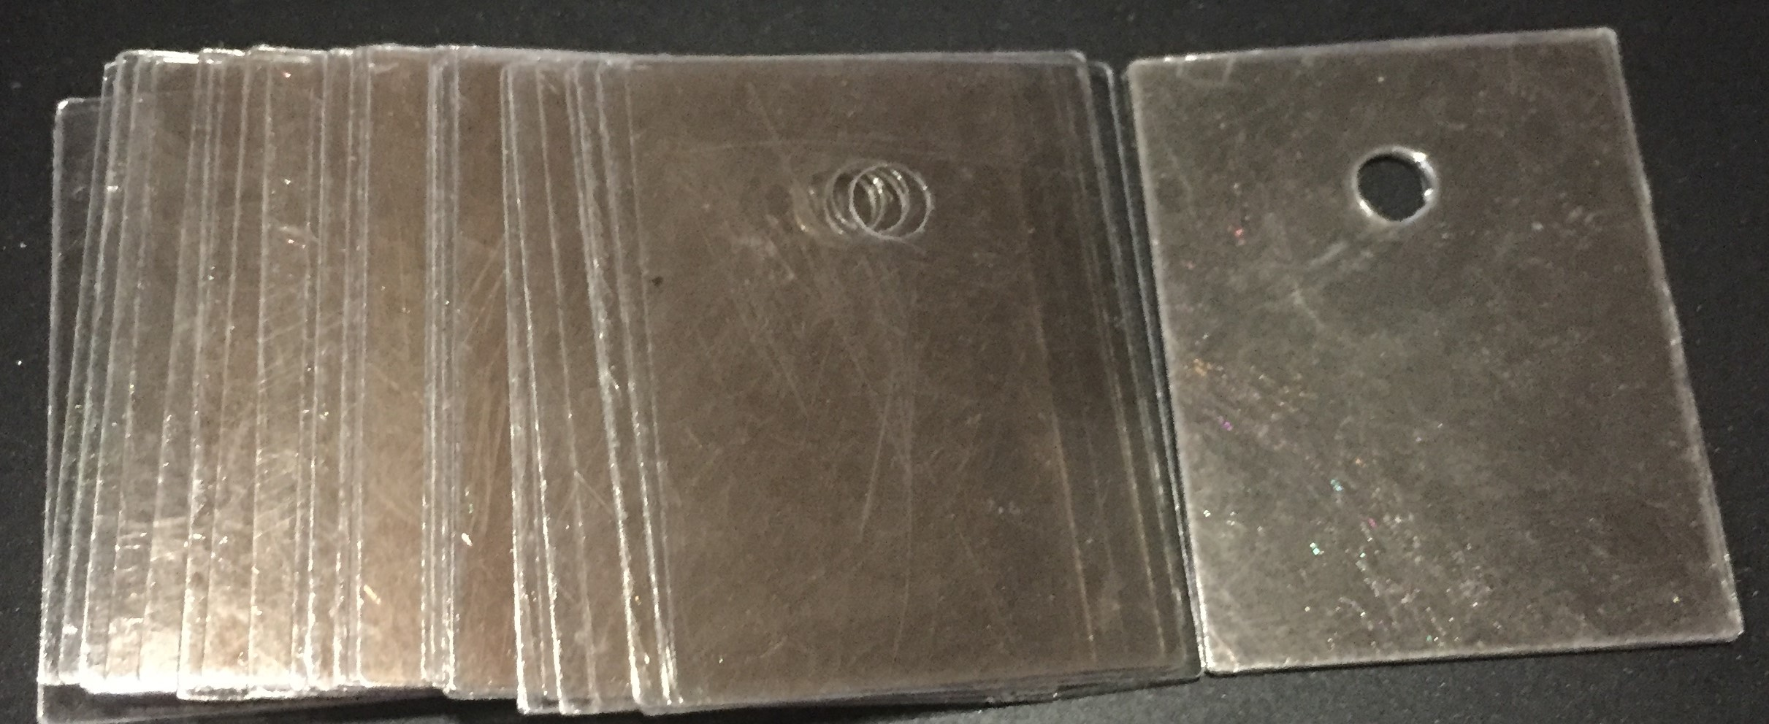
- Fabricated Mica  Size: 22X29MM | 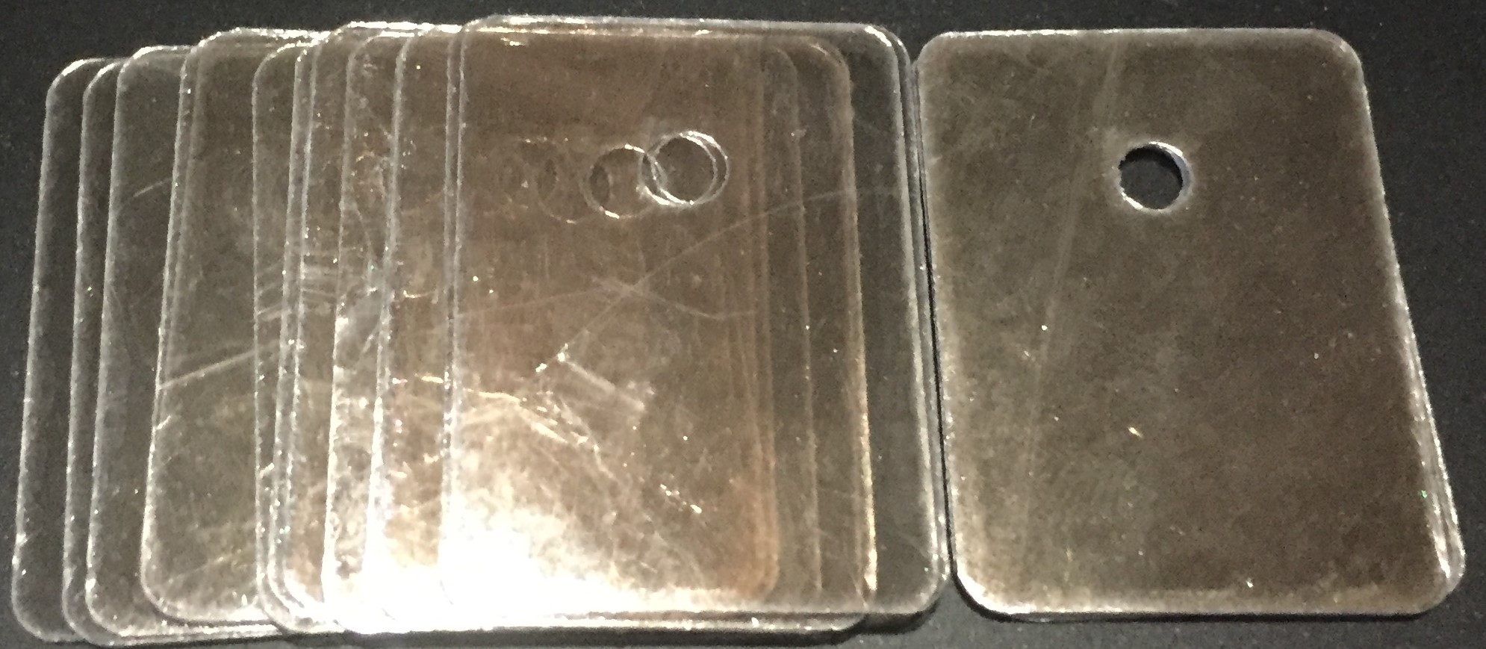
- Fabricated Mica  Size: 24X39MM | 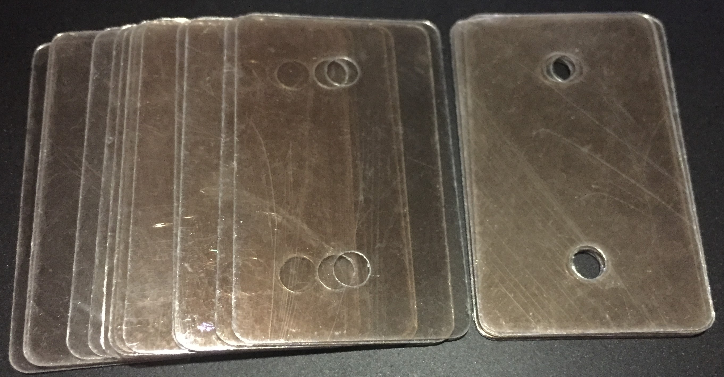
- Fabricated Mica  Size: 22.2X24.7MM  Thickness: 60/100 Microns | 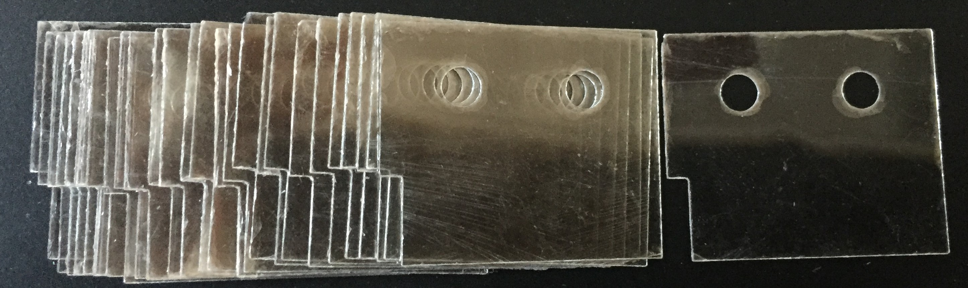
- Fabricated Mica Plate  Size: 13X18MM | 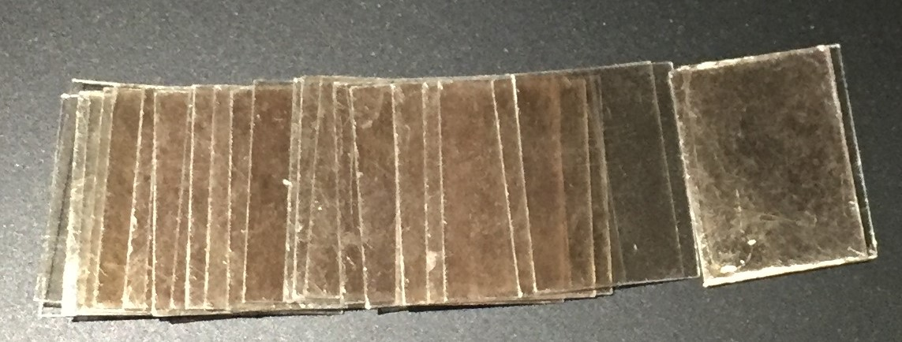
- Fabricated Mica Plate  Size: 18X22MM  Thickness: 60/100 Microns | 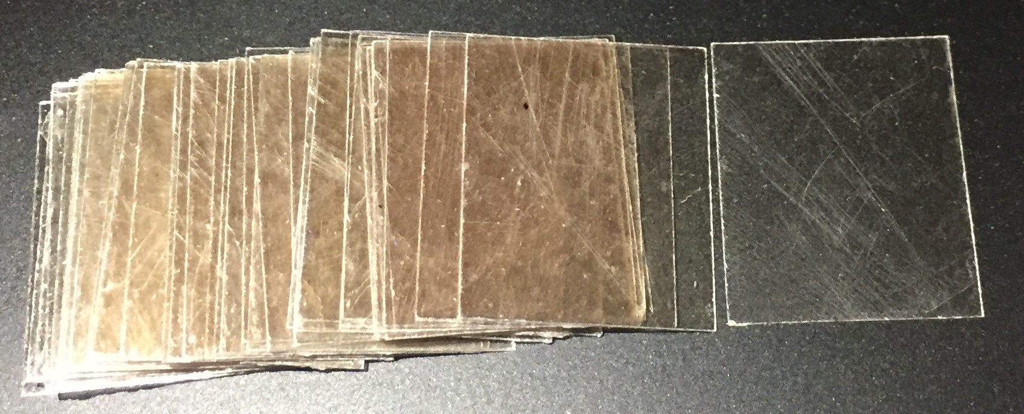
- Fabricated Mica Plate  Size: 20X25MM  Thickness: 60/100 Microns | 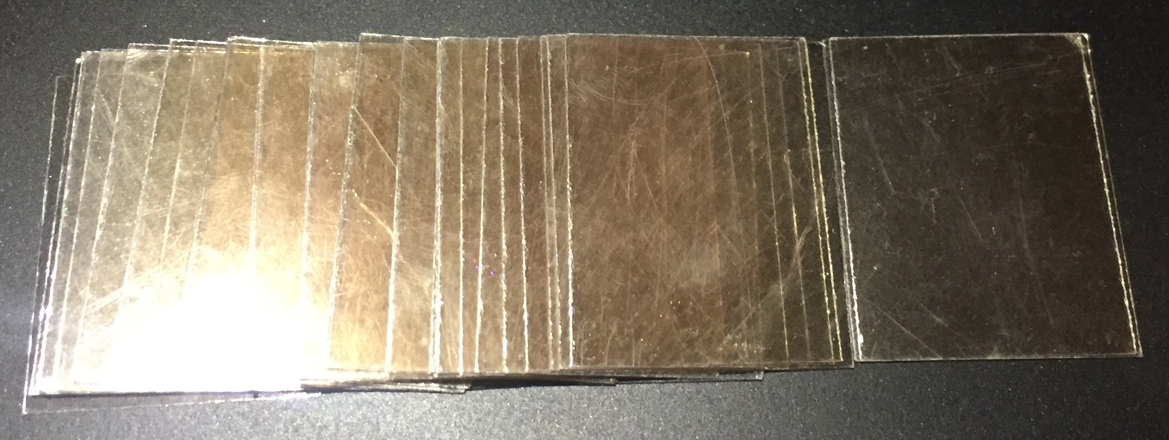
- Fabricated Mica Plate  Size: 22X29MM | 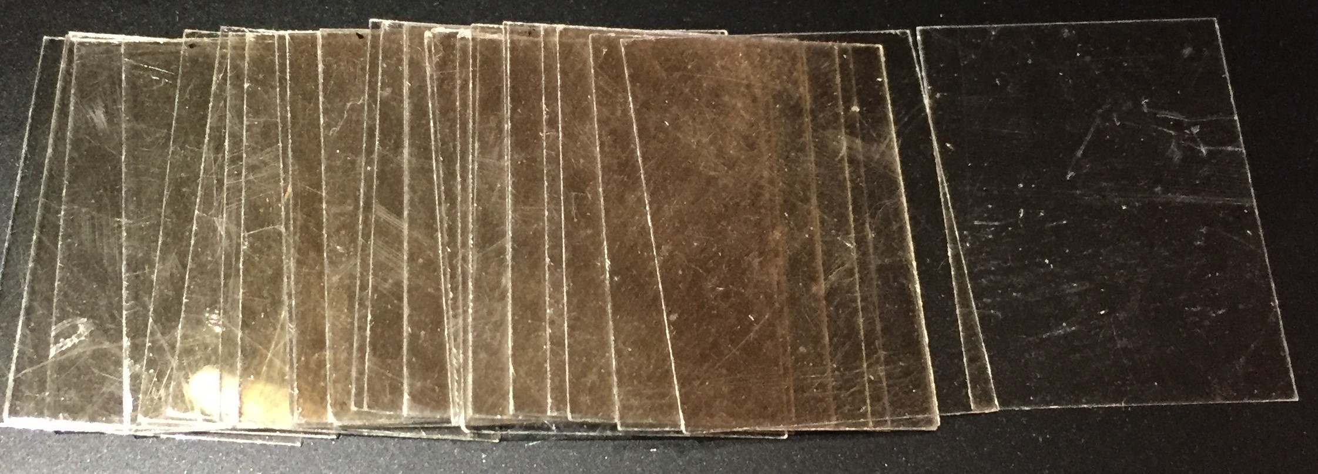
- Fabricated Mica Plate  Size: 24X39MM | 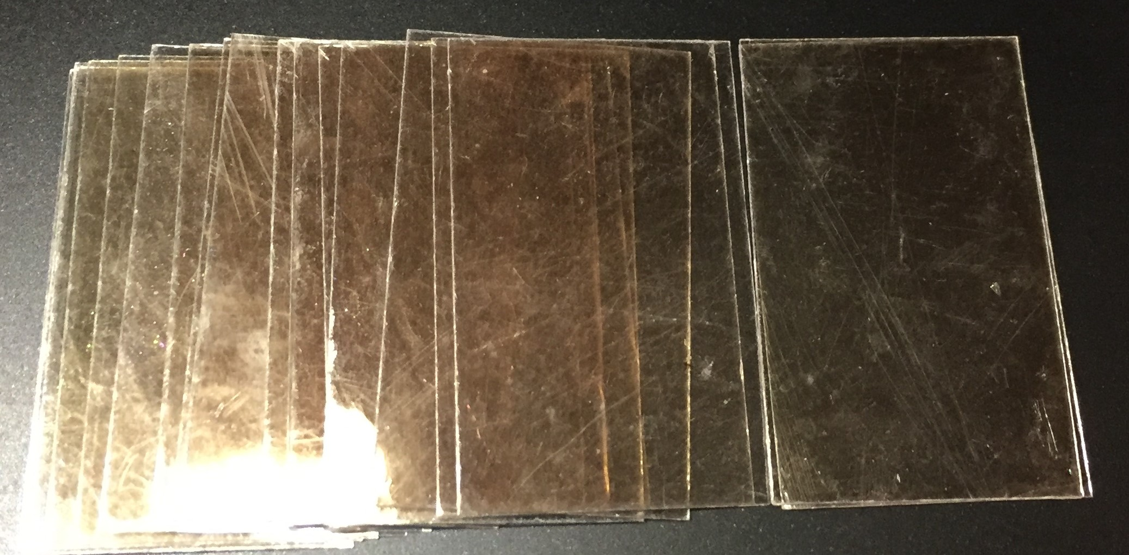
- Fabricated Mica Plate  Size: 25X25MM  Quality V2 | 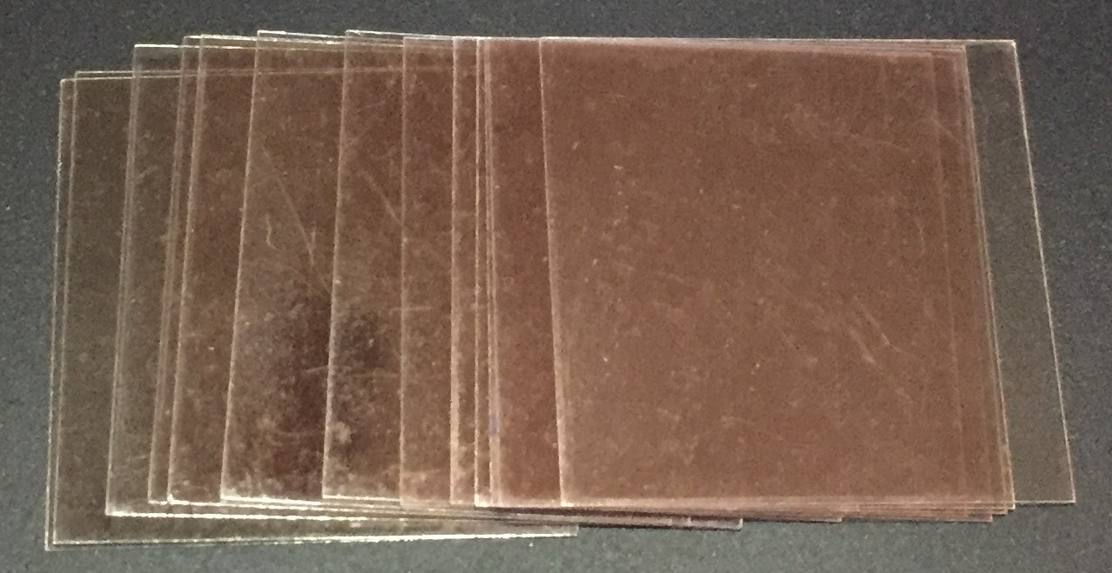
- Fabricated Mica Gear Wheel  Quality V3 | 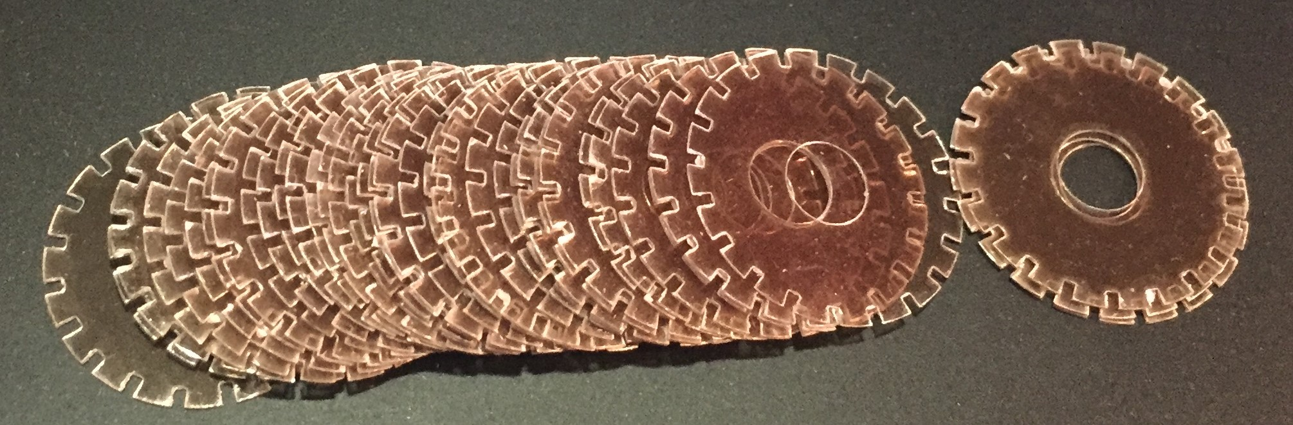
- Corrugated Mica  Size: 48X52MM | 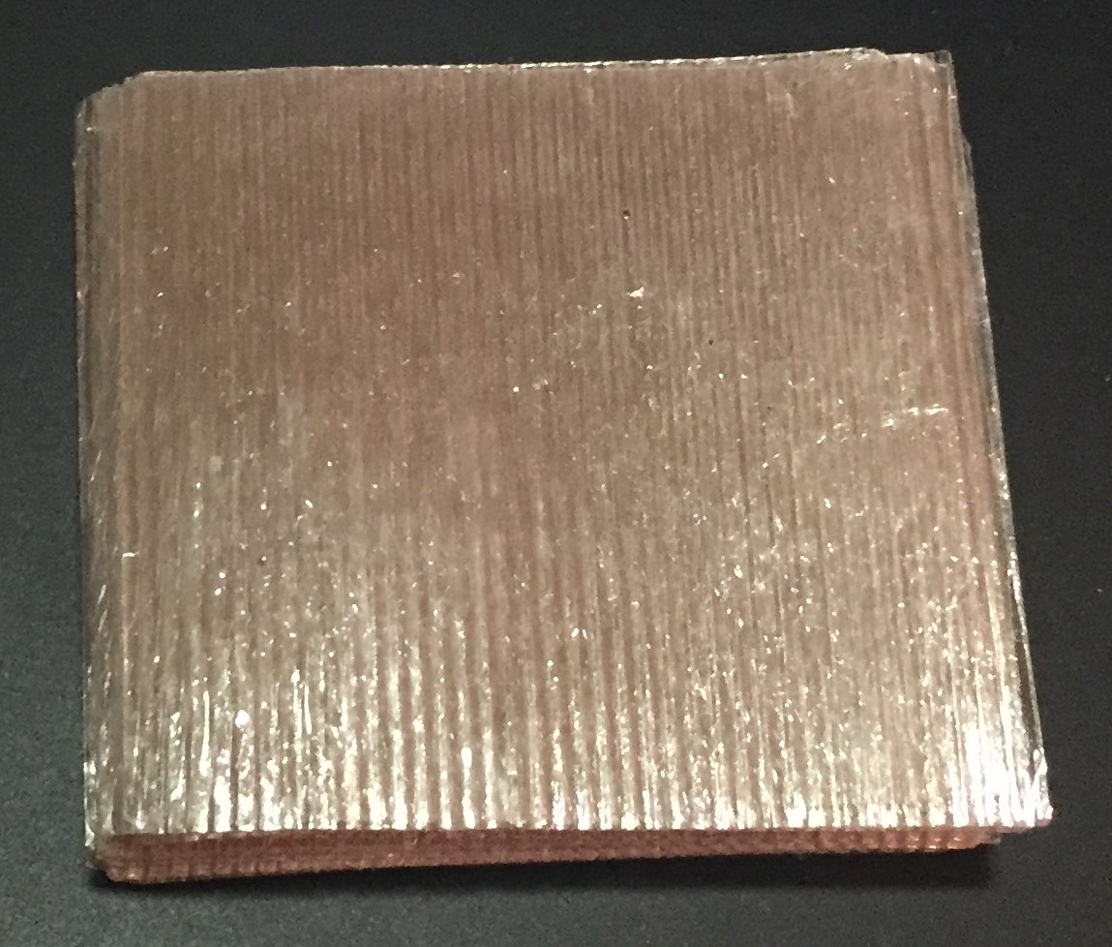
- Ruby cut Mica Discs  Quality: V2 | 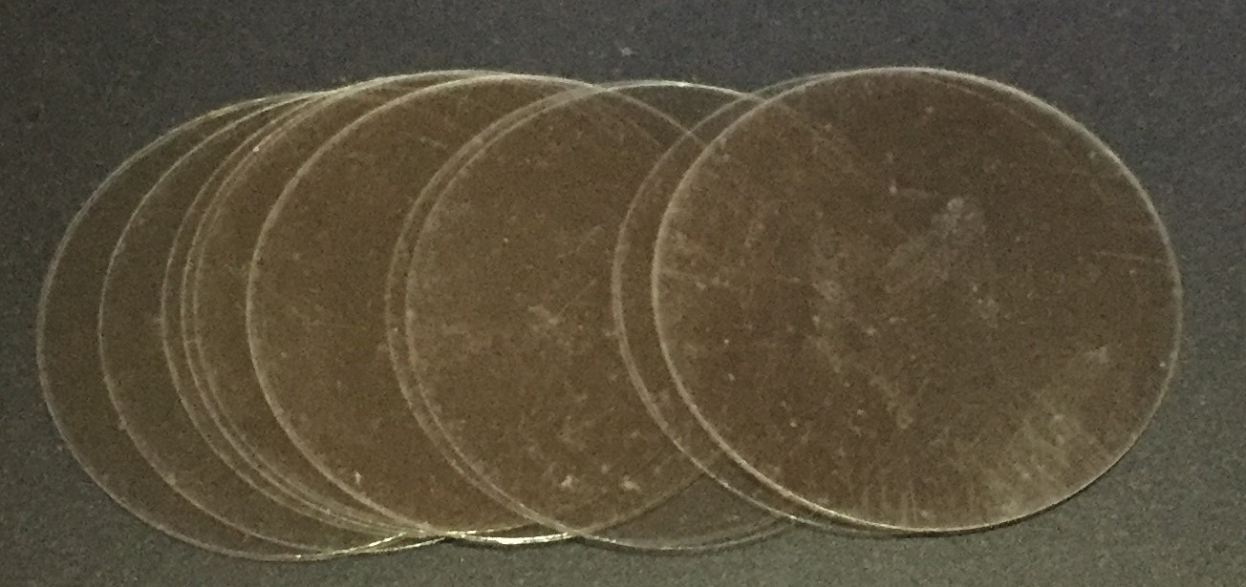
- Ruby cut Mica Discs  Size: 45MM Dia. | 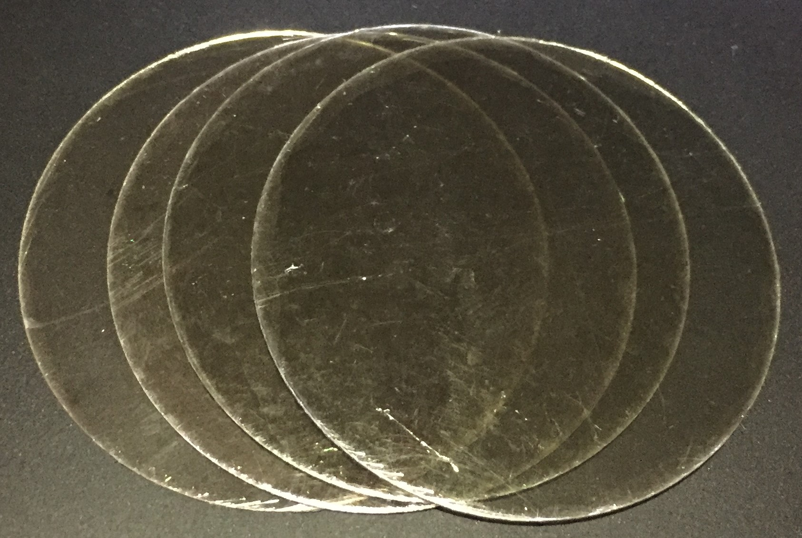
- Ruby Mica Block  Grade: No5  Quality: V6  Thickness: Random | 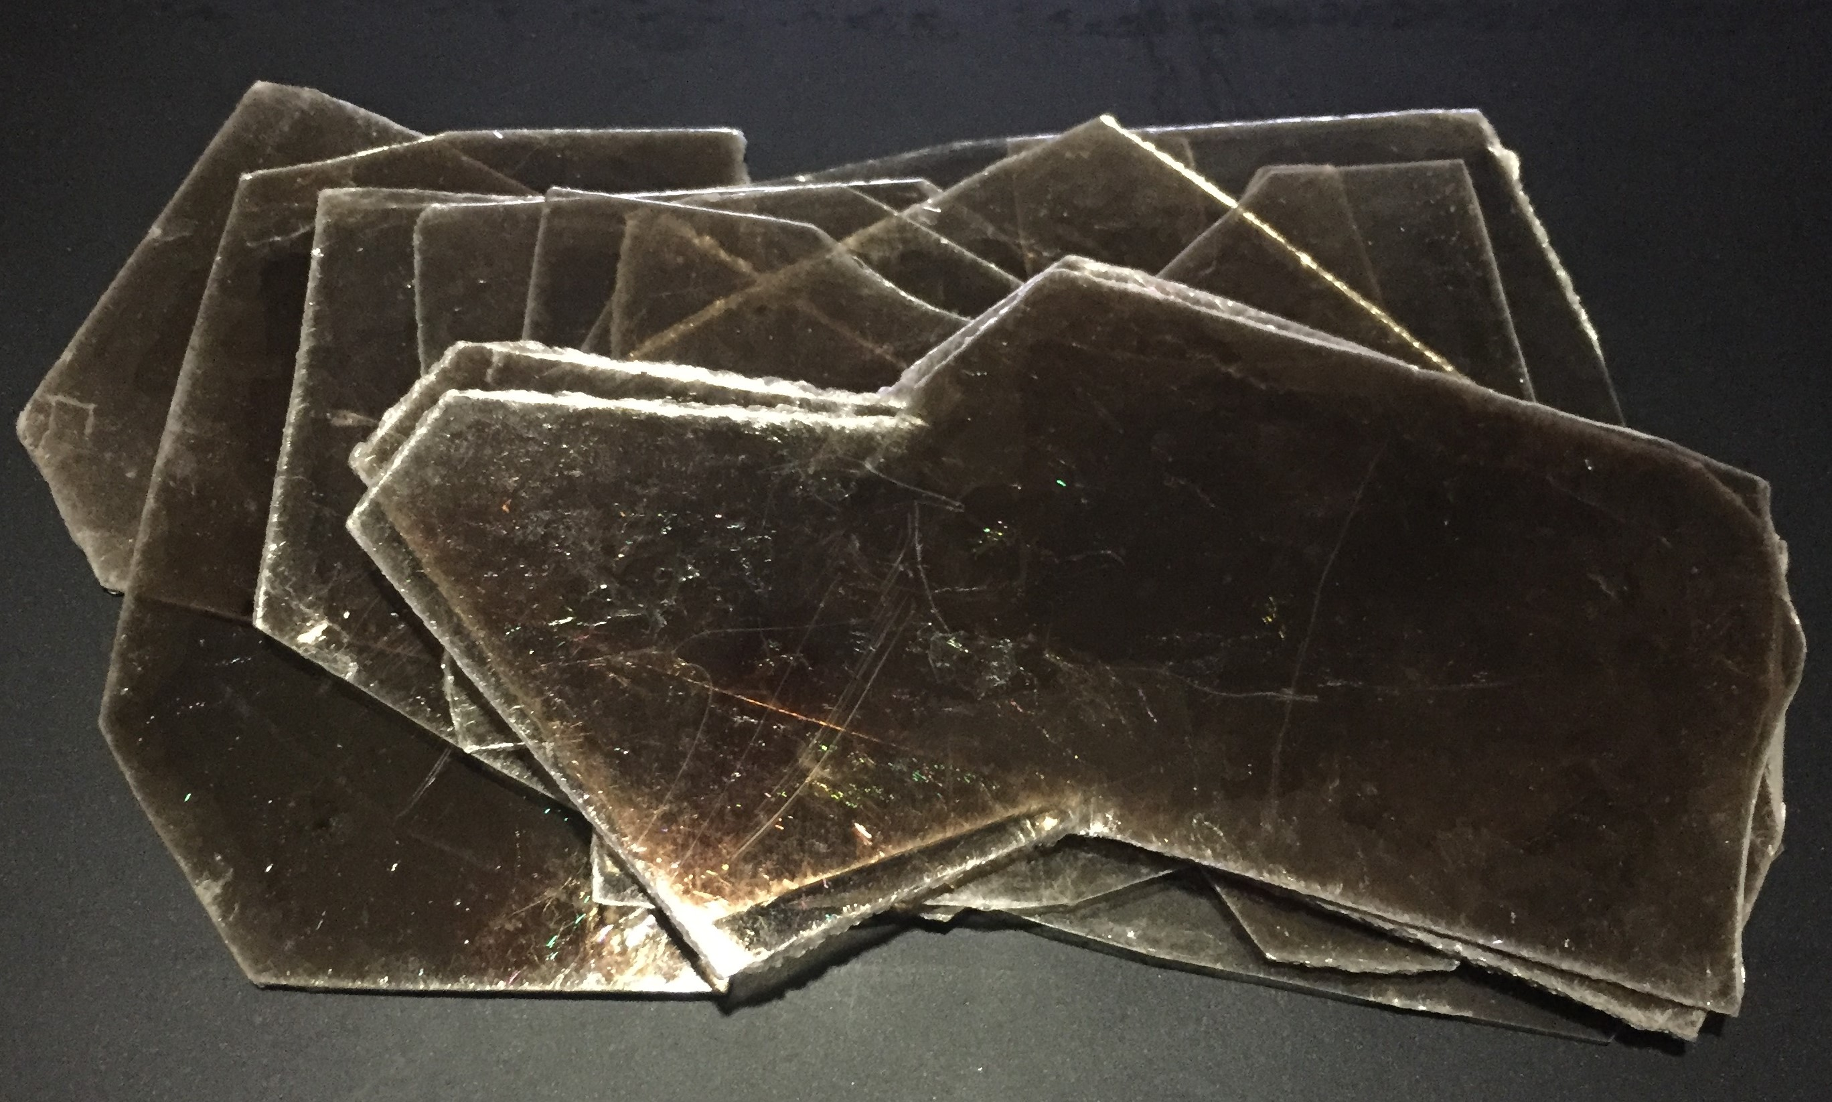
- Ruby Mica Block  Grade: No5  Quality: V4  Thickness: Random | 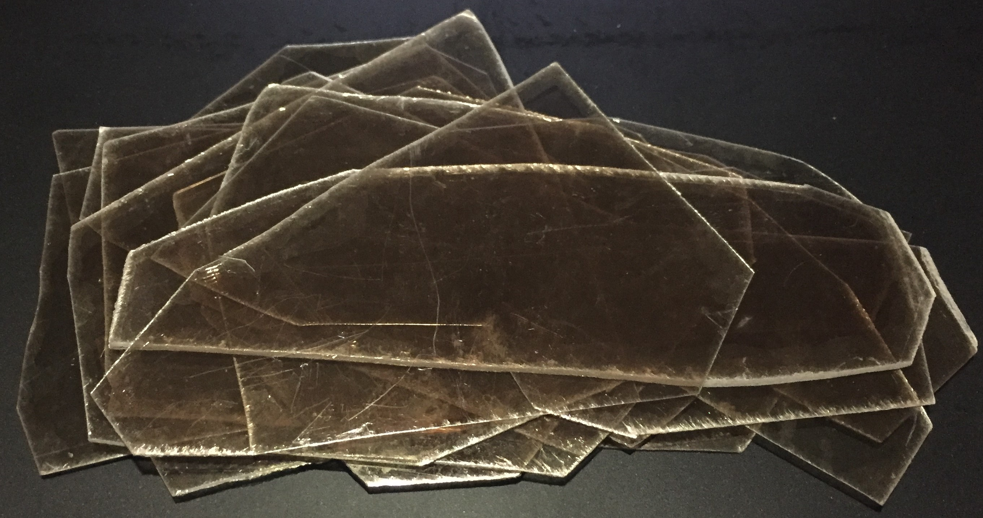
- Ruby Mica Block  Grade: No5  Quality: V7  Thickness: Random | 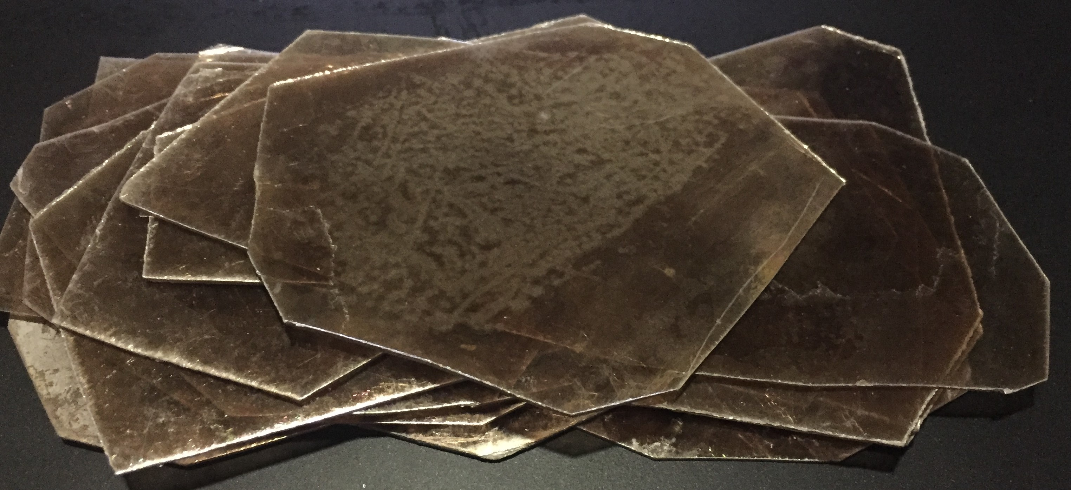
- Ruby Mica Block  Grade: No5  Quality: V7  Thickness: Random | 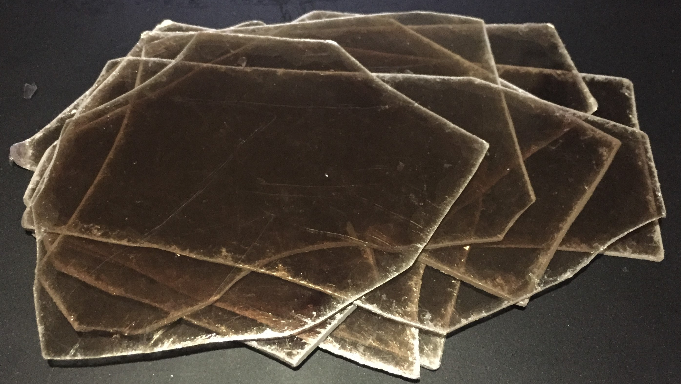
- Ruby Mica Block  Grade: No5  Quality: V2  Thickness: Random | 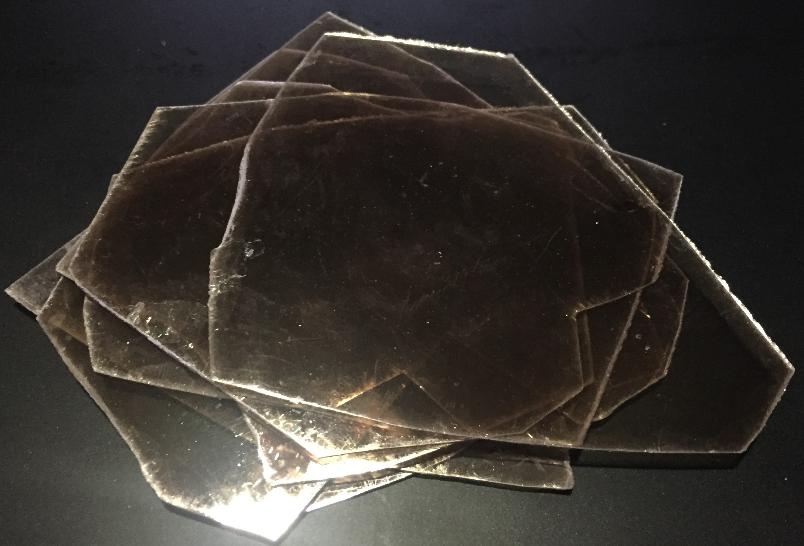
- Ruby Mica Block
Grade: No5
Quality: V5
Thickness: Random
- Green Mica Block  Grade: No5  Thickness: Random | 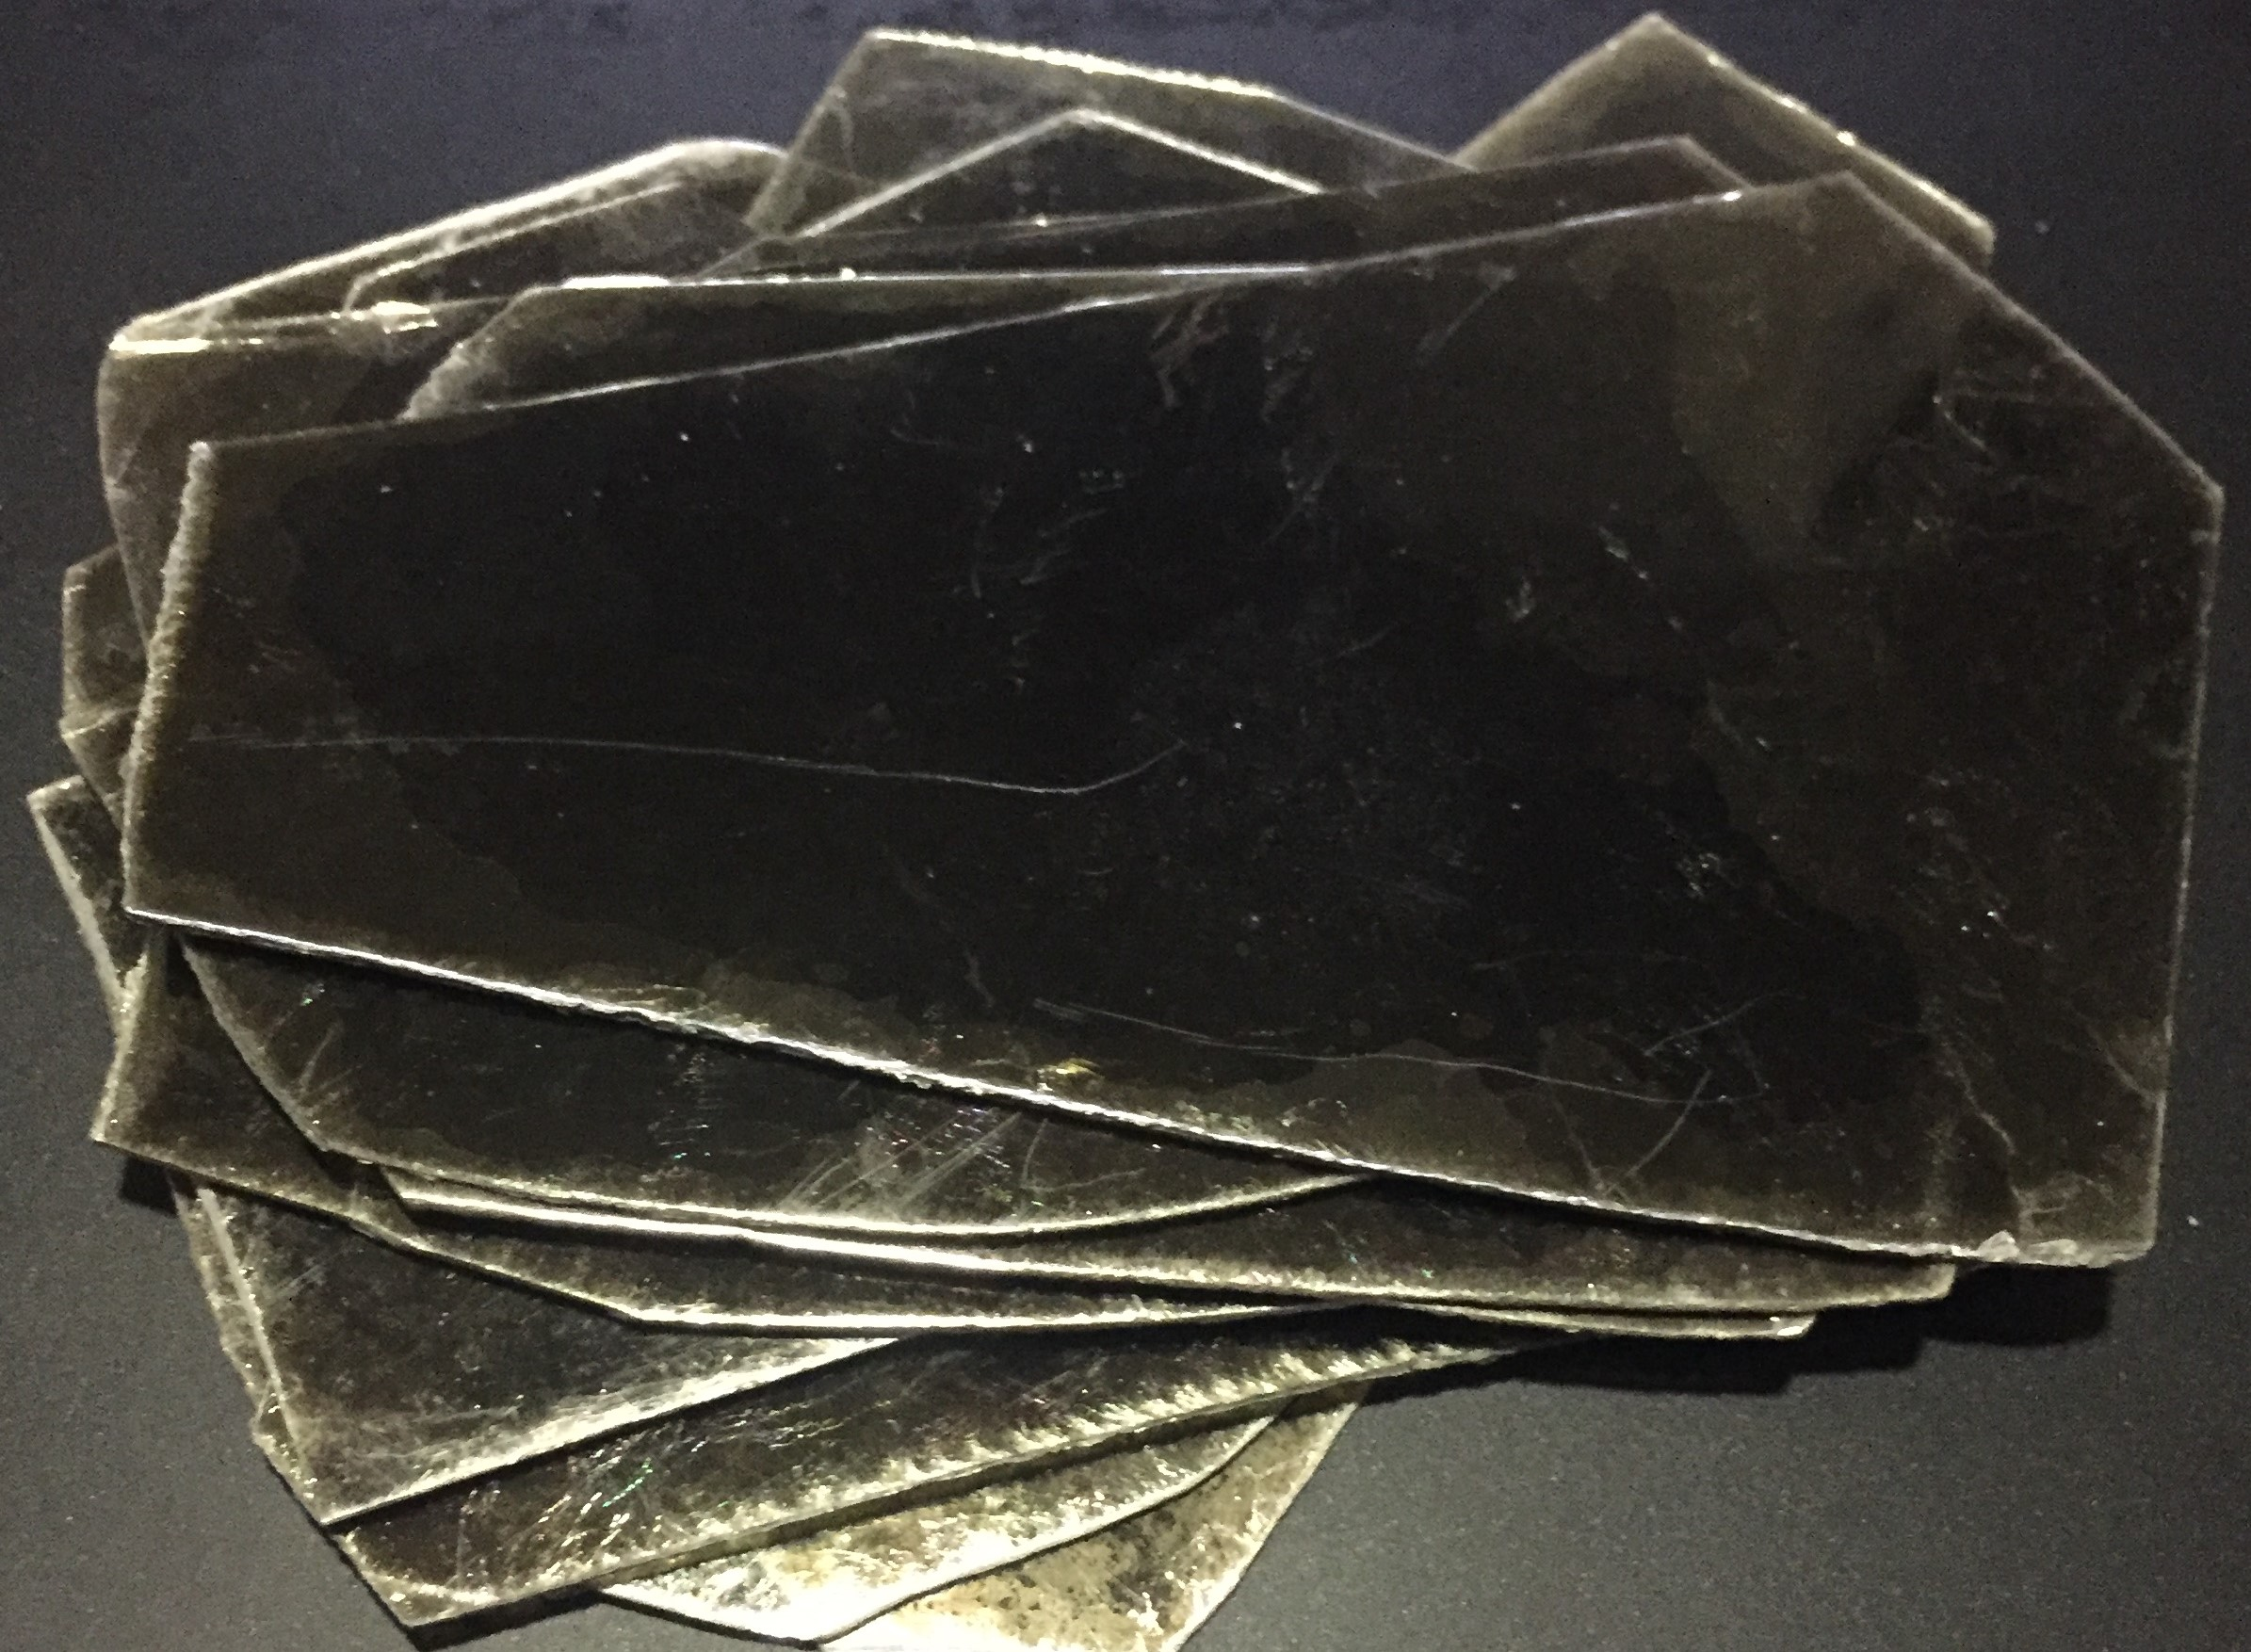
- Green Spotted Mica Block  Grade: No5  Thickness: Random | 