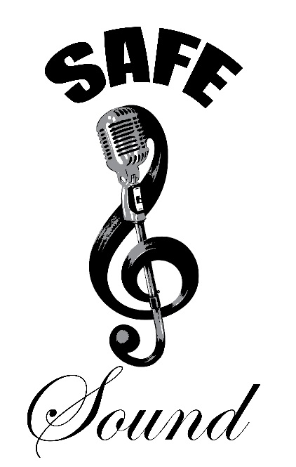

Name: Click here to enter text.
Scholarship Category: Choose an item.

Safe & Sound
Arts and Activism Scholarship
Application Form

In addition to the list of requirements below, various prize categories may require multimedia materials such as video, photos or sketches. For performance submissions, please send a link to YouTube, Vimeo, Facebook, Google Drive, etc. For visual art submissions, please email attachments or photos along with application.

Application Checklist:
☐ 1. Completed Application Form
☐ 2. One Page Essay: “Why I am a perfect choice for Safe & Sound’s Art and Activism Scholarship”
☐ 3. (2) Reference Letters including Contact Info.
☐ 4. Copy of Last Report Card showing Cumulative GPA
☐ 5. Artistic Submissions/Video (Written submissions such as Poetry or Volunteer Reflections must be at least 250 words but must not exceed 500 words in length Mandatory for Volunteer Category)
☐ 6. Evidence of Enrollment by an accredited two or four-year college or university or trade school (If not yet received, copies must be submitted upon receipt)

Incomplete applications will NOT be considered.
Application materials are considered public information once submitted, so should not include private or privileged information.

Applicant Information
First Name  Click here to enter text. | Middle Name  Click here to enter text. | Last Name  Click here to enter text.
Mailing Address  Click here to enter text. | City  Click here to enter text. | State  Click here to enter text.
Home Phone  Click here to enter text. | Cell Phone  Click here to enter text. | Parent(s) Cell Phone  Click here to enter text.
Email (Applicant or Parent)  Click here to enter text. | Age on April 12th Deadline  Click here to enter text. | Date of Birth  Click here to enter text.
Submission Category (i.e. Dance)  Choose an item. | Submission Title  Click here to enter text.
Are you a young lady applying for the Martanisha Robinson Award?
Choose an item.

Have you lost a parent? This is only a requirement for the Henry Williams Love Foundation Awards.
Choose an item.
How did you hear about Safe & Sound’s Arts and Activism Award? (Please be specific)
Click here to enter text.
Are you providing a link to performance material?
If so, please provide link here: Click here to enter text.

Applicant’s School Info
Name of School Applicant is Currently Attending  Click here to enter text. |  | Current Year in School  Click here to enter text.
City  Click here to enter text. | State / Zip  Click here to enter text. | Phone  Click here to enter text.
Website  Click here to enter text. | Extracurricular Activities, Clubs, Programs  Click here to enter text.

Reference (1) Contact Info
First Name  Click here to enter text. | Middle Name  Click here to enter text. | Last Name  Click here to enter text.
Organization/School  Click here to enter text. | Title/Position  Click here to enter text. | Email Address  Click here to enter text.
Mailing Address  Click here to enter text. | City  Click here to enter text. | State/Zip  Click here to enter text.
Work Phone  Click here to enter text. | Home Phone  Click here to enter text. | Cell Phone  Click here to enter text.
Summer Email  Click here to enter text. | Summer Phone  Click here to enter text. | Years Knowing Applicant  Click here to enter text.
Describe in what capacity you know the applicant. (May not be related)
Click here to enter text.

Reference (2) Contact Info
First Name  Click here to enter text. | Middle Name  Click here to enter text. | Last Name  Click here to enter text.
Organization/School  Click here to enter text. | Title/Position  Click here to enter text. | Email Address  Click here to enter text.
Mailing Address  Click here to enter text. | City  Click here to enter text. | State/Zip  Click here to enter text.
Work Phone  Click here to enter text. | Home Phone  Click here to enter text. | Cell Phone  Click here to enter text.
Summer Email  Click here to enter text. | Summer Phone  Click here to enter text. | Years Knowing Applicant  Click here to enter text.
Describe in what capacity you know the applicant. (May not be related)
Click here to enter text.

EMAIL ALL APPLICATION MATERIALS AS DESCRIBED ABOVE BY April 30th TO:
info@safeandsoundconnect.org
OR

If you have additional questions regarding the application process, please refer to our FAQ’s: https://safeandsoundconnect.org/faqs
Still have questions? Send us an email!

Safe & Sound
Arts & Activism Scholarship
Media Release Form

Student Media Project/ Video Release Form

I hereby give my permission, as the undersigned or parent / legal guardian of the participating student named below, for Safe & Sound to receive and use a video, media project and/or on-camera interview for release to interested parties and or educationally related video hosting sites. I understand that the use of the participant's image and voice will be primarily for the purposes listed below; I hereby waive any right that I may have to inspect or approve the finished student product that may be used in connection herein.

The video, media project and/or interview may be Arts and Activism Scholarship selection
      - Safe & Sound promotions
      - Arts and Activism Scholarship promotional material
      - Informational presentations
      - Posted on Safe & Sound website
      - Used as part of a future Safe & Sound promotional video

Safe & Sound will credit any use of your/your student’s work in the presentations listed above.

Safe & Sound will provide that your/your student’s work, in whole or in part, will not be used in a way which will change the original meaning of their work.

I understand and agree that I must comply with any and all applicable state and federal laws, including copyright laws and restrictions, as well as any applicable license agreements.

I assume responsibility for any actions on my part which may result in a claim against the Safe & Sound or any other party related to resources which I use, and I agree to indemnify and hold the Safe & Sound Organization harmless from any such claim.

There is no time-limit on the validity of this release nor is there any geographic specification of where these materials may be distributed.

I have retained a copy of this release for my records. Choose an item.

*Signature required on Page | 6
Safe & Sound
Arts & Activism Scholarship
Media Release Form

Participating students 17 and under in age must have parental permission.

Student Name: Click here to enter text.
Name of your submission: Click here to enter text.
Parent/Legal Guardian (If student is under 18): Click here to enter text.
Student Age: Click here to enter text.

Student Date of Birth: Click here to enter text.
Address: Click here to enter text.

Phone: Click here to enter text.

Dated: Click here to enter a date.

Student Signature: ______________________________________________________________

Date: ____________________

Parent/Legal Guardian Signature: __________________________________________________

Date: ____________________

I have retained a copy of all pages for my records. Choose an item.

