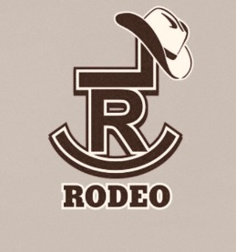
High School Order of Events
Saturday Slack @ 9am:
Pole Bending – All (Last 8 will be up in Saturday’s Performance)
Team Roping – 1st Section
Breakaway – 1st Section
Tie Down Calf Roping – 1st Section
Goat Tying – All (Last 8 will be in Saturday’s Performance)
Team Roping – 2nd Section (Last 8 will be in Saturday’s Performance)
Breakaway – 2nd Section (Last 8 will be in Saturday’s Performance)
Tie Down Calf Roping – 2nd Section (Last 8 will be in Saturday’s Performance)
Barrels – All (Last 8 will be in Saturday’s Performance)

Saturday Performance @ 7 pm:

Pole Bending - (Last 8 from Saturday’s Draw)
Bareback – All
Goat Tying - (Last 8 from Saturday’s Draw)
Steer Wrestling – All
Team Roping – (Last 8 from Saturday’s Draw)
Saddle Bronc – All
Breakaway - (Last 8 from Saturday’s Draw)
Tie Down Calf Roping - (Last 8 from Saturday’s Draw)
Barrels - (Last 8 from Saturday’s Draw)
Bulls - All

**Cowboy Church Sunday Morning at 7 am.**

***Mandatory member meeting Sunday morning at 8:30 am!!!!!***

Sunday Rodeo @ 9 am:

Bulls – All Tie Down Calf Roping – 1st Section
Team Roping – 1st Section Breakaway – 2nd Section
Bareback – All Tie Down Calf Roping – 2nd Section
Team Roping – 2nd Section Goat Tying - All
Saddle Bronc – All Barrels - All
Pole Bending – All
Steer Wrestling – All
Breakaway – 1st Section

