Today’s Date: __________________

CURRENT INFORMATION

Full Name: ____________________________________________________________________________
Date of Birth: ________________________

Address: _____________________________________________________________________________
Age: _____ Gender Identity: _________

City/State/Zip: _________________________________________________________________________
Phone: _____________________________

Email: _______________________________________________________________________________
Referred by/hear of us? _________________________________________________________________

Emergency Contact: ____________________________________________________________________
Phone: ____________________________

Your physician: ________________________________________________________________________
Physician’s contact: ____________________________________________________________________

Occupation: ___________________________________________________________________________
Employer: ____________________________________________________________________________

Do you have any pets? Yes/No If yes what types? _______________________________________________________________________________________________________________________________________________________________________________________________________________________________________________________________

CONCERN(S)
What is the primary concern or goal for today? Have you had this in the past? If so, describe.
_______________________________________________________________________________________________________________________________________________________________________________________________________________________________________________________________
Please describe when the above began. What makes it better/worse? Its severity? Anything else…
_________________________________________________________________________________________________________________________________________________________________________________________________________________________________________________________________________________________________________________________________________________________________________________________________________________________________________
Is it? (circle one) getting worse getting better coming and going staying the same.
Please list other current concern(s):
Complaint Since Cause (if known)
___________________________________________________________________________________________________________________________________________________________________________________________________________________________________________________________________________________________________________________________________________________________________________________________________________________________________________________________________________________________________________________________________________________________________________________________________________________
Do you have any specific body discomfort? If yes, please describe: ______________________________________________________________________________________________________________________________________________________________________________________________________________________________________________________________________________________________________________________________________________________________________________________________________________________________________________________________________________________________________________________________
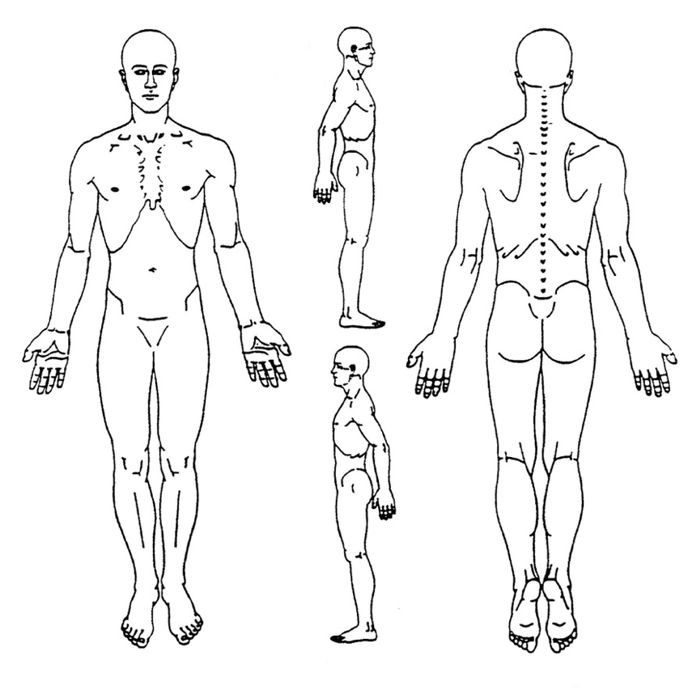
If relevant to your visit, please circle any problem areas in the drawing and if possible, write a word to indicate the type of sensation or sensations there, such as tight, burning, numb, sharp pain, etc.

Do you perform any repetitive movement in your work, sport, yoga practice, recreation, home care, or other activities?
____________________________________________________________________________________________________________________________________________________________________________________________________________________________________________________________________________________________________________________________________________________
Are you seeing healthcare or other service providers for this issue/condition? (acupuncturist, physical therapist, massage practitioner)? (Yes/No) If so, what is the diagnosis and what treatment if any have your tried?
_________________________________________________________________________________________________________________________________________________________________________________________________________________________________________________________________________________________________________________________________________________________________________________________________________________________________________
Have you made any observations about your body, energy, mental or emotional life, beliefs and life philosophy in relation to this concern that you would like to share? _________________________________________________________________________________________________________________________________________________________________________________________________________________________________________________________________________________________________________________________________________________________________________________________________________________________________________
In what way(s) do you think yoga movement therapy can be of help to you?
_________________________________________________________________________________________________________________________________________________________________________________________________________________________________________________________________________________________________________________________________________________________________________________________________________________________________________
LIFESTYLE
How many hours do you work each week? __________ Do you like your work? ____________

Does your work stress or exhaust you? (Yes/No)

Do you generally get enough sleep? (Yes/No) Please describe: _________________________________________________________________________________
What are your favorite/ most craved foods? __________________________________________________________________________________________________________________________________________________________________________
Do you consider yourself more comfortable at night/ day/ mornings/etc? __________________________________________________________________________________________________________________________________________________________________________
Do you feel support from your family and friends?
__________________________________________________________________________________________________________________________________________________________________________
What is your favorite meal of the day? _____________________________________________________
Living Status: _______________________________________________________________________
Children: __________________________________________________________________________
(single/married/partner/divorced/widowed)

Are you currently or have you recently gone through an unusually stressful life change or event?
(divorce, death in family, etc.)_________________________________________________________________________________
_______________________________________________________________________________________________________________________________________________________________________________________________________________________________________________________________
What kind of diet do you eat?
___ Typical American ___Vegetarian ___Vegan ___Other:

Do you smoke cigarettes, cigars, marijuana? (Yes/No) If yes, list: __________________________________________________________________________________________________________________________________________________________________________
Do you drink alcohol? (Yes/No) If yes, how many drinks per week? _____________________________________________________________________________________
Do you use recreational drugs? (Yes/No) If yes, what and how often? _____________________________________________________________________________________
__________________________________________________________________________________________________________________________________________________________________________
What do you do to exercise and how often? (Ex. Walk 30 min/5 days a wk.)
____________________________________________________________________________________________________________________________________________________________________________________________________________________________________________________________________________________________________________________________________________________
__________________________________________________________________________________________________________________________________________________________________________
What current or past sport, movement, dance, performance or art experience do you have?
__________________________________________________________________________________________________________________________________________________________________________
What is your experience with yoga, meditation or similar eastern or wholistic practices?
____________________________________________________________________________________________________________________________________________________________________________________________________________________________________________________________________________________________________________________________________________________
What are your biggest stressors? __________________________________________________________________________________________________________________________________________________________________________
Do you sit for long hours at a workstation, computer, and/or driving?
__________________________________________________________________________________________________________________________________________________________________________
List allergies to medicines, foods and environmental factors:
____________________________________________________________________________________________________________________________________________________________________________________________________________________________________________________________________________________________________________________________________________________
List prescriptions or over-the-counter medications taken regularly:
_________________________________________________________________________________________________________________________________________________________________________________________________________________________________________________________________________________________________________________________________________________________________________________________________________________________________________
List vitamins, minerals, herbal preparations, tonics, supplements, flower essences, cell salts, homeopathic remedies or the like taken regularly:
______________________________________________________________________________________________________________________________________________________________________________________________________________________________________________________________________________________________________________________________________________________________________________________________________________________________________________________________________________________________________________________________
What do you do for fun and/or to relax?
____________________________________________________________________________________________________________________________________________________________________________________________________________________________________________________________________________________________________________________________________________________
HISTORY
List major illnesses and hospitalizations (operations, injuries/accidents and their dates):
__________________________________________________________________________________________________________________________________________________________________________
__________________________________________________________________________________________________________________________________________________________________________

Have you ever been diagnosed with any of the following? If so, what year?

___Pneumonia ___Skin boils ___Obesity ___Rheumatic fever
___Tuberculosis ___Eczema ___Anemia ___Measles
___Asthma ___Psoriasis ___Blood transfusion ___Mumps
___Bronchitis ___Parasites ___Colitis ___Chicken pox
___Emphysema ___Jaundice ___Ulcer ___Polio
___High blood pressure ___Hepatitis ___Epilepsy/Seizure ___Whooping cough
___Low blood pressure ___Gallstones ___Mental breakdown ___Diphtheria
___Heart disease ___Kidney stones ___Arthritis __Lyme’s disease
___Drug reaction ___Bladder Infection ___Cancer ___Chronic Fatigue
___Migraine ___Hypoglycemia ___Syphilis ___fibromyalgia
___Hives ___Diabetes ___Gonorrhea ___Other:

Please list and briefly describe any conditions, medical or otherwise, that may prohibit or limit your practice of yoga stretches, movements, breathing, meditation, introspection, or relaxation:
__________________________________________________________________________________________________________________________________________________________________________
__________________________________________________________________________________________________________________________________________________________________________
__________________________________________________________________________________________________________________________________________________________________________
List ailments of immediate family and indicate if deceased.
Mother: __________________________________________________________________________________________________________________________________________________________________________
Father: __________________________________________________________________________________________________________________________________________________________________________
Siblings: __________________________________________________________________________________________________________________________________________________________________________
Is there anything else you would like me to know?
__________________________________________________________________________________________________________________________________________________________________________
__________________________________________________________________________________________________________________________________________________________________________
__________________________________________________________________________________________________________________________________________________________________________

Practice and Student Practitioner Information, Consent and Waiver
Yoga Therapy is confidential, self-guided, holistic healing for individuals and small groups that can work in conjunction with the western healing world. Yoga Therapy utilizes all aspects of Nicole’s previous training and more to bring clients assistance with their health and wellbeing.
Life Thrive Yoga Practice Information
Life Thrive Yoga is dedicated to the promotion of personal growth, wellbeing, and the prevention of chronic illness and injury whenever possible. Yoga is an ancient science that may benefit a person at every level of their being. Yoga Movement Therapy utilizes the time-tested techniques, principles and practices of yoga to support and facilitate natural mechanisms of healing, improved functionality, and increased self-awareness.
Nicole Montanarelli holds her yoga therapist certification (cryt) through Spanda Yoga Therapy. She currently holds a 500 E-RYT through yoga alliance. She has received her 200-hour yoga certification from Yama Yoga Therapy and her 500 hour yoga certification from the Himalayan Institute. Nicole holds a BS in Natural Health and Healing through Clayton College of Natural Health and Healing. She is also an ordained Priest through the Order of Melchizedek. Nicole holds a YACEP designation through yoga alliance that allows all her to offer continued education classes to other teachers. She is insured and has an up to date CPR certification. Nicole also has training as a Thai Yoga Massage provider and has certification in Yoga for PTSD through Mindful Yoga Therapy and 3WT (3 wisdom traditions) through Kathryn Templeton and chair yoga through Blue Cross Blue Shield’s Silver Sneaker program. She holds a group fitness instruction certificate through the YMCAS. She has studied under various yoga traditions and has practiced yoga for over 2 decades. She has been teaching for the past decade and offering group classes, private trainings, workshops, and more since her career began. Nicole has been seen in Mantra Magazine, has been published on multiple blogs, and has been seen on tv and in newspapers. She also has been the creator and lead facilitator for 5 years running Yogis Take the Park, a free yoga and music festival
Fee and Billing
All sessions at this location are conducted by Nicole Montanarelli. The fee for the initial intake 75-minute session is $105 The fee for a 55-minute regular session is $75. Payment is due at the end of the session. Check and cash are preferred. If Paypal is used, an additional fee of $5 will be added. Multiple session discounts available: 5 sessions paid in full ahead of time has a %15 discount.
Zoom sessions are $55/hour.
Life Thrive Yoga does not bill on a monthly basis and does not bill insurance companies, but can provide documentation with date, fee and description of session if requested.
Cancellation
There is no charge if appointments are cancelled 24 hours in advance. Cancellations within 24 hours of the scheduled time will be charged the full fee.
Practicum Consent
In consideration of receiving services rendered by Life Thrive Yoga’s Nicole Montanarelli who has also informed me that she is not licensed as a healthcare provider under the laws in this state and is not practicing medicine. She will neither diagnose nor prescribe for any concern.
Consent
I, _________________________(print), voluntarily consent to engage in Yoga therapy and participate at my own level of comfort, knowing I can decide to discontinue at any time. I understand that Yoga therapeutic methods are based on holistic principles and practices of Yoga- its science and philosophy, and western scientific data and are not, as yet, considered standard treatments in mainstream medicine.
During Yoga sessions, I am aware I will engage in the activities designed for my concern. I agree to take responsibility by being mindful of what I can and cannot do and to inform my yoga therapist of limitations, symptoms, pain, discomfort, or other concerns that occur or change at any point. I understand that yoga involves both cognitive and physical elements and there is inherent risk when undertaking physical activity.
I realize Yoga therapy is designed to benefit my concern, but that success is not be guaranteed. I acknowledge I must take an active role in performing the recommendations given for them to be affective.
I am aware that my Yoga therapist is not a licensed physician, that Yoga therapy is complementary to licensed healing arts, and its practices are not currently licensed. I understand the qualifications of my Yoga therapist are shown above, and that my Yoga therapist is certified by the International Association of Yoga Therapists, which is the highest level of yoga expertise for therapeutic yoga practice acknowledged worldwide.
I acknowledge that it is my responsibility to consult with my physician and obtain his or her consent prior to beginning yoga therapy. I also understand I have been advised to consult a physician for any health problems if I have not done so. I recognize it is my responsibility to ascertain that there is no medical reason preventing me from any specific practice.
I realize that touching, guiding movement, or positioning my body may be necessary and I expressly consent to such physical contact. If I do not wish to be touched, I will initial the consent form here ( ) to notify the therapist, so a joint decision can be made about continuing the practice with this limitation.
Waiver
I hereby release Nicole Montanarelli, Life Thrive Yoga, and all other sponsoring agencies from responsibility for any injuries I may sustain as a result of participation in this work.
I understand that I am encouraged to ask questions and discuss my progress with the therapist at all times, and that I have read the above, understand it, and engage in this practice of my own volition.
Waiver
I hereby release Life Thrive Yoga LLC, and all other sponsoring agencies from responsibility for any injuries I may sustain as a result of participation in this work. I understand that I am encouraged to ask questions and discuss my progress with the therapist at all times, and that I have read the above, understand it, and engage in this practice of my own volition.

Date: _________________________________

Name: ______________________________________ Signature: __________________________

If under 21, Legal Guardian’s name: ____________________________________________
(Name) (Date)

Legal guardian’s signature: ______________________________________________

