Name of Teacher Candidate |  |  | Caroline Henry
Lesson Overview
Grade Level |  |  | 3rd
Estimated Time Needed |  |  | one 45 minute period
Lesson Description |  |  | Revision happens throughout the writing process
Content Area Standards |  |  | 3.11.C  Listening, speaking, reading, writing, and thinking using multiple texts--writing process. The student uses the writing process recursively to compose multiple texts that are legible and uses appropriate conventions.
Objectives |  |  | The student is expected to: revise drafts to improve sentence structure and word choice by adding, deleting, combining, and rearranging ideas for coherence and clarity.
Resources/Materials/Tools
Terms/Vocabulary |  |  | Revision-to “see again,” to look at something from a fresh, critical perspective. It is an ongoing process of rethinking the paper: reconsidering your arguments, reviewing your evidence, refining your purpose, reorganizing your presentation, reviving stale prose.  Drafting-prepare a preliminary version of (a document)  editing-Editing is a stage of the writing process in which a writer or editor strives to improve a draft by correcting errors and making words and sentences clearer, more precise, and as effective as possible  writing process-A writing process describes the series of physical and mental actions that people take in the course of producing any kind of text.
Technology Resources |  |  | https://us1files.itslearning.com/data/3000/510710/Your%20recordings/GR3-ENG-E-U1-S15-VID.mp4
Other Resources |  |  | Smartbaord, to create anchor charts and show the video. Writing process folder to help students who need additional support.
Lesson Procedures
Focus/Anticipatory Set (motivational hook) | I will ask the students to get out their writing journal. I will model by drafting and revising a teaching point. I will say “ Today i will teach you that always, writers try to remember that the qualities of good writing they learned during revision in one piece, become qualities of good writing they then think of for a new piece” I will show a bad example of narrative writing. The bad example is in the video that is linked above. I will pause the video after the bad example of the narrative is read and I will ask the students to tell me what they think needs to be fixed. |  |  | The teacher will say “today we are going to start revising our papers. Can anyone tell me what revising means? The teacher will have the bad example of the written narrative paused on the smartboard. The teacher will read it to the students. The students will be sitting in their desks listening. Once the teacher has read the narrative, she will ask the students what's wrong with the story she just read, what do they need to fix? The students will raise their hands to answer. The teacher will be writing all of the students answers on the anchor chart. | The teacher will be using the provided lesson video in ItsLearning.
Content-input  (Could include content outline, presentation, questioning, modeling, examples)  Modeling: Should include both Tier 1 (examples) and Tier 2 (think aloud) | Modeling how to revise and edit a written story using the video linked above and the smart board in the classroom. The teacher will then tell the students that they are going to be doing this same activity with their own written stories. Its called REVISION. The teacher will then play the rest of the video, pausing when needed. |  |  | The teacher is allowing students to ask any questions, playing the video and pausing at times to check for understanding. 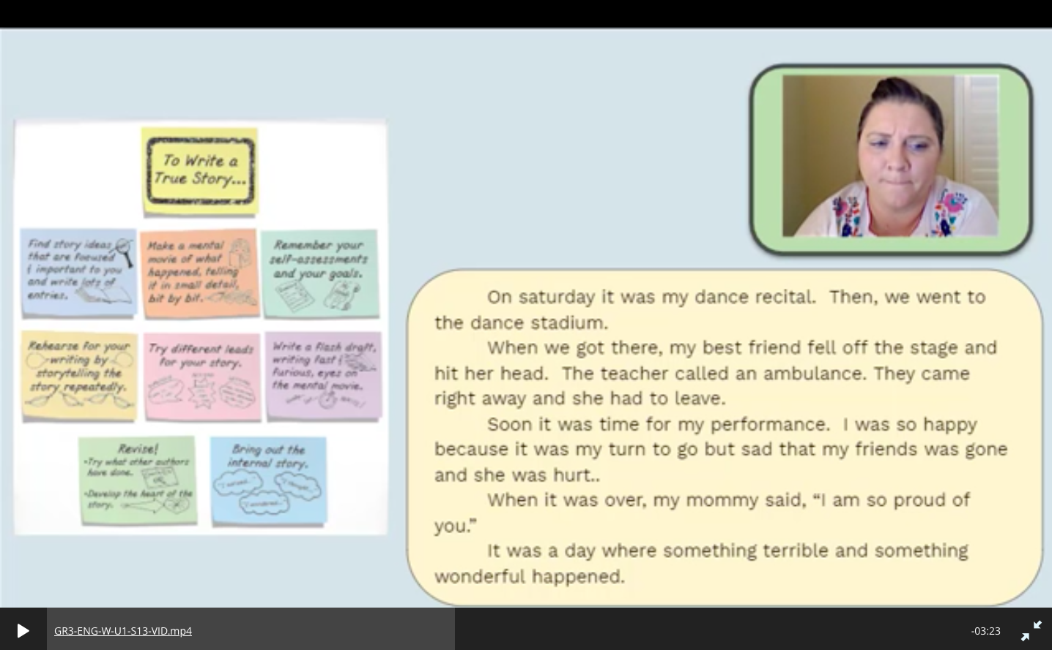 | The teacher is continuing to use ItsLearning.
Guided Practice  Include Check for Understanding Questions | The students will have their narrative writing checklist in their desk. They will start from the top of the checklist and mark not yet, starting to, or YES! marking where they are in the writing process. The teacher will go through the checklist with the class and check the revised bad example story using the checklist. |  |  | The teacher will say “those of you who will be doing revising of the stories will begin doing so at their desk. If the students need any help, after they have read through their story again while going through the writing checklist, I will come by and help or call them back to my desk. | 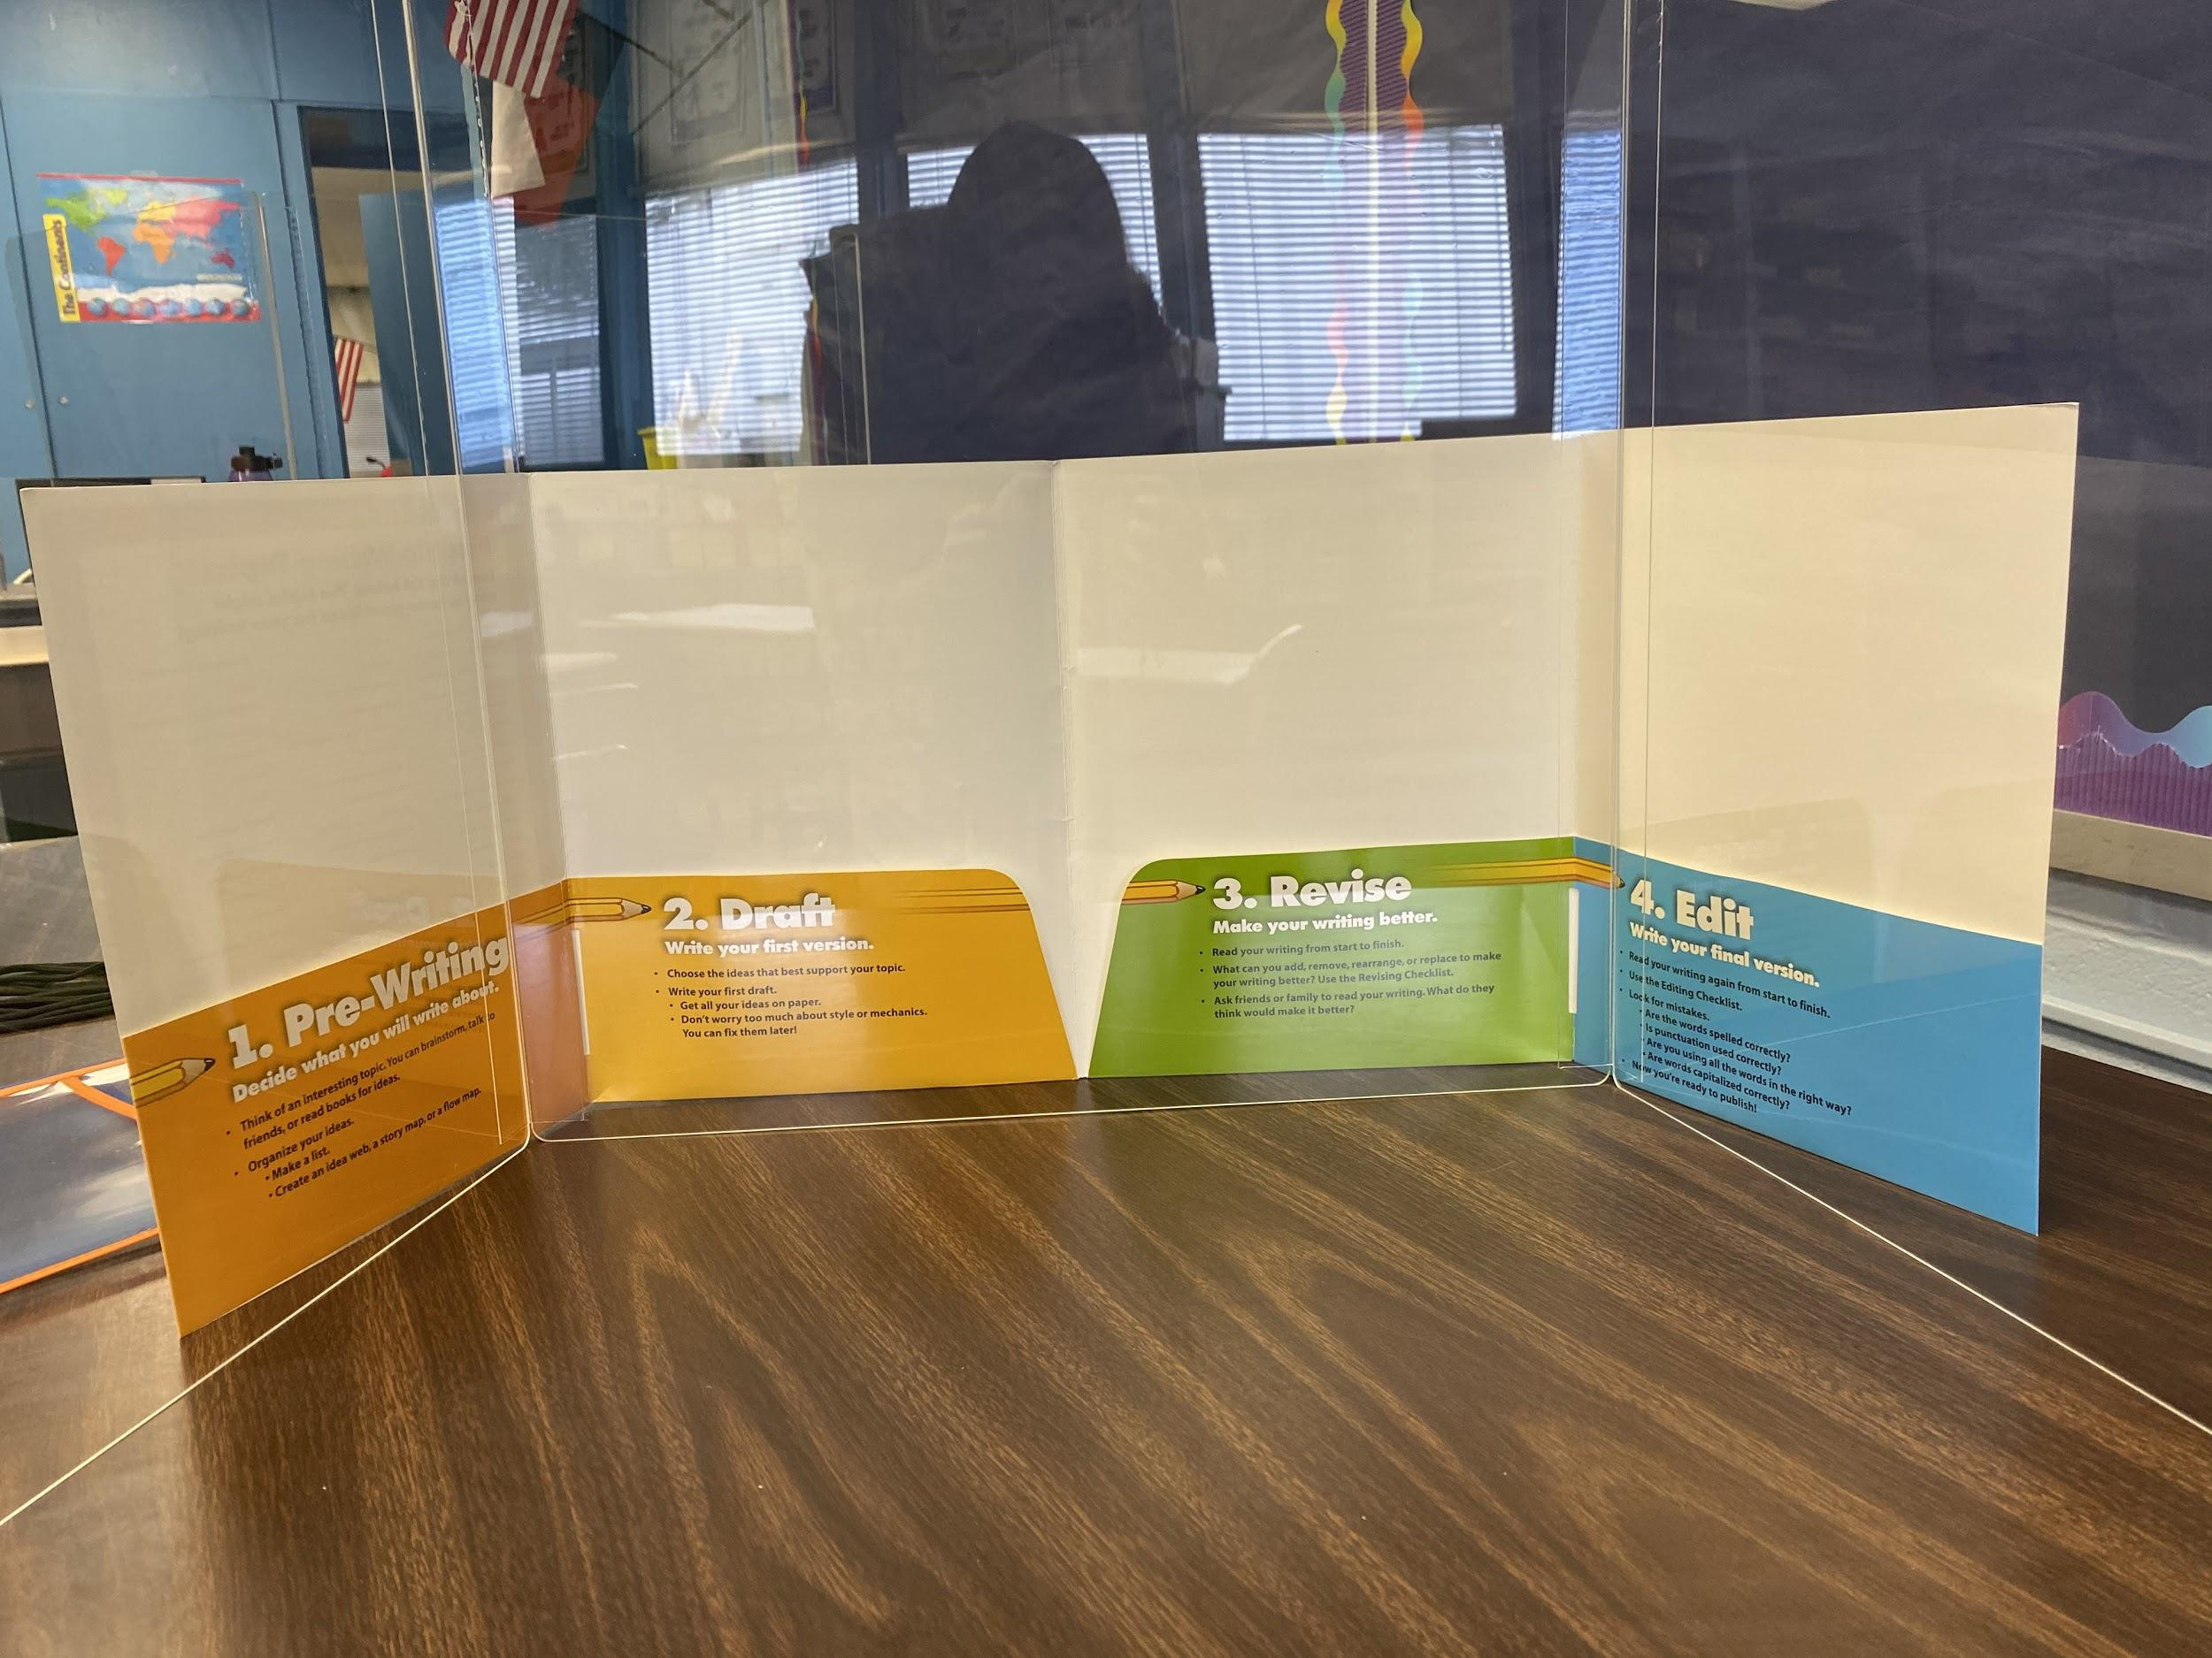
Independent Practice  Include Check for Understanding Questions | I will ask the students to open their writing sample. They will start checking their own stories using the checklist. |  |  | The teacher will allow the students to ask any questions and then the teacher will call on two students to come back to the small group table to use the writing process folders and check their work. | The students are using their narrative writing checklist and their own written stories. 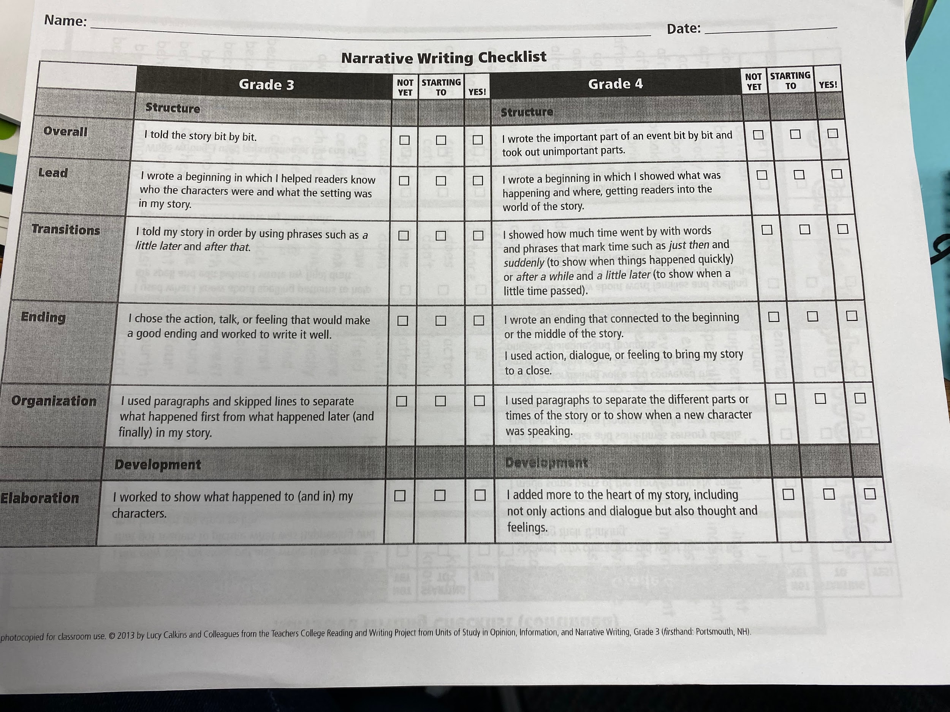
Closure | The teacher will tell the students that for the rest of the writing tiem, they will be revising and editing their stories to get ready to write their FINAL PAPER. We will spend the next two days revising and on friday is when we will all write the final papers. |  |  | The students will be at their desk while some are being called back and forth to the small group table.
Plans for Leading a Discussion Following Guided Practice and Independent Practice
Plan for Leading a 5-10 minute Discussion Following Guided Practice |  | Launch Frame  We have been learning how to draft a story, all of you have been writing your own stories. Who can tell me something about writing a story?
Eliciting, Orienting Questions to ask During the Discussion
What is something you learned about drafting your first story? What needs to be fixed in this example of a narrative? What should you do if you are checking your story using your narrative writing checklist and you don't mark “YES”?
Conclusion Frame
We have been going over drafting, revising and finalizing a narrative. This week we will finish our drafts by revising. Does anyone have any questions?
Plan for Leading a 5-10 minute Discussion Following Independent Practice |  | Launch Frame  We have gone over how to revise a story. Now we will begin to work on our own, making sure your story is ready for the final draft.
Eliciting Orienting Questions to ask During the Discussion
What will you be using to make sure your story is finished? What can you do if your checklist isn't all checked “YES”?
Conclusion Frame
We have been working on revising, tomorrow we will continue revising so that friday we can write our FINAL DRAFTS.
Plans for Differentiated Instruction/Accomodations
Special Education Students |  | I will be using differentiate instruction to ensure that I have hands on learning, guided practice, and independent practice. I will have Ivan and Jonathan come to the small group table first to work with me on their papers step by step. I will talk with them about what they want to write about, i will write out the sentences that come out of their mouth and then let them copy my writing under the lines that i wrote on. This supports both of their dyslexia.  Jackie will need help with spelling and writing.  Evelyn will need assistance with spelling and writing.
English Language Learners |  | I will support ELL’s by writing words they ask me to spell on the board so that they can reference them. All students will have access to site words list. 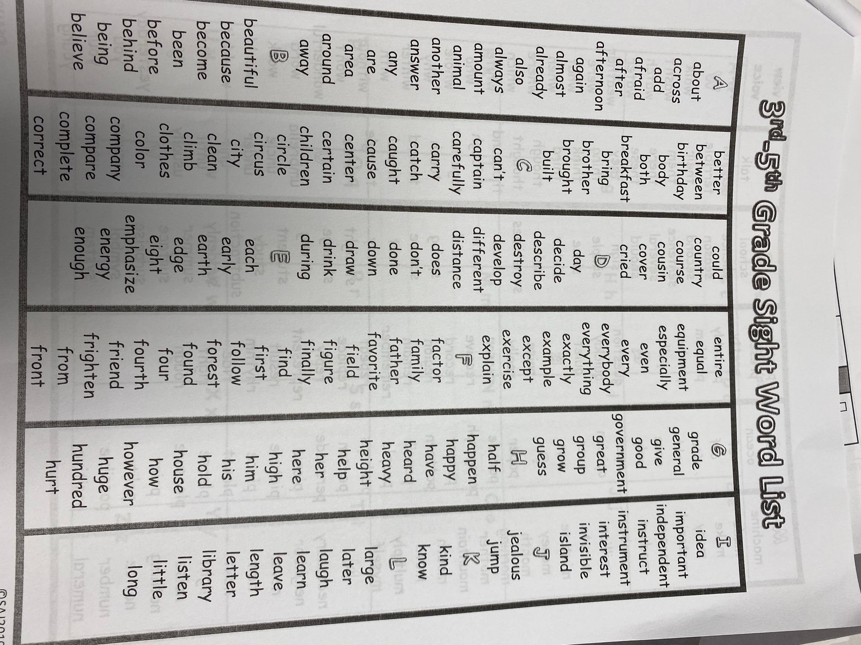
Gifted and Talented |  | Hunter and Ibeth will be able to work at their own pace, once they are done with their checklist and revising, i will allow them to start on their final papers.
Other: |  | We have new student that will stat from the beginning of the unit.
Assessment
The post assessment will be monitored using their narrative writing checklist. They will have completed their stories and gone through the checklist. I will read their stories and go through the checklist and mark if they have the correct format and information.
Classroom Management Plan for the Lesson
To ensure the classroom is under control with voice levels i will say “Your movement is in your chair, your voice level is zero, if you have any questions you will raise your hand, i will know that you are participating if i see you at your desk, writing or going through your checklist”.
Lesson Resources
- ItsLearning

