B-SIDE RECYCLING 2022

*GREEN RECYCLING PICK UP *RED CLOSED
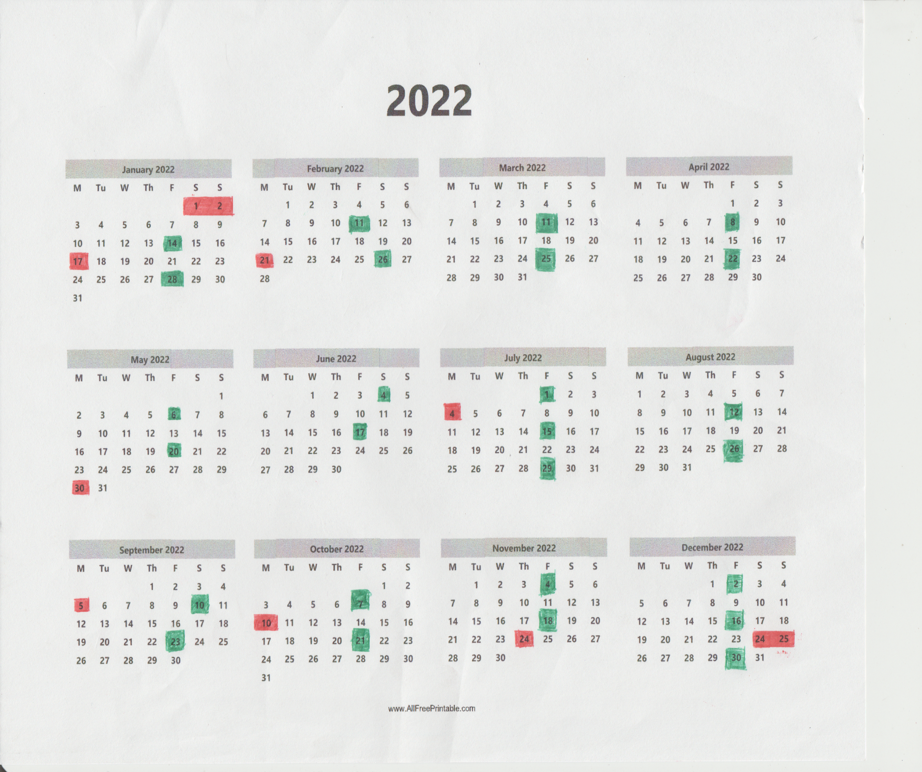
DOWNLOAD @ allcountytrash.com

