CONGRATULATIONS! You have been invited to participate in- Kumite (Sparring) and Kobudo
Kumite and Kobudo are optional and only allowed once a student has reached the Kyu of yellow belt.
Kobudo is learning to use weapons of the Okinawan Martial Arts system. Open Air Dojo teaches Tonfa, Fan, Sai, Bo, Kama, Nunchaku, and Bokken.
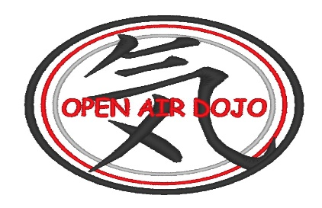
*** Bo, Tonfa, and Nunchaku are typically the first 3 weapons taught by Sensei.
The purpose of Kumite is
- To understand practical application
- Develop ongoing skills for better technique
- Learn to make controlled contact
- Build confidence in one’s ability as a karate student
- Develop self-discipline and self-control

While it is recommended students provide their own sparring gear, Open Air Dojo does have gear available for student use, except for mouthguards.
If you choose to purchase your own sparring gear, it is suggested that you attend a few classes before ordering.
If you are planning to attend Kobudo, you will need to purchase your own weapons. Open Air Dojo has some weapons available for use, but there is no guarantee there will be enough for the entire class at any given time.
Do not feel obligated to participate. We understand this is an added expense. If purchasing weapons or sparring gear is the only reason you are not able to attend Kumite and Kobudo, talk to Sensei or Sempai.
Sparring gear and Kobudo weapons can be ordered through Sensei which will save you tax & shipping, or you can purchase items through Century Martial Arts online www.century.com or in person at Karate Mart 1411 W Indian School Phoenix AZ 85013 www.karatemart.com

______________________________________________________________________________
If Kumite (Sparring) is something you are interested in, please read the Code of Conduct and sign below.
- I HAVE READ AND UNDERSTAND THE CODE OF CONDUCT

- I UNDERSTAND THAT SENSEI AND SEMPAI HAVE THE RIGHT TO REFUSE PARTICIPATION IN KUMITE IF I DO NOT FOLLOW THE CODE OF CONDUCT

STUDENT PRINTED NAME _______________________________________________
STUDENT SUGNATURE _________________________________________________
(Return to Sensei or Sempai before the next Kumite class)
KUMITÈ CODE OF CONDUCT
- I understand that to participate in Kumité,
  - I must attend a minimum of two open hand classes in a 7-day period.
  - If I do not attend two open-hand classes in a 7-day period, I understand that I will not be able to participate in Kumité that week.
  - Conditioning class and Kumité, are not considered open-hand classes as part of the curriculum
- I will conduct myself in a positive manner
- I will use what I have learned respectfully and defensively
- I will always bow and pay respect to my opponent and my instructors
- I will always display good sportsmanship-and not provoke violence inside or outside the dojo
- I will not use foul language or ‘taunt’ /’tease’ my opponent or other students
- I will strictly adhere to Sensei or Sempai's instruction- there will be no sparring without supervision
- I understand that I will be required to use protective gear when participating in sparring
- I understand full uniform is to be worn during kumite class (Gi top, Gi pants and belt required)
- I understand my skills are not to be used intentionally to harm another student or anyone else outside of the Dojo.
I agree that under no circumstances am I allowed as a student, to teach other non- members what I have learned as a student of Open-Air Dojo
****I UNDERSTAND THAT SENSEI AND SEMPAI HAVE THE RIGHT TO REFUSE PARTICIPATION IN KUMITE IF I DO NOT FOLLOW THE CODE OF CONDUCT

