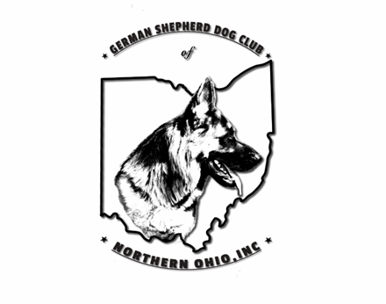 | German Shepherd Dog Club of Northern Ohio, Inc.  Organized in 1945
APPLICATION FOR MEMBERSHIP

Date: ________________

Name: __________________________________________________________________________

Phone: ___________________________ E-mail address: __________________________________

Address: _________________________________________________________________________

Registered name of dog(s) owned: ____________________________________________________

________________________________________________________________________________

Kennel name (if any): ______________________________________________________________

Sex of dogs: ________ male(s) ________ female(s) Your Birthday: month/day: ______/_________

I/we are interested in the following (please circle): Conformation Obedience Rally

Tracking Agility Scent work Herding Other: _______________________________________

Sponsored by:

_____________________________________ _______________________________________
Signatures of two GSDCNO, Inc. members in good standing, but not of the same family

Birthdate: month and day: _____________________________________________________________________________

****************************************************************************************
Please sign and submit your completed application, together with dues in the amount of $20 payable to
GSDC of No. Ohio, Inc., to the Corresponding Secretary or gsdcno@gmail.com.
*****************************************************************************************

Amount paid: ___________________________
Date: __________________________________
1st Reading: ____________________________
2nd Reading:____________________________
1st Attendance: __________________________
2nd Attendance: __________________________

THE MISSION OF THE GERMAN SHEPHERD DOG CLUB OF NORTHERN OHIO, INC. IS:

1. To encourage and promote the breeding of purebred German Shepherd Dogs
and to do all things possible to bring their natural qualities to perfection.

2. To urge members and breeders to accept the American Kennel Club standard as the only standard of excellence by which the German Shepherd Dog shall be judged.

3. To promote the use of the German Shepherd Dog Club of America’s Breeder Code among the members of the club.

4. To encourage good sportsmanship at dog shows, obedience trials and other sporting events.

5. To host sanctioned and licensed specialty shows, obedience trials and other events under American Kennel Club rules.

Membership is open to any person of good moral character who is in good standing with the American Kennel Club and who is interested in furthering the mission of this club.

I hereby apply for membership with the German Shepherd Dog Club of Northern Ohio, Inc. If this application is approved, I will abide by the rules and regulations governing this club and will do my best to promote the mission of this club.

My signature below signifies that I have received and read the German Shepherd Dog Club of Northern Ohio, Inc.’s Constitution and Bylaws and accept the terms and conditions of membership.

____________________________________________________
(Signature of applicant(s))

____________________________________________________
(Date)

