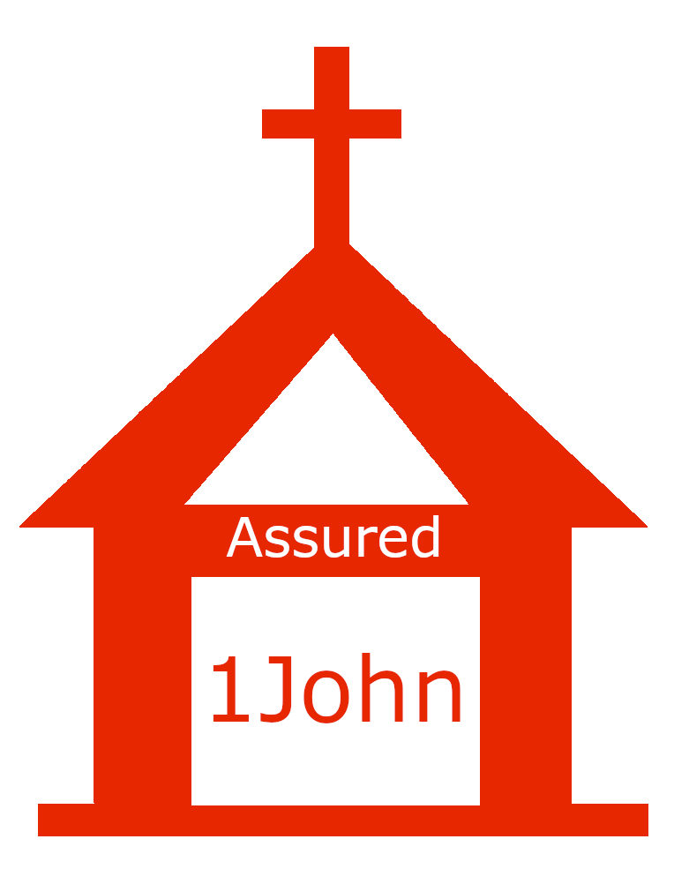

**Assurance Benefits**

**1 John 5:13-21**

**Week 17 — August 26**

*Discussion Question #1: Do you have a question or takeaway from Sunday’s sermon?*

*Discussion Question # 2: What does a lack of assurance of salvation look like in your life?*

*Discussion Question #3: In what way does assurance of salvation drive us to pray?*

*Discussion Question #4: Since we are supposed to pray for what is in God’s will, how can we know His will?*

*Discussion Question #5: What must be true in order for us to be able to see our brother committing sin?*

*Discussion Question #6: How does being born of God change our relationship with sin?*