

Odis Martin
EMERGENCY PREPAREDNESS PLAN
2021

1/1/2019
TABLE OF CONTENTS

Emergency Committee Roles & Responsibilities Page 3-6

Hurricane Preparedness Plan Page 7-8

Terrorism Preparedness Plan Page 9

Fire Safety Preparedness & Explosion Plan Page 10-12

Map of Cindiri Beach on Cross Caye Page 13

Form 1: Hurricane Procedure for Guests Page 14-15

Form 2: Hurricane Supply Inventory Checklist Page 16

EMERGENCY COMMITTEE ROLES & RESPONSIBILITIES

This section details specific activities for each member of the Emergency Committee both in terms of general preparedness and at each phase of an emergency’s progress.

EC Role 1: General Manager Emergency Committee Chair Member

Emergency/Hurricane preparedness Responsibilities
- Be responsible for the overall coordination of regular hotel or property operations and emergency procedures.
- Create the Emergency Committee with key members of staff.
- Ensure vulnerability assessment is conducted and external experts are hire where necessary.
Institute preventative measures to minimize vulnerability and risk.
- Liaise with emergency and information services (e.g. the National Disaster Organization, Tourism Sector Emergency Committee, Meteorological Office, nearby medical facilities, appropriate community contacts, etc.) as well as mutual aid partners.
- Know the property’s supply needs for both normal and emergency times.
- Write and sign mutual aid agreements with companies and organizations that could provide supplies and assistance during emergencies and disasters.
- Ensure the property is insured for the case of disaster.
- Meet regularly with members of the Emergency Committee, and review the plan and implement preparedness and mitigation activities.
- Provide staff with adequate training regarding disaster management, first aid, etc., and the implementation of these procedures.
- Create a Staff and Guests Communication Strategy.
- Create an emergency assistance policy.
- Disseminate the plan and ensure all staff and guests know what will be done if an emergency occurs.
- Plan, execute and evaluate simulation exercises to test the response of the EC and to improve the plan.
- Revise the Emergency plan and procedures every year and after every real event.

Phase A: Hurricane Alert
- Convene an emergency meeting of the EC to inform them about the situation
- and to activate the plan and procedures.
- Ensure each member of the EC executes his or her assigned responsibilities
- at this stage and is briefed after the tasks have been completed.
- Convene a meeting with guests to inform them about the situation and about measures to be taken.
- Ensure the storm/hurricane is being tracked and maps are posted at the designated area.
- Reconfirm mutual aid agreements, if necessary, and revise requirements as perceived.
- Check and revise phone numbers for emergency contacts.
- Ensure telecommunications equipment is in good working order.
- Ensure inventories of supplies are prepared and verified.

Phase B: Hurricane Watch
- Meet with the EC and discuss priorities for action based on activities achieved to date and staff/resource availability.
- Convene a meeting with guests to inform them about the situation.
- Maintain and update the hurricane tracking map at reception area.
- Request all needed materials and supplies based on inventory provided, including potable water.
- Make arrangements for employees to manage the facility and guests during the crisis.
- Develop a staff roster.
- Allow employees time to make emergency preparations at their own homes, ensuring they leave contact addresses and are aware of their possible responsibilities on the staff roster.
- Identify the employees who will most likely be unable to assist the establishment during a critical event, such as those who must take care of small children or elderly parents. Employees who are unable to assist during a critical event should be allowed to leave the establishment to return to their families.
- Recall all key personnel as deemed necessary.
- Make arrangements for those who will stay on premises.
Phase C: Hurricane Warning
- Convene a meeting with EC members to start shutting down operations and relocate guests.
- Convene a meeting with guests to inform them about the relocation to safe rooms, areas or other property and to inform them about preparations they have to take. Request assistance from them.
- Activate the Command Center and post the tracking map there.
- Ensure the Command Center has sufficient supplies and telecommunications equipment.
- Ensure that members of the EC who will stay during the hurricane.
- Ensure guests are relocated to safe rooms, areas or hotels, as needed.
- Ensure all cabanas are protected and all supplies are in place.
- Shut down all normal property operations.
Phase D: Emergency Phase
- Remain in the Command Center with key EC members as appropriate.

Phase E: Recovery Phase
- Give the ”all clear” after it has been given officially by authorities.
- Hold a briefing with the EC and guests.
- Conduct a head count and do an initial damage and needs assessment with information from EC members.
- Ensure injured guests and staff are administered first-aid when necessary.
- Report the results of the initial damage and needs assessment to the Tourism Emergency Management Committee.
- Draft an action plan to start immediate recovery.
- Establish the property’s overall ability to provide services to guests, based on resource availability, including activating mutual aid agreements.
- Assess shortfalls that might prevent a return to normal operations.
- Assess and negotiate for joint use, lending, borrowing and sharing of facilities, equipment and personnel services as needed.
- Document all incidents.

EC Role 2: Concierge Emergency Committee Crew Member

Emergency/Hurricane preparedness Responsibilities
- Prepare hurricane emergency procedures for guests and keep them on file
- Find out about assessment of risk areas and safe areas in case it becomes necessary to relocate guests. (Evacuation of guests outside the property to designated national shelters should be considered only when this is felt to be the only appropriate course of action and if it has been agreed with the National Disaster Organization.)
- Find out from the EC about the conditions under which relocation or evacuation will be necessary, and alert guests as needed.
Phase A: Hurricane Alert
- Ensure all guests are briefed by the General Manager about the situation and give them the choice to leave or to stay at the property.
- Ensure all guests receive a letter and hurricane information in their cabanas explaining the situation and measures to be taken.
- Ensure that a tracking map is posted in the designated area.

Phase B: Hurricane Watch
- Obtain a list of all the guests and their cabanas and give a copy to the Emergency Committee.
- Distribute to each guest room a memo on the current situation and a hurricane brochure instructing guests on emergency procedures as they affect them (see Form 4 at the back of this manual).
- Distribute these only when directed to do so by the General Manager.
- Determine the number of guests likely to be on site at landfall of the hurricane.
- Inform guests who will remain in the hotel about the safe rooms or central predetermined areas in which they should stay during the hurricane.
- Determine the schedule of events, entertainment etc. that will be available for guests and include it in future guest memos.
Phase C: Hurricane Warning
- Ensure that all guests are briefed by the General Manager about the situation
- and given the choice to leave or to stay at the hotel.
- Make arrangements to distribute to each guest room a memo on the current
- situation and a hurricane brochure instructing guests on emergency
- procedures as they affect them (see Form 4 at the back of this manual).
- Distribute these only when directed to do so by the General Manager.
- Inform the Emergency Coordinator about guests leaving the property.
- When instructed by the Emergency Coordinator, start relocating guests to safe areas. There should be no exceptions. In the case of a hurricane strike expected at night, all guests should move before nightfall.
- Ensure remaining guests pack all their belongings and collect passports and valuables to be locked in the hotel safe.
- Ensure any area not designated as safe areas are secured, unoccupied and locked.
- Address guests on scheduled activities for the duration of the hurricane.
- Distribute games and/or initiate the schedule of activities for guests.

Phase D: Emergency Phase
- Ensure all guests stay in their assigned safe rooms or areas until the
- Emergency Committee sends the “all clear.”

Phase E: Recovery Phase
- After the ”all clear” has been given by national authorities, perform a head count of guests in their safe areas.
- Ensure that all guests are briefed by the Emergency Coordinator about the situation and about measures to be taken to continue their safety if areas of the property are damaged (pier, walkways, etc.).
- Request the voluntary participation of guests in the recovery activities.

HURRICANE PREPAREDNESS PLAN

Monitor potential for safety impact by using the following techniques:
Phase A: Hurricane Alert (tropical cyclone in the region)
- Convene an Emergency Committee meeting upon notification of Hurricane alert in the area.
- Hold a meeting with guests.
- Place a letter and hurricane information in guests’ rooms.
- Track the storm/hurricane and post a chart/map in a common area.
- Verify working conditions/availability of emergency equipment.
- Verify inventories of food, water, hurricane supplies, etc.
- Check telecommunications equipment.
- Update directories (Staff, Tourism Disaster Emergency Center, Dangriga Medical Facilities)

Phase B: Hurricane Watch (36 hours to landfall)
- Convene a meeting for all Emergency Committee Staff.
- Hold a meeting with guests.
- Place an updated letter and hurricane information in guests’ rooms.
- Update the hurricane chart/map.
- Ensure there are enough emergency supplies (food, water, fuel, etc.) in the property.
- Update staff list.
- Clean drains, remove debris and trim trees.
- Test generator and replenish appropriate fuel.
- Check lists and status of safe rooms and locations.
- Ensure guests are prepped on location of safety areas on the island in case of storm surge.
.
Phase C: Hurricane Warning (24 hours to landfall)
- Convene a meeting of the Emergency Committee Staff.
- Hold a meeting with guests.
- Place an updated letter and hurricane information in guests’ rooms.
- Update the hurricane chart.
- Activate the Command Center.
- Secure all outside equipment, tools, boats and any objects that could become projectiles.
- Raise shutters and secure all glass windows.
- Put all food and beverages in safe locations.
- Disconnect all propane gas lines to avoid breakage and leakage during storm surge.
- Put all furniture in safe locations.
- Put all equipment in safe locations.
- Back up all vital records and put them in safe locations.
- Put all valuables (including guests’) in safe locations.
- Lock all empty rooms.
- Send home all staff not needed during the emergency.
- Shut down utilities.
- Re-locate guests to safe rooms or areas.
- Ensure there are supplies available for staff and guests remaining in the property. (3-7 days).
- If property is closing down during the emergency, ensure all guests have left and dispatch all staff.
- Keep security personnel in a safe area inside the safe locations.

Phase D: Emergency Phase (during impact)
- Make sure key staff members remaining in the property stay in the Command Center.
- Make sure that guests stay in safe rooms or safe areas.

Phase E: Recovery Phase (after the ”all clear” is given)
- Convene a meeting of the Emergency Committee, after the “All-Clear.”
- Hold a meeting with guests.
- Conduct a head count of both staff and guests.
- Start a damage and needs assessment.
- Report the results of this assessment to your national Tourism Disaster Emergency Center.
- Request relief and assistance from emergency agencies as needed.
- Start rehabilitation of utilities and services.
- Re-initiate property operations when possible.
- Start re-construction.

TERRORISM PREPAREDNESS PLAN

property protocols to activate during periods when a government authority has indicated an increased possibility for a terrorist attack to occur in the area:

- Maintain communication with tourism association networks and businesses around the islands to be on alert for suspicious activities.
- Review previously identified vulnerabilities and determine what areas leave the island most exposed to attack.
- Verify that Command Center communications are functioning properly.
- Ensure staff and guests feel encouraged to report suspicious acts, events, overheard conversations, etc. as unusual to proper staff.
- Review with employees the procedures they should follow in the event of an emergency.
- Ensure a watchman is on shift 24/7 to monitor island activity for vessels approaching and attempting to land ashore and that the Watchman is prepared to alert the Command Center of any suspicious activity.
- Check emergency supply kits to verify all supplies are present.
- Verify that all cache supplies are stocked and verify they are in a safe environment.

Ensure all Staff are trained to identify the following suspicious activity:
- Persons taking photographs of Command Center operations.
- Persons walking around in unauthorized areas.
- Persons asking questions about when security officers patrol the area.
- Persons appearing over-dressed for the current weather conditions;
- Persons acting in a suspicious manner prior to the event.
- Strange vessels attempting to land ashore.
- Persons unknown as guests or staff on the island.
- IMMEDIATELY report any unattended items.

FIRE SAFETY PREPAREDNESS PLAN & EXPLOSION PLAN

Preparation for fire prevention
- Ensure property compliance with your country’s fire and building codes
- Fire exits/ escape routes need to be clearly identified, unlocked and free from
- physical obstructions
- Fire alarms and fire sprinkler/suppression systems need to be installed in
- hotel
- Guest rooms should be equipped with smoke detectors
- Fire prevention and fire protection plans should be established. These plans
- should incorporate periodical formal inspections of floors, fire exits/ escape
- routes, smoke detectors and other equipment and housekeeping
- Create evacuation plan for guests and staff
- Staff need to be properly trained in executing evacuation plan and regular fire
- drills need to be conducted
- A fire evacuation plan should be posted in guest rooms and accessible to all
- guests
- Identify fire marshal and nearest fire station, have contact information for fire
- station and fire marshal easily accessible to staff
- If possible, fireproofing measures should be taken to protect buildings. These
- measures can include the construction of foundations, floors, roofs, walls,
- stairways, stairs, elevator shafts, and dumbwaiter shafts from materials such
- as concrete, brick, terra cotta blocks, or steel.

Fire Response
Any detection of fire or smoke should be taken seriously and fire services should
be notified immediately. Fire and smoke can overwhelm people in a very short
period, and decisive response is required. Asphyxiation is the leading cause of
death from fire or smoke, followed by burns and thermal related injury.

- If you are on fire: STOP, DROP and ROLL to extinguish the flames.
- Before opening a door, check it by placing the back of your hand against the door to test for heat.
- In the event that individuals are trapped in their rooms, they should be instructed to stay away from the main door and use wet towels to prohibit smoke from entering underneath door.
- Notify affected personnel of fire and advise on location of the fire.
- Coordinate evacuation efforts with Emergency Committee.
- Activate Bull Horn (Fire Alert System) and fire suppression system.
- Notify nearby (fire, police) of the incident as necessary.
- Advise guests and staff on evacuation routes and rally points.
- Locate fire extinguisher and deploy as needed, but do not compromise your safety or the safety of others to extinguish the fire.
- Evacuate the building using stairwells beyond primary assembly areas and away from threat of fire.
- Leave personal possessions.
- Remain low to the floor if possible.
- At rally point, conduct a roll call of all employees and where and when applicable, guests.
- Notify off-site personnel.
- Seek medical attention for injuries.
- Do not re-enter the area until deemed safe by emergency respondents.

EXPLOSION PLAN
In the event of an explosion, evacuate all staff, guests and visitors from the affected area(s) immediately. Injury from an explosion can result from the blast over-pressure, debris and thermal effects. In addition, the explosion may cause structural damage that can result in a collapse or cause mass panic.
From a safe location:
- Conduct a scene assessment and take photos if possible.
- Contact local emergency respondents (fire, police).
- Immediately notify others, such as your Cluster, of the location of the explosion.
- Collect and provide information on:
- Location of explosion;
- Size of area affected;
- Impact to personnel and property; and
- Status of employees and customers on-site.
- Conduct a roll call of allstaff, and where and when applicable, guests.
- Do not re-enter the area until deemed safe by emergency respondents.

How and When to Use a Fire Extinguisher
In case of small fires, a fire extinguisher can be used to assist in extinguishing the flames. Employees should be trained in how to use a fire extinguisher and take the time to locate the extinguisher closest
to their work area before a fire emergency occurs. Each fire extinguisher is rated based on its ability to be effective against certain types of fires. These ratings are:
• Type A: Wood or paper fires only.
• Type B: Flammable liquids or grease fires
• Type C: Electrical fires
• Type ABC: Rated for all types of fires
A simple acronym can help you remember how to use a fire
extinguisher:
PASS
P- Pull the safety pin
A- Aim at the base of the fire (approach no closer than 8 feet)
S- Squeeze the activation handle while holding extinguisher upright
S- Sweep back and forth, covering the area of the fire
If you are unable to extinguish a fire in 15 seconds using a portable
fire extinguisher, leave the area. If possible, close off the area.

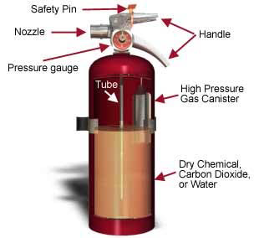

MAP AND LOCATION OF CROSS CAYE
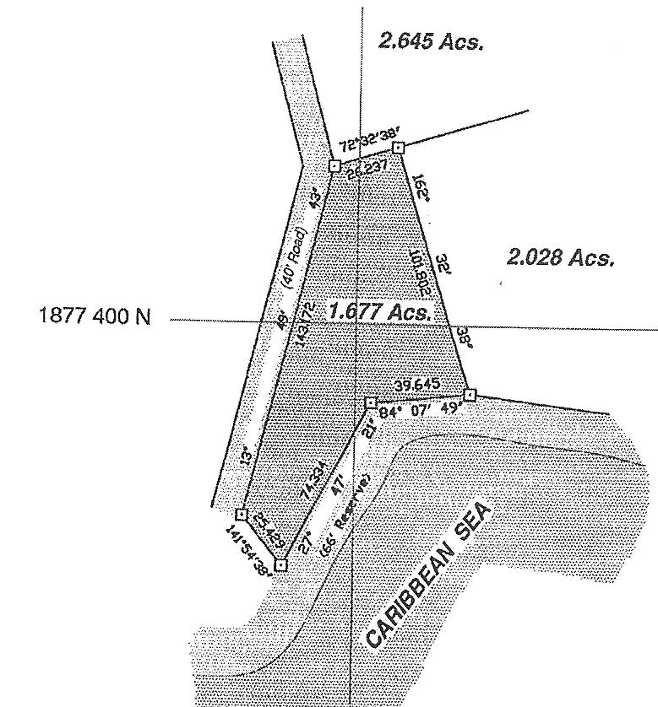

Drawing 1: LOCATION OF ODIS MARTIN’S PARCEL ON CROSS CAYE

This parcel is located on a 1.677 acre parcel located on Cross Caye. Cross Caye is 13 miles off the coast of Dangriga Town, in the Stann Creek District of Southern Belize. Cross Caye is located inside the Belize Barrier Reef on the Caribbean Sea. Cross Caye is about 1 mile in length and runs East to West. The parcel where Cindiri Beach is located is situated approximately midway along the south shore and has a protected bay, as shown in the parcel map above. The building structures are elevated 10 feet above grade and are situated on the parcel facing south, with sunrise to the east and sunset to the west.
Form 1: HURRICANE PROCEDURES FOR GUESTS

Welcome to our property.

You have chosen one of the most beautiful places on earth to spend your
holiday. We have calm, beautiful seas, lovely beaches and sunny skies - most of
the time. But, as you know, during some months of the year, usually between
July and September, hurricanes can occur in this part of the world.
We have taken every precaution to ensure your safety should a hurricane occur
while you are here. Knowing what to do is one of the most important precautions
YOU can take. Please take a few minutes and read this brochure carefully.
Then relax and enjoy all the good things we have to offer.

What is a hurricane?
Let's begin with the things you should know about a hurricane itself. A hurricane is an intense storm with wind speeds of more than 75 miles per hour. It is usually accompanied by heavy rain and sometimes high seas. It should be treated with respect.

When a hurricane is in the area, there are three phases in which it is brought to our attention. These are:

Phase A: Hurricane Alert: This means that a hurricane is in the general vicinity and, though it may be several hundred miles away, appears to be heading toward us. During this phase, the storm may change course and go somewhere else. When a Hurricane Alert is announced, you will be advised what to do by our Concierge. You many contact the front desk for updates on the situation.

Phase B: Hurricane Watch: This means that the hurricane is about 36 hours or so away. As soon as a Hurricane Watch is announced, you will be advised by our Concierge. At this time, you should read this brochure again and make sure that, if you are traveling with your family, everyone is fully briefed. It is advisable to check now and then with the Concierge for the latest information. Also, ensure that your home address, telephone numbers and contact information are on file at the front desk, if they were not recorded when you registered. Start considering whether you will go back to your country or place of origin.

Phase C: Hurricane Warning: This means that the hurricane is expected to strike our location in 24 hours. You will be advised of a Hurricane Warning through our public address system or telephone operator, or by members of our staff. As soon as a Hurricane Warning is confirmed, you should:
1. Decide if you will stay in the hotel or go back to your country or place of origin, based on facts such as the hotel remaining open or closed, availability of flights, magnitude of the hurricane, etc. If you decide to stay, follow the next steps.
2. Secure your passport or other travel documents in the hotel safe, along with any other important papers you may have with you. You should also make sure to put money, jewelry and other valuables in the hotel safe. Please note that the hotel cannot be held liable for valuables not deposited in its safe.
3. You may find it convenient to settle your bill at this time; it will make it much
simpler and easier for you later, in case there are any disruptions after the
hurricane.
4. Pack a small bag with essential personal items such as medication, towels, contact lenses, toilet articles and one change of clothing. If you have small children with you, remember to pack baby food, diapers, etc., and a change of clothing for each child.
5. Pack away all your clothes and non-essential personal items in your suitcases and put the suitcases in plastic garbage bags, which the housekeeping staff will supply for you. Seal the plastic bags with the masking tape provided and then put them in the cupboard in your room. Lock your room and take the key with you.
6. Go to the designated safe rooms, areas or hotel as soon as you are told to do so. Remain in the safe location and stay away from glass windows and doors at all times. Do not go out until you are told to do so.
7. Our trained staff members will be assigned to help you find the safe location and manage safely during the hurricane. You should follow their instructions.
8. An emergency telephone number will be activated when a hurricane is announced.
9. Our Concierge will help you with arrangements to contact your family and friends before and after the hurricane.
10. For your safety, alcoholic beverages will not be served while a Hurricane Warning is in force, and until the hurricane has passed over.
11. Stay calm. Hurricanes give us a fair amount of warning. If you follow these simple steps, and whatever other instructions you are given by our staff, you will be fine.

Form 2: HURRICANE SUPPLY INVENTORY CHECKLIST
QUANTITY ITEMS STATUS
TOOLS

- Bull horn
- Chain saws
- Rain cloaks
- All-purpose gloves
- Rubber gloves
- Suction machine
- ¾” ropes
- ½” ropes
- Masking tape
- Camera
- Film
- Batteries
- Flashlights
- Flashlight bulbs
- Battery lanterns
- Battery-operated
- radios
- Saws
- Hammers
- Nails
- Wide brooms
- Large mops/sticks
- Wringer pails
- Shovels
- Crocus bags
- Load of sand
- Water boots
- Water scrapers
- Plastic buckets
- Plastic sheeting
- Ply-board
- Lumber
- Generator
- Helmets
- 7-day's gas, diesel
- oil (minimum)
- 7-day's potable
- water
- Disposable sanitary
- ware
- Forks/knives/spoons
- Cups
- 180
- Plates
- Napkins
- Garbage bags
- Charcoal
- Chlorinating tablets
- Guy wire (to secure
- critical areas posthurricane)
- Duct tape

FOOD SUPPLIES
- Tinned protein
- Ham
- Sardines
- Tuna
- Salmon
- Crackers
- Biscuits
- Canned sodas
- Canned fruit drinks
- Bottled water
- Powdered milk
- Coffee

