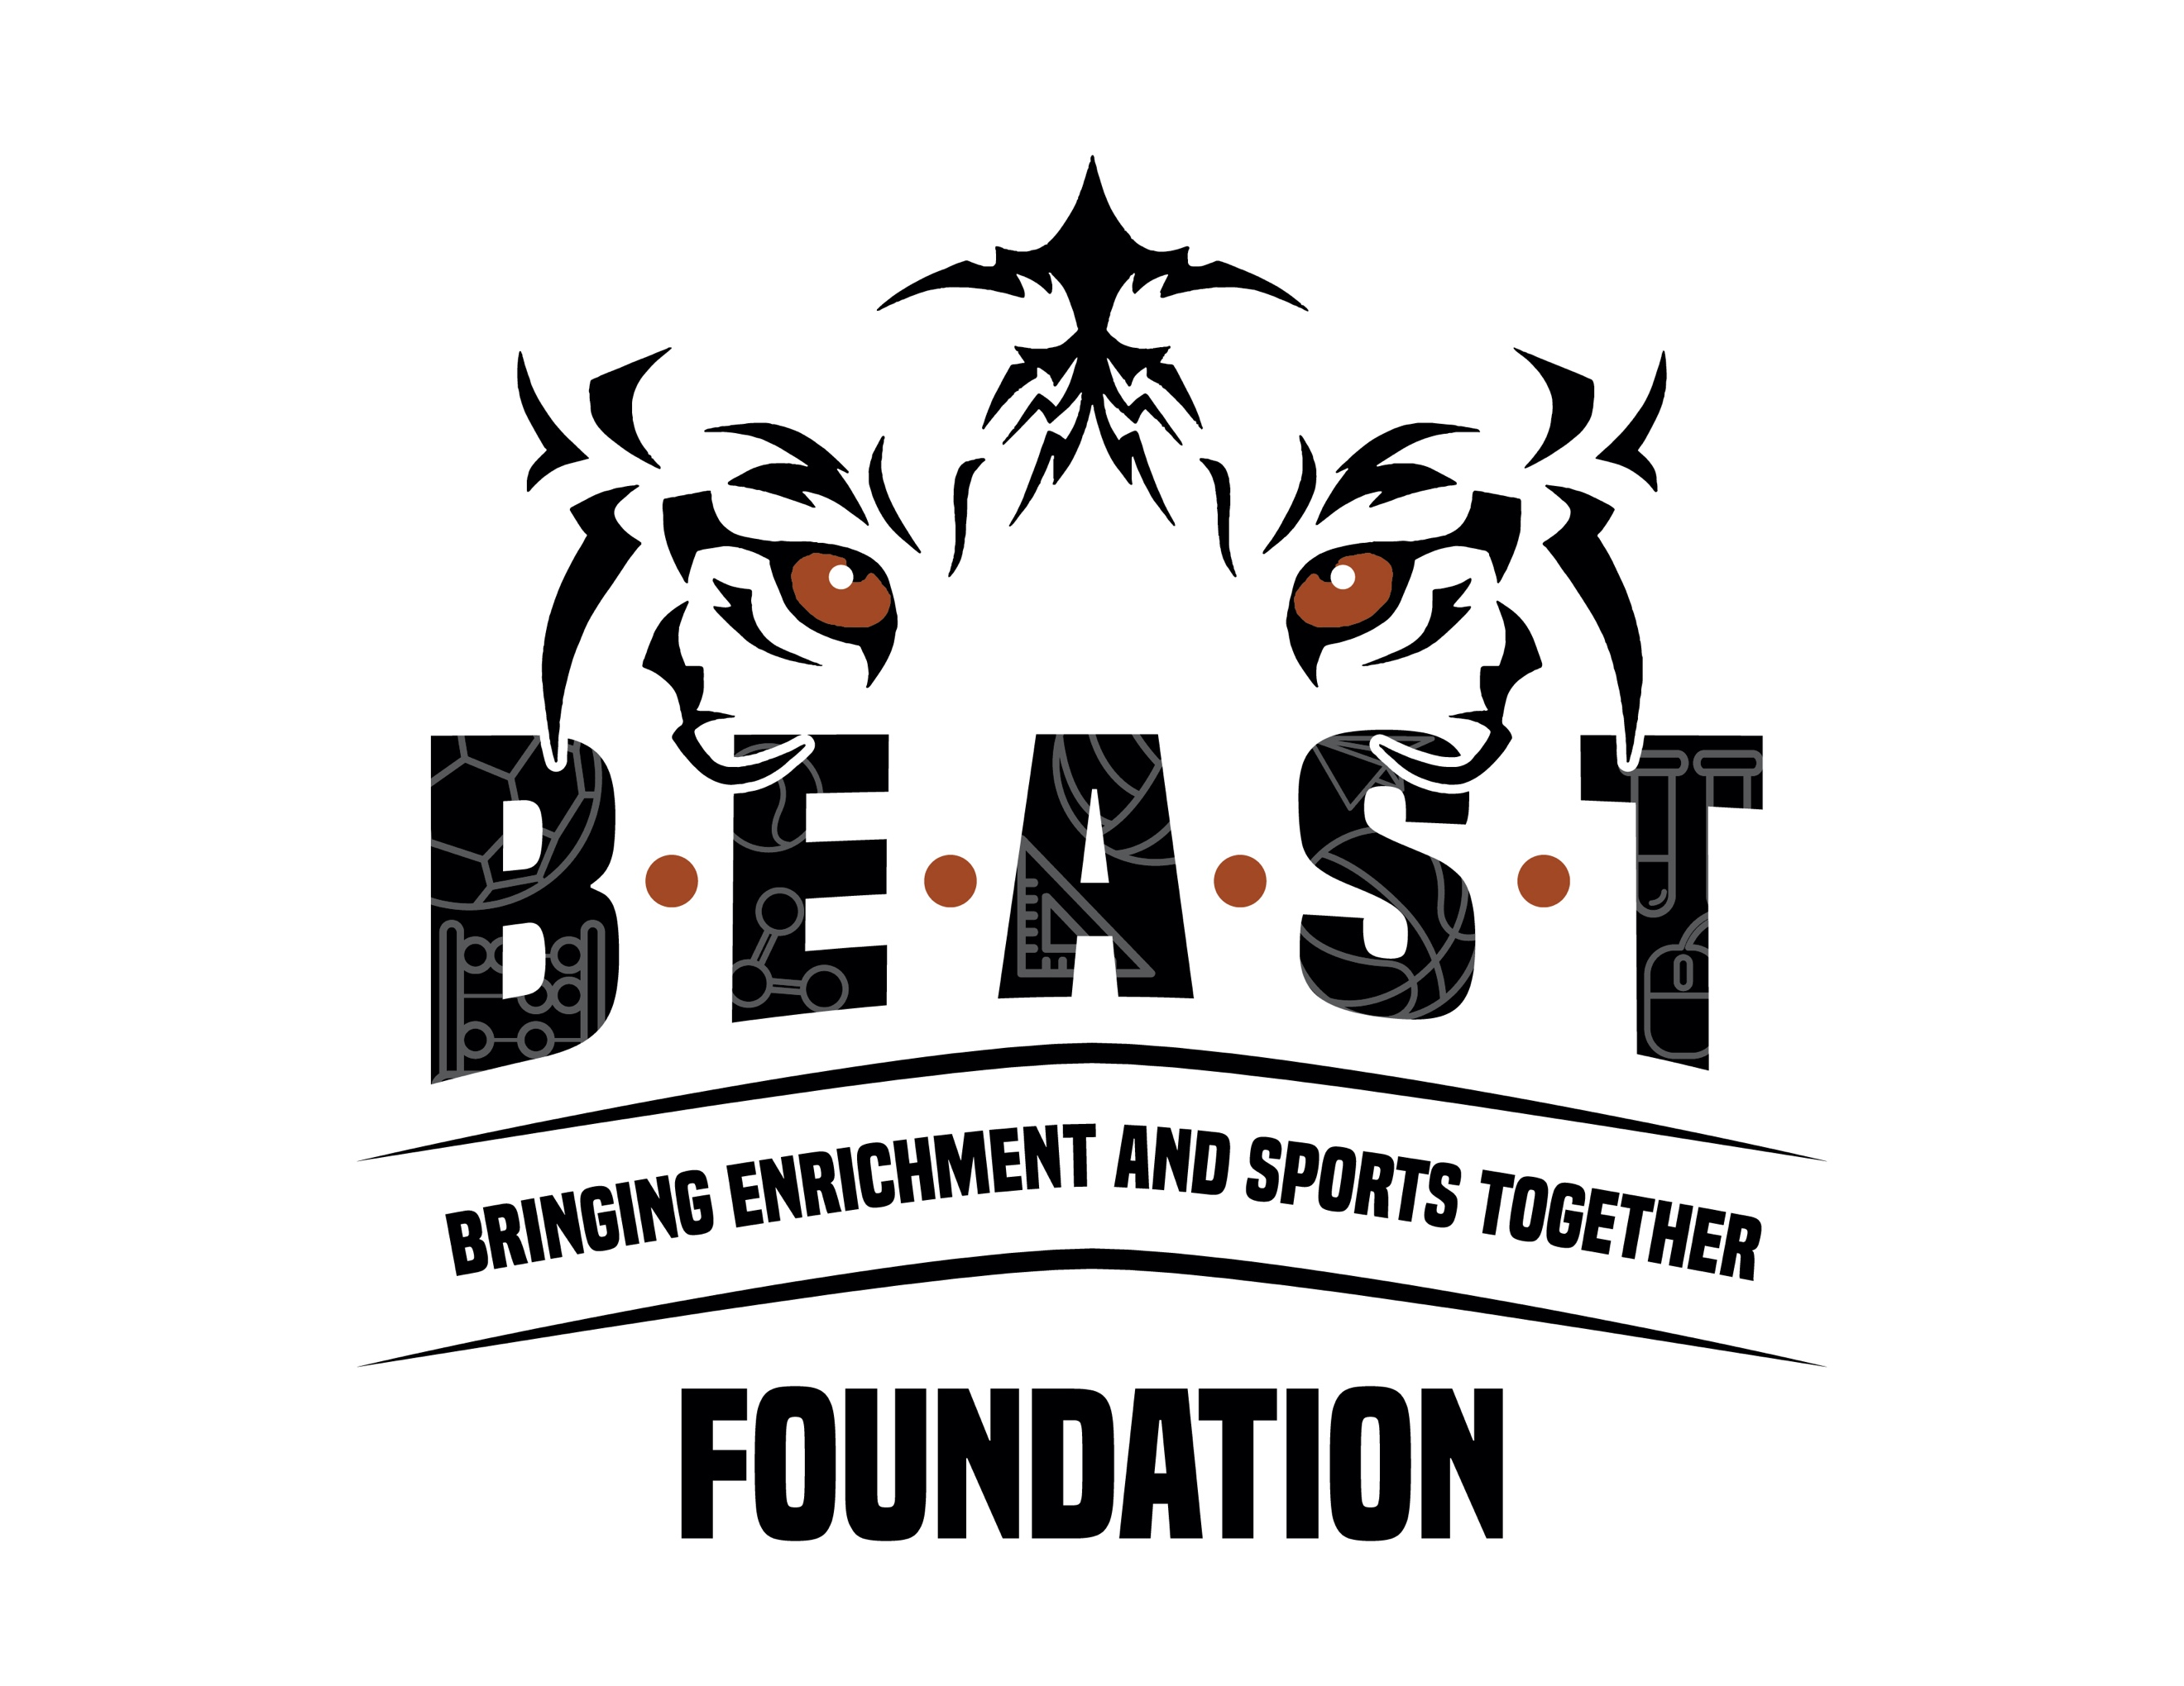

BEAST Foundation Scholarship Application

The BEAST Foundation will offer scholarships to assist in paying for monthly tuition charges for the after-school program and the summer program. This assistance can be used for either the Recreation program or the STEM program and will not exceed 50% of any families’ tuition charges. Award amounts will be based on need as determined by the information included in the application.

First time attendees that receive scholarship assistance will begin on a 3-month trial. At the end of the 3-month period, regular attendance and the child’s citizenship/behavior will be evaluated to determine continuation of scholarship funds.

To apply, complete all information on the application form and include all documentation required. If you have any questions about the application process, please call us for assistance at 307-514-0070. Or email us at carrie@beastfoundation.org. We look forward to speaking with you and answering any questions.

Scholarship Application

APPLICANT INFO: Parent/Guardian Name _________________________________Date of Birth ____________
Mailing Address: ____________________________________________________________________________
Home Phone: _(___)____________ Cell Phone: _(___)__________ Email: ______________________________

List all dependents living in the household:
Additional Adult: _____________________________________________________Date of Birth____________
Child’s Name: _______________________________________________________ Date of Birth____________
Child’s Name: _______________________________________________________ Date of Birth____________
Child’s Name: _______________________________________________________ Date of Birth____________

CARE AND CUSTODY
Who has custody of child? Both___ Mom___ Dad___ Foster___ Guardian___ I Do Not Have Custody___
Parent/Guardian #1: At Home_____ Working____ In School _____
Parent/Guardian #2: At Home_____ Working____ In School _____

REQUIRED DOCUMENTATION
All applicants must submit documentation along with the application. Photocopies only please.
- Copy of most recent tax return – Form 1040 and other forms to support your financial need.
- Proof of income – W-2’s, any of the 1099’s, and two current pay stubs.
- Any additional proof of income – child support, disability, Social Security, etc.
- Government assistance – food stamps, free or reduced meals at school.
- Letter from each child’s teacher addressing good citizenship/behavior. The letter must be emailed directly to the BEAST Foundation at carrie@beastfoundation.org for review.

APPLICATION REVIEW AND RENEWAL

I certify that the information contained in this application is true and complete to the best of my knowledge and that I do not have any unclaimed income. To cancel our participation in the scholarship program, I will contact the BEAST Foundation immediately so sponsorship can be provided to others. I agree, if necessary, to provide additional information and documentation to support the above statements. I further understand that scholarship assistance is based on need, and if I falsify any of the above information, I will not be eligible for assistance now or in the future.

_________________________________________________________ __________________
Signature of Person Completing the Form Date

Application and all documents may be submitted in person, by email, or through mail.
Mailing Address: BEAST Foundation, 2900 Sunflower Road, Cheyenne, WY 82009

